March 4rd, 2021

Nissho has partnered up with Nethone’s online fraud protection expertise, to help e-commerce businesses in Japan eliminate fraud

Nethone, a Machine Learning-based fraud prevention company, and Nissho Electronics Corporation, announced a business collaboration on delivering cutting-edge online fraud and account takeover detection and prevention solutions in Japan. Nethone will be part of the already existing Tranfis brand offered by Nissho, and will be distributed under the name “Tranfis powered by Nethone”.

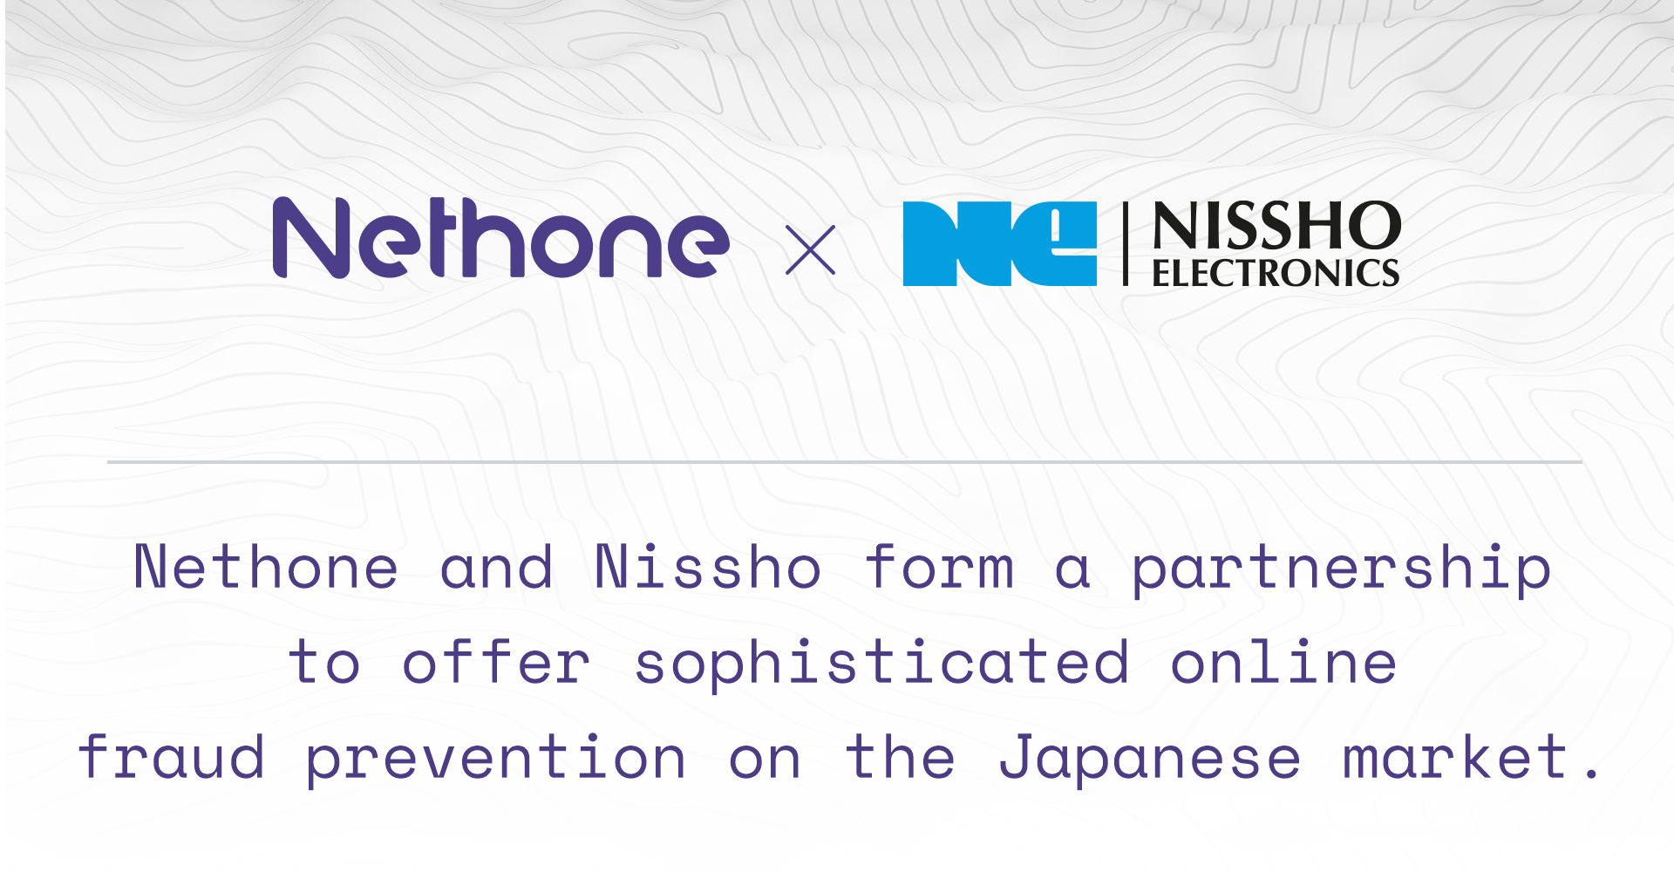

Nissho is an innovation-leading company from Japan operating in the market for over 50 years now. It provides information and communication technology (ICT) such as cybersecurity, IoT, and AI as support for customers from large enterprises to service providers as they undergo digital transformation.
Japan is continuously ranked among the top 3 world’s largest eCommerce markets, with revenue projected to reach US$112,465m in 2021. Its eCommerce revenue is expected to show an annual growth rate of 6.2%, resulting in a projected market volume of US$143,279m by 2025. As Nissho is engaged in constant exploration of ways to provide the best services in new fields, it will develop its offer on the Japanese market with fraud prevention solutions, due to announced partnership with Nethone.

"Nethone has a very similar approach to fraud prevention as ours and technology that seems to be one of the best in the market. We highly appreciate Nethone's Know Your User (KYU) approach to users profiling. In the era of customer‑centric service, we not only want to know customers, but we also want to understand their real motives" - said Hideaki Koga, Executive Officer, Senior General Manager of DX Business Division 1 at Nissho.

Nethone enables companies operating globally to combat cyber threats more effectively. It protects business entities against fraudsters by thoroughly profiling each user while interacting with the website or native application. By using advanced Machine Learning technology, Nethone profiling enriches the context of the user's understanding with over 5,500 attributes. All of them are processed into real-time recommendations, preventing card-not-present fraud, including protection against account takeover for entities and their clients from the e-commerce, digital goods, and financial institutions industries. The proprietary KYU approach enables comprehensive, in‑depth, multidimensional profiling of all online users, and at the same time radically reducing the risk management — manual verification and passive authentication, that was responsible for user‑side friction.

"With the highest penetration of online commerce in the world, Japan is the ideal place for fraudsters to hit. Especially as its citizens are shifting from cash to online payments, i.e. credit cards. Soon damages from offline credit card fraud will be lower than online" - says Patrick Drexler, Head of Business Development Team at Nethone. "Many companies in Japan are not ready for the upcoming changes and security threats. They still do not even have such positions as a chief online security officer or fraud manager, which are common in online business in Western countries. But Nethone solutions will help them with effectively fighting online fraud. Nissho is fully aware of that, that is why we decided to form business collaboration and invest in this crucial region" - adds Patrick Drexler.

Nissho will help Nethone with the distribution of its two core products - Guard and ATO. Nethone Guard prevents online payment fraud by identifying anonymization, automation, and suspicious behaviour. Nethone ATO is a comprehensive fraud-prevention tool based on behavioural biometry that secures business from diverse types of fraud - not only from account takeover (ATO) but also payment fraud from newly created accounts. It can counteract them with great precision thanks to an authorial AI modelling approach and combining raw behavioural data from Nethone Profiler.

In 2021, Nissho plans to sell "Tranfis powered by Nethone" advisory worth Yen200m. Also, by using the data and profiler information accumulated by Nethone's KYU technology, Nissho will provide solutions for e-commerce operators aiming to improve the customer experience, enhance engagement, and improve conversion rate both in Japan, and the whole Asia.
“We saw the potential for great synergy between both Nissho and Nethone, as well as the Japanese and Southeast Asian markets. We had the chance to meet Nethone in Warsaw, where we saw great energy, enthusiasm, and passion in the Nethone team, which made it even more so of an appealing alliance” - explained Hideaki Koga.

***
About Nethone
Machine Learning-based fraud prevention SaaS company that allows online merchants to understand their end-users holistically—also referred to as "Know Your Users (KYU)" in industry parlance. With cutting edge ML technology, Nethone can detect and prevent card not present fraud, including protection against account takeover (ATO).
Founded in 2016 by data scientists, security experts, and business executives, Nethone is one of the fastest-growing technology companies in CE, successfully cooperating with e-commerce, digital goods, travel, and financial industries on a global scale.
More information about the company can be found at nethone.com.

About Nissho Electronics Corporation
Provider of information communications equipment, IT infrastructure, and other cutting-edge solutions both in Japan and around the world, as well as a provider of services such as system design and construction, maintenance, operation, and monitoring.
For over 50 years since the founding, Nissho is focusing the efforts on the fields of growth, such as IoT, smart factories, detection of illicit payment data, cybersecurity, and robotic process automation (RPA) to help the customers along in their digital transformation. They are also braving forward with overseas operations and combining the applications they have developed with the solutions offered by other companies to create new value in the world.
More information about the company can be found at nissho-ele.co.jp.

Media contact:
Magdalena Kowalska, Marketing & PR Manager
magdalena.kowalska@nethone.com
+48 502 581 918

