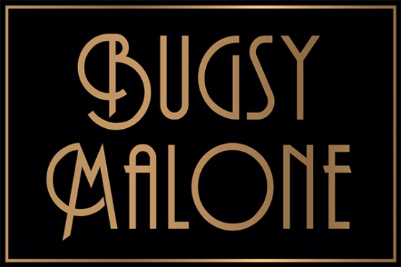
Summer Youth Project 2024
Audition Pack

Thank you for your interest in the Crewe Lyceum Summer Youth Project 2024. This is an extremely exciting opportunity for enthusiastic and committed young performers to take part in our fantastic production of the wonderful family classic, Bugsy Malone on our Main Stage!

Please read this document very carefully before booking to audition.

Age Range
To apply for an audition, participants must be at least 8 years old and no older than 17 years old by Monday 5th August (proof of ID may be requested). Applicants must read through this pack and share the information with their parent/guardian if under 18 years of age.
The Audition Pack
This Audition Pack contains;
- Information about the project and auditions
- Link to the online audition form
- Contact Form
- Costume Measurement Form

IMPORTANT: We are asking applicants to complete an Online Form no later than Sunday 21st April at 11PM. If you are choosing to audition via video submission, the same deadline applies.
The audition form must be completed in full online and you are also required to complete paper copies of the Contact Form and Costume Measurement Form at the end of this pack.
DATES FOR THE 2024 PRODUCTION ARE:
Project Dates Monday 5th August – Saturday 17th August
Performance Dates Friday 16th August and Saturday 17th August (3 performances)
Auditions Sunday 28th April – 10AM
Taster/Info Day (Optional) Saturday 23rd March – 1-3PM (£6)

YOU MUST BE AVAILABLE FOR THE ENTIRE DURATION OF THE PROJECT – NO EXCEPTIONS.

This is the second year that Crewe Lyceum Theatre will be delivering a Summer Youth Project, and we are so excited to be bringing around 80 young people to stage a musical in two weeks! The project is the product of a lot of hard work, and it is only through the commitment of everyone involved that the final result will be so spectacular.

Our participants have the opportunity to work with a highly skilled creative team including a professional Theatre Director, Choreographer, Musical Director & Technical team to create a full-scale musical on our main stage.
Bugsy Malone
It is 1929 in New York and the city is divided by gang warfare. On one side, Dandy Dan’s mob terrorise the district, taking out those they turn against with their new splurge guns. On the other side, Dandy Dan’s rival, Fat Sam, runs his successful Grand Slam Speakeasy. However, Sam is jealous of Dandy Dan’s gang as he still uses old-fashioned custard pies to take out their victims. When Fat Sam’s gang is brutally splurged and his empire under severe threat, he engages the help of Bugsy Malone, a smooth-talking man about town.

Principle Roles

Bugsy Malone: He is the hero of our story and a former boxer. Bugsy alternates as the narrator and the main part of the show. He has a sense of charm and sincerity as well as a streetwise sensibility.
Blousey Brown: Blousey is at first the typical young, wide-eyed, would-be star, just off the bus from a small town. However, we find out that Blousey is a force to be reckoned with and certainly nobody's fool.
Cagey Joe: He is a Boxing Coach, who used to train Bugsy Malone.
Dandy Dan: He is the unflappably stylish, debonair underworld businessman who outwits Fat Sam every step of the way.
Fat Sam: He is the baddest of the bad guys whose biggest rival is Dandy Dan. Fat Sam should be an adept physical comedian with a commanding stage presence.
Fizzy: He is an employee of Fat Sam's at the Grand Slam Speakeasy, whose duties involve cleaning up the place. However, he dreams of being a singer and dancer.
Knuckles: Is Fat Sams right hand man, whose nickname soon becomes apparent when he is constantly, cracking his knuckles.
Leroy: Saves Bugsy from an attack. Bugsy sees potential in him to become a great boxer and introduces him to boxing coach Cagey Joe.
Tallulah: She is the classic gangster's moll, and is the girlfriend of Fat Sam. She is confident and the main singer at the Speakeasy.

Ensemble/Speaking Roles:
Gang Members, Undertakers, Boxers, Reporters, Down and Outs, Performers (Singers and Dancers), Waiters/Waitresses, Policeman/women, Customers at the Speakeasy, Violinist, Auditionees.

Auditions
Sign in for auditions will begin at 9.00AM on Sunday 28th April at the Crewe Lyceum Theatre. Please arrive on time at the main doors in order to hand in your forms & photo and get signed in. For security reasons, the front doors will be locked from 10:00AM when everyone has signed in. Anyone arriving after this time will be unable to audition.
Once everyone is signed in, we will introduce the Creative and Production Team and explain how the day will run. If you audition for the ensemble or small speaking role, you do not need to prepare anything for the audition as you will be taught a verse and chorus of a Bugsy Malone song and a short dance piece on the day. However, if you wish to audition for a principal role, once you have registered to audition the material will be sent to you a month in advance to prepare beforehand.
It is important to highlight that we don’t just expect the ‘best’ dancers, singers, and actors; we like to recognise potential and work with individuals throughout the process. If this is your first-time taking part in a musical or you are not too worried about being a speaking part, then the ensemble is the perfect place, as you get all the fun and experience of being in a musical without having to learn all the lines! You'll still get plenty of time on stage and there'll be lots of opportunities to be really creative with your performance.
We cannot predict an exact finishing time, but we aim to have seen everyone by approximately 12.30PM. After that for anyone who would like to audition for a principal part will stay for the afternoon.
If you do return after lunch, you may be here for the rest of the day (no later than 6PM) so please ensure you bring plenty to eat and drink, and a good book or something quiet to do as there may be some waiting around as other people are auditioned. Please do not bring anything valuable as we cannot be responsible for your personal belongings.
We recommend that you bring a mobile phone so that you can contact your parents at the end of the auditions if you need to be collected.
Clothing: Please wear sensible clothing and footwear to the auditions. Everyone will take part in a physical warm up so please come in comfortable, loose clothing. Please do not wear any jewellery. Please note you will not be allowed to audition barefoot or in socks.
Please note only people auditioning will be allowed into the auditorium. Parents / guardians will not be able to stay and wait for their children, so please be prepared to leave once they have registered.
If you can’t make it to the audition, we are offering the option to submit a video in case you can’t make 28th April in person. If you need to send a video, please email Hollie at hwimpenny@crewelyceum.co.uk for full instructions on how to do this.

Decisions
You will be notified of the result of your audition by email no later than Friday 10th May and will have 48 hours to accept your offer. The full cast list will be made public once all emails have gone out and places have been accepted. The decision of the creative team is final and correspondence regarding casting will not be entered into.

Rehearsals
All rehearsals take place at the Crewe Lyceum Theatre, 10AM till 5PM.

Fees
The participation fee for this year’s Summer Youth Project is £200.00 per participant (which works out at around £17 per day). Siblings of full paying places will be charged at £180.00.
The fee covers two full weeks of Summer Youth Project and does not include meals, transport, or show tickets. Please note: once payment has been made there are no refunds unless we can fill your place.
All fees must be paid by Saturday 27th July Failure to pay will result in the exclusion of the participant from the Project. Details on how to pay will be emailed to you upon successful audition. You can also pay in instalments if you prefer, please contact Hollie Wimpenny at hwimpenny@crewelyceum.co.uk to arrange a payment plan.
Subsidised Places / Bursary Funding
There are a very limited number of subsidised or part-subsidised places on offer for those who genuinely cannot afford the fees. Please contact Hollie Wimpenny, Summer Youth Project Producer hwimpenny@crewelyceum.co.uk for details.

Costumes and Props
Costumes and props will be provided, but participants will be asked to provide basic elements of a base costume that hopefully can be found at home or from a charity shop/supermarket etc for a few pounds.

Keeping in touch
We rely on good communication with parents/guardians to ensure the production runs smoothly, and on that basis we ask you to please check forms are filled out correctly. We will endeavour to email any information to you as well as your child to keep you informed of rehearsal times and schedules.

Please don’t hesitate to contact us should you need to discuss any further information about your child or their involvement with the project.

Please click this LINK to complete your online audition form.
CHECKLIST – HAVE YOU
- Read ALL of the audition pack.
- Completed your online form.
- Printed and completed a paper copy of the Contact Form (with passport photo attached) and Costume Measurement Form to bring with you on Audition Day. Please do not forget to attach a

- photo so that we know who you are when casting decisions are being made!! If you don’t have access to a printer, you can collect paper copies of the 2 forms from the Ticket Office Tues-Sat 11-4.

Never auditioned before? Want to have a practice before the auditions or find out more about the project?
On Saturday 23rd March, we are running a Taster Workshop from 1-3PM to familiarise people with the audition process, meet the creative team and learn more about the show and project. Spaces are strictly limited & cost £6. Please check our website for details and to book.

We look forward to seeing you at auditions for a fun and creative day!

Very best wishes
Hollie Wimpenny
Creative Learning Manager & Summer Youth Project Producer

CREWE LYCEUM THEATRE SUMMER YOUTH PROJECT 2024

CONTACT FORM

Name of Participant:

Date of Birth:

Photo

Your age on 17th August 2024:
Email Address of Participant:
Home Address of Participant:

Name of Parent(s)/Guardian(s):

Email Address of Parent(s)/Guardian(s):

Contact Number(s) for Parent(s)/Guardian(s):

Please tick this box to confirm that you have completed the Online Application Form:
Please sign below to confirm that the details you have entered here and online are correct.

Signed
Relationship to the participant

PLEASE BRING WITH YOU TO THE AUDITIONS ON SUNDAY 28 APRIL

CREWE LYCEUM SUMMER YOUTH PROJECT 2024

MEASUREMENT FORM

(Please complete carefully and accurately and attach it to your contact form)

Name: ………………………………………………………………………………..
- CHEST - Circumference ………………..inches
- WAIST - Circumference ………………..inches
- HIPS - at the widest point ………………..inches
- OUTSIDE LEG ………………..inches
- INSIDE LEG ………………..inches
- OVER ARM - with bent arm ………………..inches
- NECK ………………..inches
- NECK-WAIST - down back ………………..inches
- WAIST-KNEE ………………..inches
- SHOULDER ………………..inches
- WRIST ………………..inches
- HEAD - circumference ………………..inches
- HEIGHT ………………..inches
- SHOE SIZE ………………..
- AGE ………………..

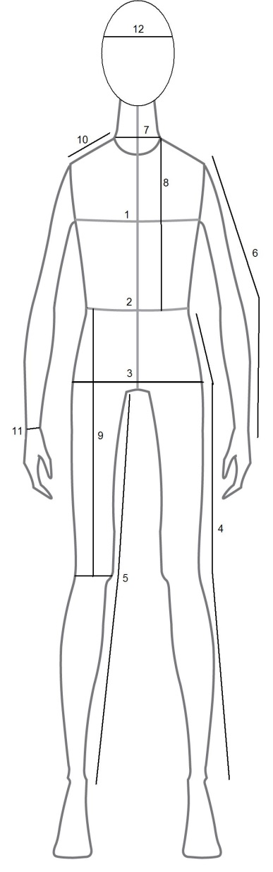
Character: ………………………………………………………………………………………………………………
(For Production Team Use Only)

PLEASE BRING WITH YOU TO THE AUDITIONS ON SUNDAY 28 APRIL

