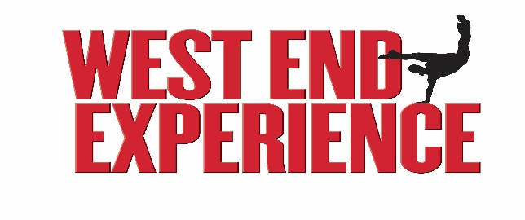

Easter Youth Project

14-18 April 2025

Welcome to West End Experience! Your workshop sessions **(Moulin Rouge, Matilda, Wicked, Back to the Future, Hadestown, Six & Les Miserables)** are run by professional West End performers, and you will also be working with a professional choreographer, Musical Director, and Creative Director.

At the end of the week, you will perform in a concert style show alongside professional performer in front of a live audience. Tickets for the concert will be on sale via the Wyvern Theatre website and ticket office 01793 535534.

**Registration**

Please follow the below link to complete your online registration form before Midnight Sunday 23rd February

<https://forms.office.com/e/dZhJyk7FSh>

**Fees**

The fee for West End Experience is £200, £180 for siblings.

This fee covers all tuition and the project T-shirt

Fees can be paid at the ticket office Mon-Sat 11am-3pm, 4pm-6pm)

The fee can be split into: £50 deposit, then two payments of £75

I will be in touch with final details & a list of the professionals you will be working and performing with in due course.

**Rehearsals**

Monday-Thursday 9:30am-4:30pm. Registration 9:15am

* A folder to hold all your words
* Pencils and Erasers
* Water bottles
* Suitable clothes to move freely in
* Sensible footwear (trainers, dance shoes etc)
* Packed lunch & Snacks

Mobile phones are not to be used in the day.

We cannot be held responsible for the loss, theft, or damage of any personal items

**Show day**

Friday 11am-9pm. Registration 10:45am

* Black trainers/dance shoes (no logos)
* Black trousers/leggings you can move in
* Your Youth Project T Shirt
* 2 Packed Lunches and lots to drink

Chaperones

If you have a Chaperone Licence or Enhanced DBS and can help with chaperone duties for any of the workshops or on show day, please let us know on your registration form. If you would like to help, but want to know more, please email Jo to organise a time to chat! We always appreciate any help you can give.