magnifying potentials

Digital Experience Designer
Potsdam/Berlin/Stuttgart
You want to work with a good team and realize innovative projects? Look forward to an exciting work environment with multifaceted tasks as a digital experience designer at D-LABS!
WHO WE ARE MISSING, IS YOU!
YOUR PROFILE
- You’re passionate about the user-centered design of digital products and services.
- You have completed a degree in design with a focus on e.g. interaction or user experience (UX) design.
- You specialize in UX design, interaction design and service design, and have excellent skills in creating, presenting and communicating viable concepts.
- You know the ins and outs of Figma. You’re used to operating within frameworks and design libraries, but can also work with less strict design specifications.
- You are a team player who masters challenges with know-how and creativity.
YOUR TASKS
- You design digital products and services. In doing so, you develop use cases and user stories in close collaboration with our user researchers.
- You also create information architectures, flowcharts and wireframes, and visualize user interfaces in mockups and prototypes.
- You take part in interdisciplinary workshops to co-create and develop conceptual approaches.
- You're happy to spar and serve as a source of inspiration for the D-LABS team.
You know you're the one for us – but you don't fulfill all requirements? Convince us!
We love to hear from you.

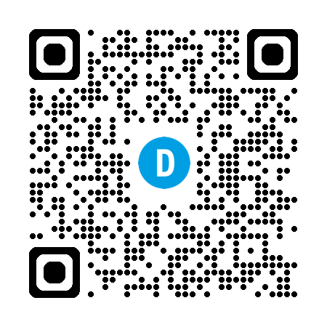
SOUNDS GOOD! WHAT NOW?
Are you ready?
Please contact:

Elina Bass-Mazana
T +49 331 97 992 334
jobs@d-labs.com

