Health professions associations (HPAs) exist in every state and represent healthcare professionals in specific fields (medicine, physical therapy, optometry, and many more). Building partnerships with them can expand work-based learning opportunities for your students and help them clarify their career aspirations, build critical skills, and cultivate professional connections in healthcare. HPA members can be excellent sources of information and inspiration for your students.

Ways HPAs & their members can support Work-Based Learning Activities
Guest speakers
- Health professionals can share the realities of what work and life are like
- Having a speaker or panel can be part of a lesson or classroom activity or could be a standalone activity
Leaders for hospital/clinic tours
- Health professionals can help academies plan tours
- Health professions schools may allow your students to sit in on a class

Skills workshop presenters
- Health professionals could talk about their career for 15 minutes and then lead the students in an activity related to their work (for example, walking through a patient case)

Facilitators for informational interviews and mock interviews
- Students can speak with health professionals 1:1 or in small groups
- Health professionals can give students feedback on their interviewing skills since communication is an essential skill in clinical settings
Resume review coaches
- Can give feedback to students seeking to apply for healthcare positions
- Caveat: This will depend a lot on the volunteers

Providers/Connectors for shadowing opportunities
- Students could shadow these individuals or their contacts

Speaking/presentation opportunities for students
- Students could participate in their annual scientific meetings
Supervisors for clinical experiences
- Private clinics often have more leeway in terms of hosting high school and college students
- Some HPAs run or have databases about summer programs for high school students (example: AAMC)
Supporters for mentored industry projects
- Small groups of students can work on a project and receive feedback from mentors

Strategies & Resources for locating HPAs

Locating National Health Professions Associations
- MedLine Plus - Organizations List & Directories
- CareerOneStop Professional Association Finder

Locating State Health Professions Associations
- Visit the national health professions association website and navigate to the section on “Chapters”
- Do a direct search for the state HPA

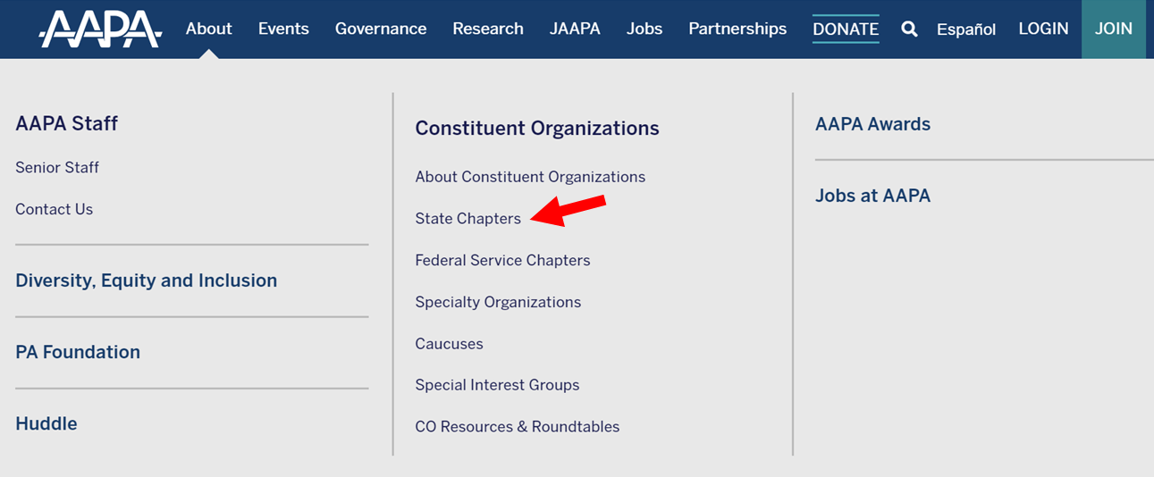

Contacting an HPA
- Navigate to the “About Us” section of the website, which typically lists leadership and staff
- A back-up option is the “Contact Us” page

Email template for outreach

Customize and personalize this message depending on who you are contacting.

Hello <name of person or name of organization Leadership Team>,

We are a high school NAF Academy of Health Sciences in <add city> and our students are passionate about pursuing careers in healthcare. An important element of their educational experience is work-based learning, where volunteers share information about their education, training, and job experiences and give students a unique look into the professional world that awaits them outside of high school. You have the opportunity to directly influence the next generation of leaders in healthcare. We need your commitment, creativity, and energy to help us prepare them to be successful as they prepare for the next phase of their education and career development.

Would members of the <add name of HPA> be willing to volunteer their time to help students connect classroom lessons with the world of college and careers in healthcare?

I would welcome the chance to speak with you further about potential ways we could collaborate on work-based learning events and opportunities.

Thank you in advance for your support of our Academy of Health Sciences. We look forward to the opportunities that you and your members can provide that will help our academy students further explore different health professions and build the skills needed to prepare for healthcare careers.

Sincerely,

Name
Position
Academy Name
Email
Phone

