*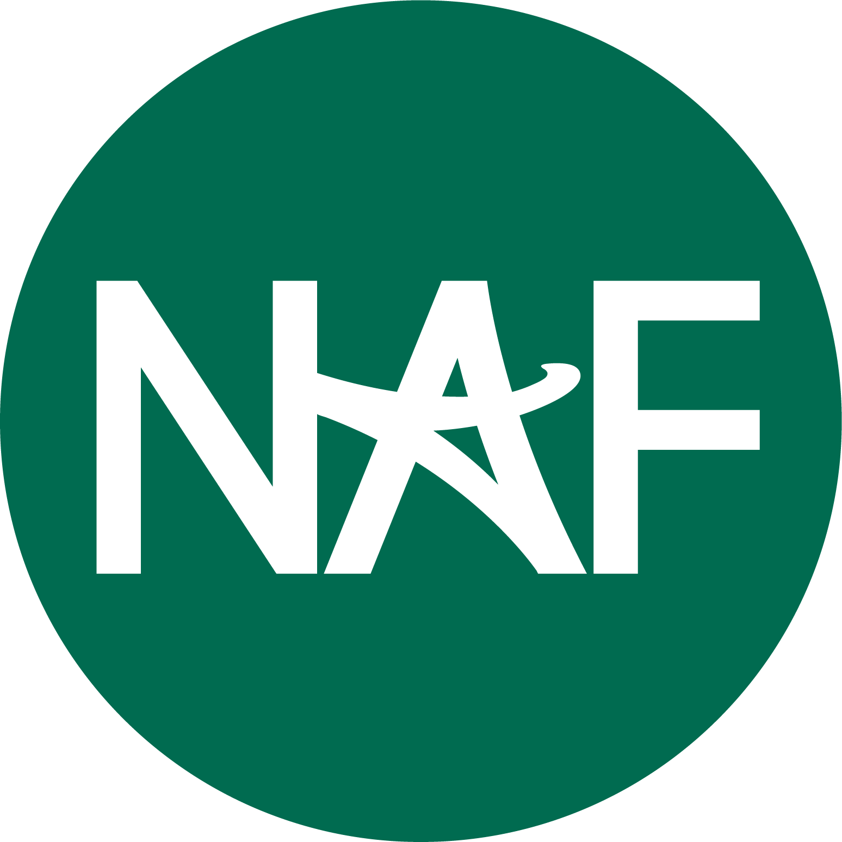CURRICULUM PRINCIPLES*

*October 2024*



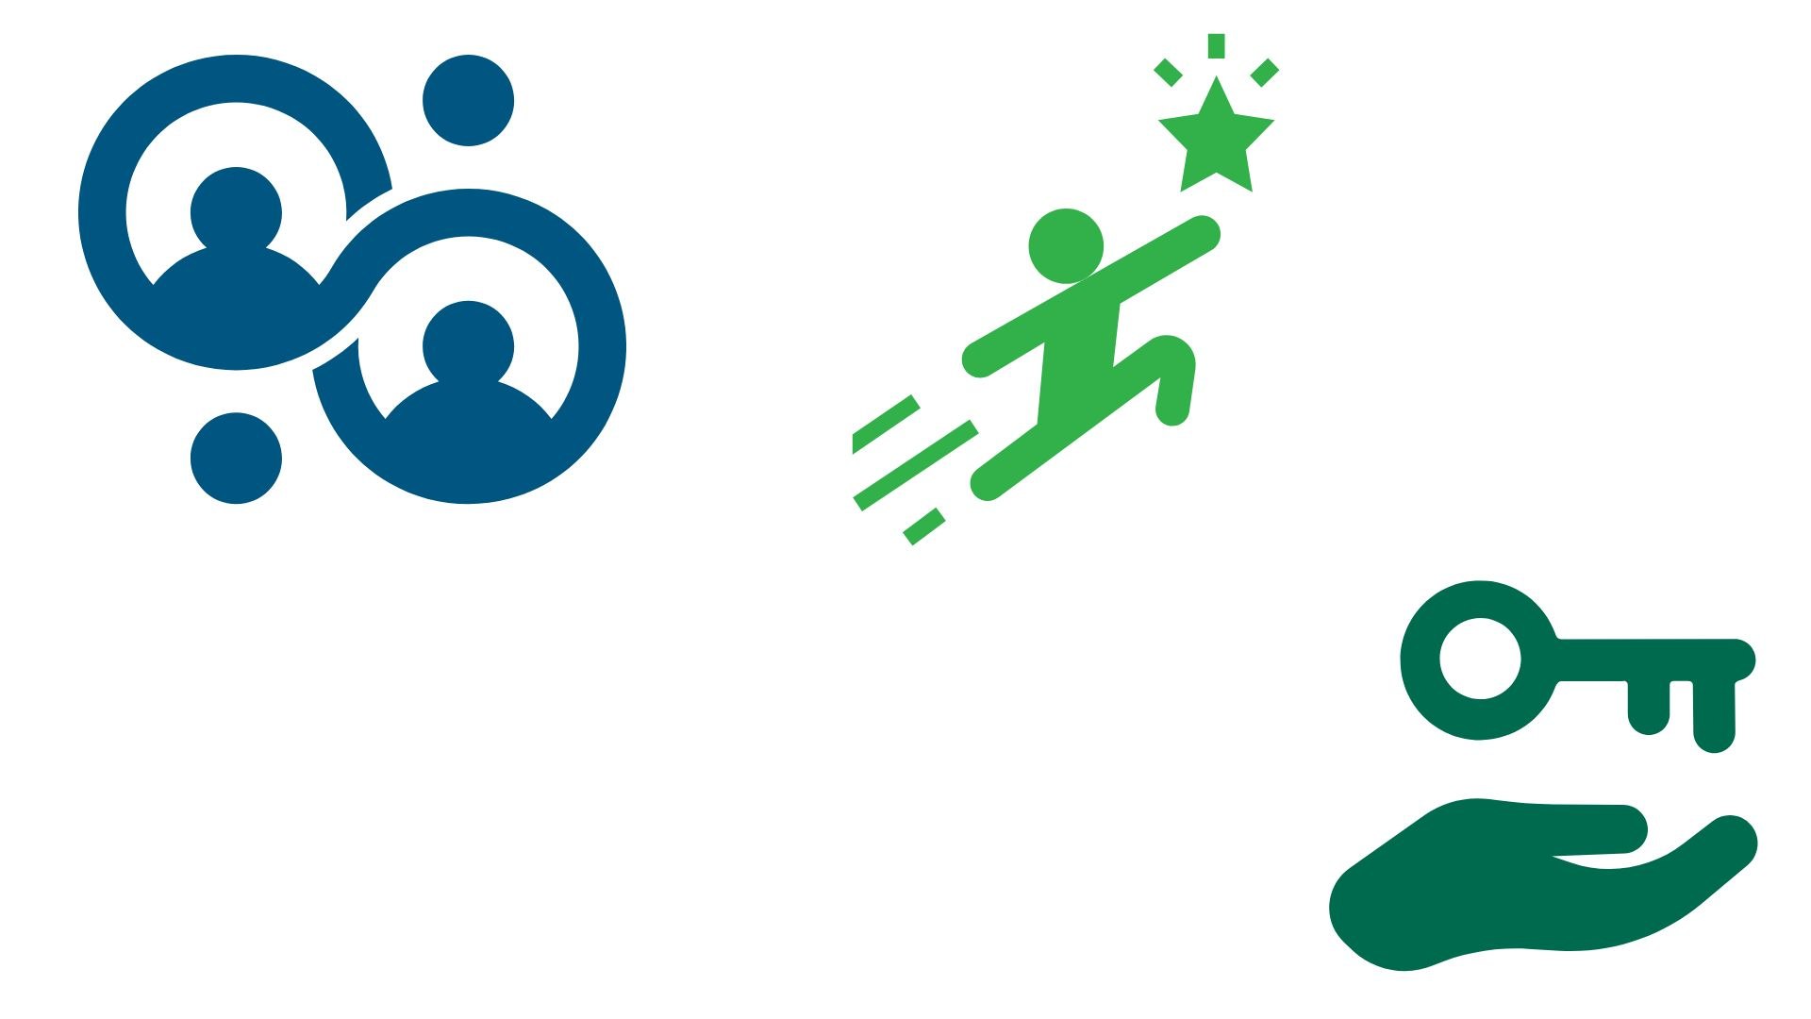

# GUIDING PRINCIPLE 1: CONNECT CONTENT AND LEARNING TO INDUSTRY AND CAREERS

## Work-Based Learning (WBL)

## Incorporate the full continuum of WBL activities to foster students' aspirations, skills, and industry connections.

## Upskilling

## Embed activities and assessments that develop Future-Ready Skills (collaboration, communication, problem-solving, social awareness, initiative/self-direction, and planning for success).

## Industry Competencies

## Align learning with industry standards, professional organizations, and current practices, including emerging technologies (e.g., AI).

## Post-Secondary and Career Exploration

## Showcase careers, workplaces, and post-secondary options that align with unit themes, helping students make informed decisions about their future.

# 

# GUIDING PRINCIPLE 2: PERSONALIZE THE LEARNING ENVIRONMENT WITH ENGAGING CONTENT AND ACTIVITIES

## Engaging, Multi-modal Instruction

* + Infuse differentiated, multi-modal instruction based on Universal Design for Learning (UDL) principles to meet diverse learner needs.
  + Incorporate hands-on experiences like experiments, simulations, and problem-solving.
  + Provide choice within lessons, activities, assessments, and projects.

## Authentic and Relevant Learning

* + Design activities and assessments that reflect real-world problems, current industry trends, skills and competencies needed to succeed in the workforce.
  + Utilize authentic assessments like portfolios, performance tasks, and real-world projects.
* **Diversity, Equity, Inclusion, and Access (DEIA)** 
  + Integrate diverse perspectives and backgrounds in content, ensuring students feel represented and valued.
  + Prioritize asset-based language that highlights the strengths of individuals and communities.
  + Provide opportunities for students to appreciate their own cultures and those around them.

## Reflecting and Connecting to Their Why

* + Encourage students to reflect on the relevance of activities to their career aspirations.
  + Provide opportunities for them to select activities aligned with their personal goals.
  + Encourage reflection and self-assessment, with opportunities for students to share their learning and progress.
  + Highlight their connection to a national network of NAF students, alumni, and supporters.

# GUIDING PRINCIPLE 3: SUPPORT EDUCATORS AND STUDENTS WITH A COMPREHENSIVE LEARNING ECOSYSTEM

## Educator Resources and Tools

* + Define clear, specific learning outcomes and provide resources aligned with them.
  + Offer planning tools (e.g., scope and sequence, rubrics, culminating projects) and provide links to relevant resources to more easily integrate with various LMS.
  + Share suggestions for lesson plans or other ways to use and integrate the resources provided (e.g., teacher tips or scripts).
  + Ensure language and content represent our diverse network of students and global community while also being sensitive to limitations set forth by some state policies.

## Student Resources and Tools

* + Provide accessible materials (e.g., slides, rubrics, resources) to enhance learning and engagement.
  + Ensure resources are easy to find and use, supporting both in-class and independent study.