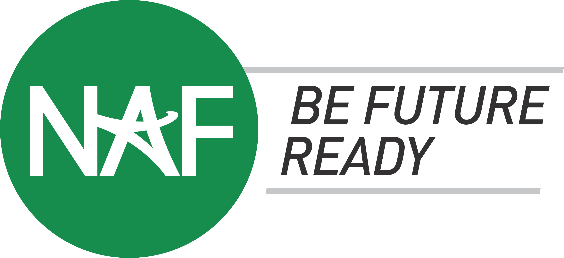

Katherine Blasik Distinguished & NAF Model Announcement
Sample Social Media Posts

Congratulations on achieving Katherine Blasik Distinguished or NAF Model status! Please see below for suggested social media posts. We encourage all NAF academy leaders and students to post on LinkedIn, Facebook, Instagram, and X (Twitter) to celebrate their academy's successes.
You are welcome to use photos of your academy and/or the NAF Katherine Blasik Distinguished or Model [graphics] Be sure to use #BeFutureReady and tag @NAFCareerAcads on Instagram and X, and @NAF on LinkedIn and Facebook.

The NAF press release will be posted to: naf.org/press-releases

X (Twitter)

- We’re thrilled to announce that @nafcareeracads Academy of [insert pathway] at [high school] has been awarded Katherine Blasik Distinguished - NAF's highest level of achievement! #BeFutureReady

- [Number of years] strong! 🏆 The NAF Academy of [insert pathway] has reached NAF's Katherine Blasik Distinguished level for [number of years] consecutive years! Learn more: [link to NAF’s press release] #BeFutureReady
- Exciting News! The @nafcareeracads Academy of [insert pathway] at [high school] has been awarded Model level! #BeFutureReady

- We’re career ready! 🌟 The @nafcareeracads Academy of [insert pathway] has been awarded [Katherine Blasik Distinguished/Model level]! Learn about our achievement: [link to NAF’s press release] #BeFutureReady

Instagram

- We’re proud to announce that our @nafcareeracads Academy of [insert pathway] has been awarded Katherine Blasik Distinguished - NAF's highest level of achievement! This recognition showcases our dedication to delivering high-quality educational experiences for students to prepare them for college, career, and upward mobility. We’re incredibly proud of our students, educators, and partners who made this achievement possible. #BeFutureReady

- [Number of years] strong! 💪 @nafcareeracads Academy of [insert pathway] at [high school] has reached NAF's Katherine Blasik Distinguished for [number of] consecutive years! 🏆 See the link in our bio to learn more. #BeFutureReady

- Exciting News! 🎉 The @nafcareeracads Academy of [insert pathway] at [high school] has been awarded Model level! A huge thank you to our educators and partners who go above and beyond to help students discover their interests and prepare for real careers. #BeFutureReady
- We’re career ready! 🌟@nafcareeracads Academy of [insert pathway] at [high school] has been awarded NAF's [Katherine Blasik Distinguished/Model level]! See the link in our bio to learn more about this accomplishment. #BeFutureReady
- Congratulations to the @NAFCareerAcads Academy of [insert pathway] at [high school] for reaching [Katherine Blasik Distinguished/Model level]! 🏆 NAF Chief Executive Officer, Lisa Dughi, said,

“Congratulations to all of our Katherine Blasik Distinguished and NAF Model academies, and especially to this year’s first-time honorees! Your commitment to preparing students for successful futures is not only changing lives but also setting the standard for excellence across the NAF Network.”

#BeFutureReady

LinkedIn and Facebook

- Congratulations to the @NAF Academy of [insert pathway] at [high school] for achieving [Katherine Blasik Distinguished/Model level]! 🎉NAF Chief Executive Officer, Lisa Dughi, said,

“Congratulations to all of our Katherine Blasik Distinguished and NAF Model academies, and especially to this year’s first-time honorees! Your commitment to preparing students for successful futures is not only changing lives but also setting the standard for excellence across the NAF Network.”

#BeFutureReady

- We’re honored to announce that the @NAF Academy of [insert pathway] at [high school] has been awarded Katherine Blasik Distinguished —NAF’s highest level of achievement! This recognition showcases our dedication to delivering high-quality educational experiences for students to prepare them for college, career, and upward mobility. We’re incredibly grateful to our students, educators, and partners who made this achievement possible. #BeFutureReady

- Exciting News! The @NAF Academy of [insert pathway] has been awarded Model level! Thank you to our educators and partners who go above and beyond to help students discover their interests and prepare for real careers. Learn more: [link to press release] #BeFutureReady

- A Legacy of Excellence! 🏆 The @NAF Academy of [insert pathway] at [high school] has been awarded Katherine Blasik Distinguished status for [number of] consecutive years! This achievement is a testament to our academy’s dedication to career-connected learning and helping students develop transferable skills that prepare them for the real world. Learn more: [link to press release] #BeFutureReady

