NGPF Case Study

Insurance

Spanish version

Case Study Summary  Description: In this Case Study, students will help a worried young graduate understand his insurance costs, how they compare to the national averages, and what he can do to make insurance more affordable.  Internet Usage: Required  Spreadsheet Skills: None |  | Jump$tart Standards  Risk Management & Insurance  - 1c: Recommend insurance for the types of risks that young adults may face  - 2b: List factors that determine auto insurance premiums and the factors that cause them to change  - 2c: Determine the legal minimum amounts of auto insurance coverage required in one's state of residence and the recommended optimal amounts  Financial Decision Making  - 1a: Discuss how individual responsibility for financial well-being will change over a lifetime with changing life circumstances  - 1b: Compare how financial responsibility is different for individuals with and without dependants  - 2a: Evaluate whether financial information is objective, accurate and current

Like a Good Neighbor, Noelle Is There

NoRisk Insurance Co is trying to increase their business, so they’ve hired a new employee, Noelle, and they’ve launched a call-in web series called “No Risk Insurance Talk with Noelle!”

Noelle’s first caller of the day is Eugene, a disenchanted recent college grad who’s convinced he’s overpaying for insurance.

Noelle: Hi, Eugene. Welcome to the show! What seems to be your insurance question?

Eugene: Noelle, I’m so upset. I saw an infographic on social media, and it made me realize not only do I make far less than the average American, I think I’m also overpaying for insurance! Can you help me out? Here’s the data I’m referring to:

Exhibit 1
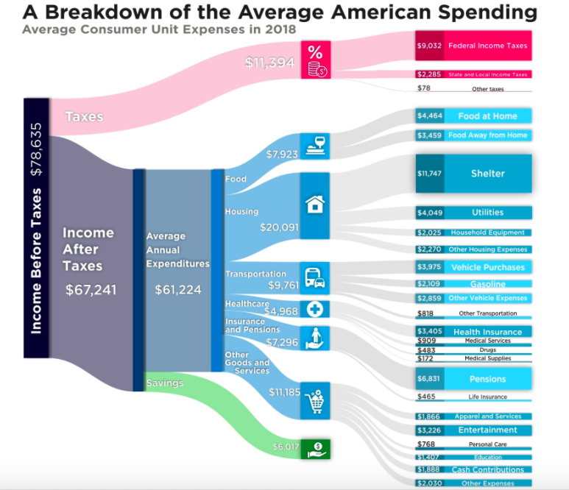
Noelle: Let’s figure this out for you. First, how old are you, what kind of work do you do, and, if you don’t mind sharing, what is your annual pretax income?

Eugene: I’m 23 years old, I’m in my second year as an accountant at a midsize company, and I only make $47,500 per year!

Noelle: Let’s tackle your income concerns first by checking out Dice Salary Calculator for an accountant using the following information:
- Location: National Average
- Years of Experience: 1

Answer This:
- Help Noelle figure out if Eugene’s being paid fairly. Which data on the website led Noelle to the answer?

Noelle: OK, now that we’ve got some insight on your annual income, let’s tackle your insurance costs. I’m going to visit the site where you found this data, A Breakdown of the Average American Spending, and let’s take a look at the data from 2018 (also shown in Exhibit 1). These charts are fun to look at, but when I think critically about what they’re telling me, we can get some real answers.

Answer This:

- Noelle suggests they divide the Insurance and Pensions cost by 12 to determine the average monthly expenditure for an American. How much would this be?

- Noelle reminds Eugene that, as an early career professional, he’s only making a fraction of the average American household income. So, she recommends Eugene calculate what his monthly Pension & Personal Insurance cost would be if it was in proportion to the salary he’s making. How much would this be?

Eugene: ARGH! My car insurance alone is more than that!

Noelle: Whoa! Not so fast. What I think you’re not understanding is that the Pensions & Personal Insurance category is a measure of how much you’re paying into Social Security, any pensions your job might have (not likely as you’re not a government or unionized employee), and personal insurance policies, like life insurance. We’re not talking about car insurance here.

Eugene: What? I don’t even have life insurance! I’m 23! But can we look at my car insurance payments anyway? I pay $400 per month to insure my car. The whole thing’s probably worth about $2000, and I’m spending that much every five months just to insure it!

Noelle: Whoa! That does sound pretty steep; I’m sure NoRisk Insurance Co could offer you better rates, though you may have a few factors working against you. Let’s review our Reference: Car Insurance Rates to figure it out!

Answer This:
- What assumptions might Noelle make about why Eugene’s auto premiums are so high?

- Compared to the rates in the reference Noelle provided, IS Eugene paying too much for auto insurance? Support Noelle’s findings with data from Reference: Car Insurance Rates.

Eugene: My other major complaint is that I’m an impeccable driver -- no accidents in my 7 years of driving. I feel like I’m paying these premiums so that other people can drive crazy! I’m about to cancel my car insurance. Noelle is trying not to panic on-air, as she certainly doesn’t want other viewers to decide they should cancel their auto insurance, too.

Noelle: There are ways we can lower your auto insurance bill without cancelling altogether. Insurance plans include different types of coverage. Most states require basic liability insurance, but you can adjust how much coverage you want for other types of auto insurance. Learn more about those categories before making any changes.

Answer This:
- If Eugene wants to decrease his auto insurance bill, which type of coverage would be the best option to reduce? Why?

- Noelle’s beginning to sweat but wants to play it cool. Write a response for Noelle to convince her viewers that auto insurance is a must-have financial tool.

Eugene: OK, I hear what you’re saying, that I shouldn’t cancel my car insurance, but I’m still not happy. I am still paying way too much, TOTAL, for insurance. Right now, I’m still on my mother’s health insurance plan, which she receives through her employer, but she makes me pay $200 per month towards it!

Exhibit 2
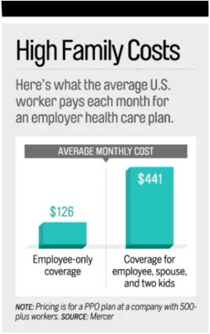

Noelle: Well, let’s see if you’ve got a good thing going there on your mother’s health plan, or whether maybe buying insurance on the marketplace would be a better option. We can use this chart as a point of reference regarding the family plan.

Answer This:
- Noelle uses the federal Health Care Plan Finder and what she knows about Eugene to find marketplace rates currently. Assuming Eugene lives in your home state and is a nonsmoker, would Eugene save money by buying insurance on the marketplace? Why or why not?

- Is Eugene getting a good deal by chipping in to stay on his mother’s plan? Explain.

Noelle: If we’re trying to decide between the lowest cost option on the marketplace and the plan you share with your family, we’ll need to compare more specifics. Here’s a side-by-side of the two plans.

Exhibit 3 (continued on the next page)
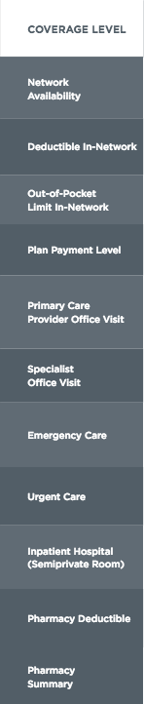

Answer This:
- Eugene has never looked in depth at a health insurance policy before. Noelle doesn’t want to overwhelm him, so she wants to point out three key differences Eugene should care about when comparing catastrophic coverage to what his mother’s silver plan provides.

  - Key Difference 1:

  - Key Difference 2:

  - Key Difference 3:

- Now that Noelle has helped him understand insurance better, what should Eugene’s next steps be? Remember, he’s ultimately concerned about the insurance costs he’s paying each month.

Exhibit 4
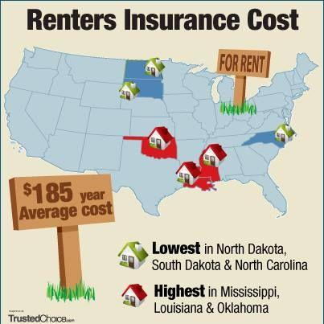

Noelle: Alright, Eugene, we’re just about out of time, but I’ve got to ask: Do you have renters insurance?

Eugene: No! I do know I don’t want my insurance bill going up any higher than it needs to.

Noelle pulls up a flyer for No Risk Insurance Co (Exhibit 4 above) and asks Eugene to take a look at just how affordable renters insurance is.

Answer This:
- How much would Eugene’s total insurance bill increase monthly if he added a renters insurance policy?

- Help Noelle convince Eugene that if he wants to ultimately save money, renters insurance is a policy he cannot afford to skip.

Eugene: Noelle, please don’t end the call just yet. We’ve been chatting so long, I’m not sure if I’m walking away spending more or less than I previously was on insurance. Can we review everything?

Answer This
- Compare the amount Eugene was originally spending on car, health, and renters insurance versus how much he will be spending if he follows Noelle’s advice as answered in the questions above.

- Noelle needs to wrap up this episode of “Insurance Talk with Noelle.” Summarize what Eugene and the viewers at home learned today about insurance.

