Assignment Focus
 | 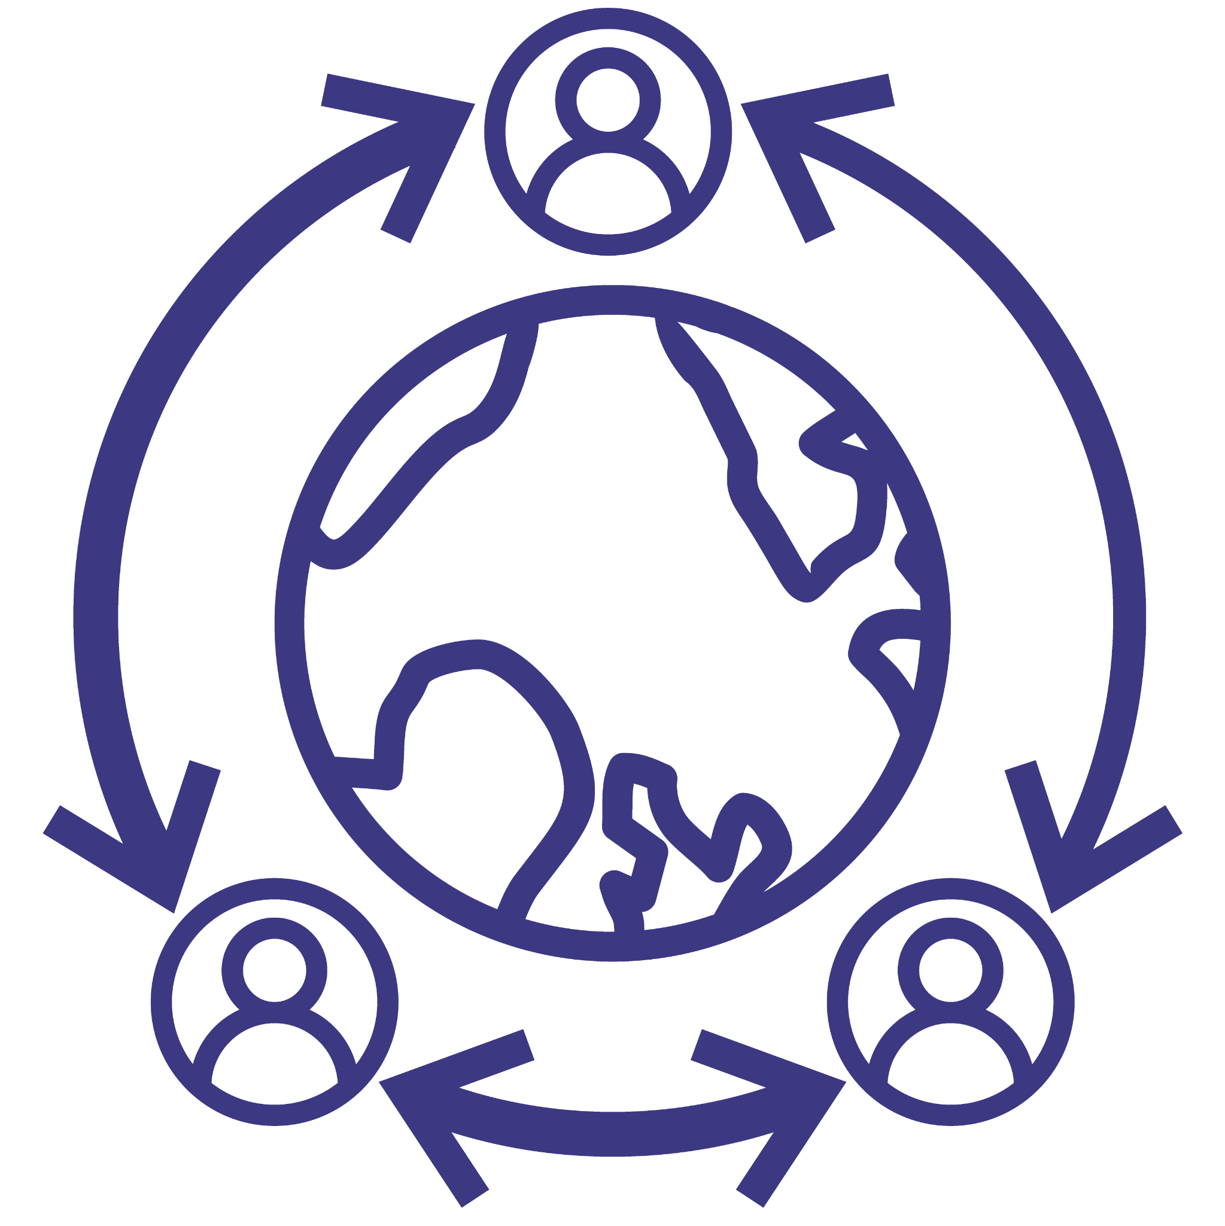
Problem-Solving | Social Awareness | Collaboration | Communication

No matter what career field you enter, there will always be issues and conflicts that need to be resolved. Problem-solving and communication are skills that everyone should practice to prepare themselves for any unprompted situations that require creative solutions. While working internationally, thinking ahead and being knowledgeable about your environment helps break down barriers and prevent challenges while strengthening your social awareness as well. Behavioral, social, and cultural customers are all things that need to be considered when you travel to new places to avoid any offensive behavior.

In this short activity, you will prepare to visit an international country on behalf of a company, tasked to develop business connections while navigating cultural clashes. In groups of four, you and your classmates will decide on an international country to visit, determine a company to represent, and do some research on both the chosen country and company to understand any business practices that might conflict with cultural norms and/or common customs. Together, you will explore various cultures to widen your social awareness and practice problem-solving by creating solutions to avoid cultural clashes.
- Use this resource to collect information on international countries and their cultures
  - https://www.commisceo-global.com/resources/country-guides

Country:_____________
Company:____________

Complete the chart below and be ready to present your findings to the class.

International Customs
Language | Society & Culture
Common Etiquette & Manners | Business Etiquette

Reflection Questions
- Compare these customs to your home country. What are some similarities and differences?

- Identify cultural clashes that affect your business. Create a solution to at least one of the identified challenges.

- What was a cultural clash from your chosen country that surprised you?

- As other students are presenting their country and company, record one cultural clash from their chosen country. Does your chosen country share challenges with theirs?

