[Career Pathway (e.g., Academy of Finance)] at
[High School]
Joins National Network
[DATE]
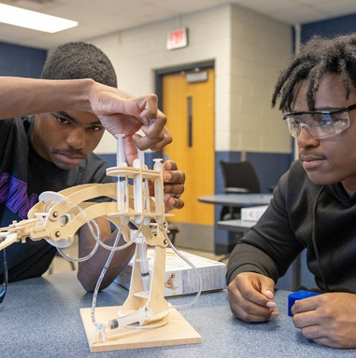
NAF’s Newest Members Become Part of a
Transformative Movement to Ensure All High School Students
are College, Career, and Future Ready!
We’re excited to announce that [High School Name] will launch a NAF Academy of [Career Pathway] in the [2025-26] school year! This new academy will provide students with hands-on learning experiences, including real-world, work-based learning opportunities that connect classroom knowledge to future careers.

After completing a comprehensive academy development process, the planning team has built a strong foundation for a career-focused program aligned with NAF’s proven design and future workforce needs. This means students will benefit from a program designed to support their success in school and beyond.
This marks an important step in expanding access to meaningful, career-connected learning experiences that prepare students for success after graduation.
Want to Learn More?
Join us for an Information Session to discover how your student can benefit from this exciting opportunity!
📅 [Date]
🕕 [Time]
📌 [Location or Virtual Link]

** Update [bracketed] text & photos. Replace info session with Academy Lead contact information if needed. **
** Optional: Add a quote here from an academy leader on how the academy will benefit students. **
“We’re thrilled to welcome the newest members of the NAF family – our Year of Planning and Fast Track academies!” said Lisa Dughi, NAF Chief Executive Officer. “Your commitment to preparing students to be future ready and reach their full potential is truly inspiring. We applaud your passion and are excited to support your work as you build meaningful opportunities for young people. Together, we will celebrate the incredible success your students are sure to achieve!”

