[Career Pathway (e.g., Academy of Finance)] at
[High School]
Joins National Network
[DATE]
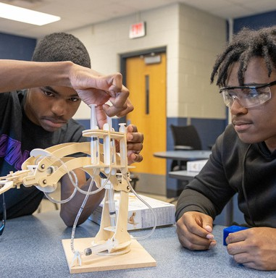
NAF’s Newest Network Members Join a National Movement
Preparing Students for College, Career, and Future Success!
We’re excited to announce that [High School Name] will launch a NAF Academy of [Career Pathway] in the [0000-00] school year! This new academy will provide students with hands-on learning experiences, including real-world, work-based learning opportunities that connect classroom knowledge to future careers.

After completing a comprehensive academy development process, the planning team has built a strong foundation for a career-focused program aligned with NAF’s proven design and future workforce needs. This means students will benefit from a program designed to support their success in school and beyond.
Insert Your Academy Student Photos Here
This marks an important step in expanding access to meaningful, career-connected learning experiences that prepare students for success after graduation.
Want to Learn More?
Join us for an Information Session to discover how your student can benefit from this exciting opportunity!
[Date]
[Time]
[Location or Virtual Link]

[Optional Quotes: Add academy leader quote here from an academy leader on how the academy will benefit students]
— [Name, Title, High School]

“We are thrilled to welcome the newest members of the NAF network as they complete their Year of Planning and Fast Track experiences,” said Lisa Dughi, Chief Executive Officer of NAF. “At a time when preparing young people for an evolving economy has never been more important, these schools are making a powerful commitment to expanding opportunity. Together, we are helping students build future-ready skills, discover their potential, and connect education to meaningful careers. We can’t wait to see what these students accomplish.”

