

**Infosys Springboard USA Digital Academy**

**Account Creation Instructions for NAF interns**

June 2024

1. Go to <https://infyspringboard.us.onwingspan.com/>
2. If you do not have an account yet: Click “Get Started”

1. Click the orange button “CREATE NEW ACCOUNT”

1. Fill in your name, email, password, then click “CREATE NEW ACCOUNT”

1. After clicking “CREATE NEW ACCOUNT”, you will see the below screen:

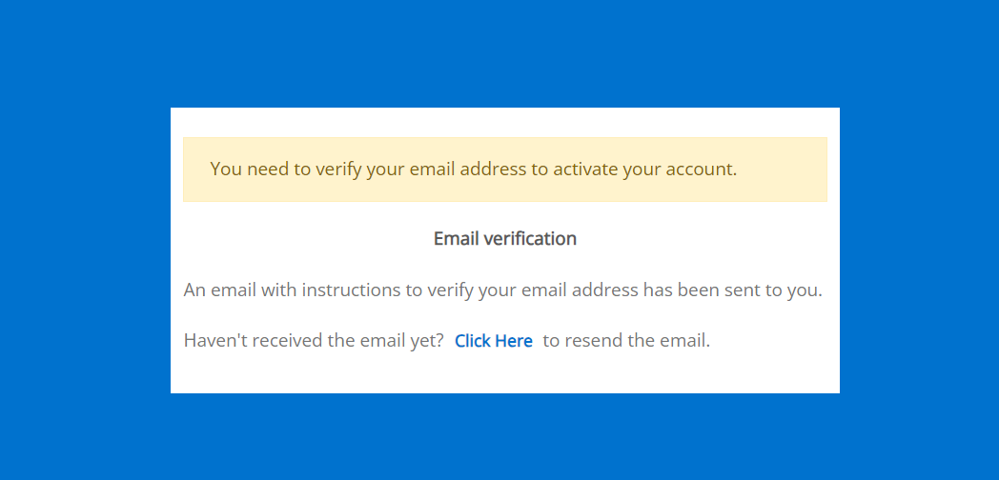

1. Go to your email and follow the instructions to verify the email address
2. Log back in with the new credentials. When this screen pops up, click yes

1. You will then see this profile creation page. Make sure to add in your details. 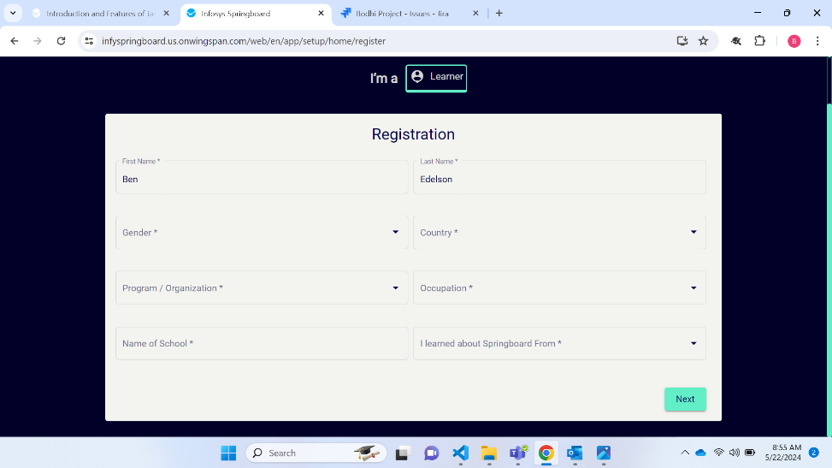

*Under Program/Organization make sure to select **“NAF”**

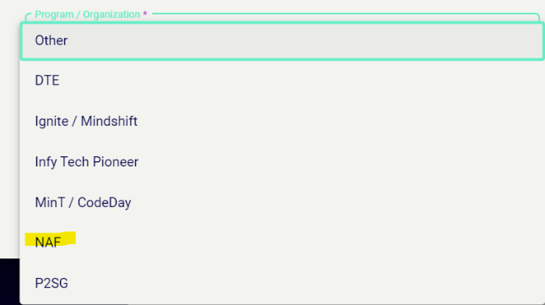

*You can also add or change your profile details later after login. On the home page, click on your profile image at the top right corner. Then select “edit profile”.

1. After logging in, go to the top of the screen, right below the search bar. You will find several banners rotating. Navigate to the “NAF” banner using the arrows on the left and right.

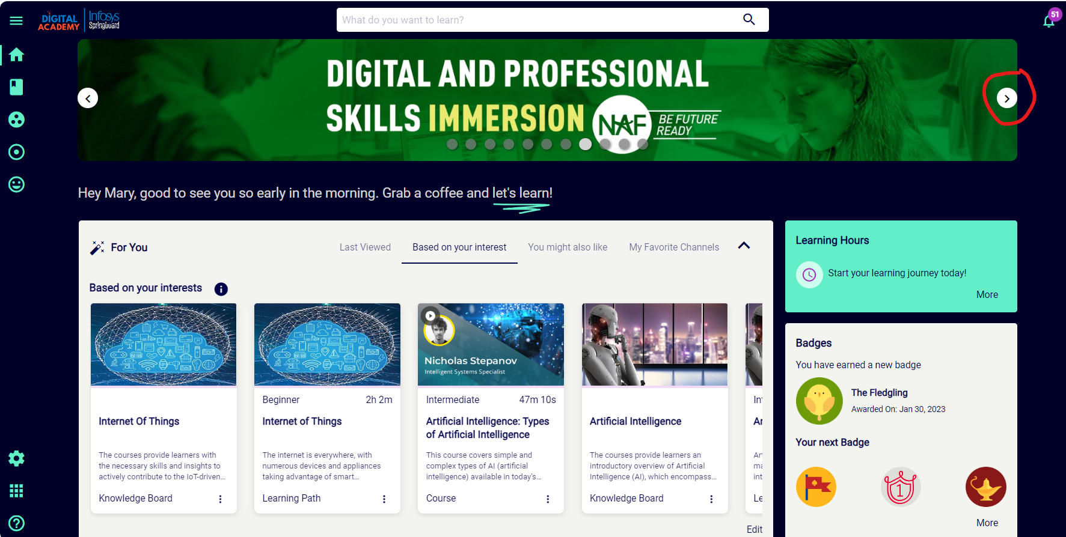

1. Click on this and you will enter the NAF channel page dedicated to this program. Start learning!

