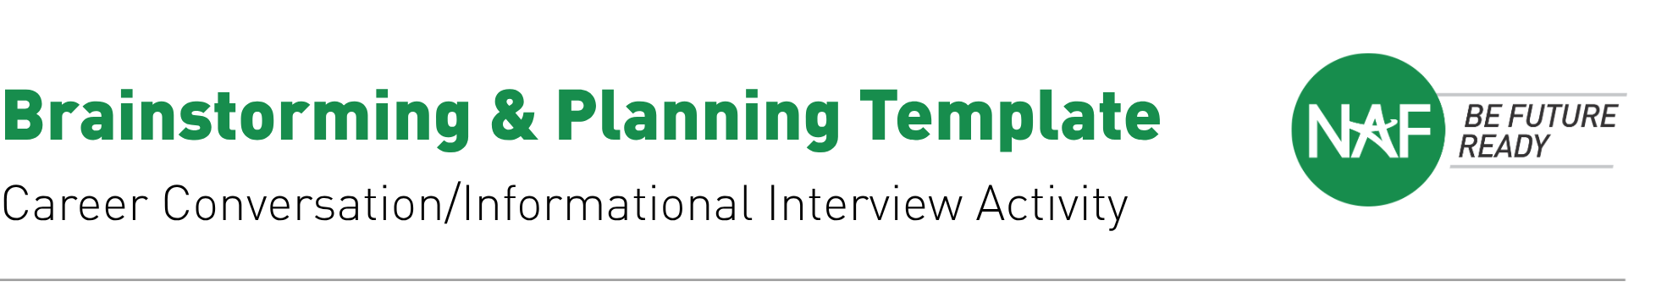

Use this worksheet to plan how you'll bring an informational interview activity to your students.
Educator Name:

Course / Academy:

Target Date to Launch Activity:

1 What do I want my students to take away from this activity?
Consider career knowledge, workplace communication skills, industry connections, or personal reflection goals.

2 Where/when will this take place?
Think about class time vs. outside class, in-person vs. virtual, and how it fits your course pacing.

3 What will my role be?
Will you identify interviewees, coach students on questions, facilitate connections, or step back and let students lead?

4 Is there a budget to support this activity?
Consider costs for curriculum, guest stipends, transportation, materials, technology, or incentives — and potential funding sources.

5 Notes & Additional Thoughts

