Instructions: This document should be completed in two steps. Please read the instructions below.

- Project Plan: Outline the main projects the student will complete during the career preparation activity. This could focus on one large project or 2-3 smaller projects that differ in work planning. An example of the project plan is included below. Use this before the student begins their work to ensure the project is well developed, can span the course of the career preparation experience, and adds value to the host company and student.

- Skill Development Plan: Help students identify skill development opportunities through the Skill Development Plan. Students should complete the skills self-assessment and discuss these results with their supervisor or project mentor at the beginning of the project process. Focus on the six Future Ready Skills as you help the student identify skills of focus for their career preparation experience. Additionally, identify activities or project elements that will help the student develop and practice these skills. Examples and templates are included in the Skill Development Plan below.

STEP 1: PROJECT PLAN
To be completed before the CAREER PREPERATION ACTIVITY

Template and Example

PROJECT # | A project/assignment for the student that will provoke the learning objective.  Ex. Create a database of San Francisco civic leaders with their contact information.
ACTIVITIES | Tasks that will be performed to complete the project.  Ex. Attend Board of Supervisors meetings. Formulate questions to ask Supervisors. Introduce self to Supervisors and distribute business card. Send a thank you email to Supervisors.
DOCUMENTATION | Evidence of the student’s work.  Ex. List of questions for Supervisors, List of thank you notes sent, Contact list
TIMELINE | Project due date(s) and planned supervisor/mentor check-ins.  Ex. Prepare list of questions for Supervisors meeting by February 1, attend Supervisors meeting on February 4, write and send thank you emails by February 6, finalize contact list by February 15
SKILLS | Select the applicable skills that you expect the student will develop through the completion of the project. Refer to NAF’s Future Ready Skills Assessment.  Ex. Communication, Collaboration, Problem Solving

PROJECT #1
ACTIVITIES
DOCUMENTATION
TIMELINE
SKILLS

PROJECT #2
ACTIVITIES
DOCUMENTATION
TIMELINE
SKILLS

PROJECT #3
ACTIVITIES
DOCUMENTATION
TIMELINE
SKILLS

STEP 2: SKILL DEVELOPMENT PLAN
To be completed with the student/intern

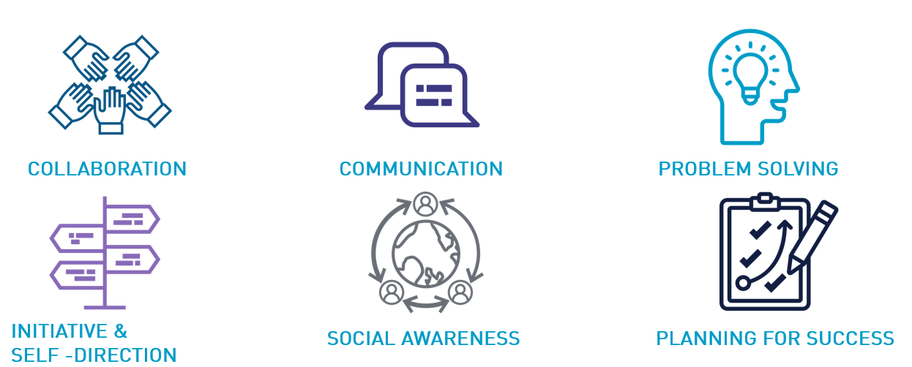
Template and Example

SKILL | A skill from the NAF’s Future Ready Skills Assessment.  Ex. Communication
ACTIVITY | Tasks that will help the student grow and/or master the skill through work on the project.  Ex. The student will communicate with the supervisor/mentor to set up check-in times and share progress and challenges throughout the project.

SKILLS

ACTIVITIES

SKILLS

ACTIVITIES

SKILLS

ACTIVITIES

SKILLS

ACTIVITIES

