


naf.org
@NAFCareerAcads #BeFutureReady

NAF ALUMNI MENTORSHIP PROGRAM
GUIDE FOR MENTORS

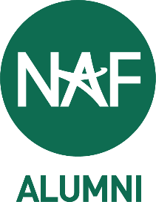

MENTORSHIP PROGRAM GUIDE

The NAF Alumni Mentorship Program provides college-age NAF alumni with the ability to build professional skills and connect with alumni working in their fields of interest.
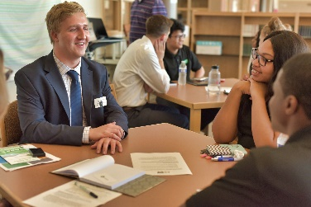
As a NAF alumni mentor, you will serve as a guide and resource to share your NAF academy, postsecondary, and professional experiences, helping to pave the way for students to succeed in college and beyond. The partnership between mentor and mentee is built upon trust, respect, and professionalism.

The mentorship process is designed to be structured yet flexible, allowing for a progressive development of the mentor-mentee relationship. A time commitment of arranging, at minimum, one session per month is expected to participate in the program. Micro-engagements (quick conversations to check-in or ask questions) between sessions are highly encouraged. Throughout the course of the program, participants should expect to receive regular communication from NAF staff regarding expectations and gathering feedback.

We hope this guide will be helpful as you begin your journey as an alumni mentor!
BUILDING THE RELATIONSHIPS
For mentoring to be a successful endeavor, there must be a reciprocal, comfortable relationship between the mentor and mentee. Both parties must work at building a rapport within the relationship by being open-minded, respectful, and abiding by the initial expectations. Ideally, the mentoring relationship will be mutually beneficial for both parties.

Tips for being a good mentor:
- Be Committed: Mentoring is a long-term commitment to a student. Please make sure you have the time and motivation to stay committed to the mentoring relationship. However, we do understand that conflicts arise, so make sure to communicate with your mentee and NAF in a timely fashion.
- Be Proactive: Take initiative in the relationship. Often students can be shy and intimidated at first by the idea of reaching out to mentors. Make it easier for students by reaching out first and often!
- Get to Know Your Mentee on a Personal Level: NAF hopes that most mentoring relationships develop a personal touch. This makes conversations much more interesting and rewarding. It makes both mentors and mentees look forward to the next conversation.

MENTORSHIP PROGRAM GUIDE

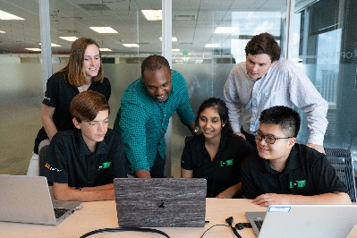
- Tell Stories: Students love hearing about your experiences! You probably learned a lot from your college and professional experiences, and these anecdotes can be invaluable to your mentee.
- Provide a Fresh Perspective: As a mentor, you can provide a fresh perspective for your mentee. This can help students tremendously as they are swayed by their own personal emotions and biases. An outside perspective can be very beneficial.
- Give Advice: Bounce ideas back and forth with your mentee. Make sure you are only providing your thoughts and feedback instead of directly telling your mentee what to do. This helps them hone their judgement and decision-making abilities.
- Be Encouraging: Students are often going through difficult times at school. Try to be positive and be a source of encouragement to help them through those situations. This can also be a good time to provide a seasoned perspective on your mentee’s problems (some of which you may have faced as a student).
- Find Shared Experiences: Relationships are stronger when you share something in common. Try to find this common ground by asking about their hobbies and interest.
- Respect your Mentee: Respect is vital in any relationship. Ensure that they know you value their opinions and feedback to build mutual respect.
SUGGESTED MENTORING ACTIVITIES
Here are some ideas for topics that you and your mentee can discuss during your time together:
Career Conversations & Goal-Setting - **1st meeting conversation & activity!
- Discuss your educational background and the role your education played in preparing you to work in your current field.
- Talk about your career trajectory and how you ended up in the position you are in today.
- Share information about current events or issues in your field.
- Work with your mentee to set goals for at least the first half of the program.
Tell Your Story
- How did you prepare for your transition from college to career?
- Talk about how you have balanced your career and personal life, and what they can expect.
- Discuss what you would have done differently as a student.
- Talk about how you have dealt with personal or professional challenges.

MENTORSHIP PROGRAM GUIDE

Job-Search Process
- Review your mentee’s resume and/or cover letter and offer tips to improve these documents.
- Lead the mentee through a mock interview.
- Offer guidance on where to best look for jobs/internships.
- Share tips for successful networking.
Networking Pursuits
- Introduce your mentee to colleagues or other contacts.
- Attend a professional association meeting or conference together, virtually
or in-person (if proximity allows).
- Guide the mentee on how to conduct an informational interview.
MISCELLANEOUS TIPS & TRICKS
- It may be difficult to find the time to talk or meet with your mentee, especially
if you live in different time zones, so schedule your next conversation at the
end of each meeting.
- Trust your natural mentoring skills: You probably already serve as a mentor in
a variety of settings in your life as parents, supervisors, and friends all act as mentors. Trust your instincts!
- Be enthusiastic and encouraging. Enthusiasm to learn and share information shows your mentee you care about the relationship!
- Do not interrupt when your mentee is speaking.
- Respond to your mentee’s efforts. Mentees are learning to network, build and sustain relationships with professionals. Make time for your mentee and
respond to them within 48 hours, if possible.
- Do not assign “homework” or things to do. Students have enough from their
own teachers and tend to shy away from their mentor when this happens. Suggestions are better, especially if you can assist the mentee through the process.

Sources:
Duke | Nicholas School of the Environment Alumni Student Mentorship Program (n.d.) Retrieved
from https://nicholas.duke.edu/people/alumni/alumni-student-mentorship-program
St. Francis University Student Alumni Mentoring (n.d.) Defining Your Role (Mentor). Retrieved from https://www.stfrancis.edu/wp-content/uploads/2020/04/MENTOR-Binder-Content.pdf

