Assignment Focus
 | 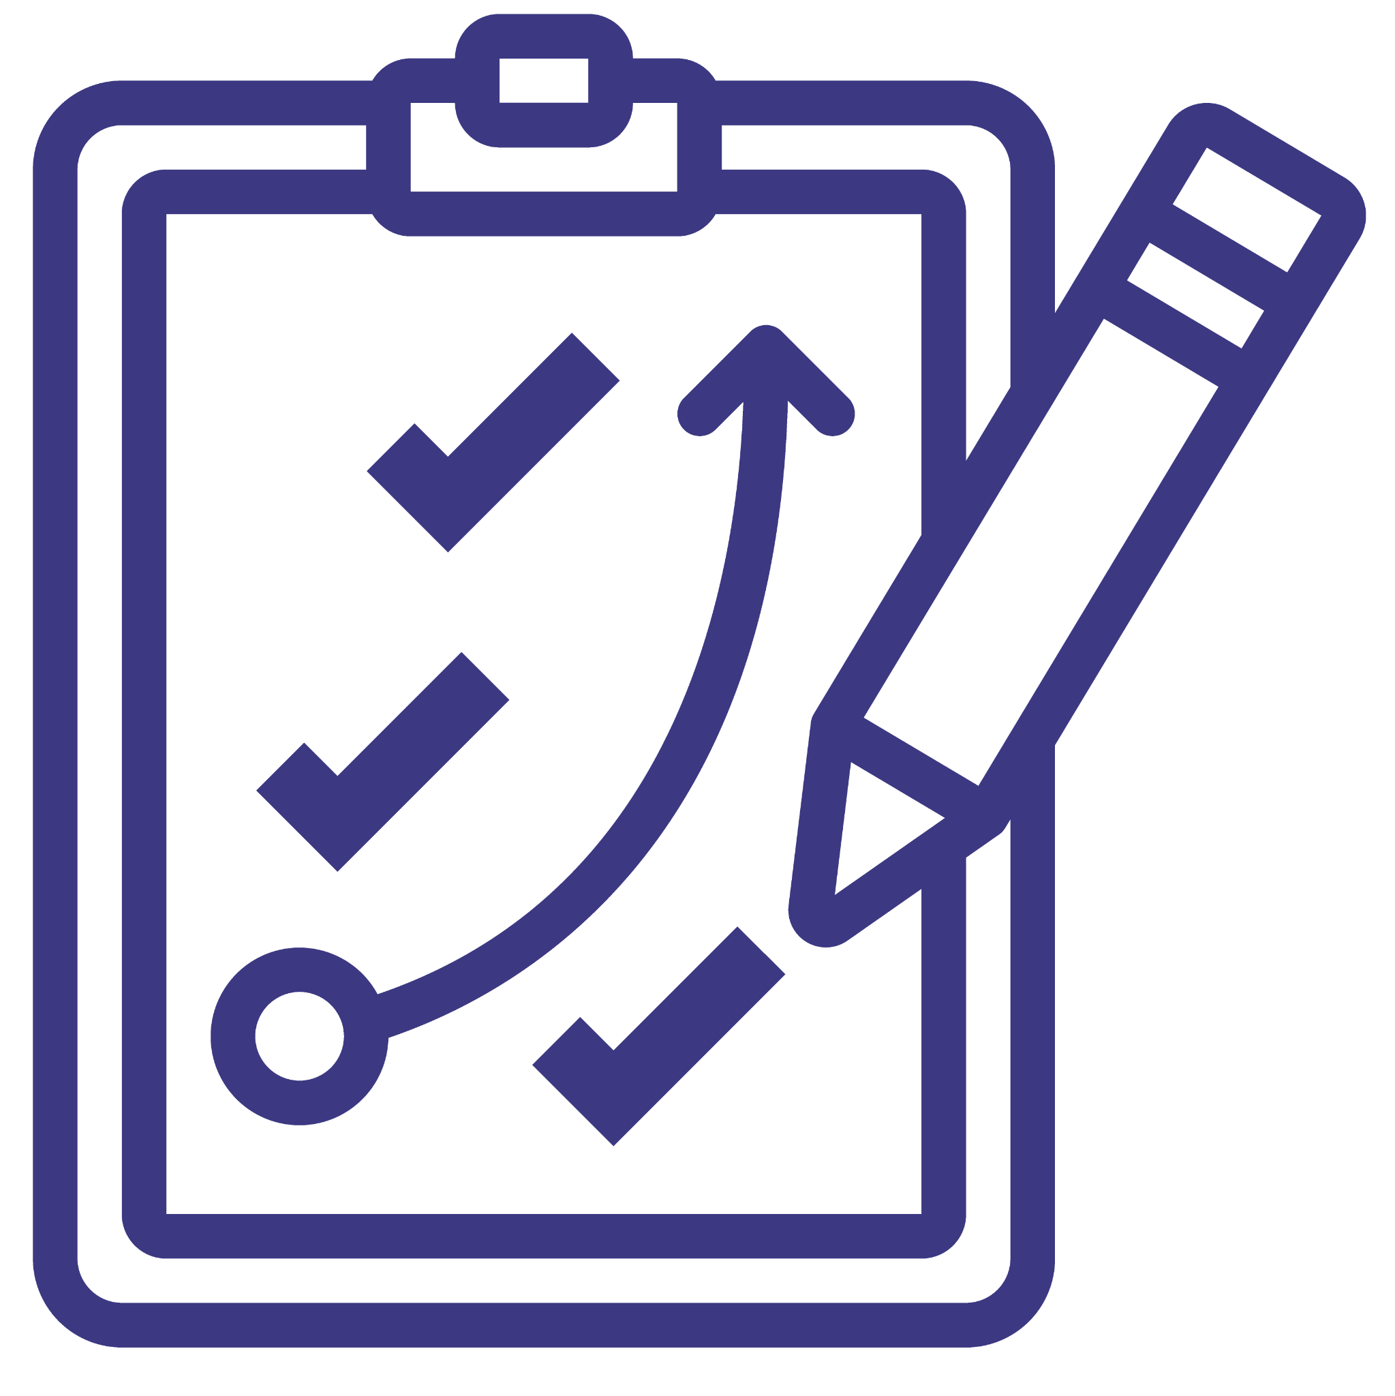 |  | 
Aspirations | Planning for Success | Communication | Connections

Research from various sources has concluded that 85% of jobs are secured due to networking, and 70% of these positions were never originally advertised. Networking is a useful way for people to interact with seasoned professionals in any career field to receive help in building a successful future. Connections are one way that people can get in touch with others who may be able to help them. Anyone can be a connection, whether they are a family member, friend, employer, teacher, etc. It is important to make connections as you begin to explore careers and plan your future, as they can provide advice, and resources, and in some cases, help you get hired.

In this activity, you will be tasked to interview two individuals who you believe have connections that might be beneficial to you in the future. As you discuss with your chosen individuals, you will record information such as what their occupation is, how they obtained their position, etc.

Begin by watching this brief video explaining why networking is an essential and powerful resource for those interested in planning a successful career and future.
- https://youtu.be/Zi3QGjEcQNU

Now that you have some background information, start to prepare for your interviews. Using the space below, formulate questions you will ask during the interview. Try to create insightful questions that will help discover connections they have while adjusting your language to match their occupation and career field. For example, you might ask a high school teacher if they kept in touch with teachers that had a lasting impact on their career, but you wouldn’t ask that question to someone who works in Human Resources.

Example Questions
- Was your position originally advertised? How did you initially hear about it?
- Do you have any colleagues that helped you obtain this position?
- In past jobs, did you utilize connections?
- Are there any coworkers you could recommend to people who are interested in this career field as a connection?
- Are you a college graduate? If so, how many years did you attend? Did your degree help you secure this position?
- Are you still in touch with people from past jobs and/or past educators?

Interviewee #1

Interviewee #2

Once you have thoroughly prepared for your interviews, the next step will be to meet with your interviewees and discuss their careers. Ask your prepared questions, create ones on the spot, and do whatever feels necessary to adequately discuss their occupations and connections. Either during or after, record all the information you gathered and complete the charts below. In addition, answer all the reflection questions.

Interviewee #1
Connection to You
Ex: Father
Occupation
Ex: Kindergarten Teacher
Daily Responsibilities
Ex: Teach, entertain, and monitor kids
How They Got the Job
Ex: Former teacher recommended them
Connection They Have
Ex: Various teachers within the school
Additional Information

Interviewee #2
Connection to You
Ex: Father
Occupation
Ex: Kindergarten Teacher
Daily Responsibilities
Ex: Teach, entertain, and monitor kids
How They Got the Job
Ex: Former teacher recommended them
Connection They Have
Ex: Various teachers within the school
Additional Information

- How did your interviews go? Did your questions allow you to receive the desired information?

- Would you be interested in pursuing any of the careers you explored? Explain your answer.

- Did your interviewees have any connections that could be beneficial to you? Explain your answer.

Follow-Up Assignment
After completing the activity, you should have discovered and gained new connections in career fields you might have known you were interested in. Even if you aren’t sure about pursuing these careers, keeping the connections you made today could benefit you in the future. Staying organized and storing useful information is one of the best ways to plan for success.

Finish this assignment by organizing your connections. This can be done by creating a Google Spreadsheet, saving phone contacts with notes, downloading this assignment into google drive, or using this pre-made template. Do it in whatever way works best for you. Being organized is a useful skill to practice and will help you easily find and access documents in the future.

