Parcels league table 2025 - Citizens Advice
November 2025

Contents
Parcels league table 2025 2
2025 findings 2
Five years of our parcels league table… Too many problems and not enough progress 2
Delivery 3
Accessibility 4
Customer service 4
Trust 5
Context criteria - Cost 6
Context criteria - environmental data 7
Disparities within the parcels market 7
Social media analysis 8
5 year trends 14
5 years on from our first parcels league table - Overall star ratings by company 14
5 year trends - Delivery problems 15
5 year trends - the most common issues 16
5 year trends - Customer service issues 17
5 year trends - Demographic disparities 18
5 year trends - People with accessibility needs 19
Looking forward 26
Recommendation 1: Proactive enforcement 26
Recommendation 2: Harmonise regulatory requirements 27
Methodology 27
Methodology - Data 28
Citizens Advice helps people find a way forward. 30

Parcels league table 2025
Rank 1: Royal Mail are first place, with an overall score of 3.25 out of 5. This is an increase on their score from the previous year.
- Delivery score: 3.2
- Accessibility score: 2.8
- Customer service score: 3.4
- Trust score: 4
Rank 2: Amazon Logistics are second place, with an overall score of 3 out of 5. This score is the same as their score from the previous year.
- Delivery score: 3.2
- Accessibility score: 1.8
- Customer service score: 3.5
- Trust score: 3.8
Rank 3: DPD and Evri are tied third place.
DPD scores are as follows…
- Delivery score: 2.4
- Accessibility score: 2
- Customer service score: 2.1
- Trust score: 3.4
Their overall score is 2.25 out of 5. This score is a decrease on their score from the previous year.
Evri’s scores are as follows…
- Delivery score: 2.4
- Accessibility score: 1.6
- Customer service score: 2.7
- Trust score: 2
Their overall score is 2.25 out of 5. This is an increase on their score from the previous year.
Rank 5: Yodel is in last place, with an overall score of 2 out of 5. Their score has stayed the same as the previous year.
- Delivery score: 2.4
- Accessibility score: 1.4
- Customer service score: 2.2
- Trust score: 1.8

2025 findings

Five years of our parcels league table… Too many problems and not enough progress
This is our fifth annual parcels league table. As the consumer advocate for post, we compare consumers’ delivery experiences with the top 5 biggest parcel companies.
We focus on 4 key indicators related to consumer views and priorities. These are: delivery, accessibility, customer service and trust.
For the fifth year in a row, we see a parcels market that is still not working for people relying on it.
- The rate of delivery problems remains at the highest level seen in the past five years. 37% of people experienced a problem with their last delivery - the fifth year in a row it has stood above 33%.
- One parcel company has scored above a 3 out of a possible 5 stars. No company has increased or decreased beyond 0.25 of a star since last year.
- Trust scores are the lowest they have been. We now urgently need action from Ofcom to secure the improvements consumers need in this vital market.
In 2025:
- Royal Mail scored highest: 3.25 - the highest any company has scored.
- Yodel came last with 2 stars out of 5.
- There is a 1.25 stars difference between highest and lowest scoring companies.
- Accessibility continues to be the lowest average score of all the criteria.

Delivery
- To calculate delivery scores, we use social media analysis, consumer service data and polling data. The polling data comes from a nationally representative survey of 8,000 people.
- These scores have improved by a small margin from last year - with an overall increase of 0.2 of a star.
- But on polling data alone, rates of delivery problems remain at the highest level seen in the past five years.
- Improvements are driven by reduced complaints raised on social media and to our consumer service.
- This could suggest that people are beginning to simply expect poor parcel service.
37% of people had a problem with their last parcel delivery.
Of the people that had a problem:
- 24% said the parcel was left in an insecure location.
- 24% said the parcel arrived late.
- 29% said the delivery driver left before they had time to get to the door.

Accessibility
In November 2023, Ofcom introduced a new regulatory condition on accessibility.
However, two years on, accessibility continues to be the lowest scoring category across the league table.
1 in 5 (20%) people reported they had an accessibility need that they would like to share with their parcel delivery company.
Accessibility needs are self-identified. They include needing parcels left in specific locations, additional time to get to the door or help with carrying or picking up parcels. They also include other reasons why arranging parcel delivery or answering the door can be difficult, such as childcare or health conditions.
Out of just those who said they had an accessibility need to share:
- 37% were unable to share this with the delivery company.
- Over half (56%) had a delivery problem with their last parcel delivery, compared to 37% of the general population.
- Of those who did manage to share their accessibility need, 84% said their needs were taken into account.
- Our advice page explains how you can tell all five parcel companies about your accessibility needs.

Customer service
Our evidence shows that, when people do experience a parcel delivery problem, they often find it hard to resolve. The process can be confusing, with people sometimes unsure whether to contact the retailer or the parcel carrier. Contact information can be difficult to find, operators can be unresponsive or slow, and automated systems often don’t work well.
In April 2023, Ofcom responded to our concerns in this area. The regulator introduced more specific guidance for parcel companies on managing complaints processes. This introduced greater clarity about who to contact, the process and how long it would take to resolve.
This year’s results show that complaints are the area where companies have most improved on last year. However, this is a modest improvement - at 0.4 of a star as an average across all companies.
13% of people said they received too little information about their delivery overall
Out of the those who had a delivery problem they were struggling to resolve:
- 31% of people (almost a third) experienced more than one problem whilst trying to resolve their issue.
- 38% (over a third) were not satisfied with the outcome of the complaints process.
*Notes: Base: those who had an issue when trying to raise a complaint about a parcel problem.

Trust
To develop the trust metric, we asked consumers how much confidence they had in the parcel company who had made their most recent delivery. Trust also looks at how satisfied they were with the service from that company.
Trust is an important metric to consider because it informs consumer expectations of the market, such as their faith in companies’ complaints processes.
- 77% of consumers didn’t get to choose who delivered their parcel themselves.
- 3 out of 4 (76%) consumers who were not happy with their parcel company said this was because of a previous experience of poor quality of service or poor customer service.
- Royal Mail received the highest, whereas Yodel received the lowest, trust score. There is a 2.2 difference between their scores on trust.

Context criteria - Cost
These criteria do not contribute to the companies’ overall rankings
Amazon Logistics
- no cost rating given
Royal Mail
- Cost to send a 1kg parcel - ££ Mid priced
- Cost to send 5kg parcel - ££ Mid priced
- Overall cost rating - ££ Mid priced
DPD
- Cost to send a 1kg parcel - £££ Expensive
- Cost to send 5kg parcel - ££ Mid priced
- Overall cost rating - £££ Expensive
Evri
- Cost to send a 1kg parcel - ££ Mid priced
- Cost to send 5kg parcel - ££ Mid priced
- Overall cost rating - ££ Mid priced
Yodel
- Cost to send a 1kg parcel - £ Affordable
- Cost to send 5kg parcel - £ Affordable
- Overall cost rating - £ Affordable
We compare the cost of a drop off at a shop or pick up point and delivery to a UK mainland address. It’s not an exact comparison because the services provided offer different delivery times. A DPD parcel sent this way should be delivered the next working day. Yodel should deliver within 2 working days, Royal Mail between 2 to 3 business days and Evri in 2 to 4 working days.

Context criteria - environmental data
This year we have removed the CO2 emissions table from the parcels league table report. This does not affect the overall league table, since we have never used this data to inform a company’s ranking. It has always been treated as separate contextual information.
Several parcel companies raised questions about the comparability of the emissions data across companies. We agree that the current data available is limited and may be inconsistent. Therefore, we have not included this metric this year. Instead we are asking for those companies who do not publish detailed data on emissions to share this information publicly.
Tools already exist in other European countries, such as Belgium and Germany, to help consumers understand the relative environmental impacts of different companies.
Notes: For more information, you can read our full methodology report.

Disparities within the parcels market
Our research found that some groups experience problems in the parcels market at a higher rate than others.

Disabled people
47% of disabled people who experienced an issue resolving a parcel delivery problem were dissatisfied with the outcome. This compares to 34% of those who do not identify as disabled.
*Note: Disabled people are people who self-identify as having a disability or long-term health condition. This condition could relate to either physical or mental health, or both.

Racially minoritised groups
51% of people from a racially minoritised background experienced a problem with their last delivery, compared to 35% of White people.
** Any references to ethnicity data should be treated as indicative, as the sample was not weighted to be representative of ethnicity.

People with irregular working hours
In comparison to 37% of the general UK population, almost half (48%) people who work zero hour contracts or shifts (and therefore might need their parcel left in a specific place) had a problem with their last parcel delivery.

People with caring responsibilities
77% of people with a caring responsibility had a further issue when trying to resolve a delivery problem compared to 68% of people without caring responsibilities.
*Note: People with caring responsibilities includes those who care for people older and/or younger than them. This includes caring for children under the age of 18.
** Note: The caring responsibilities statistic was rebased to include those who had a delivery problem and took action to resolve their problem.

Social media analysis
We use a tool called Brandwatch to analyse parcel problems reported via social media.

Trending topics
The word cloud highlights the most frequent words mentioned when consumers are making a complaint about their parcel online. 'Lost', ‘item’, ‘delivered’ and ‘missing’ are amongst the top words mentioned.
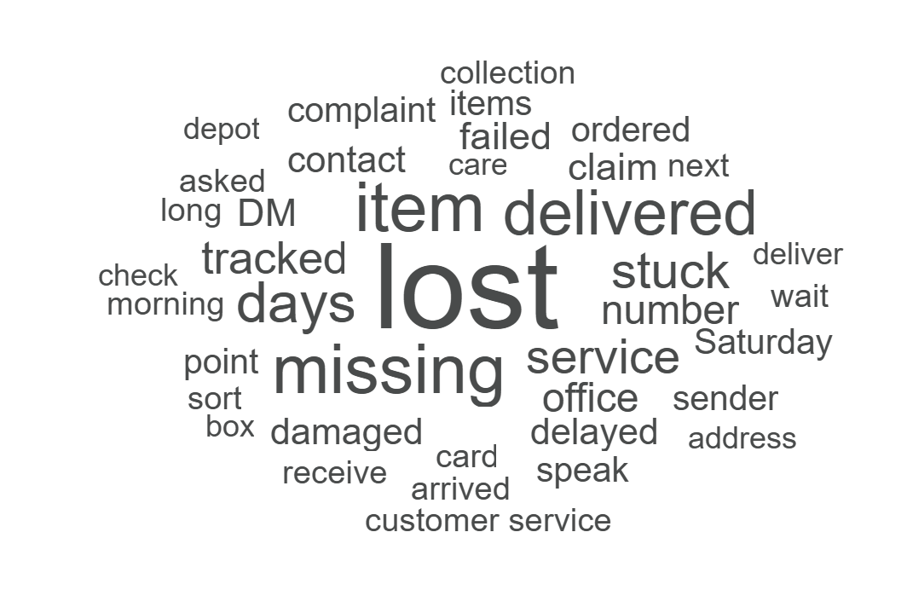
Notes: For more information, you can read our full methodology report.

Social media analysis - types of negative mentions by company
We use this tool to break down negative mentions by categories.
The four categories are: lost parcels, damaged parcels, delays and failed deliveries.
Taking the percentages of mentions across all five companies, “lost parcels” and “delays” are the most common.
Amazon Logistics is the outlier to this trend, with “failed deliveries” being their most common negative mention.
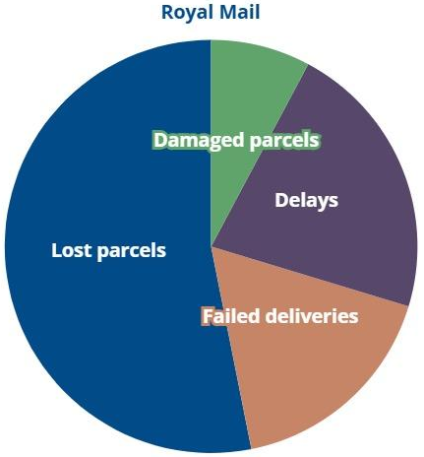

Graph description
Pie chart showing proportion of types of negative mention for Royal Mail. Over half of negative mentions relate to lost parcels, whilst around a fifth relate to delays, around a sixth relate to failed deliveries and around a twelfth relate to damaged parcels.
Notes: For more information, you can read our full methodology report.

Amazon logistics
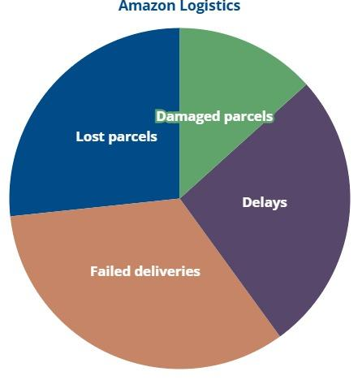

Graph description
Pie chart showing proportion of types of negative mention for Amazon Logistics. Around one third of mentions relate to failed deliveries. Around a quarter relate to delays and another quarter relate to lost parcels. Around an eighth relate to damaged parcels.

DPD
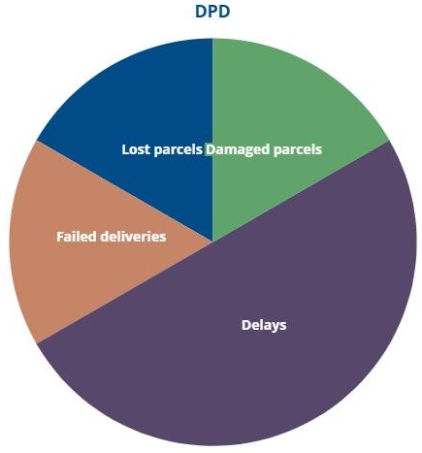

Graph description
Pie chart showing proportion of types of negative mention for DPD. Half of mentions relate to delays and failed deliveries, lost parcels and damaged parcels each make up around a sixth of mentions.
Notes: For more information, you can read our full methodology report.

Evri
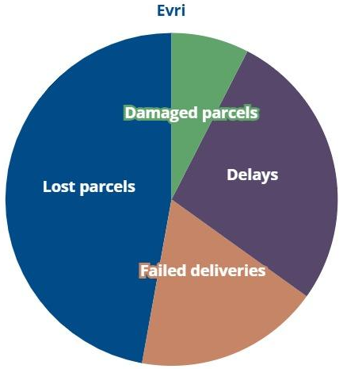

Graph description
Pie chart showing the proportion of types of negative mention for Evri. Almost half of negative mentions relate to lost parcels. Over a quarter relate to delays, around a fifth relate to failed deliveries and around a twelfth relate to damaged parcels.

Yodel
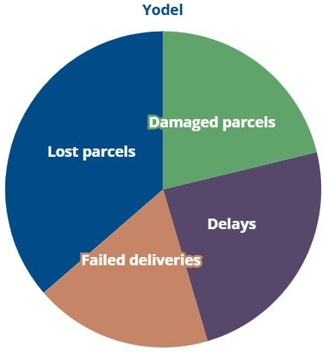

Graph description
Pie chart showing the proportion of types of negative mention for Yodel. Over a third of negative mentions relate to lost parcels, around a quarter relate to delays. Damaged parcels and failed deliveries each make up around a fifth.
Notes: For more information, you can read our full methodology report.

5 year trends

5 years on from our first parcels league table - Overall star ratings by company
Over the last five years there has been an overall increase in the average scores across parcel companies. However, this improvement is very marginal - at 0.35 of a star.
Given that we have never seen less than a third of people experiencing a problem with their last delivery, we need to see faster rates of improvement.
Interestingly, the same companies consistently seem to score on the lower end and the higher end.
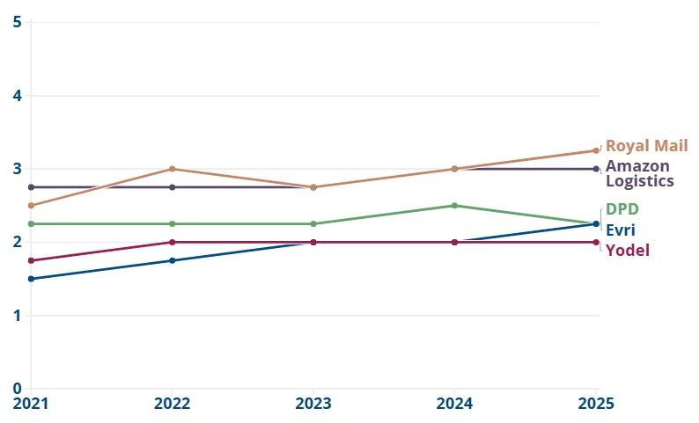

Graph description
Line graph shows Amazon Logistics and Royal Mail have consistently scored highest, with around 3 stars each year from 2021 to 2025. Evri and Yodel have consistently scored lowest, with around 2 stars each year. DPD usually scores just over 2 stars. Royal Mail and Evri’s scores have improved the most, by three quarters of a star since 2021.

5 year trends - Delivery problems
The market as a whole is not working for consumers. The incidence of delivery problems is no better now than it was 5 years ago.
In 2021, 36% of people experienced a problem with their last delivery.
Since then, there were brief signs of improvement in 2023, but this trend didn’t last.
The rate of delivery problems is now 1 percentage point higher than it was in 2021.
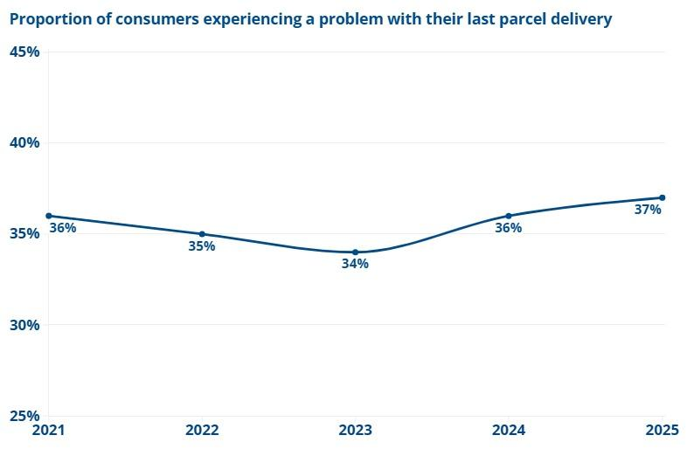

Graph description
Line graph shows that in 2021, 36% of people had a problem with their last parcel delivery. This dropped to 34% in 2023 but has now risen to 37% in 2025.

5 year trends - the most common issues
Over the last five years, rates of delivery problems have remained high. Almost every year since 2021, the most common delivery problem has been the driver leaving too quickly. The only exception was in 2022 when the most common issue was parcels arriving late.
Since 2021, accessibility has consistently been the lowest scoring criteria overall.

Issue: Most common delivery problem
2021: Driver left too quickly
2022: The parcel arrived late
2023: Driver left too quickly
2024: Driver left too quickly
2025: Driver left too quickly

Lowest scoring criteria
2021: Accessibility
2022: Accessibility
2023: Accessibility
2024: Accessibility
2025: Accessibility

5 year trends - Customer service issues
The rate of issues related to trying to resolve a delivery problem have remained fairly constant throughout five years.
Over the last five years, there have been some very marginal shifts in the proportion of people experiencing an issue in resolving their delivery problem.
In 2025 we are only 2 percentage points better off compared to in 2021. We would expect to see a greater improvement, considering Ofcom introduced new guidance on complaints in 2023.
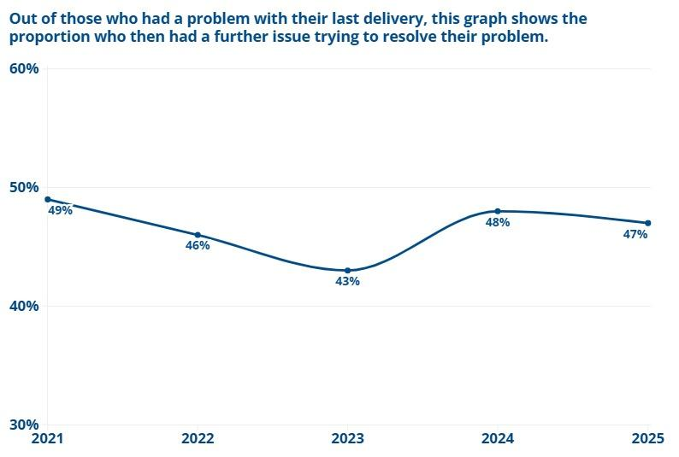

Graph description
Line graph shows that in 2021, 49% of those who had a problem with their last parcel delivery experienced a further issue when trying to resolve the problem. This proportion dropped to 43% in 2023, but has now risen to 47%.
The base for this graph is of those who had a problem with their last delivery, and so this would also include people that did not attempt to resolve their problem.

5 year trends - Demographic disparities
Our research consistently shows that certain groups are disproportionately affected by failures in the parcels market.
We have been highlighting these disparities and calling for improvements.
We can now compare trends in these disparities over five years.
5 year trends - Racially minoritised groups
Racially minoritised groups continue to be more likely to experience parcel delivery problems than White people.
There is a gap of at least 16 percentage points between the two groups over five years. These figures are indicative only.
There has been a slight narrowing of the gap over the last 3 years but the disparity remains.
We are carrying out further analysis to understand the possible drivers of this striking disparity.
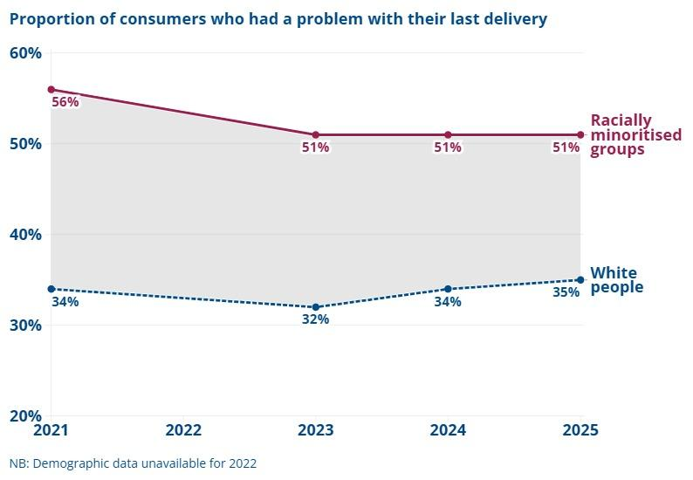

Graph description
Line graph shows the proportion of consumers from racially minoritised groups experiencing a problem with their last delivery has plateaued at 51% over the last three years starting in 2023. In 2021, this proportion was 56%. For White people, the graph shows an overall lower proportion of delivery problems, starting at 34% in 2021, falling to 32% in 2023 and then increasing to 34% in 2024 and peaking this year at 35%.

5 year trends - People with accessibility needs
Accessibility needs are self-identified. They include needing parcels left in specific locations, additional time to get to the door or help with carrying or picking up parcels. They also include other reasons why arranging parcel delivery or answering the door can be difficult, such as childcare or health conditions.
The below graph shows the proportion of people who said that their delivery driver left before they had time to get to the door. It compares this percentage between people with access needs and those with none.
The disparity between the two groups has ranged between 7%-10%. Recently this disparity has been on the higher end. These rates are indicative.
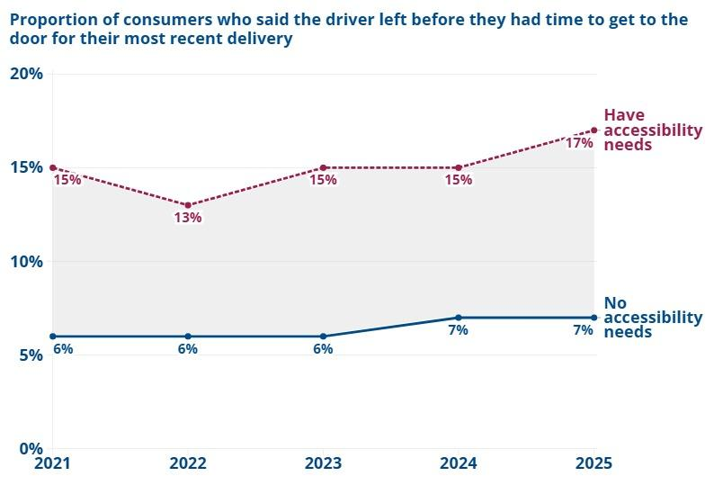

Graph description
Line graph shows the proportion of consumers with accessibility needs who said the delivery driver left before they had time to get to the door has ranged from 13% (2022) to 17% (2025) over the last five years, peaking this year. For those without accessibility needs, the figure has risen from 6% to 7% in the same period

A new accessibility condition: Has it worked?
We have been highlighting accessibility disparities in the parcels market since 2021. In November 2023, Ofcom responded by adding a new accessibility condition to their Postal Regulation Statement. This required parcel companies to introduce policies aimed at improving accessibility. For example, people must be able to specify delivery instructions. These can include louder knocking, having more time to get to the door and parcels being left in accessible locations.
So, two years on from the new regulation, are we seeing improvements for people with access needs?
- For the fifth year running, accessibility continues to be the worst performing criteria in the league table.
- The rate of people who wanted to share their accessibility needs, but were not able to share their needs remains high at 37%. Last year this was 39%.
- Furthermore, out of those who were able to share their needs, 14% said their needs were not taken into account. This is in line with last year, where 13% of people who shared their access needs reported these were not taken into account.

A new accessibility condition: Has it worked?
Accessibility star ratings have not changed much since before the introduction of the new condition in 2023.
Most companies (except Yodel) improved on their accessibility star rating in 2024, but then all worsened again in 2025.
The highest accessibility rating ever was Royal Mail (3 stars) in 2024. But this year this has dropped back to 2.8.
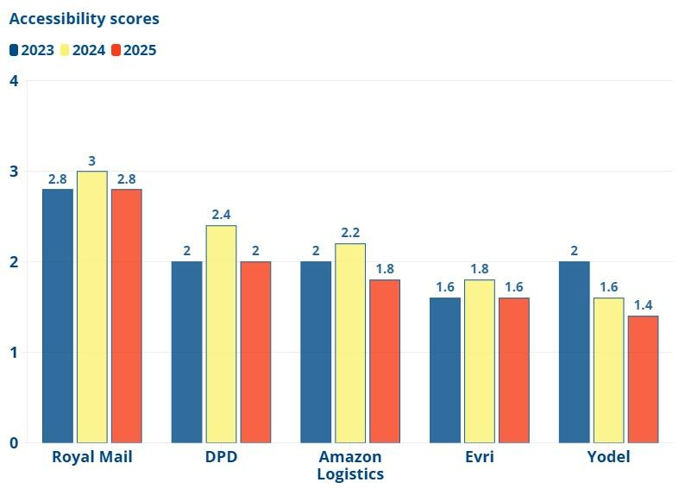

Graph description
Column graph shows how accessibility scores improved for all companies (by around 0.2 of a star) in 2024, except Yodel whose score dropped by 0.4. Scores dropped in 2025, with Royal Mail, DPD and Evri's scores equal to 2023. Amazon Logistics and Yodel have worse accessibility ratings now than in 2023.
Scores showing on the graph are:
Royal Mail
- 2023: 2.8
- 2024: 3
- 2025: 2.8
DPD
- 2023: 2
- 2024: 2.4
- 2025: 2
Amazon Logistics
- 2023: 2
- 2024: 2.2
- 2025: 1.8
Evri
- 2023: 1.6
- 2024: 1.8
- 2025: 1.6
Yodel
- 2023: 2
- 2024: 1.6
- 2025: 1.4
A table containing the data is provided on the next page.

A new accessibility condition: data table
Company | 2023 | 2024 | 2025
Royal Mail | 2.8 | 3 | 2.8
DPD | 2 | 2.4 | 2
Amazon Logistics | 2 | 2.2 | 1.8
Evri | 1.6 | 1.8 | 1.6
Yodel | 2 | 1.6 | 1.4

New complaints guidance: has it worked?
Over the last five years, our evidence has highlighted the challenges people face when they want to complain about a delivery issue. Ofcom recognised these problems and introduced new guidance on managing complaints processes in April 2023. The purpose of this guidance was to ensure consumers could easily contact parcel companies and see their query dealt with promptly. There were also new specifications for staff training.
The additional guidance has now been in place for well over two years, so has it had an impact?
- Compared to last year’s scores, customer service is the most improved category this year. All companies except DPD have higher scores.
- However, when placed in wider context, the evidence is less encouraging. If we compare scores with those achieved in 2023 - when the new guidance took effect - only two companies have improved scores since then.
- 47% of people who experienced a problem with their last delivery had a further issue when trying to resolve their problem. This compares to 48% of people in 2024. Issues included slow or unresponsive service and problems with automated systems.
38% of those who encountered an issue trying to resolve the problem were not satisfied with the outcome.
DPD has the worst customer service score this year, scoring 2.10 stars.
Scores are improved for customer service for all companies apart from DPD compared to last year.
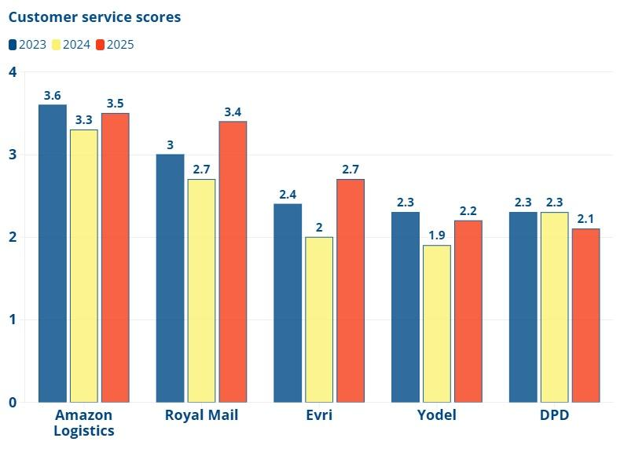

Graph description
Column graph shows ratings for 2023-2025 across Amazon Logistics, Royal Mail, Evri, Yodel and DPD. Customer service scores dropped for all companies in 2024. Scores recovered to varying degrees in 2025, but the only companies whose scores have improved since the new guidance in 2023 are Royal Mail and Evri. The highest score in 2025 is Amazon Logistics with 3.5, and the lowest is DPD with 2.1.
Amazon Logistics
- 2023: 3.6
- 2024:3.3
- 2025:3.5
Royal Mail
- 2023: 3
- 2024: 2.7
- 2025: 3.4
Evri
- 2023: 2.4
- 2024: 2
- 2025:2.7
Yodel
- 2023: 2.3
- 2024: 1.9
- 2025: 2.2
DPD
- 2023: 2.3
- 2024: 2.3
- 2025: 2.1
A table containing the data is provided on the next page.
Customer service scores: data table
Company | 2023 | 2024 | 2025
Amazon Logistics | 3.6 | 3.3 | 3.5
Royal Mail | 3 | 2.7 | 3.4
Evri | 2.4 | 2 | 2.7
Yodel | 2.3 | 1.9 | 2.2
DPD | 2.3 | 2.3 | 2.1

Looking forward
So what does five years’ worth of evidence tell us about the current state of the parcels market? Although on the face of it the sector is rapidly evolving, what is striking when we look at our findings is that the consumer experience and scale of problems many face has remained much the same.
Since 2021, the proportion of people experiencing a problem with their last delivery has never dropped below 1 in 3. This year’s rate of 37% remains at the highest level seen in the past five years - and trust scores for parcel companies are the lowest.
Ofcom has begun to acknowledge the significance of the issues in a sector which is now vital for millions of people and businesses. In 2023, they introduced a new accessibility condition and additional guidance for parcel companies on improving complaints processes. But our evidence shows this has not led to the sustained improvements needed.
For the fifth year running, accessibility is the lowest scoring criteria and Ofcom’s own research finds people with limiting conditions remain significantly more likely to experience delivery problems. On complaints, only 2 of the 5 parcel companies have higher customer service scores than they did when new guidance was introduced in 2023.
This simply isn’t good enough. People often cannot punish companies for poor service - 77% had no choice over the parcel company making their delivery. We therefore need the regulator to take action now, both in starting to actually enforce the new measures it has put in place, and in harmonising a set of minimum standards to cover all parcel operators.

Recommendation 1: Proactive enforcement
We have long highlighted problems in the market related to accessibility and complaints and we welcomed Ofcom’s new guidance in these areas in 2023. Yet our evidence - as well as Ofcom’s own - makes clear that non-compliance persists.
For the fifth year running, accessibility is the worst performing criteria overall. Customer service scores have improved slightly this year compared to last: an average rating of 2.8 (2025) compared to 2.4 (2024). However, only two companies have improved their individual customer service score since 2023. It is clear that the additional guidance is not a substitute for enforcement. We now urge Ofcom to support regulation with proactive enforcement.
Ofcom must:
- Publish company-level accessibility findings to incentivise improvement, as Ofcom already do for complaints data.
- Take enforcement action, including fines, where needed. Our research shows the same companies continue to underperform year after year.

Recommendation 2: Harmonise regulatory requirements
As the postal Universal Service Provider, Royal Mail are subject to stricter regulations than other parcel operators (such as mail security requirements and stronger complaints resolution procedures). Royal Mail has also taken one of the top two spots in all five parcel league tables. But consumers deserve the same level of protection, regardless of the company that delivers their parcel. We need Ofcom to:
- Extend Essential Condition 1 to all parcel operators to protect consumers across the market—not just those using Royal Mail. Essential Condition 1 sets out that Royal Mail has to take certain actions to ensure that mail is not lost, damaged, or stolen. Given consistently high rates of delivery problems, all parcel companies should be subject to these rules.
- Standardised complaints processes: Despite new rules, complaints issues have not shown the consistent or sustained improvement people need. Only Royal Mail and DHL eCommerce currently offer access to an independent Alternative Dispute Resolution (ADR) scheme (where an independent party helps resolve disputes between a consumer and a company). Ofcom must require all parcel operators to join an ADR. This would ensure all consumers can resolve complaints fairly, regardless of who has delivered their parcel.

Methodology
Our annual parcels league table compares the 5 largest parcel delivery companies in the UK (by estimated parcel volumes) against 4 indicators:
- Delivery
- Accessibility
- Customer service
- Trust
Note: Unless otherwise referenced, the information in this report is based on original research conducted by Citizens Advice for the 2025 parcels league table.
Delivery
Such as missing a delivery, a parcel arriving late or being left in an insecure location.
Accessibility
The ability to specify accessibility needs and have them met. Accessibility needs include needing longer to get to the door or not being able to reach certain parcels.
Customer service
The ability of consumers to make a complaint about an issue and get their issue resolved in a timely manner.
Trust
How do people view the parcel company that delivered their parcel?
Read our complete methodology

Methodology - Data
To create our league table we used data from the following sources:
- Consumer polling
- Citizens Advice Consumer Service
- Social media complaints
- Apex Insight
- Cost data from company websites

Consumer polling
Between the 29th of August to the 27th of September 2025. Opinium carried out an online survey of 8,000 UK adults who have received a parcel in the last month from Royal Mail, DPD, Yodel, Amazon Logistics or Evri. Data was weighted to be representative of those that had received a parcel from one of those 5 companies in the last month on age and gender, region, social grade, and working status.

Citizens Advice Consumer Service
We conducted a keyword search of company names carried out through the Citizens Advice Consumer Service Partner Portal to identify case volumes associated with each company in the 6 months between 1st of March 2025 and 31st of August 2025.

Social media complaints
To identify and categorise social media mentions, we used a tool called Brandwatch, which analyses social media to identify parcel problems. Brandwatch monitors social media activity from X and Instagram.

Apex Insight
To identify the 5 largest parcel delivery companies in the UK, we commissioned research to Apex Insight.

Cost data
Cost data is a contextual metric which don’t impact the overall star rating. Cost data is from parcel company websites.
Note:
*For cost companies are rated according to 3 levels of cost across various data points which are then averaged to find a total score. ‘Affordable’ is the cheapest cost rating, ‘mid-priced’ is the middle rating, and ‘expensive’ is the most expensive.

Citizens Advice helps people find a way forward.
We provide free, confidential and independent advice to help people overcome their problems. We’re a voice for our clients and consumers on the issues that matter to them.
We value diversity, champion equality, and challenge discrimination and harassment.
We’re here for everyone.
citizensadvice.org.uk
© Citizens Advice
Citizens Advice is an operating name of The National Association of Citizens Advice Bureaux. Registered charity number 279057.
2

