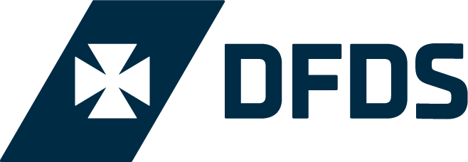

Request to film on board DFDS ships

Name: | Date application submitted:
Organisation: | Contact details (address, phone, email):
Names of crew: | Number, size (height & length in metres) and registration of vehicles:
Equipment in use:

Lighting – use, type and position

Power cables / power requirements

Proposed special effects

Proposed stunts

Storage of equipment

Use of tripod / camera jib arm or camera dolly

Use of boom microphones

Use of a green room area for actors/presenters/crew

List of shots required:

1.

2.

3.

4.

5.

6.

Date and time (including preferred sailing time – see sailing schedules): | Duration of filming (e.g. one outward trip / one return trip / multiple return trips):
Booking number (if you have already booked your ferry crossing): | Footage air date:
Please describe your project and how you will use DFDS in your footage:

