

SERVICES DESCRIPTION
ADVANCED CLOUD SERVICES PROGRAMMING OVERVIEW
FORMALIZE, EXPAND & MATURE

AVIATRIX CLOUD NETWORKING - SOLUTION PROGRAM SERVICES

At Aviatrix, we understand that cloud networking can sometimes feel like a maze of possibilities and challenges. That's why our team of seasoned experts are here to demystify, streamline, and optimize your network. Aviatrix’s unrivaled networking technology provides security, visibility, performance, and control. Aviatrix Advanced Cloud Services (“ACS”) is designed to accelerate your time to value with outcome-based services we call ProductPlus+. You apply ProductPlus+ to Solution-Program-Services.

SOLUTION PROGRAM SERVICES with PRODUCTPLUS+
Solution-Program-Services support cloud networking use cases with ProductPlus+ Services Credit Program. We use your credits purchased upfront with software, to stand up projects over the term for Use Case-Onboarding, Use Case-Adoption and Instructor-led Training, as well as core implementation services to cover Controller, CoPilot and a variety of other specific use cases. All Services in ProductPlus+ deliver measurable outcomes for your networking and business success.

Our ProductPlus+ Services Credit Program has (3) three plan levels that allocate credits on top of your software investment to redeem for pre-packaged projects:

ESSENTIAL PLAN | 15% added to your software investment to redeem for Onboarding, Adoption, and Enablement.
PROFESSIONAL PLAN | 20% added to your software investment to redeem for Onboarding, Adoption, and Enablement.
ENTERPRISE PLAN | 25% added to your software investment to redeem for Onboarding, Adoption, and Enablement.

Below are project types for which you can redeem services credit plans for:
ONBOARDING LEVELS I - III | Day 1 services expertly designed to deploy the Controller, CoPilot and use case-based solutions.
ADOPTION LEVELS I - IIII | Day 2 services to expand, migrate, automate and optimize use case-based solutions.
INSTRUCTOR-LED TRAINING | Equip your team with essential skills through our instructor-led training.

PROJECT APPROACH

SOLUTION PROGRAM SERVICES - PROGRAM SPRINTS
With Solution Program Services; it is used case focused; an Onboarding program is included with the Software Starter Packages. Aviatrix Engagement Managers and Aviatrix Consulting Services Engineers use the proven Aviatrix Delivery Methodology to deliver rapid time to value using 3 core sprint phases.
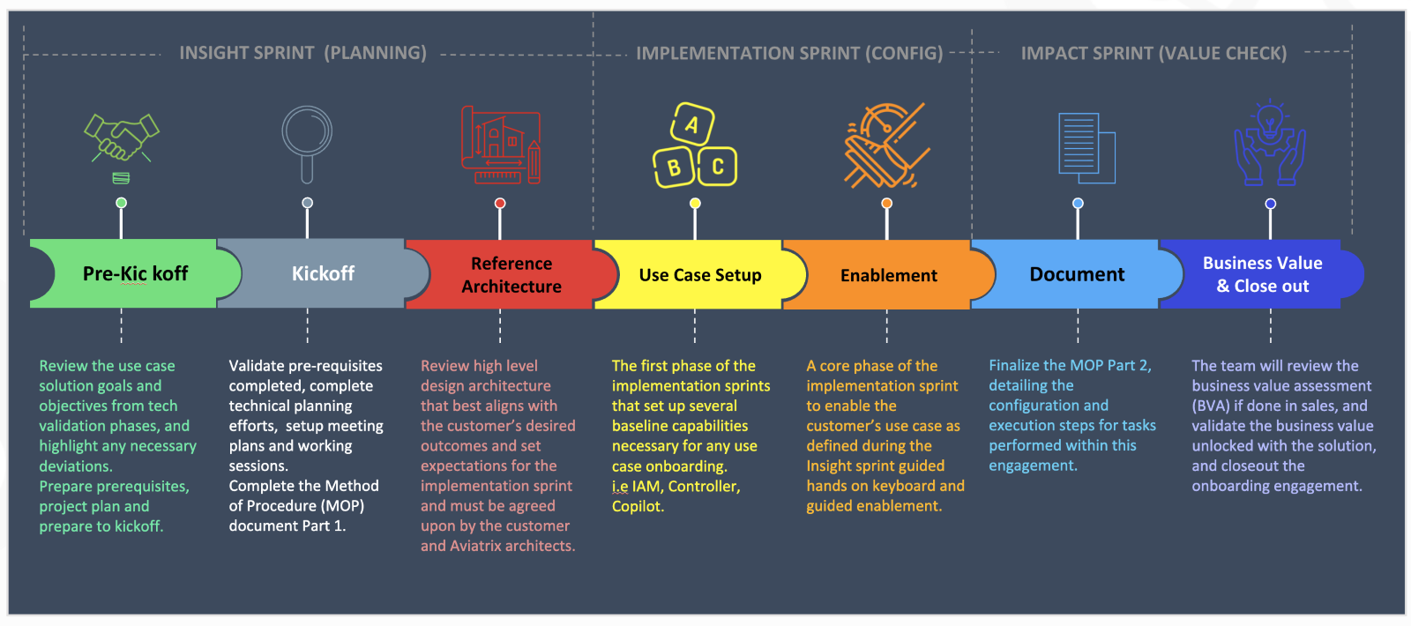
DATASHEET QUICKVIEW
ONBOARDING LEVELS (I – III) for SOLUTION PROGRAM SERVICES
Our Onboarding service is designed to deliver a comprehensive solution for your cloud infrastructure needs, using either Flagship or Aviatrix PaaS* offerings. It consists of the following key phases:
Pre-Build Phase: We kick off the process by implementing the management infrastructure. This involves launching the Aviatrix Controller and CoPilot in your specified cloud provider, providing you with a centralized platform to manage your infrastructure.

Enable Use Case: Based on the customer’s business outcome requirements, our experts will enable your cloud networking infrastructure with Aviatrix features. This phase involves translating your vision into reality by enabling either of the use case patterns:

- Secure Cloud Perimeter: The Aviatrix Secure Cloud Perimeter is designed to accelerate the deployment of distributed egress security solutions for your cloud network infrastructure. It provides a robust framework for managing and securing outbound cloud traffic, offering deep visibility, centralized policy enforcement, and cost-efficiency. Bundled programs include 2 weeks of Onboarding to establish the use case.
- Secure High-Performance Datacenter Edge: The Aviatrix High-Performance DC Edge is designed to extend the Aviatrix Cloud Networking architecture to the edge of your network, delivering a consistent and scalable solution for architecture, visibility, security, and control. This package ensures seamless integration with native cloud services such as AWS Transit Gateway and Azure Virtual WAN, addressing and overcoming their inherent limitations. Bundled programs include 2 weeks of Onboarding to establish the use case.

Automation: As per your requirement, we utilize industry-leading Infrastructure such as Code (“IaC”) tools such as Terraform, AWS CloudFormation, etc. to automate the deployment, minimizing manual effort and reducing the chance for error.

Engagement Length for Secure Cloud Perimeter:
Scope | Onboarding target | Duration
Level 1 | Clouds: Single CSP  Regions: Maximum two regions  Spoke Gateways: upto 5 VPC’s/Vnet’s | Up to 2 Weeks**
Level 2 | Clouds: Up to 2 CSP’s  Regions: Multi-region  Spoke Gateways: upto 25 VPC’s/Vnet’s | Up to 4 Weeks**
Level 3 | Clouds: Multi Cloud  Regions: Multi-region  Spoke Gateways: upto 75 VPC’s/Vnet’s | Up to 8 Weeks**

Secure Cloud Perimeter Details:
Management Plane | Assist with IAM permission, storage, key components required for Aviatrix build.  Deploy Controller and CoPilot.  High Availability enabled for the Control Plane (AWS only).  Assist with IAM permissions needed for cross accounts.
Control Plane | Configure CoPilot alerts and notifications.  Enable backup for Controller and CoPilot.  Assist with SAML enablement as needed.  Onboard CSP accounts on to the Controller for gateway deployment.  Control Plane hardening, including security group enforcement, access control, and patching.
Data Plane | Deploy Aviatrix Spoke Gateways.  Level 1: in up to 5 VPCs/Vnets  Level 2: in up to 25 VPCs/Vnets  Level 3: in up to 75 VPCs/Vnets
Secure Egress | Enable local egress on spoke gateways.  Enable global greenfield DCF policy for visibility.  Validate outbound connectivity & logging.

Engagement Length for Secure High-Performance Datacenter Edge:
Scope | Onboarding target | Duration
Level 1 | Clouds: Single CSP  Regions: Maximum two regions  Transit Gateways: up to 2 VPC’s/Vnet’s  Edge Gateways: up to 2 Gateway pairs | Up to 2 Weeks**
Level 2 | Clouds: Up to 2 CSP’s  Regions: Multi-region  Transit Gateways: up to 6 VPC’s/Vnet’s  Edge Gateways: up to 6 Gateway pairs | Up to 4 Weeks**
Level 3 | Clouds: Multi Cloud  Regions: Multi-region  Transit Gateways: up to 15 VPC’s/Vnet’s  Edge Gateways: up to 15 Gateway pairs | Up to 8 Weeks**
Secure High-Performance Datacenter Edge Details:
Management Plane | Assist with IAM permission, storage, key components required for Aviatrix build.  Deploy Controller and CoPilot.  High Availability enabled for the Control Plane (AWS only).  Assist with IAM permissions needed for cross accounts.
Control Plane | Configure CoPilot alerts and notifications.  Enable backup for Controller and CoPilot.  Assist with SAML enablement as needed.  Onboard CSP accounts on to the Controller for gateway deployment.  Control Plane hardening, including security group enforcement, access control, and patching.
Data Plane | Deploy Aviatrix Transit Gateways.  Level 1: in up to 2 VPCs/Vnets  Level 2: in up to 6 VPCs/Vnets  Level 3: in up to 15 VPCs/Vnets
Secure Edge | Assist with establishing Aviatrix Transit connectivity to AWS TGW/Azure vWAN using BGPoGRE/BGPoLAN/BGPoIPSEC.  Customer needs to provision the underlay connectivity. I.e LAN/WAN for Dell Hardware  Configure Aviatrix Edge Gateways.  Level 1: in up to 2 gateway pairs.  Level 2: in up to 6 gateway pairs.  Level 3: in up to 15 gateway pairs.  Attach the edge gateways to the appropriate transits.  Validate outbound connectivity & logging.

Note:
* Onboarding for Aviatrix PaaS offering will skip the pre-build phase, automation and use case capabilities will be restricted to the secure cloud perimeter.
** A program week is 40 hours and can be consumed over multiple calendar weeks but must be used within 90 days of order.

ADOPTION LEVELS (I – III) for SOLUTION PROGRAM SERVICES
Our Adoption strategy offers a comprehensive array of solutions, ranging from configuration, migration and providing a seamless experience, enhancing both performance and security. Our services cover a wide range of network configuration and optimization tasks, structured as projects over a retainer period and we customize our approach based on customer requirements, which will determine the duration of the retainer period. Projects covered under adoption as follows:

Expansion: Expansion is tailored to the scale Aviatrix specific use cases based on customer requirements. i.e. Assistance with onboarding more accounts, regions, applications using Aviatrix solution.

Migration: The migration process is designed to seamlessly migrate either of various components i.e. Transit Gateways (“TGW”), Transit Gateway Orchestrator (“TGWO”), Virtual WAN (“VWAN”), Native Peering and NAT Gateways to a more efficient and cost-optimized Aviatrix Multi Cloud Network Architecture (“MCNA”) solution. We provide a following structured approach:
- Discovery & Prep: The discovery process identifies your CSP native constructs in-use and prepares the cloud native infrastructure for deployment of Aviatrix solution.
- Deployment: Following the discovery phase, Aviatrix Solutions are deployed within your environments, running in parallel with your existing infrastructure. Which safeguards against disruptions to your services, enabling a seamless transition to the newly deployed Aviatrix Infrastructure.
- Cutover: During the cutover phase, traffic is transitioned to the newly deployed infrastructure and closely monitored for any potential impacts. This process is carefully executed in distinct phases to guarantee a smooth transition and minimize any disruptions. A rapid rollback plan is incorporated to swiftly address and mitigate any disruptions if they occur.
- Cleanup: Upon confirmation of a smooth cutover, our team will proceed with cleanup activities, which may involve the removal of legacy constructs such as old routing tables, peering connections, transit gateways, VPN gateways, and other redundant elements. This ensures your infrastructure remains optimized and clutter-free.

Optimize: Evaluate current network performance and offer recommendations to enhance it, meeting specific operational requirements and maintaining an optimal network setup.

Upgrades: Ensure network compliance with security patches, software versions, and related elements.

Automation: We utilize industry-leading Infrastructure as Code (“IaC”) tools such as Terraform, AWS CloudFormation, etc. to automate the deployment, minimizing manual effort and reducing the chance of errors.

Documentation: Develop essential documentation, including design documents and Method of Procedure (MOP) documents to assist in the ongoing management and troubleshooting of your Aviatrix infrastructure.
Engagement Length:
 | Onboarding target | Duration
Level 1 | Up to 8 hours/week  Up to 10 vpcs/vnets* | 3 Month Retainer
Level 2 | Up to 16 hours/week  Up to 25 vpcs/vnets* | 3 Month Retainer
Level 3 | Up to 32 hours/week  Up to 75 vpcs/vnets* | 3 Month Retainer

*Applicable only for migration service under Adoption program

