

SERVICES DESCRIPTION
ADVANCED CLOUD SERVICES PROGRAMMING OVERVIEW

CLOUD NETWORKING PLATFORM

AVIATRIX CLOUD NETWORKING – ENTERPRISE PLATFORM SERVICES

- At Aviatrix, we understand that cloud networking can sometimes feel like a maze of possibilities and challenges. That's why our team of seasoned experts is here to demystify, streamline, and optimize your network.

- Aviatrix’s unrivaled networking technology provides security, visibility, performance, and control.

- Aviatrix Advanced Cloud Services (“ACS”) is designed to accelerate your time to value.

Aviatrix Advanced Cloud Services (ACS) hosts a range of Professional Services designed to accelerate your time to value using our Enterprise Platform Services. This document will outline the Enterprise Platform Services to help simplify, improve and manage the network cloud journey.

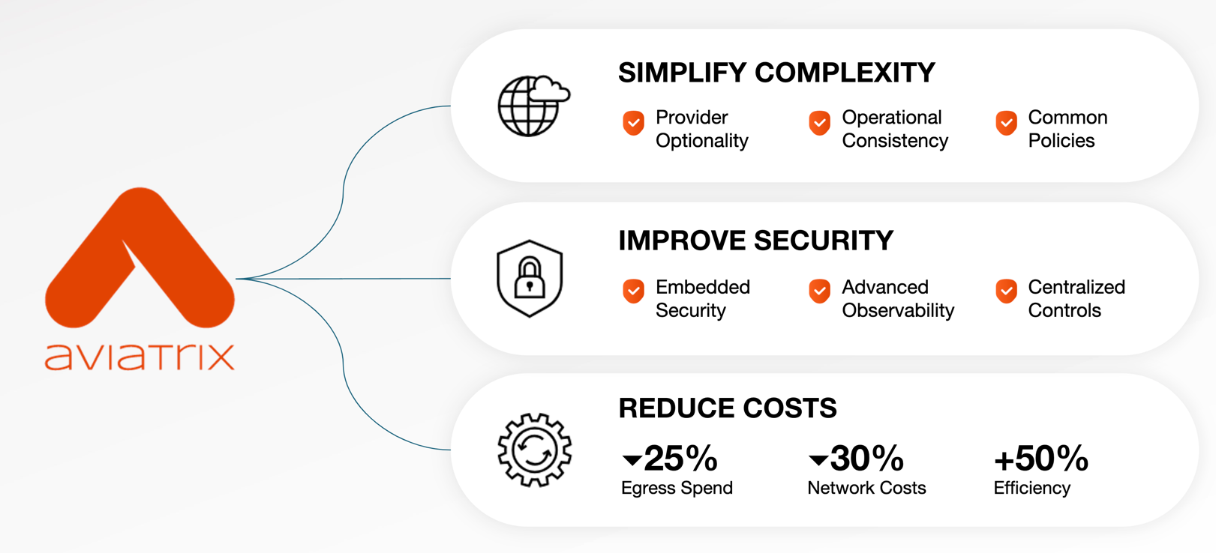

The Aviatrix Cloud Networking Platform® enables your cloud team to overcome these challenges when deploying business-critical apps in the cloud. By consolidating networking, management, automation, and security into one enterprise-grade solution, you’ll have the visibility, security, and control you need to adapt with ease and move ahead at speed. Aviatrix Professional Services programs below are designed to help customers across the full Aviatrix platform.

FIXED DURATION SERVICES
Our Fixed duration services cover more general activities with our projects for Discovery and Design, Build and Configure, and Migration. These are pre-determined duration services (scoped with one-week minimum work effort) encompass a wider range of product configuration goals and objectives.
Scope: Strategic recommendations, best practices, configuration steps and/or frameworks that may not be tied to a specific implementation.
DISCOVER & DESIGN | Collaborate with us to define your objectives for implementing Aviatrix products while assessing your current cloud network and security infrastructure for optimal performance.
BUILD & CONFIGURE | Receive a tailored Aviatrix solution that meets all your cloud infrastructure needs.
MIGRATION | Our migration services are customized to your specific requirements, prioritizing minimal service disruption and ensuring a smooth integration with your existing infrastructure.

ENABLEMENT SERVICES
Kickstart Day and Time & Materials (T&M) programs are rapid consulting workshops that are part of our enablement services to help with simple product setup and customized work efforts with statements of work.
Scope: Quick consultative product setup workshops and customized work efforts with hourly rates.

KICKSTART DAY | Kickstart your journey with our foundational services, expertly designed to deploy the controller & copilot.
TIME & MATERIALS | Flexible to engage our services as needed, allowing you to scale resources based on project requirements and budget constraints.

DISCOVER & DESIGN for FIXED DURATION SERVICES
If your team needs our team to think things through before any onboarding or adoption project, our team of experts can help by understanding your primary objectives for implementing Aviatrix products in a new initiative, such as security, performance, or operational efficiency. We then assess your current cloud provider network and security infrastructure, including third-party network components and operational constraints.
Objective-driven: We prioritize aligning Aviatrix products with your specific goals, whether it's security, performance, or operational efficiency.

Assessment & Analysis: We thoroughly evaluate your existing network architecture, including third-party components, to ensure alignment with best practices and identify areas for improvement.

Performance Optimization: Our team analyzes network performance for latency and scalability, providing recommendations for design enhancements to meet your operational needs and maintain optimal configuration.

Future-Proof Design: We craft an architecture that aligns with your long-term strategic objectives, ensuring your cloud networking is prepared for future advancements and changes in the market.

Comprehensive Documentation: Expect detailed design documentation that captures the final constructs of your operational environment, enabling seamless deployment and ongoing management.

Engagement Length: 5 Days* SKU: AV-ACS-CS-DD
*Note: Discover & Design hours must be used within 90 days from effective date of Software Order

BUILD & CONFIGURE for FIXED DURATION SERVICES
Our Build & Configure service is designed to deliver scope for projects outside solution use cases, which has been described over following key phases:
Pre-Build Phase: We kick off the process by implementing the management infrastructure. This involves launching the Aviatrix Controller and Copilot in your specified cloud provider, providing you with a centralized platform to manage your infrastructure.

Building and Configuring: Based on the design documentation, our experts will build and configure your cloud networking infrastructure using Aviatrix. This phase involves translating your vision into reality and may encompass various tasks, including:

- Deployment of Aviatrix Secure Multi-cloud transit-spoke architecture.
- Controller migration.
- Software Upgrades.
- HPE enablement on gateways.
- Securing your infrastructure by setting-up Aviatrix Distributing Cloud Firewall or Transit Firenet Solutions.
- Implementation of DCF solution.
- Establishing Connectivity to vendors via Site-2-Cloud tunnels.

Automation: As per your requirement, we utilize industry-leading Infrastructure such as Code (IaC) tools such as Terraform, AWS CloudFormation, etc. to automate the deployment, minimizing manual effort and reducing the chance of error.

Engagement Length: 5 Days* SKU: AV-ACS-CS-BC
*Note: Build and Configure hours must be used within 90 days from effective date of Software Order

MIGRATION for FIXED DURATION SERVICES
Our Migration service is designed to deliver scope for projects outside solution use cases, whether manual or automated, is tailored to the scale and specific customer needs with the goal of minimizing service impact. We aim to ensure minimal disruption and seamless integration with your current infrastructure. Our experts undertake customer’s migration through the following structured phases:
Discovery & Prep: The discovery process identifies your CSP native constructs in-use and prepares the cloud native infrastructure for deployment of Aviatrix solution. This may include:
- Configuration of required IAM permissions.
- Subscription to required marketplace products.
- Provisioning of VPC/VNETs required for Aviatrix management plane.

Deployment: Following the discovery phase, Aviatrix Products are deployed within your environments, running in parallel with your existing infrastructure. Which safeguards against disruptions to your services, enabling a seamless transition to the newly deployed Aviatrix Infrastructure.

Cutover: During the cutover phase, traffic is transitioned to the newly deployed infrastructure and closely monitored
for any potential impacts. This process is carefully executed in distinct phases to guarantee a smooth transition and minimize any disruptions. A rapid rollback plan is incorporated to swiftly address and mitigate any disruptions if they occur.

Cleanup: Upon confirmation of a smooth cutover, our team will proceed with cleanup activities, which may involve the removal of legacy constructs such as old routing tables, peering connections, transit gateways, VPN gateways, and other redundant elements. This ensures your infrastructure remains optimized and clutter-free.

Documentation: We will provide you with essential documentation, including design documents and Method of Procedure (“MOP”) documents to assist in the ongoing management and troubleshooting of your Aviatrix infrastructure.

Engagement Length: 5 Days* SKU: AV-ACS-CS-MIG

*Note: Migration hours must be used within 90 days from effective date of Software Order

ENGAGEMENT MANAGER for FIXED DURATION SERVICES
Our Engagement Manager (EM) is a multifaceted role with overarching accountability for Aviatrix customers in terms of service delivery. The EM is often engaged for custom Service Description scopes and complex projects that involve multiple SKUs. The core responsibilities of this role encompass:

Resource Coordination: Collaborating with Aviatrix leadership to coordinate the assignment of Aviatrix resources, ensuring alignment with project requirements.
Project Planning and Coordination: Strategically planning and coordinating project tasks to drive efficient and effective project execution.
Project Tracking: Continuously monitoring and tracking project activities to ensure they remain on schedule and within scope.
Project Status Communication: Providing transparent and effective communication of project status to both the customer team and the internal Aviatrix team, fostering collaboration and clarity.

Engagement Length: 1 Day* SKU: SKU: AV-PS-EM
*Note: EM hours must be used within 30 days from effective date of Software Order.

TIME & MATERIALS (T&M) for ENABLEMENT SERVICES
Our Time and Materials (“T&M”) offering provides flexible support tailored to your specific cloud infrastructure needs, ensuring efficient utilization of resources and precise execution of tasks under an hourly billable context. This service encompasses a dynamic approach, allowing you to engage with our experts on-demand, leveraging their expertise to address diverse challenges within your cloud environment. It consists of the following key phases:
Assessment and Planning: We commence by conducting a thorough assessment of your existing cloud infrastructure and understanding your unique requirements and objectives. This phase involves collaborative discussions to outline the scope of work, identify potential areas for optimization, and devise a strategic plan to achieve your desired outcomes.
Building and Configuring: Based on the information gathered from previous step, our experts will build and configure your cloud networking infrastructure using Aviatrix. This phase involves translating your vision into reality and may encompass various tasks, including:

- Deployment of Aviatrix Secure Multi-cloud transit-spoke architecture.
- Securing your infrastructure by setting-up Aviatrix Distributing Cloud Firewall or Transit Firenet Solutions.
- Implementation of Egress solutions via Aviatrix gateways.
- Connectivity to on-prem via Aviatrix Edge or Site-2-Cloud tunnels.
- Enhancing migration toolkit or extensibility framework for customer specific requirements.
Flexibility and Transparency: With our T&M offering, you have the flexibility to engage our services as needed. We maintain transparency throughout the engagement similar to our fixed fee programs, providing detailed insights into resource utilization and billing, empowering you to make informed decisions and optimize costs effectively.
Engagement Length: Per hr SKU: AV-PS-TM

KICKSTART DAY for ENABLEMENT SERVICES
Our Kickstart service is designed to accelerate the deployment of your cloud network infrastructure in a single program day. It is based on a best practices approach that provides a solid foundation for your cloud journey.
Pre-Build Phase: We kick off the process by implementing the management infrastructure. This involves launching the Aviatrix Controller and Copilot in your specified cloud provider.

Engagement Length: 1 Day* SKU: AV-PS-KD
*Note: Kickstart hours must be used within 30 days from effective date of Software Order

