Primary white logo of Melbourne Convention and Exhibition Trust.

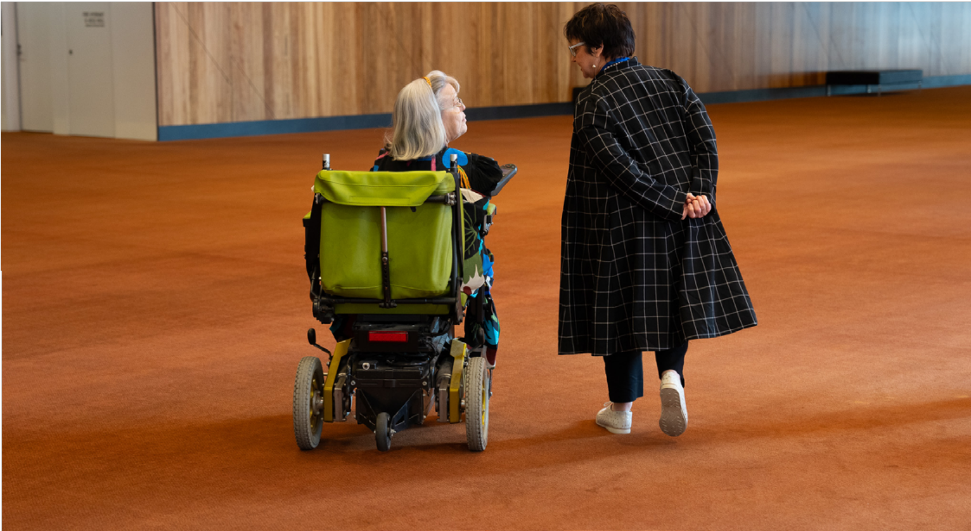

**FY 25-27**

Accessibility Action Plan

# Natalie O’Brien, Chief Executive of Melbourne Convention and Exhibition Trust.Statement of Intent

My name is Natalie O’Brien. I am the Chief Executive of the Melbourne Convention and Exhibition Trust (MCET). MCET operates Melbourne Convention and Exhibition Centre (MCEC). It will also run Nyaal Banyul Geelong Convention and Event Centre from 2026. I am pleased to share our first Accessibility Action Plan.

Our Accessibility Action Plan has four main goals that match our business strategy and the aims of the Victorian Disability Act 2006.

This plan will make both MCEC and Nyaal Banyul more welcoming to people with disabilities. It aims to tackle current obstacles. This will enable improved access and full participation. This is for customers, visitors, and employees.

In this plan, we’re looking at the challenges faced by people with all types of disabilities. These can be physical, cognitive, intellectual, or hidden. We want to make things easier for them. We’ll do this by improving our processes, systems, and surroundings. We’ll also tackle discriminatory attitudes and practices. We’re putting people with disabilities in all their diversity at the heart of our planning. We’re involving them so we can make better decisions.

As we put this plan into action, we see that we need to change the physical environment, attitudes, communication, and social settings. This is so that people with disabilities can fully participate in society like everyone else.

We’ll check the progress of our actions every quarter. An action in our first year is to establish an Accessibility Advisory Group and report to it regularly. MCET’s Annual Report and Impact Report will also include these updates.

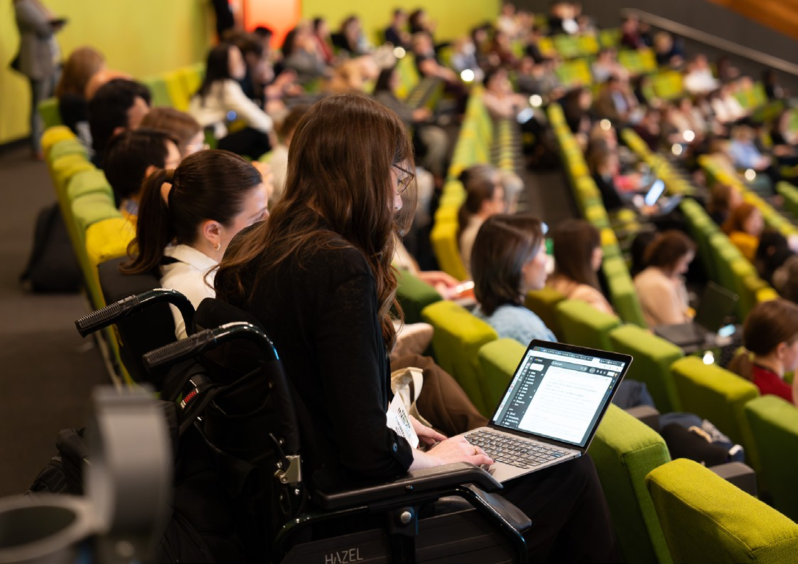

|  |  |  |  |  |
| --- | --- | --- | --- | --- |
| **Goal 1: Make it easier for people with disabilities to get and keep jobs** | | | | |
| **Action** | **Deliverable** | **Target or Measure** | **Responsibility** | **Timeline** |
| **1.1**  Use hiring methods that make it easier for people with disabilities to apply for and get jobs. | Find ways to help people apply for jobs more easily and increase their chances of being chosen. | Review all processes and find areas for improvement. | * People Support and Services | Ongoing |
| Speak well about hiring people with disabilities. Correct any wrong ideas. | Send updates to all employees every three months. | * Organisational Development * Advocacy, Impact and Reputation | Quarterly |
|  | Add a statement on the website and job advertisements, that  encourages applications from people with diverse backgrounds, including those with disabilities, to apply. | Add statement to MCEC and Nyaal Banyul websites. | * People Support and Services * Marketing | Ongoing |
|  | Provide job descriptions and all related materials on our hiring portal in Word format or accessible PDFs. | Every month, ensure that accessible versions of job descriptions are created. | * People Support and Services | Ongoing |

|  |  |  |  |  |
| --- | --- | --- | --- | --- |
| **Action** | **Deliverable** | **Target or Measure** | **Responsibility** | **Timeline** |
| **1.2**  Make it easier for people with  disabilities to start their careers. | Where possible help people with disabilities get work experience through community programs. | Talk to a community partner every six months. They can help to find job opportunities for  people with disabilities. | * People Support and Services * Customer Service | Ongoing |
| **1.3**  Help employees with disabilities at work. | Make sure there is a written process to review requests for flexible work. This process must go beyond Fair Work requirements. | Process is written down and approved. | * People Support and Services | FY 25 |
|  | A Healthy Day is available for all full-time and part-time employees to recharge, reset, and maintain their wellbeing. | Give permanent employees one day off per financial year. | * People Support and Services | Ongoing |
| **1.4**  Make sure all policies consider accessibility in design and implementation. | Make a checklist to check policies for accessibility.  Do this when they are approved or renewed. | Checklist made and approved. | * People Support and Services * Safety and Security * Policy owners | FY 25 |

|  |  |  |  |  |
| --- | --- | --- | --- | --- |
| **Action** | **Deliverable** | **Target or Measure** | **Responsibility** | **Timeline** |
| **1.5**  Give employees accessible information. | Check if MCEC’s internal website follows WCAG 2.2 standards.  Then, make a plan to fix any problems. Start with the most important ones. | Action Plan completed. Improvement Plan completed. | * Information and Communication Technology * Corporate Communications | Action Plan FY 25  Improve- ment Plan FY 26 |
|  | Set up a central place on MCEC’s internal website. Employees can find resources and help there. It’s all related to accessibility. | Central place created. | * Corporate Communications | FY 25 |

|  |  |  |  |  |
| --- | --- | --- | --- | --- |
| **Action** | **Deliverable** | **Target or Measure** | **Responsibility** | **Timeline** |
| **1.6**  Make employee office spaces easier to use for everyone. | Improve the signs, paths, and lighting. Do this in the main areas we have identified, where employees work behind the scenes. | Entirely finished. | * Infrastructure and Facilities | FY 27 |
|  | Look into adding toilets that are easy to use.  They are for people who can walk but may have mobility challenges. They would go in the level 3 office of the Melbourne  Exhibition Centre. | Completion depends  on whether the building design requirements make it possible. | * Infrastructure and Facilities | FY 27 |
|  | Any furniture changes should consider adjustable heights. They should also include backrests and armrests. | Review all purchases to make sure they meet accessibility guidelines. | * Infrastructure and Facilities | Ongoing |

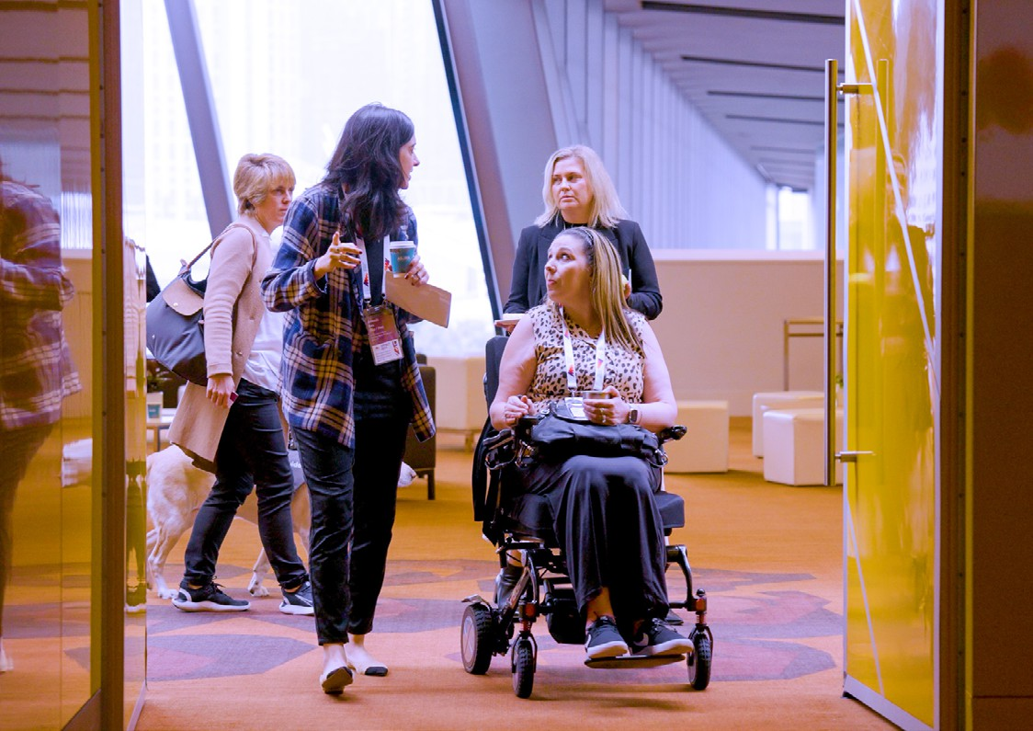

|  |  |  |  |  |
| --- | --- | --- | --- | --- |
| **Goal 2: Make it easier for people with disabilities to use the goods, services, and facilities at MCEC and Nyaal Banyul** | | | | |
| **Action** | **Deliverable** | **Target or Measure** | **Responsibility** | **Timeline** |
| **2.1**  Make sure Nyaal Banyul Geelong Convention and Event Centre is built to follow Universal Design. | Make sure the building design and  construction follow the newest accessibility recommendations. | Meets all requirements. | * Nyaal Banyul Project | FY 26 |
| **2.2**  Tell people about the accessibility features at the venues. These features help visitors and event attendees. | Create and share easy- to-read accessibility information on the MCEC website. Organise it by  different features to make it simple to find. | Put on the website. | * Infrastructure and Facilities * Marketing | FY 25 |
|  | Create and share easy- to-read accessibility information on the Nyaal Banyul website. Organise it by different features to make it easy to find. | Put on the website. | * Nyaal Banyul Project * Marketing | FY 27 |

|  |  |  |  |  |
| --- | --- | --- | --- | --- |
| **Action** | **Deliverable** | **Target or Measure** | **Responsibility** | **Timeline** |
|  | Mark on visitor maps where you can find power outlets to charge mobility devices. | Put on visitor maps. | * Marketing | FY 25 |
|  | Look into installing chargers for mobility aids at customer service desks. | Chargers purchased. | * Customer Service | FY 25 |
| **2.3**  Make sure that all marketing  materials and public information are easy to understand by everyone. | Keep the MCEC website in line with W3C Guidelines. | Any new parts we add to the website follow the guidelines. | * Marketing * Information and Communication Technology | Ongoing |
|  | Make sure Nyaal Banyul’s website is in line the W3C Guidelines. | Any new parts we add to the website follow the guidelines. | * Marketing * Information and Communication Technology | Ongoing |

|  |  |  |  |  |
| --- | --- | --- | --- | --- |
| **Action** | **Deliverable** | **Target or Measure** | **Responsibility** | **Timeline** |

|  |  |  |  |  |
| --- | --- | --- | --- | --- |
|  | Create guidelines for making all marketing materials easy  to use. This includes thinking about different ways people might need the information.  This can mean using different fonts, sizes, and colours. | Guidelines created and put into action. | * Marketing | FY 26 |
|  | Check all PDF marketing materials for accessibility. Do this before sending them out. | Full compliance achieved. | * Marketing | FY 27 |
|  | Add written captions to videos on social media and the website. | Full compliance achieved. | * Marketing | Ongoing |

|  |  |  |  |  |
| --- | --- | --- | --- | --- |
| **Action** | **Deliverable** | **Target or Measure** | **Responsibility** | **Timeline** |

|  |  |  |  |  |
| --- | --- | --- | --- | --- |
| **2.4**  Make the public toilets and other facilities at MCEC easier to use for everyone. | Install a Changing Places facility. | The facility is completed. | * Infrastructure and Facilities | FY 25 |
| Make toilets more accessible. Create a plan to add toilet lids, backrests, and clothing hooks. | We'll finish checking if it's possible. If it is, we'll go ahead with the upgrades. | * Infrastructure and Facilities | FY 27 |
| Look into adding more signs for ambulant toilets all around MCEC. | All toilets with signs. | * Infrastructure and Facilities | FY 27 |
| Check the mobile toilet cubicles in the Melbourne Exhibition Centre. Make sure they meet modern standards. | We'll finish checking if it's possible. If it is, we'll go ahead if approved. | * Infrastructure and Facilities | FY 27 |
| Look into adding bathrooms for people of any gender at MCEC. | We'll finish checking if it's possible. If it is, we'll go ahead if approved. | * Infrastructure and Facilities | FY 27 |

|  |  |  |  |  |
| --- | --- | --- | --- | --- |
| **Action** | **Deliverable** | **Target or Measure** | **Responsibility** | **Timeline** |

|  |  |  |  |  |
| --- | --- | --- | --- | --- |
| **2.5**  Make it easier for everyone to find their way around MCEC. | Look into a mobile option to help people find their way around MCEC. It should be easy for everyone to use. | We’ll check if it is possible to launch a mobile option to help people find their way around. If it is, we’ll go ahead if approved. | * Marketing | FY 26 |
| Show the important accessibility features of the venue on the MCEC maps. For example, show where you can charge motorised mobility aids. | Changes completed. | * Infrastructure and Facilities * Marketing | FY 26 |
| Check how people are using the hearing loops and use that information to improve the signs at MCEC. | User feedback completed. | * Information and Communication Technology * Customer Service * Marketing | FY 26 |
| Create a plan for how to help people find their way better in the long term, to ensure it's easy for everyone to use. | Decide whether to approve or reject the strategy exploration. | * Marketing * Infrastructure and Facilities | FY 27 |

|  |  |  |  |  |
| --- | --- | --- | --- | --- |
| **Action** | **Deliverable** | **Target or Measure** | **Responsibility** | **Timeline** |

|  |  |  |  |  |
| --- | --- | --- | --- | --- |
| **2.6**  Make safety features at MCEC easier to use for everyone. | Plan to install Tactile Ground Surface Indicators (TGSI). Put them in key areas of the Melbourne Exhibition Centre. | Half of the TGSI upgrade has been completed. | * Infrastructure and Facilities | FY 26 |
| Plan the installation of visual indicator strips on glass windows and doors. | We have installed all visual indicator strips. | * Infrastructure and Facilities | FY 27 |
| Look into adding 30% luminance contrast to solid colour doors. | Half of the luminance contrast has been completed. | * Infrastructure and Facilities | FY 27 |
| Make sure all furniture, fixtures, and equipment bought for public areas at MCEC are accessible. | Review all purchases to make sure they meet accessibility guidelines. | * Infrastructure and Facilities | Ongoing |

|  |  |  |  |  |
| --- | --- | --- | --- | --- |
| **Action** | **Deliverable** | **Target or Measure** | **Responsibility** | **Timeline** |

|  |  |  |  |  |
| --- | --- | --- | --- | --- |
| **2.7**  Make the ramps and doors at MCEC more accessible. | Consider buying more portable ramps and wheelchair risers for events. They are available to customers for free. | Purchase made, with free use for customers. | * Technology Services | FY 27 |
| Check that you can open all manual doors with no more than 2kg of force. | We’ll make adjustments to the doors that do not need to be replaced. | * Infrastructure and Facilities | FY 26 |
| **2.8**  Make customer service better for people with disabilities. | Starting the Hidden Disabilities Sunflower program. | Choose whether to go ahead with the program or not. | * Customer Service * Organisational Development | FY 25 |
| Think about and provide accessibility training for all team members and contractors who work directly with customers. If it’s a good idea, go ahead and do it. | Program suggested and approved. | * Organisational Development | FY 26 |

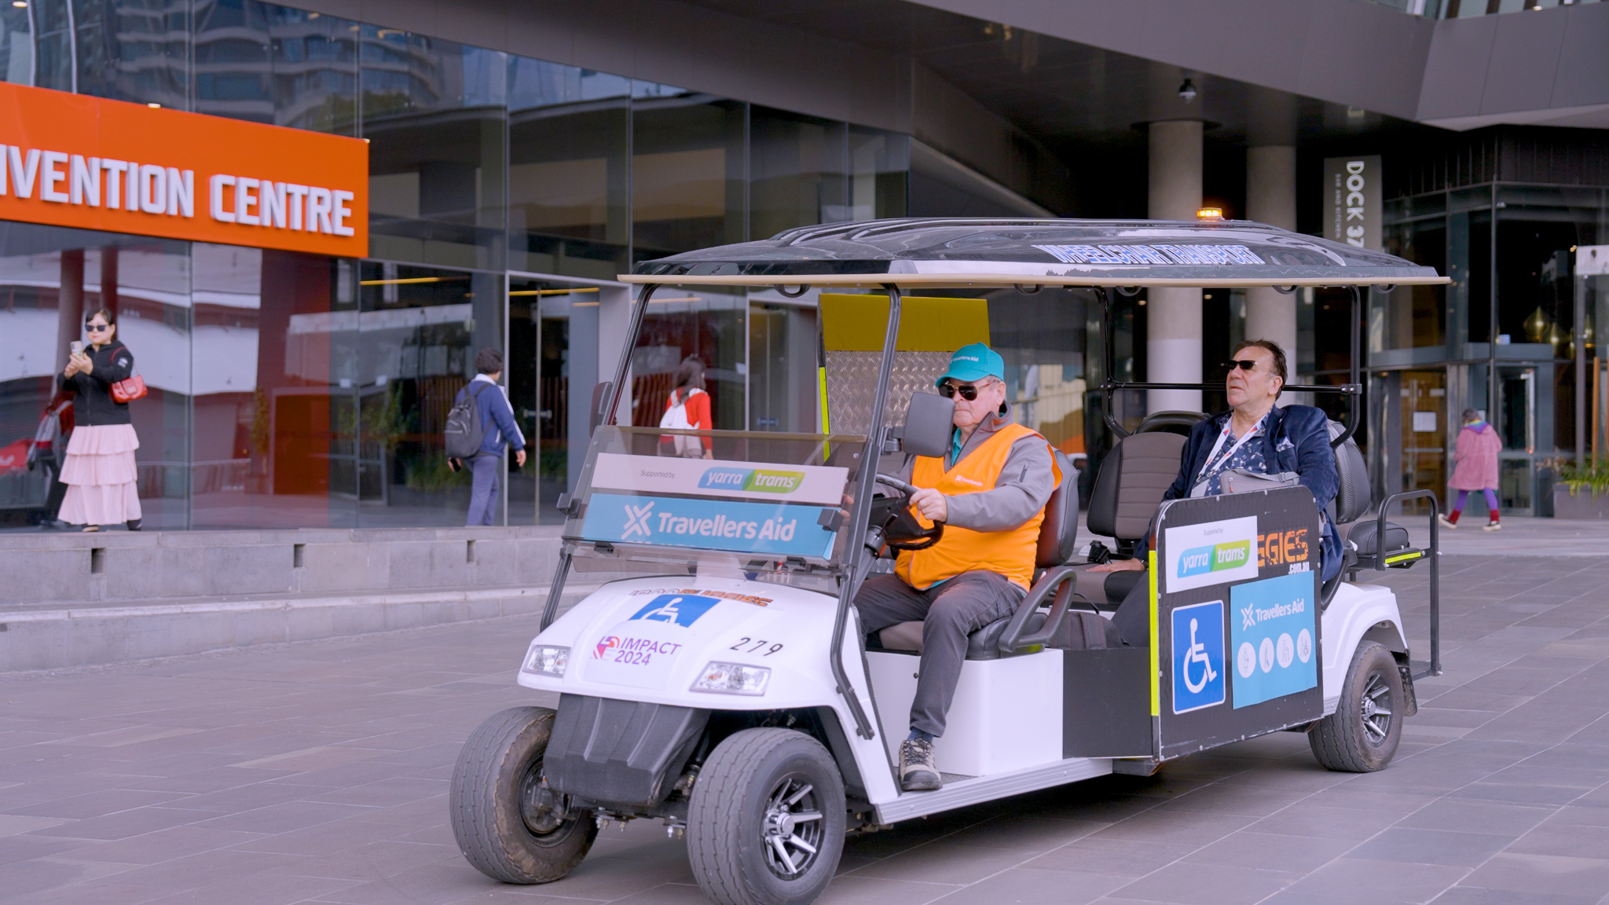

�

|  |  |  |  |  |
| --- | --- | --- | --- | --- |
| **Goal 3: Work with event organisers. The goal is to ensure people with disabilities can join and take part in events at MCEC or Nyaal Banyul** | | | | |
| **Action** | **Deliverable** | **Target or Measure** | **Responsibility** | **Timeline** |
| **3.1**  Encourage more people with disabilities to take part in events. | Tell event organisers about Travellers Aid services. | Include in Positive Impact Guide. | * Advocacy, Impact and Reputation | Ongoing |
| Encourage event organisers to use Alkira’s Independent Me program for volunteer opportunities. | Include in Positive Impact Guide. | * Advocacy, Impact and Reputation | Ongoing |
|  | Look into creating sensory spaces at MCEC. | We'll finish checking if it's possible. If it is, we'll go ahead if approved. | * Infrastructure and Facilities | FY 27 |

|  |  |  |  |  |
| --- | --- | --- | --- | --- |
| **Action** | **Deliverable** | **Target or Measure** | **Responsibility** | **Timeline** |

|  |  |  |  |  |
| --- | --- | --- | --- | --- |
| **3.2**  Help event organisers make their events accessible. | Revise the Accessible Features Guide. Add the new features  and make it match the current brand and accessibility policy. | Developed as a webpage. | * Infrastructure and Facilities * Marketing | FY 25 |
| Consider requiring event organisers to accept Companion Cards. They must do so according to MCEC's licence terms and conditions. | Suggestion based on advice about contract law. | * Advocacy, Impact and Reputation * Sales | July 2025 |
| Look into whether it's possible and if we can get them, provide sensory bags for event attendees. They can pick them up for free at the customer service desk. | Sensory bags approved and made available. | * Customer Service | FY 25 |
| Create a checklist for event organisers to make their events accessible. | Include in Positive Impact Guide. | * Advocacy, Impact and Reputation | July 2025 |

|  |  |  |  |  |
| --- | --- | --- | --- | --- |
| **Action** | **Deliverable** | **Target or Measure** | **Responsibility** | **Timeline** |

|  |  |  |  |  |
| --- | --- | --- | --- | --- |
|  | Create and advertise menus for events that are easy for everyone to use. | Use accessible menus for events at MCEC. | * Food and Beverage * Marketing | FY 25 |
|  | Sales proposals should guide customers to find accessibility information on the website. | Update proposals after adding the information to the website. | * Sales * Marketing | FY 25 |
|  | Find out the recommended heights for accessible tables, crockery, and utensils.  Then, check our inventory to see what we have and what we will need. | Find ways to make the delegate experience better. | * Food and Beverage * Set Ups | December 2024 |

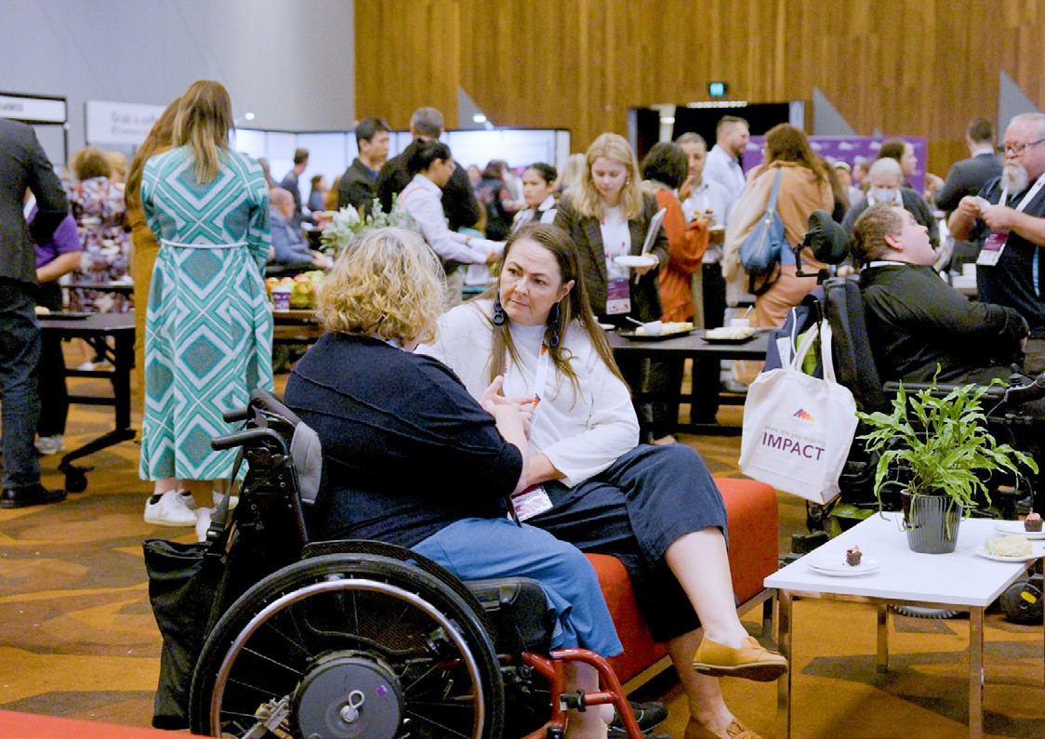

|  |  |  |  |  |
| --- | --- | --- | --- | --- |
| **Goal 4: To make real changes. It will change how employees, customers, and everyone else treat and includes people with disabilities** | | | | |
| **Action** | **Deliverable** | **Target or Measure** | **Responsibility** | **Timeline** |
| **4.1**  Ask employees questions to see how they feel about disabilities,  compared to before. | Consider making an accessibility survey for employees to take. | We have approved and added at least one question. | * Organisational Development | FY 25 and ongoing |
| **4.2**  Help the industry grow. | Sponsor the 2024 Accessible and Inclusive Tourism Conference. | $51,000 sponsorship support. | * Advocacy, Impact and Reputation | August 2024 |
|  | Get and advertise Accessible Tourism accreditation. | Accreditation | * Advocacy, Impact and Reputation | July 2025 |

|  |  |  |  |  |
| --- | --- | --- | --- | --- |
| **Action** | **Deliverable** | **Target or Measure** | **Responsibility** | **Timeline** |

|  |  |  |  |  |
| --- | --- | --- | --- | --- |
| **4.3**  Keeping track and being responsible. | Include a report on how well we're doing with the Accessibility Action Plan in the Annual Report.  Also, include it in the annual Impact Report. | Changes added to the final version. | * Advocacy, Impact and Reputation | Yearly |
|  | Tell people inside and outside MCEC why the Accessibility Action Plan is important. | Publish two articles each quarter about accessibility in our Backstage internal newsletter. Keep including accessibility as an important topic in our content. | * Advocacy, Impact and Reputation * Marketing | FY 24 and ongoing |
| **4.4**  Committees | Set up an outside group called the Accessibility Advisory Committee.  It includes people who have experienced disabilities. They’ll give us ongoing feedback. | Start in fiscal year 2025 and have one meeting. After that, we meet twice a year. | * Advocacy, Impact and Reputation | FY 25 |
|  | Look into creating or joining a network. It’s for MCEC employees with disabilities to connect. | Approved or rejected. | * Organisational Development | FY 25 |

# Evidence

About 15-20 percent of people in Australia and around the world have a disability. That’s a lot of people. They face barriers that make it hard for them to join in at work and in daily life, such as going to events.

We’re the team behind MCEC. It is known globally. We believe it’s our duty to set the standard for accessibility and inclusion. This affects more than just our local community in Victoria. It also affects visitors from abroad and our peers in the industry worldwide. Our venue in Melbourne already has many features for people with disabilities. But we know there’s room for improvement. Also, we’re excited about the chance to get things right from the start at our new venue, Nyaal Banyul in Geelong. As we plan, we’re making sure that Universal Design is a top priority in building the new venue. It is set to open in 2026.

We made this plan with the help of expert review. We also talked to people with lived experience with disability. They were both employees and a consultant. In early 2024, we asked Philip Chun Building Compliance to review the oldest part of our building. We asked them to find ways to make it more accessible. Their advice has guided the development of our Accessibility Action Plan.

The plan aligns with MCET’s main goals and key parts of the Disability Discrimination Act. The plan also aligns with the 2030 United Nations Sustainable Development Goals.

In 2023, we introduced the Positive Impact Guide, a new tool for event organisers using our venue. It offers advice on how to make events better. This includes information on MCEC’s accessibility features and services for people who attend events.

Some actions in this plan need funding or need changes to our building. We can only make these changes if they’re approved and funded.

**For more information about this Accessibility Action Plan, please contact:**

+61 3 9235 8000

[enquiries@mcec.com.au](mailto:enquiries@mcec.com.au) [www.mcec.com.au/our-impact](https://www.mcec.com.au/our-impact)

**Melbourne Convention and Exhibition Trust** (MCET) Acknowledges the Traditional Owners of the lands on which we operate, the peoples of the Kulin Nation. We pay our respect to them, their culture and their Elders, past and present.

**Our venues**

1006_July 2024



