

Accessibility Action Plan 2025 to 2028

**Easy English**

# How to use this plan

## Melbourne Convention and Exhibition Trust



or **MCET** wrote this plan.



When you see the words **“we”** or **“our”** or

**“us”**, it means **MCET**.

We wrote this plan in an easy to read way.

We use pictures to explain some ideas.

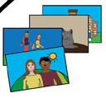

# Bold

Not Bold

This book has some hard words.

* Hard words are written in **bold**
* The words are thicker and darker.
* We will explain what the **bold** word means.

This plan is a short version of our full plan.

It has the most important ideas.

Our full plan has more pages and more words.

You can find our full plan on our website.

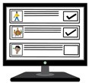

[**www.**](http://www/)

[www.mcec.com.au](https://www.mcec.com.au/our-impact/accessibility-action-plan)/our-impact/accessibility- action-plan

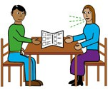You can ask someone to help you:

* read this plan
* know what this plan is about
* find more information.

# About this plan

My name is Natalie.

I am the boss of MCET.

We look after two **venues** in Victoria.

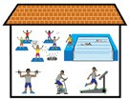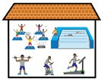

**Venues** are places where people meet and things happen.

The **venues** we look after are called:

## Melbourne Convention and Exhibition Centre or MCEC

A **Convention** is a big meeting where people talk about work or things they like.

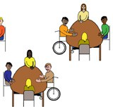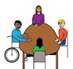

An **Exhibition** is a meeting where people show things like art, objects, or skills.

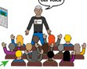

* 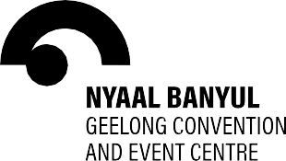**Nyaal Banyul** Geelong Convention and Event Centre or **Nyaal Banyul**

**Nyaal Banyul** is the name given to the venue by the **First Peoples** of Geelong.

**First Peoples** are the Aboriginal and Torres Strait Islander people.

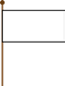

In Geelong, the name of the First Peoples are the **Wadawurrung**.

**Nyaal Banyul** are **Wadawurrung** words.

In English, this means ‘open your eyes to the hills’.

**Nyaal Banyul** is not open yet.

It will open in 2026.

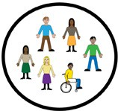I want to tell you about our **Accessibility Action Plan**.

**Accessibility** means to make things easier.

When you see the word ‘**plan**’ it means

## Accessibility Action Plan.

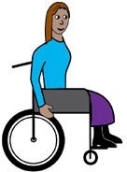The plan is about how we will make things better for

* visitors with disability
* staff with disability
* **community** with disability.

A **community** is a group of people who live near each other or like the same things.

The plan is from July 2025 to June 2028.

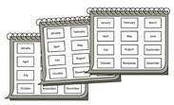

**2028**

**2025**

The plan has 4 goals.

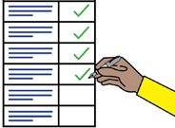

# Goal 1. Help people with disability to work with us

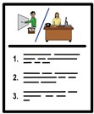We will make it easier for people with disability:

* to apply for and get a job with us
* to start a **career** with us.

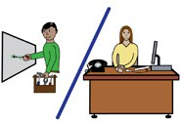A **career** means you stay in the same type of work. It can be one job or many jobs.

We will make sure staff with disability:

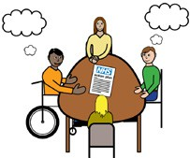

* have what they need to work
* can get information
* can use our office spaces easily.

We will make sure our **policies** can be used

by staff with disability.

**Policies** are plans that help people to decide important things.

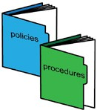

# Goal 2. Make it easier for people with disability to visit and use our venues

We will make sure people with disability:



* can safely use our spaces
* can easily get around our venues
* know how to use our venues
* can read our messages and ideas.

# Goal 3. Help event organisers to make it easier for people with disability to be at and join events

**Event organisers** are people who host events at our venues.

We can help people with disability when they visit us.

We will share guides on how to make events better for people with disability.

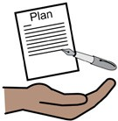

# Goal 4. Help to change the way people act and think about people with disability

We will do this by:

* asking staff how they feel about disability

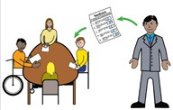

to see if it gets better over time

* helping the industry grow

An **industry** is a group of businesses that do the same thing.

* 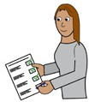keeping track of how we are doing
* 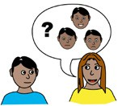sharing how we are doing
* asking people with disability to tell us what they think
* 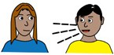helping staff with disability to talk and

meet with each other.

# How we will make sure this plan is working

Every three months we will check what we have done.

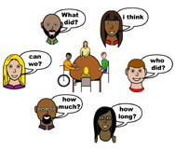Every year we will think about

* what we have done
* what we can do better.

We will put it into a report.

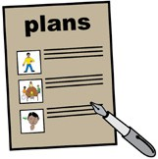

We will make an **advisory group** and tell them what we are doing.

An **advisory group** is a group of people who help a business on a topic.

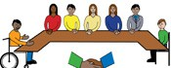

We will ask the **advisory group** what they think about the things we are doing.

# More information



For more information contact MCET.

Call +61 3 9235 8000

Website [www.mcec.com.au](http://www.mcec.com.au/)

[**www.**](http://www/)



Email [enquiries@mcec.com.au](mailto:enquiries@mcec.com.au)

Page 15

# If you need help to speak or listen

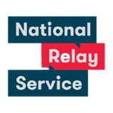

The National Relay Service can help you make a phone call.

Call 1800 555 660

Page 16

+61 3 9235 8000

[enquiries@mcec.com.au](mailto:enquiries@mcec.com.au) [www.mcec.com.au/our-impact](https://www.mcec.com.au/our-impact)

**Our venues**

1006_July 2024



