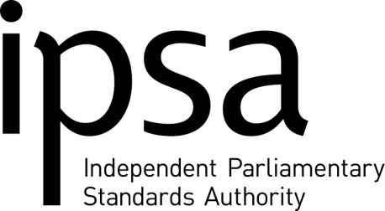

Register of Interests

Name: Will Lifford Date: 28/1/21

FINANCIAL INTERESTS
None

DIRECTORSHIPS AND SHAREHOLDINGS
Director, Yorkshire Community Property Services Limited

INVESTMENT PROPERTY
None

.
SPONSORSHIPS
None

PUBLIC APPOINTMENTS
Board Member, Charity Commission for England & Wales

CHARITIES AND NON-PUBLIC ORGANISATIONS
Board Member and Chair, Yorkshire Housing

ANY OTHER RELEVANT INTERESTS
None

RELEVANT INTERESTS OF SPOUSE, PARTNER OR CLOSE FAMILY MEMBER
None

DECLARATION

I confirm that the information that I have given is, to the best of my knowledge and belief, true and complete. I confirm that I understand the purpose of the form and the reasons for the collection of my personal data and that I agree to my personal data being used as stated.

Your name: Will Lifford

Your signature (please type if submitting an electronic application):
W L Lifford 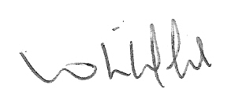

Date: 28 January 2021

This includes interests held by a board member that are directly relevant to his/her position within IPSA. It is not a list of all financial interests including all investments or loans held by a board member. It indicates where financial interests are held in a blind trust held independently from the owner so that a board member is shielded from involvement in their management.
Shareholdings are not listed where they are de minimis in nature
In line with the Registers of Interest in the Houses of Parliament, property owned and/or occupied by board members for their own use is not included in the list.

