Safe Travel Back to School (secondary)

Overview
This toolkit provides you with the latest travel information for you to share with parents and pupils ahead of the new school year.
It aims to encourage students, parents and guardians to think about their options and plan ahead for the new term, including promotion of new, low bus fares across Greater Manchester.
Contents
This toolkit includes:
- Social media content (assets are attached to the email you received)
- Newsletter content - aimed at students and parents
- Web copy for your website – also aimed at students and parents
We also have a dedicated webpage for the return to school at tfgm.com/schools, with tailored travel advice pages for every secondary school in GM.
More information about new, simple and low bus fares can be found at tfgm.com/get-on-board.
Please also consider sharing content from TfGM social media accounts:
- Twitter: @OfficialTfGM
- Facebook page: facebook.com/OfficialTfGM
- Metrolink Twitter: @MCRMetrolink
To note: Important information regarding future changes to school bus services
Please note that moving forwards, in accordance with new regulations, TfGM will only be able to make short notice changes to school bus services under exceptional circumstances.
While we have tried to work closely with schools early in the planning process to identify potential reasons for any change to schools bus services in the subsequent academic year, in some instances it only becomes apparent changes may be needed after these services have started running. In these instances, we have previously worked with schools and operators to make necessary changes during the first few weeks of term.
Due to the new regulations, we will be limited to only making these types of changes in exceptional services and are therefore reminding schools of the importance of keeping TfGM informed around any considerations which may impact the scheduled school bus services as early as possible.
SOCIAL MEDIA CONTENT
Please feel free to use whichever image you find most suitable for each post. If you experience any issues with the supplied creatives, please email Engagement@tfgm.com
You can download the images via: https://tfgm.sharefile.com/d-s4b85dafff8744b3892563ef0c6bb47c6
Platform | Draft posts | Suggested image(s)
Twitter | Travelling to us in the new term? #GetOnBoard with new low bus fares!  From September 4, a child’s bus fare in Greater Manchester will be capped to £1 for a single, or £2.50 for an AnyBus travelcard!  Check @OfficialTfGM for more tips 👉 tfgm.com/schools  #BackToSchool | 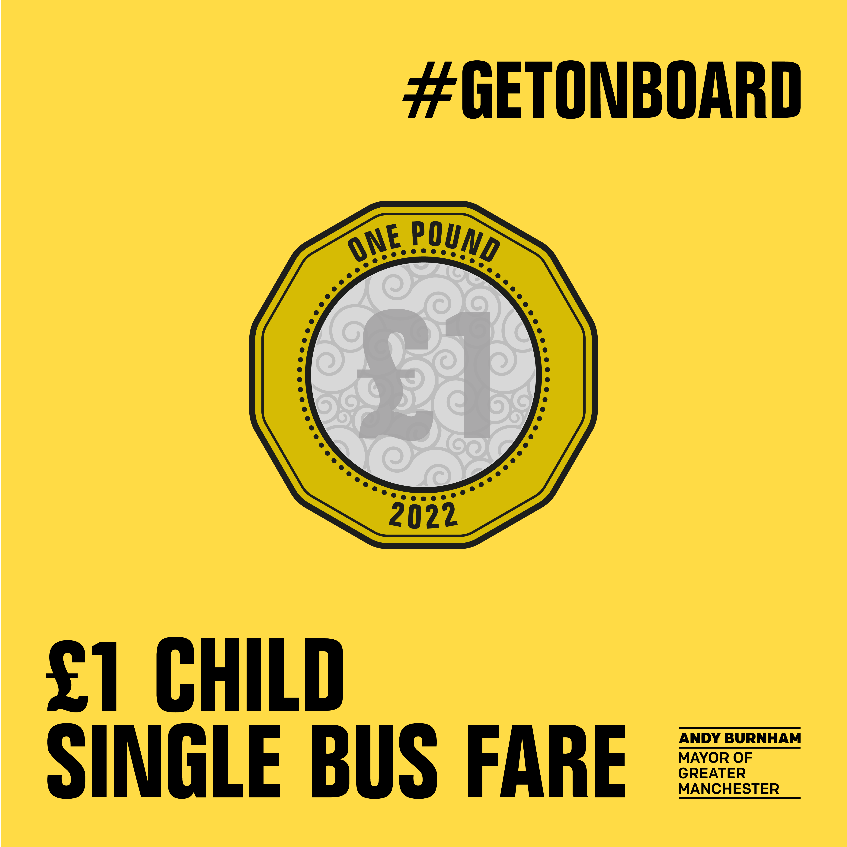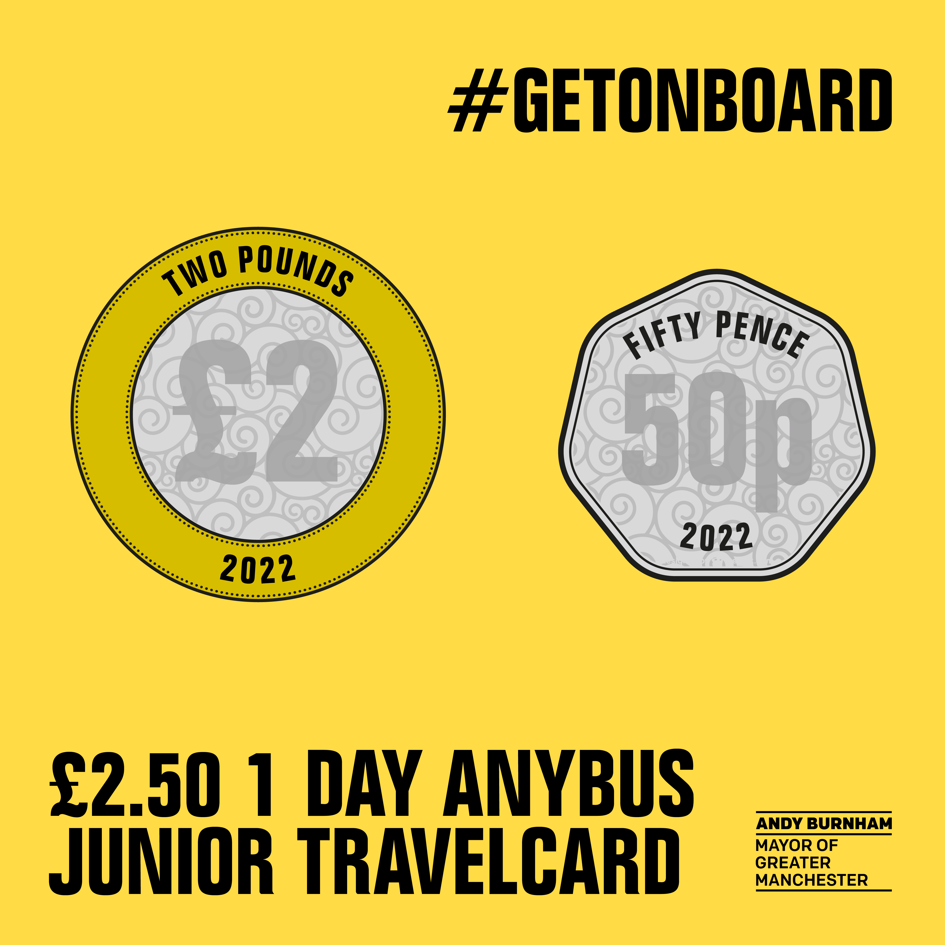
Twitter | New term, new you?  September is a great opportunity to start afresh and try something new! Why not consider cycling or walking to our school if it’s a short journey? 🚲 🚶‍  Check @OfficialTfGM advice: tfgm.com/schools  #BackToSchool #BeeActive | 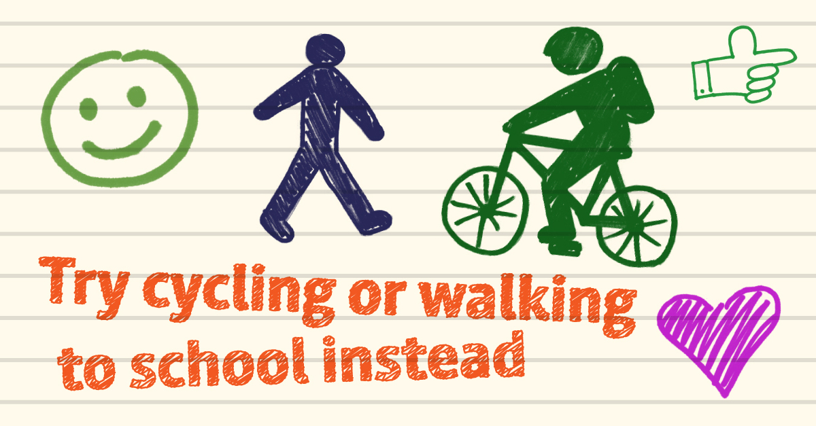
Twitter | If your child uses public transport to get to us, please make sure:  ✅They’ve got their igo card from @OfficialTfGM  ✅They plan ahead & check timetables before travelling  Find dedicated travel advice for our school via: tfgm.com/schools  #BacktoSchool | 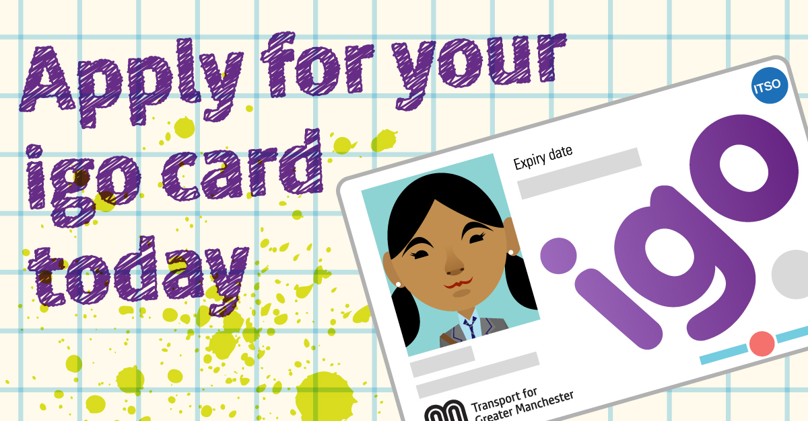  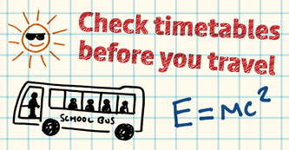
Facebook | From September 4, a child’s bus fares in Greater Manchester will be capped at £1 for a single journey and £2.50 for a 1 day AnyBus travelcard!  Before you #GetOnBoard, there are a few things you can do to plan ahead:  ✅Check timetables before travelling, they may have changed over the Summer  ✅Ensure they have their igo card  More handy travel tips, including dedicated journey advice for our school is available via 👉 tfgm.com/schools  #BackToSchool
Facebook | New term, new you?  September is a great opportunity to start afresh and try something new! Why not consider cycling or walking to our school if it’s a short journey? 🚲 🚶  For parents who have to drive students to and from our school, please switch off your engine when waiting outside and consider parking further away and walking the last part of your journey🚗  Check @OfficialTfGM advice: tfgm.com/schools  #BackToSchool #BeeActive | 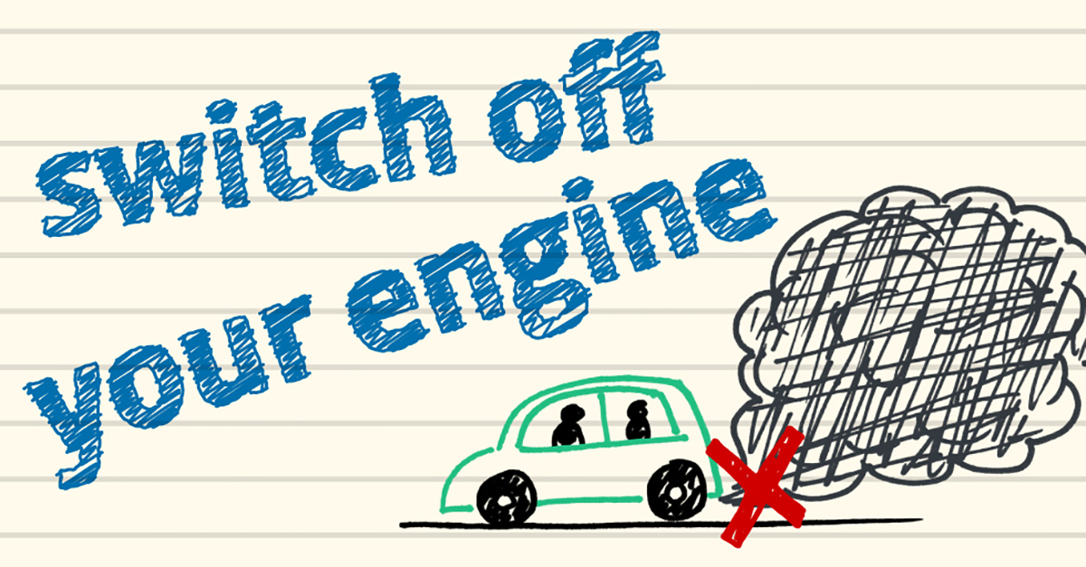

SECONDARY SCHOOL PARENTS’ EMAIL/NEWSLETTER COPY
Consider your travel options ahead of a new school year
A new school year is a great opportunity to start afresh and try something new and this year is no different – particularly when it comes to the journey to and from our school.
From September 4, the cost of child’s bus fare in Greater Manchester will be capped at £1 for a single journey and £2.50 for an 1-day AnyBus travelcard. With this in mind, if they don’t already, why not consider talking to your child about catching the bus to school?
There are a couple of things you can do to plan ahead, including ensuring they have their igo card.
With new cycling and walking routes popping up all the time, your child may also wish to consider getting here by foot or bike - it safer and easier than ever to do so! This can be a great, healthy way to start your day – particularly for shorter trips.
If you do need to drive, please switch off your engine when waiting outside to reduce air pollution and, if possible, try parking further away and walking the last part of the journey.
However, you chose to travel, it’s important to plan ahead and check the latest travel advice. Support and information about this can be found on TfGM’s Schools Hub, including dedicated advice for our school.
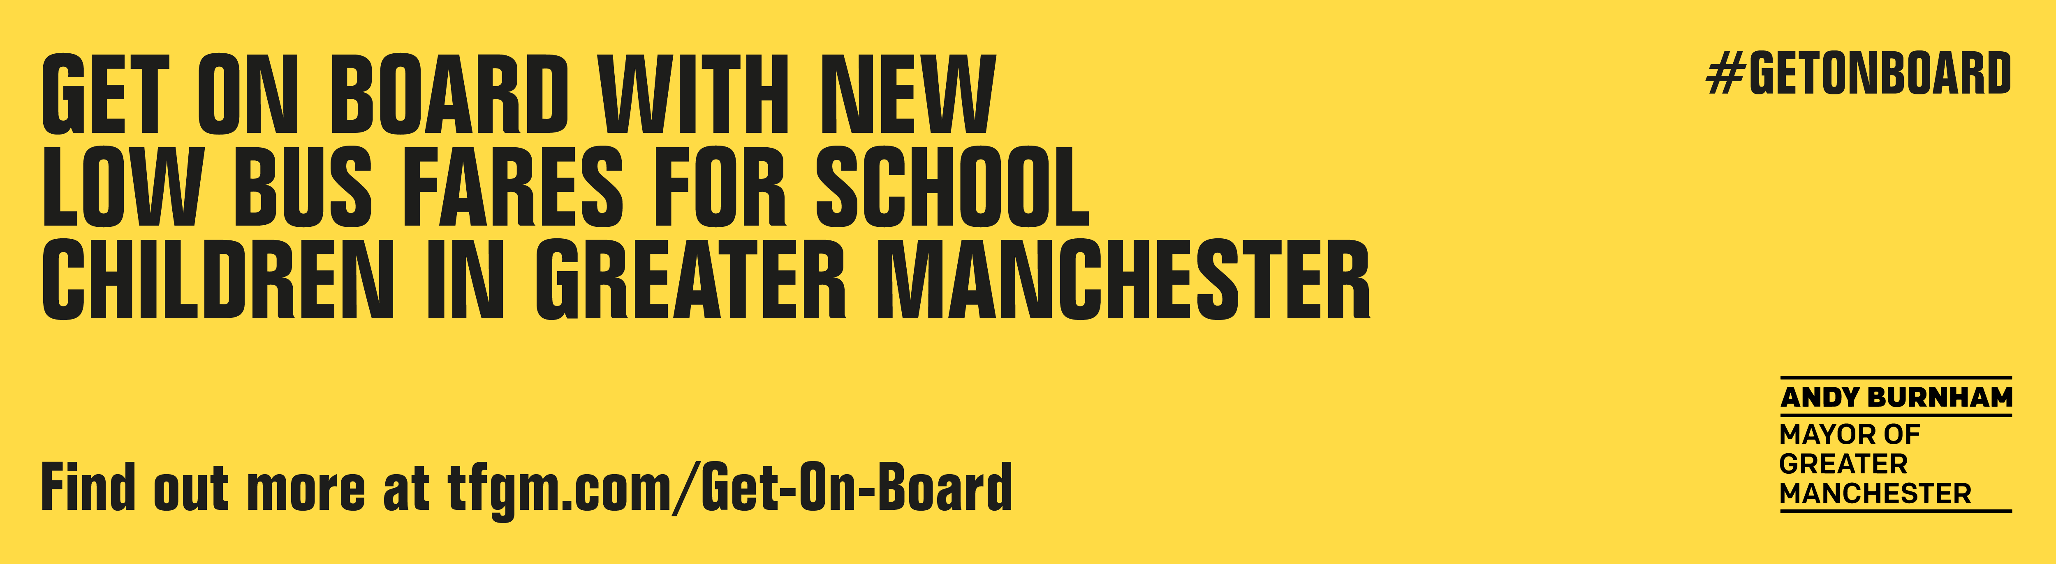
SECONDARY SCHOOL WEBSITE COPY (FOR PARENTS AND STUDENTS)
Before travelling to and from school it is important to plan-ahead and consider different options.
Transport for Greater Manchester has a dedicated School’s Hub, with information about public transport services, tickets and passes, latest dedicated travel advice for our school and tips around cycling and walking.
If you can, please consider whether your child can walk or cycle to school – it can be a safe and healthy way to make shorter trips. With new cycling and walking routes popping up across the region, it is safer and easier than ever to get about on foot or by bike.
If you do need to drive, please switch off your engine when waiting outside to reduce air pollution and, if possible, try parking further away and walking the last part of the journey.

