Travel Advice for Company Websites

Travel advice is a vital part of any company’s website. However, it also a fantastic opportunity to influence visitors’ travel decisions.
TfGM would advise that the most sustainable methods of transport should be highlighted first, with the least sustainable last. We would therefore recommend the following hierarchy of services:
- Walking
- Cycling
- Bus
- Metrolink
- Train
- Taxi
- Car
- Air [only for larger organisations]

Top Tips
- Visitor information should be easy to reach from the homepage, with clear and helpful information.
- Information should be kept up-to-date with at least an annual review of the information.
- Maps or videos of a walking/cycling route are particularly helpful and should be included where possible. Best practice examples are included at the end of this document.

Listed below is a suggestion of what should be included in each section.

- Walking
Encouraging regular walking can help a person’s physical health, mental wellbeing and is good for the environment. Walking one mile in 20 minutes burns 100 calories, and done once a day can add seven years to our life.
Advice should include time and distance from major points of interest; such as transport interchanges as well as the closest train station, Metrolink stop and bus stop.
For example:
Point of interest | Distance from TfGM office | Time to walk to TfGM office
Piccadilly Train Station | 100 metres | 2 minutes
Victoria Train Station | 750 metres | 10 minutes
Oxford Road Train Station | 1km | 15 minutes
Piccadilly Station Metrolink | 100 metres | 2 minutes
Piccadilly Gardens Metrolink | 300 metres | 5 minutes
Market Street Metrolink | 400 metres | 6 minutes
Piccadilly Gardens Bus Stop | 400 metres | 6 minutes

Include relevant links, such as:
Walkit http://walkit.com/cities/manchester/

2. Cycling
Cycling helps people become fitter, healthier and more motivated. Just one minute of cycling burns five calories and reduces high blood pressure.
Information for cyclists should include information on the closest cycling parking, their location and the number of spaces available.
If cycling parking is available at the organisation, explain if parking is free to use or if they need to complete any relevant forms.

Include relevant links, such as:
TfGM Cycle Maps https://www.tfgm.com/cycling/plan-a-journey
Cycle Streets https://manchester.cyclestreets.net/journey/
Sustrans www.sustrans.org.uk

3. Bus
Buses are an affordable and convenient way to travel. Many modern buses have free wi-fi, perfect for business travel and commuting. Some routes also feature separate bus lanes with traffic light priority.
When outlining bus information, clearly define the nearest bus stops to the organisation and include a map showing where these services arrive/depart from.
Advise which services cater for the organisation, and where they begin/end.
If a limited number of services cater for the site, consider linking the specific service’s timetable.
For businesses in Manchester city centre, Bolton and Stockport it may be appropriate to include information on free Metroshuttle services.

Include relevant links, such as:
TfGM Journey Planner https://my.tfgm.com/#/planner/
Stagecoach www.stagecoachbus.com
First Bus www.firstgroup.com/greater-manchester
Arriva www.arrivabus.co.uk
Metroshuttle www.tfgm.com/public-transport/bus/metroshuttle
A full list of bus operators is available at: www.tfgm.com/public-transport/bus/contact

4. Metrolink
Metrolink provides a fast and easy alternative to travelling by car, with no need to worry about where to park at the end of your journey.
Metrolink is the UK’s largest light rail network with 93 stops across seven lines.
Details should include which stops and lines cater for the organisation and the frequency of the service, i.e. every six minutes.
Free park and ride facilities are also available at a number of stations.

Include relevant links, such as:
Metrolink page on TfGM https://tfgm.com/public-transport/tram
Metrolink network map https://tfgm.com/public-transport/tram/network-map
Get me there app www.getmethere.com
Park and ride www.tfgm.com/public-transport/park-and-ride
TfGM Journey Planner https://my.tfgm.com/#/planner/

5. Train
Greater Manchester has 97 rail stations, offering more than 70 direct connections to major cities and towns across the country.
Details should include the nearest station the subsequent route to the business.
City centre businesses should include advice on how to travel from the three main Manchester stations; Piccadilly, Oxford Road and Victoria.
Free park and ride facilities are also available at a number of stations.

Include relevant links, such as:
Northern www.northernrailway.co.uk
Arriva Trains Wales www.arrivatrainswales.co.uk
CrossCountry www.crosscountrytrains.co.uk
East Midlands Trains www.eastmidlandstrains.co.uk
TransPennine Express www.tpexpress.co.uk
Virgin Trains www.virgintrains.co.uk
Park and ride www.tfgm.com/public-transport/park-and-ride
TfGM Journey Planner https://my.tfgm.com/#/planner/

6. Taxi
For taxis, include a phone number of reliable local companies. Check if the business has a relationship with one particular provider, and if so, be sure to include their details.

7. Car
Encourage people that they should use public transport where possible, and if they must use a car, to try and car share.
When advising of car parking locations, include postcodes so that people can enter it into their satnav, the number of spaces, price and the distance from the organisation.
If possible, try to include interactive map identifying the car parking locations.

Recommended best practice websites
Football Club United of Manchester www.fc-utd.co.uk/travel_hub.php
MediaCityUK http://travel.mediacityuk.co.uk
Example map
The below map created by FC United is a fantastic example of best practice. It includes clear information on walking routes from metrolink and rail stops with the expected time and distance.
It is also highlights bus stops, which services stop there and the company which runs them.
www.plotaroute.com is a recommended website for creating a map.
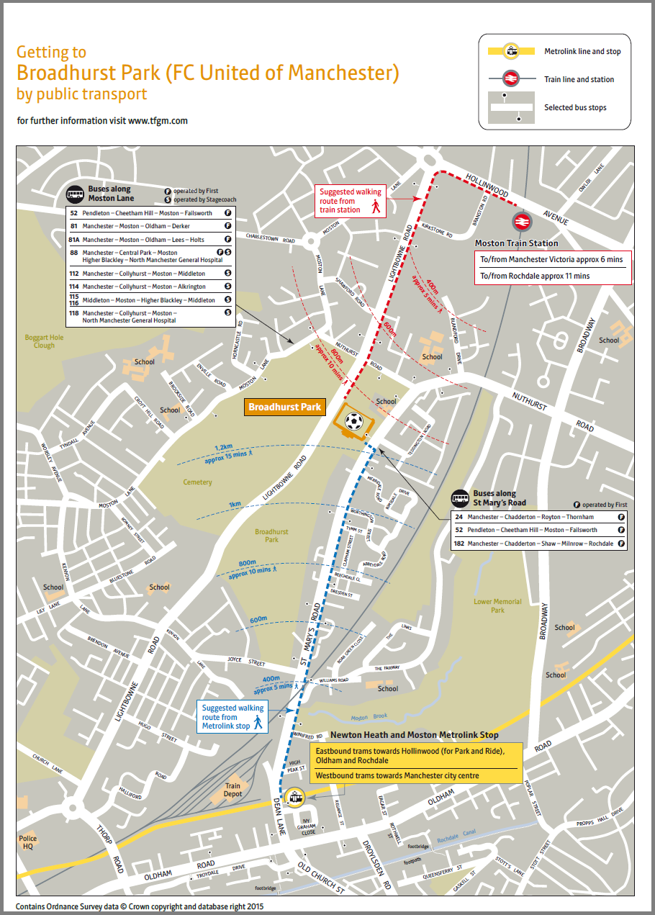

Example video
HOME, a centre for international contemporary art, theatre and film in Manchester, produced two handy videos guiding users on the route from the closest Metrolink and train stations.

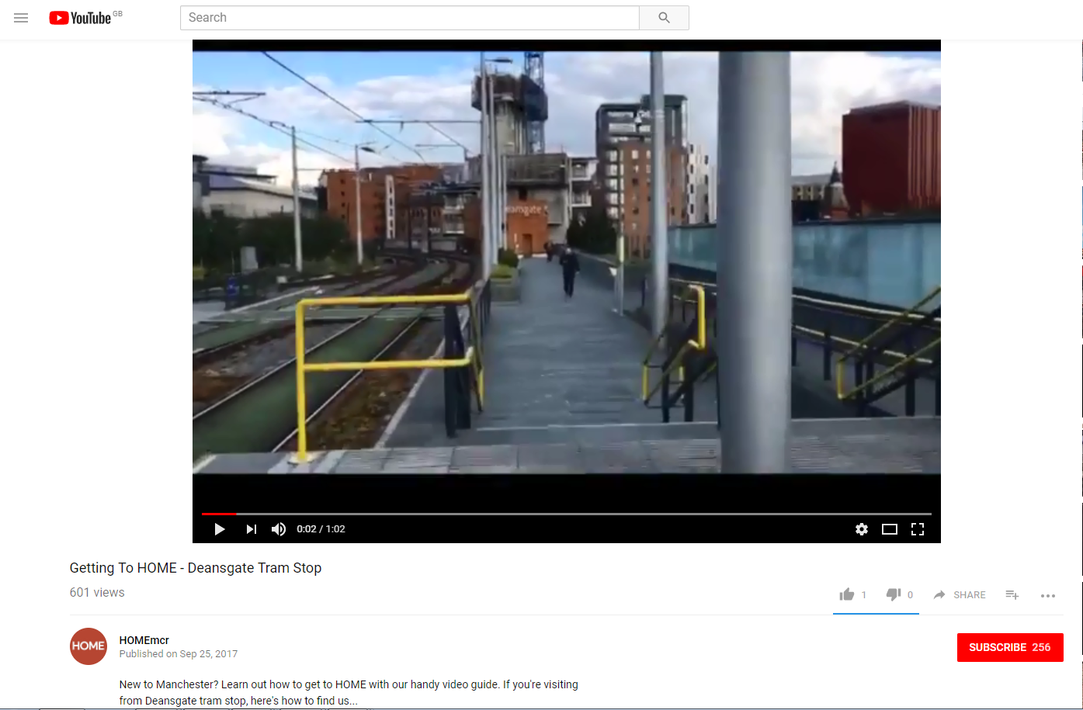

Example car park map

