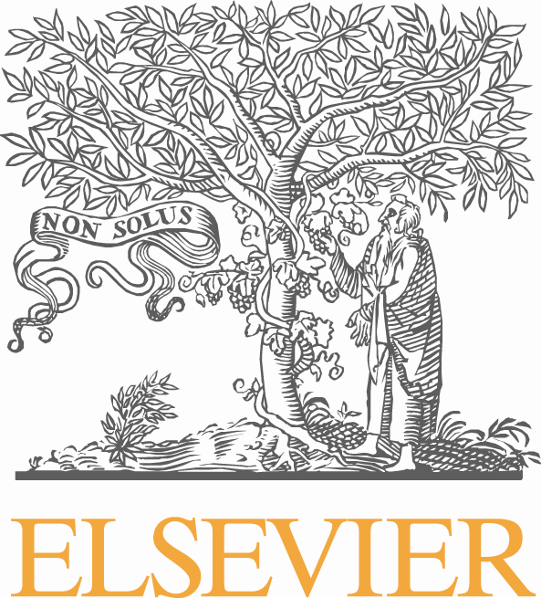

Elsevier Books Guidelines for Invoicing

Invoicing Standards for the US and UK
Elsevier Books

Contact details in the USA and the UK:
Quality Assurance Mailbox
Tel: + (1) 573-417-3062
Email: c.blauvelt@elsevier.com

Updated: December 2025

Elsevier Books Guidelines for Invoicing

- Every invoice must contain an identifying author name
- Every Invoice must contain our 13-digit ISBN
- Every invoice must contain a Purchase Order #
- Every invoice must contain the Print Specialist contact’s name
- All invoices must contain specific paper brand basis weight and PPI
- In addition, we require some internal coding for our Accounting Department called Expenditure Type. This coding aids the team in moving invoices to the allocated budget swiftly for payment approval. There are only two codes that would be pertinent for print books, and must be included somewhere on the invoice to note the expenditure type.

- 701 – Paper - Only used for Paper that is supplied by Elsevier.

- 801 - Printing Binding, & Plates - For all charges on a print project including (Prepress, Plates, Press MR and Run, Binding MR and Run, Shrink-wrapping, cartoning, labeling and vendor supplied paper.

While this information can be included anywhere on the invoice, we recommend this format for quick reference:

Author: Smith
ISBN: 9780000000000
Purchase Order #: PT1000345 (example)
Print Specialist: Joshua Watts (example)
Expenditure Type: 801-Printing, Binding & Plates
Contact: Josh Watts j.watts.1@elsevier.com

