Elsevier Trademarks

June 2023

Elsevier Trademarks
Elsevier and its affiliates own the below registered trademarks.
Please note, this list is not intended to be comprehensive of Elsevier’s trademarks or intellectual property rights, and the absence of a mark from this list does not waive Elsevier’s rights.
Third-party use of Elsevier trademarks may require a written license, such as when used:
- in a stylized or logo form
- to suggest an affiliation or endorsement
- as the most prominent brand in your content.
All third-party use must comply with applicable law and include an applicable ownership notice, for example: “ELSEVIER is a registered trademark of Elsevier BV.”

A1 | Mark
A
ABREGES M | 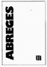
ABREGES VETERINAIRES
ACADEMIC PRESS | WORD MARK
ACADEMIC PRESS
ACADEMIC PRESS
ACADEMIC PRESS
ACRES | WORD MARK
ACTUALITES PHARMACEUTIQUES MENSUEL DE FORMATION PHARMACEUTIQUE CONTINUE
ADVANCES IN ANESTHESIA | WORD MARK
ADVANCES IN PEDIATRICS | WORD MARK
ADVANCES IN SURGERY | WORD MARK
AJO | WORD MARK
AKOS | WORD MARK
AKOS ENCYCLOPEDIE PRATIQUE DE MEDECINE
ALCHEMY

A2 | Mark
AMERICAN JOURNAL OF OPHTHALMOLOGY | WORD MARK
AMIRSYS | WORD MARK
AMIRSYS
ANALYTICA CHIMICA ACTA | WORD MARK
ANALYTICAL BIOCHEMISTRY | WORD MARK
ANATOMYONE | WORD MARK
ANNALES DE CHIRURGIE PLASTIQUE ESTHETIQUE
ANNALES DE DERMATOLOGIE ET DE VENEREOLOGIE
ANNALES DE PATHOLOGIE ANNALES D'ANATOMIE PATHOLOGIE | 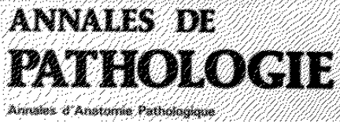
ANNALES PHARMACEUTIQUES FRANCAISES | WORD MARK
ANNUAL REPORTS IN MEDICINAL CHEMISTRY | WORD MARK
ANUARIO DOYMA | WORD MARK
AP ACADEMIC PRESS
ARCHIVES DES MALADIES DU COEUR ET DES VAISSEAUX

A3 | Mark
ARCHIVES DES MALADIES DU COEUR ET DES VAISSEAUX PRATIQUES SOCIETE FRANCAISE DE CARDIOLOGIE
ARCHIVES DES MALADIES PROFESSIONNELLES ET DE L'ENVIRONNEMENT
AREZZO | WORD MARK
AREZZO PATHWAYS | WORD MARK
ARIES SYSTEMS
ARIES SYSTEMS
ARTICLECHOICE | WORD MARK
ATENCION PRIMARIA | WORD MARK
ATENCION PRIMARIA BASADA EN LA EVIDENCIA | WORD MARK

B | Mark
BIOCHEMICAL PHARMACOLOGY | WORD MARK
BODY SPECTRUM | WORD MARK
BRAIN RESEARCH | WORD MARK

C1 | Mark
C.C. CARDIOLOGIA CLINICA | WORD MARK
CAHIERS DE L'INFIRMIERE
CAHIERS DES SCIENCES INFIRMIERES
CALCUMED | WORD MARK
CALCUVAC | WORD MARK
CAMPUS NO CAMPUS
CARDIOLOGIE DU PRATICIEN M | 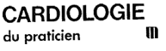
CARDIO-MAIL | WORD MARK
CASOS MEDICINA CLINICA | WORD MARK
CELL | WORD MARK
CELL
CELL PRESS | WORD MARK
CELL PRESS
CG CUADERNOS DE GESTION | WORD MARK
CHEMEFFECT | WORD MARK
CHEMTIVA | WORD MARK
CHIMICA | WORD MARK
CHURCHILL LIVINGSTONE | WORD MARK

C2 | Mark
CIRUGÍA. CASOS CLÍNICOS | WORD MARK
CLÍNICA E INVESTIGACIÓN EN DIABETES | WORD MARK
CLINICA E INVESTIGACIÓN EN HIPERTENSIÓN | WORD MARK
CLINICA E INVESTIGACION EN HTA | WORD MARK
CLINICAL KEY | WORD MARK
CLINICAL SUPPORT TODAY (Japanese Kanji, Hiragana, and Katakana) | 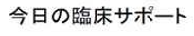
CLINICALKEY | WORD MARK
CLINICALKEY (Chinese simplified characters) | WORD MARK
CLINICS AND RESEARCH IN HEPATOLOGY AND GASTROENTEROLOGY | WORD MARK
COMPENDEX | WORD MARK
CONIFER | WORD MARK
COPDdirekt | WORD MARK
CORDIAL MAG | 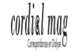
CORE JOURNALS IN | WORD MARK
CUADERNOS DE GESTION PARA EL PROFESIONAL DE ATENCION PRIMARIA | WORD MARK
CURRENT BIOLOGY | WORD MARK
CURRENT PROBLEMS | WORD MARK
CURRENT PROBLEMS IN CANCER | WORD MARK
CURRENT PROBLEMS IN CARDIOLOGY | WORD MARK

C3 | Mark
CURRENT PROBLEMS IN DIAGNOSTIC RADIOLOGY | WORD MARK
CURRENT PROBLEMS IN SURGERY | WORD MARK

D | Mark
D.C. DERMATOLOGIA CLINICA | WORD MARK
DAITO & Chinese characters
DAITO (Chinese characters)
DENTAL ABSTRACTS | WORD MARK
DERMATOLOGIE DU PRATICIEN M | 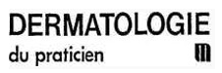
DEVELOPMENTAL BIOLOGY | WORD MARK
DIABETE & METABOLISME
DIARIO CONGRESOS FARMACEUTICOS | WORD MARK
DIGITAL COMMONS | WORD MARK
DIGITAL COMMONS
DISEASE-A-MONTH | WORD MARK
DISEASEFX | WORD MARK
DOLOMAIL | WORD MARK
DORLAND'S | WORD MARK
DOULEURS EVALUATION DIAGNOSTIC TRAITEMENT
DOYMA | WORD MARK
DOYMA, SCIENTIFIC MEDICAL COMMUNICATIONS | WORD MARK

E1 | Mark
E.C. ENFERMERIA CLINICA | WORD MARK
EDICIONES DOYMA | WORD MARK
EDITORA CAMPUS | WORD MARK
EDITORA CAMPUS
EDITORIAL MANAGER | WORD MARK
EDUCACION MEDICA | WORD MARK
e-ECN | WORD MARK
ELSA | WORD MARK
ELSEVIER | WORD MARK
ELSEVIER
ELSEVIER
ELSEVIER (chinese characters) | 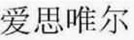
ELSEVIER FINGERPRINT ENGINE | WORD MARK
ELSEVIER NON SOLO & design
ELSEVIER REVIEW | WORD MARK
EM CONSULTE | WORD MARK
EM PREMIUM | WORD MARK
EM SELECT | WORD MARK
EMBASE | WORD MARK

E2 | Mark
EMBIOLOGY | WORD MARK
EMC | WORD MARK
EMC
EMC ENCYCLOPEDIE MEDICO CHIRURGICALE | 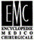
EMJ EUROPEAN MEDICAL JOURNAL M
EMMET | WORD MARK
EMPOWERING KNOWLEDGE | WORD MARK
EMTREE | WORD MARK
ENCUENTROS FMC | WORD MARK
ENFERMERIA CLINICA | WORD MARK
ENGINEERING VILLAGE | WORD MARK
ENHANCING THE POWER OF KNOWLEDGE | WORD MARK
ENTELLECT | WORD MARK
ES NEUROPSYCHIATRIE DE L'ENFANCE ET DE L'ADOLESCENCE | 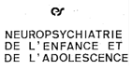
ETHIQUE & SANTE
ETICOM ETIM | WORD MARK
EVISE | WORD MARK
EVISE

E3 | Mark
EVISE (English and simplified Chinese characters)
E-VOLUTION
EVOLVE | WORD MARK
EXPERTDDX | WORD MARK
EXPERTPATH | WORD MARK
EXPRESSO | WORD MARK

F | Mark
FARMACIA PROFESIONAL | WORD MARK
FARRERAS - ROZMAN | WORD MARK
FEUILLETS DE RADIOLOGIE M | 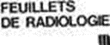
FINGERPRINT | WORD MARK
FISTERRA LA REVISTA DE PRACTICA CLINICA | WORD MARK
FISTERRAE | WORD MARK
FMC | WORD MARK
FMC-FORMACION MEDICA CONTINUADA. | WORD MARK

G | Mark
G.C. GERIATRIA CLINICA | WORD MARK
GASTROENTEROLOGIE CLINIQUE ET BIOLOGIQUE
GASTROENTEROLOGIE CLINIQUE ET BIOLOGIQUE HEPATOX
GASTRO-ENTEROLOGIE DU PRATICIEN M
GENE | WORD MARK
GEOBASE | WORD MARK
GEOBIOS PALEONTOLOGIE, STRATIGRAPHIE, PALEOECOLOGIE | 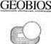
GERIATRIC NURSING | WORD MARK
GERONTOLOGIE DU PRATICIEN M
GOLD JOURNAL | WORD MARK
GUÍA DOCENTE EN... | WORD MARK
GUIDE AS
GUIDES DE THERAPEUTIQUE M | 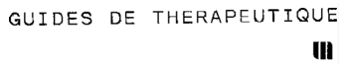
GUNNER GOGGLES | WORD MARK
GYNECOLOGIE OBSTETRIQUE DU PRATICIEN M

H | Mark
HEALTHPULSE | WORD MARK
HEART & LUNG | WORD MARK
HELIYON | WORD MARK
HESI | WORD MARK
HIVEBENCH | WORD MARK

I | Mark
IMAGERIE DE LA FEMME | 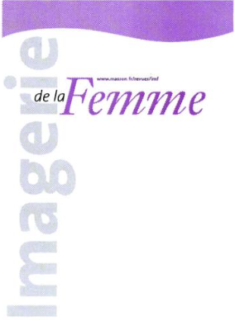
IMAGERIE DE LA FEMME | 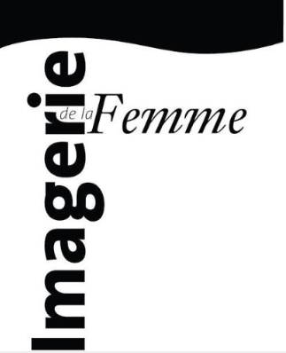
IMMUNOQUERY | WORD MARK
INORDER | WORD MARK
INSPIRING CHEMISTRY | WORD MARK
INTELLIGENT PHARMACEUTICAL PLATFORM (Chinese characters)
INTER BLOC | WORD MARK
INTERFOLIO | WORD MARK
iPRC | WORD MARK

J | Mark
JANO | WORD MARK
JANO MEDICINA | WORD MARK
JANO MEDICINA Y HUMANIDADES | WORD MARK
JNP JOURNAL FOR NURSE PRACTITIONERS
JOURNAL DE CHIRURGIE VISCERALE | 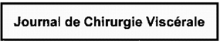
JOURNAL DE READAPTATION MEDICALE M
JOURNAL DE TRAUMATOLOGIE DU SPORT M | 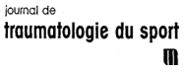
JOURNAL DES ANTI-INFECTIEUX | WORD MARK
JOURNAL OF CHROMATOGRAPHY | WORD MARK
JOURNAL OF CHROMATOGRAPHY | 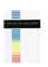
JOURNAL OF COMPUTATIONAL PHYSICS | WORD MARK
JOURNAL OF VISCERAL SURGERY | 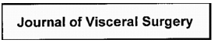
JOURNAL SENSE | WORD MARK

K | Mark
K-CLINICAL TRIALS | WORD MARK
KNOVEL | WORD MARK
KNOVEL READER | WORD MARK
KNOWLEDGE FINDER | WORD MARK

L | Mark
LA COLLECTION DES COLLEGES | WORD MARK
LA REVUE DE SANTE SCOLAIRE & UNIVERSITAIRE
LA REVUE D'HOMEOPATHIE | 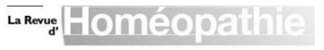
L'AIDE SOIGNANTE | 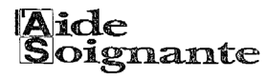
LANCET (Katakana) | WORD MARK
LE PRATICIEN EN ANESTHESIE REANIMATION
LE PRATICIEN EN ANESTHESIE REANIMATION | 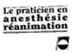
LINGUA | WORD MARK

M | Mark
MAGPATIENTS | WORD MARK
MANUAL DE MEDICINA PRACTICA "MEDICINE" | WORD MARK
MANUAL DE PATOLOGIA Y CLINICA MEDICA MEDICINE | WORD MARK
MASSON | WORD MARK
MASSON M
MASSON THERAPEUTIQUE
MDS MEDECINE DU SOMMEIL | 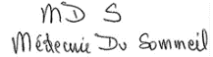
MEDECINE DU SPORT DU PRATICIEN M
MEDICAL ECONOMICS | WORD MARK
MEDICINA CLINICA | WORD MARK
MEDICINA CLINICA EN IMAGENES | WORD MARK
MEDICINA INTENSIVA | WORD MARK
MEMO-GUIDES
MENDELEY | WORD MARK
MK
MOLECULAR CELL | WORD MARK
MONOGRAFIAS MEDICAS JANO | WORD MARK
MOSBY | WORD MARK
MOSBY'S | WORD MARK
MOSBY'S NUTRITRAC | WORD MARK
MYPGMEE | WORD MARK

N | Mark
NAMES YOU KNOW. CONTENT YOU TRUST. | WORD MARK
NEOPLASIA | WORD MARK
NEWNES | WORD MARK
NNNCONSULT
NON SOLUS | WORD MARK
NON SOLUS | 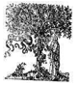
NON SOLUS | 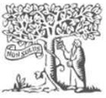
NOUVEAUX CAHIERS DE L'INFIRMIERE
NUEVAS FRONTERAS EN... | WORD MARK
NURSING OUTLOOK | WORD MARK
NURSING PASSPORT
NURSING PASSPORT | 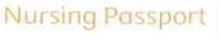
NURSING PASSPORT (Katakana Characters) | 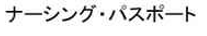
NURSING SKILLS | WORD MARK
NURSING SKILLS (Katakana Characters)
NUTRICION Y OBESIDAD | WORD MARK
NUTRITRAC | WORD MARK

O | Mark
O.C. ONCOLOGIA CLINICA | WORD MARK
OBESIDAD | WORD MARK
OFFARM | WORD MARK
ONCOWRITER | WORD MARK
OPEN ACCESS. POWERED BY SCHOLARS. PUBLISHED BY UNIVERSITIES. | WORD MARK
OPTIONS/BIO | WORD MARK
ORTHOPAEDICS & TRAUMATOLOGY SURGERY AND RESEARCH | 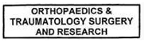
OSMOSIS | WORD MARK
OSMOSIS
OSTEOPATIA CIENTIFICA | WORD MARK
OUR EXPERTS, YOUR PRACTICE | WORD MARK
OXYMAG

P | Mark
P.B. PSIQUIATRIA BIOLOGICA | WORD MARK
PASS'SANTE | WORD MARK
PATHIQ | WORD MARK
PATHWAY STUDIO | WORD MARK
PATIENTPASS | WORD MARK
PEDIATRICS | WORD MARK
PEDIATRIE DU PRATICIEN M | 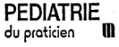
PHARMACUP INFIRMIER | WORD MARK
PHARMAPENDIUM | WORD MARK
PHYSICA | WORD MARK
PHYSICS LETTERS | WORD MARK
PIEL CLINICA, DIAGNOSTICO Y TERAPEUTICA | WORD MARK
PM PRODUXION MANAGER
POCKETRADIOLOGIST | WORD MARK
POLYMER | WORD MARK
PRACTICEUPDATE | WORD MARK
PRATIQUE INFIRMIERE M | 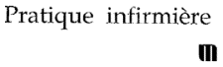
PRATIQUE NEUROLOGIQUE FMC | 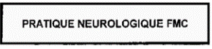
PROCEDIA | WORD MARK
PSYCHIATRIE DU PRATICIEN M

R1 | Mark
RADPRIMER | WORD MARK
RADSEARCH | WORD MARK
RADTOOLS | WORD MARK
REACTIONFLASH | WORD MARK
REAXYS | WORD MARK
REAXYS XPAND | WORD MARK
RESEARCH PULSE | WORD MARK
RESEARCHFISH | WORD MARK
RESNET | WORD MARK
RESPIRATORY MEDICINE AND RESEARCH
REVISTA CLINICA ESPAÑOLA | WORD MARK
REVISTA DE ENFERMEDADES INFECCIOSAS Y MICROBIOLOGIA CLINICA | WORD MARK
REVISTA DE LOGOPEDIA,FONIATRIA Y AUDIOLOGIA | WORD MARK
REVISTA DE MEDICINA FAMILIAR Y COMUNITARIA
REVISTA DE PATOLOGIA RESPIRATORIA | WORD MARK
REVISTA DOYMA DE CLINICA E INVESTIGACION EN GINECOLOGIA Y OBSTETRICIA | WORD MARK
REVISTA DOYMA DE GASTROENTEROLOGIA Y HEPATOLOGIA | WORD MARK
REVISTA ESPAÑOLA DE ATENCION PRIMARIA | WORD MARK
REVISTA ESPAÑOLA DE ENFERMEDADES INFECCIOSAS | WORD MARK
REVISTA ESPAÑOLA DE PEDIATRIA R.E.P. | WORD MARK

R2 | Mark
REVISTA INTERNACIONAL DE ACUPUNTURA | WORD MARK
REVISTA MEDICA DE HOMEOPATIA | WORD MARK
REVUE DE CHIRURGIE ORTHOPEDIQUE ET TRAUMATOLOGIQUE | 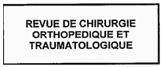
REVUE DE L'INFIRMIERE
REVUE DE L'INFIRMIERE
REVUE DE PNEUMOLOGIE CLINIQUE M | 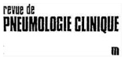
REVUE D'EPIDEMIOLOGIE ET DE SANTE PUBLIQUE EPIDEMIOLOGY AND PUBLIC HEALTH | WORD MARK
REVUE NEUROLOGIQUE M | 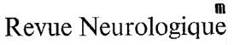
RHUMATOLOGIE DU PRATICIEN M | 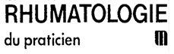
RHUMATOWRITER | WORD MARK

S1 | Mark
SAFETYPLUS (Katakana and English) | 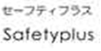
SAUNDERS | WORD MARK
SAVOIR ET PRATIQUE INFIRMIERE M | 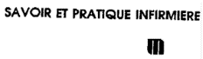
SCIBITE | WORD MARK
SCIENCEDIRECT | WORD MARK
SCIVAL | WORD MARK
SCIVERSE | WORD MARK
SCOPUS | WORD MARK
SHADOW HEALTH | WORD MARK
SHERPATH | WORD MARK
SIMCHART | WORD MARK
SOBOTTA | WORD MARK
SOINS AVEC LA PARTICIPATION DE CEEIEC FORMATION PEDAGOGIE ENCADREMENT
SOINS CADRES | WORD MARK
SOINS GERONTOLOGIE
SOINS GERONTOLOGIE
SOINS PEDIATRIE PUERICULTURE PRATIQUE ET SAVOIR INFIRMIERS
SOINS SAVOIR ET PRATIQUE INFIRMIERE

S2 | Mark
SOINS SAVOIR ET PRATIQUE INFIRMIERE CHIRURGIE | 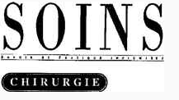
SOINS SAVOIR ET PRATIQUE INFIRMIERE GYNECOLOGIE OBSTETRIQUE PUERICULTURE PEDIATRIE | 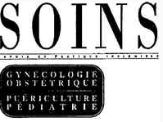
SOINS SAVOIR ET PRATIQUE INFIRMIERE PSYCHIATRIE | WORD MARK
SSRN | WORD MARK
STATDX | WORD MARK
SURFACE SCIENCE | WORD MARK
SURVEY OF OPHTHALMOLOGY | WORD MARK
SURVEY OF OPHTHALMOLOGY | 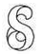
SYNGRESS | WORD MARK

T1 | Mark
T THERAPEUTIQUE POUR LE PHARMACIEN
TARGETINSIGHTS | WORD MARK
TARGETINSIGHTS
TETRAHEDRON | WORD MARK
THE AMERICAN JOURNAL OF CARDIOLOGY | WORD MARK
THE AMERICAN JOURNAL OF MEDICINE | WORD MARK
THE AMERICAN JOURNAL OF SURGERY | WORD MARK
THE CASE MANAGER | WORD MARK
THE ENGINEERING INDEX | WORD MARK
THE GOLD JOURNAL | WORD MARK
THE LANCET | WORD MARK
THE LANCET
THE LANCET & Chinese Characters
THE LANCET (Chinese simplified characters) | 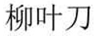
THE LANCET (Chinese traditional characters) | 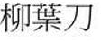
THE LANCET (katakana) | WORD MARK
THE LANCET (Series of two Chinese characters) | 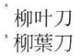
THE NETTER PRESENTER | WORD MARK

T2 | Mark
THE PEARLS SERIES | WORD MARK
THE REQUISITES | WORD MARK
THE SECRETS SERIES | WORD MARK
TOMORROW'S RESEARCH TODAY | WORD MARK
TRANSLATIONAL ONCOLOGY | WORD MARK
TRATADO DE MEDICINA INTERNA - MEDICINE | WORD MARK
TRATADO DE MEDICINA PRACTICA “MEDICINE” | WORD MARK
TRATADO DE MEDICINA PRACTICA MEDICINE

U | Mark
UROLOGY | WORD MARK
UROLOGY THE GOLD JOURNAL | WORD MARK

V | Mark
VACUNAS | WORD MARK
VERIDATA | WORD MARK
VIA ONCOLOGY | WORD MARK
VIROLOGY | WORD MARK
VIRTUAL CLINICAL EXCURSIONS | WORD MARK

W | Mark
W.B. SAUNDERS | WORD MARK

X | Mark
XPHARM | WORD MARK

Y | Mark
YEAR BOOK | WORD MARK
YEAR BOOK OF CRITICAL CARE MEDICINE | WORD MARK
YEAR BOOK OF EMERGENCY MEDICINE | WORD MARK
YEAR BOOK OF GASTROENTEROLOGY | WORD MARK
YEAR BOOK OF HAND AND UPPER LIMB SURGERY | WORD MARK
YEAR BOOK OF MEDICINE | WORD MARK
YEAR BOOK OF NEONATAL AND PERINATAL MEDICINE | WORD MARK
YEAR BOOK OF OBSTETRICS, GYNECOLOGY, AND WOMEN'S HEALTH | WORD MARK
YEAR BOOK OF OTOLARYNGOLOGY-HEAD AND NECK SURGERY | WORD MARK
YEAR BOOK OF PLASTIC AND AESTHETIC SURGERY | WORD MARK
YEAR BOOK OF PULMONARY DISEASE | WORD MARK
YEAR BOOK OF VASCULAR SURGERY | WORD MARK

