

Lighthouse Supplier User Guide

Standards and user guide for Lighthouse

Contact for Sign-in, Access, and Permissions
Harikumar Sundaram - Product And Process Manager
Tel: +91 44 4299 4564
Email: mailto:H.Sundaram@elsevier.com

Updated: December 2025

Guide to Suppliers

To register and start submitting cost estimates:
- This document is to introduce suppliers to use the cost estimate tool (Lighthouse) to submit their estimates.
Please follow the below steps to submit a cost estimate for Elsevier titles.
- Suppliers will be receiving an email (seen in the example below) when a new title (New/re-print) is transmitted.

Dear Team,
A new Print project is available to quote. Please use the link below and submit your quote within 2 business days.
https://seisint.quickbase.com/db/brj5ebqym?a=dr&r=ky
For any queries, write to Wade, Gregory (g.wade@elsevier.com)
Regards,
Elsevier Print Specialist team

- When suppliers click on the link in the email, it will ask them to sign in. Scroll down and use the Create a login button if you are using this tool for the first time.

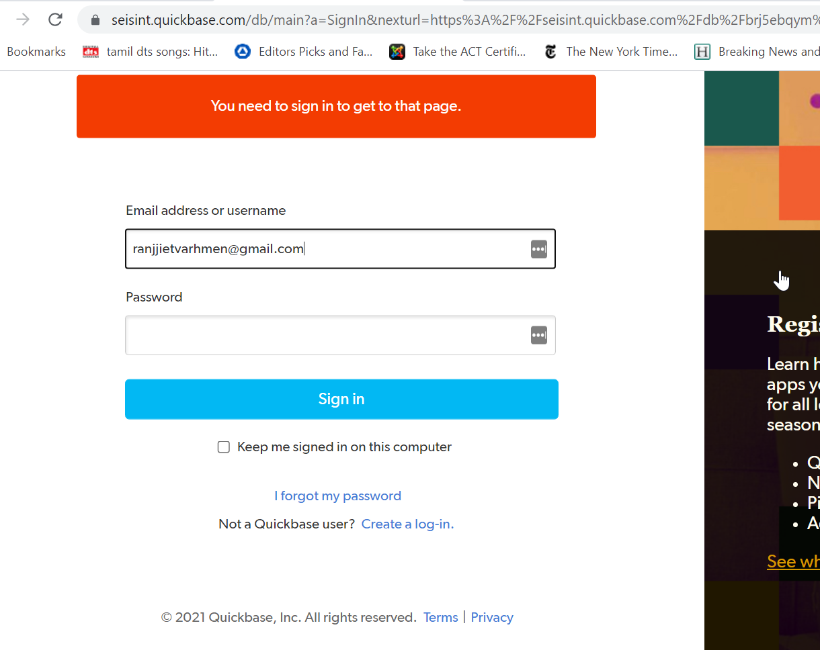

- Fill in your official email ID
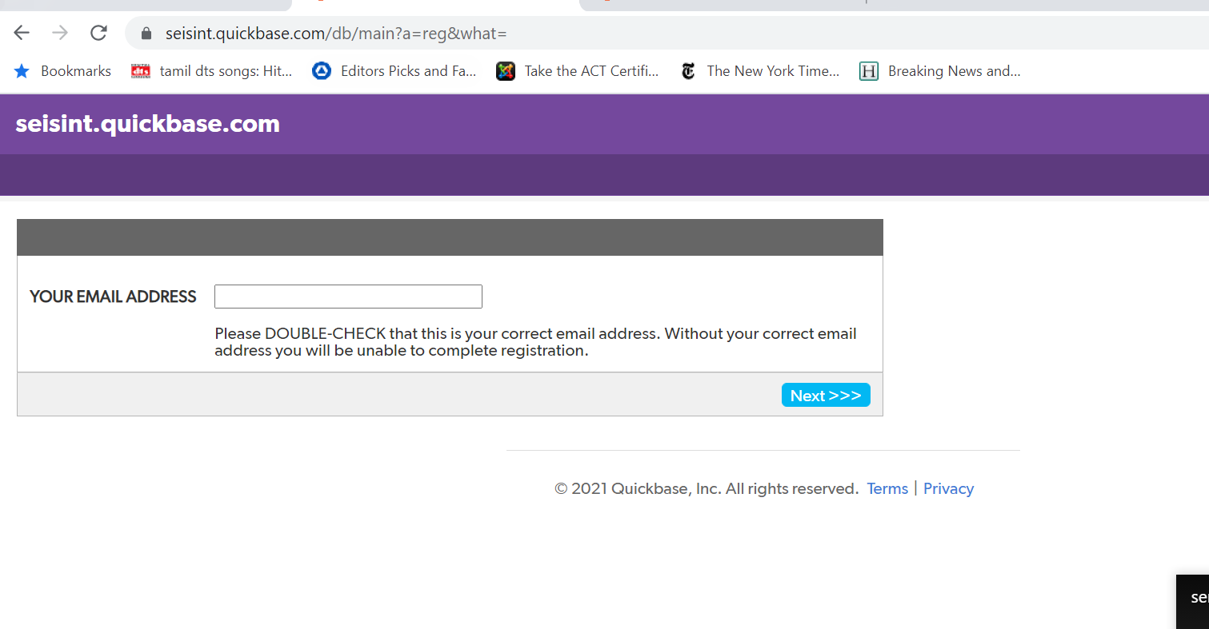

- Fill in other information. Please remember to create a password that can be shared with other estimators (if more than one person will be estimating in your organization).
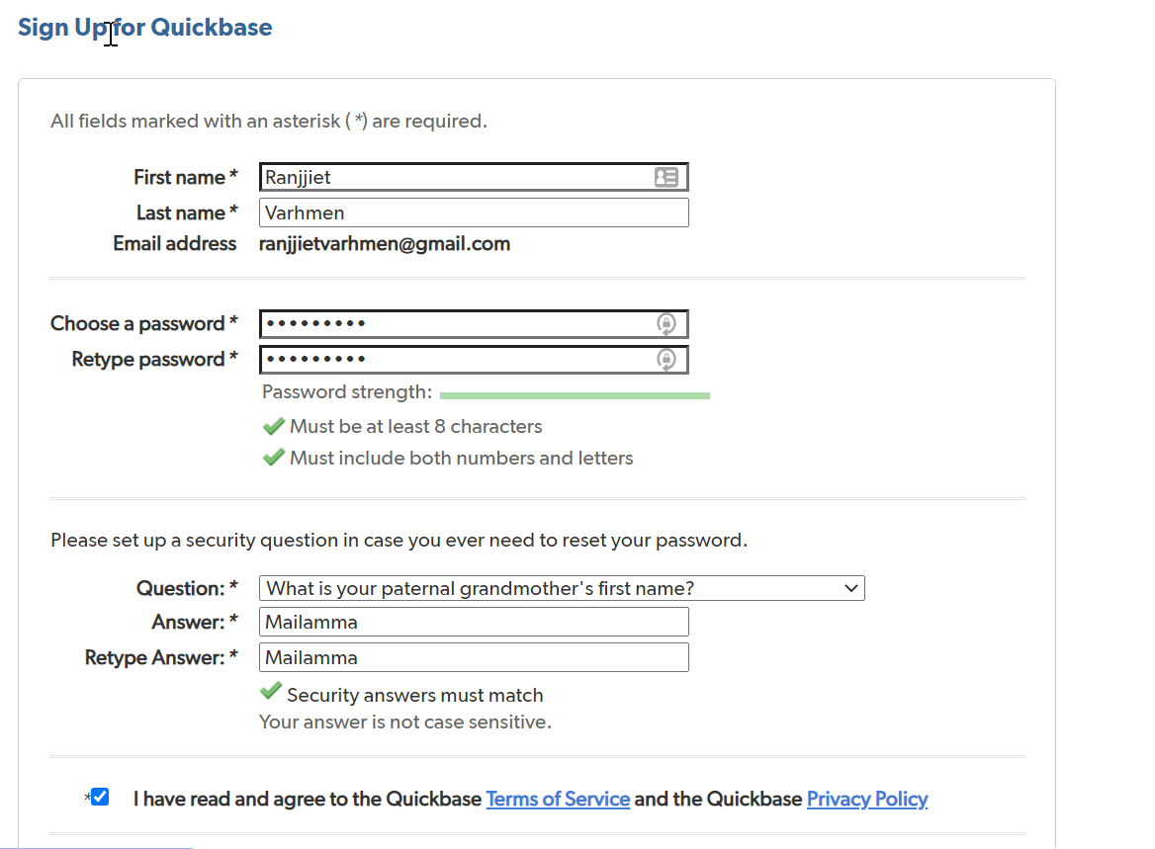

- You will be able to login using the new credentials that you have created.

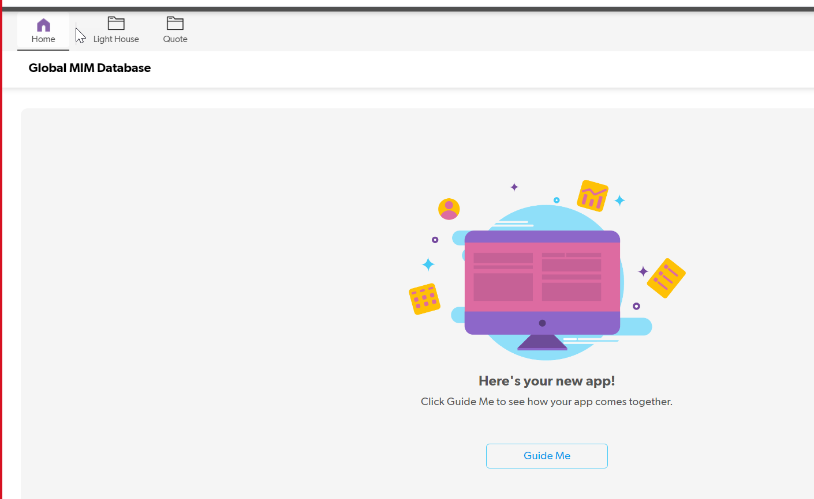

- Click on the lighthouse button at the top and you will be able to see all the titles that are available to estimate. Click on the eye or blue ISBN number to view a specific title’s estimate request.

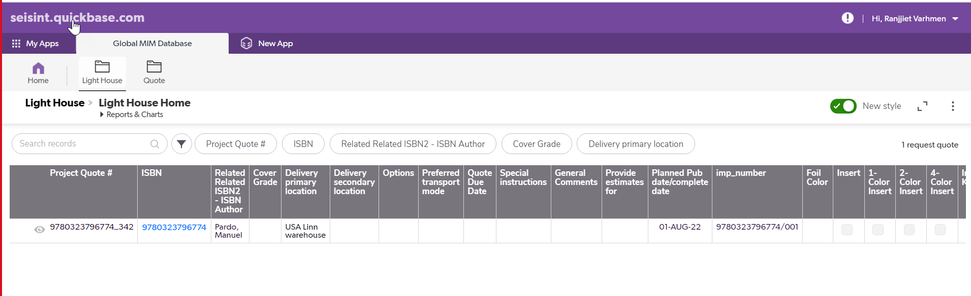

- Review the title specs and other information. Click on ‘Add request quote’ button when costs are ready to be submitted to the Lightouse tool.
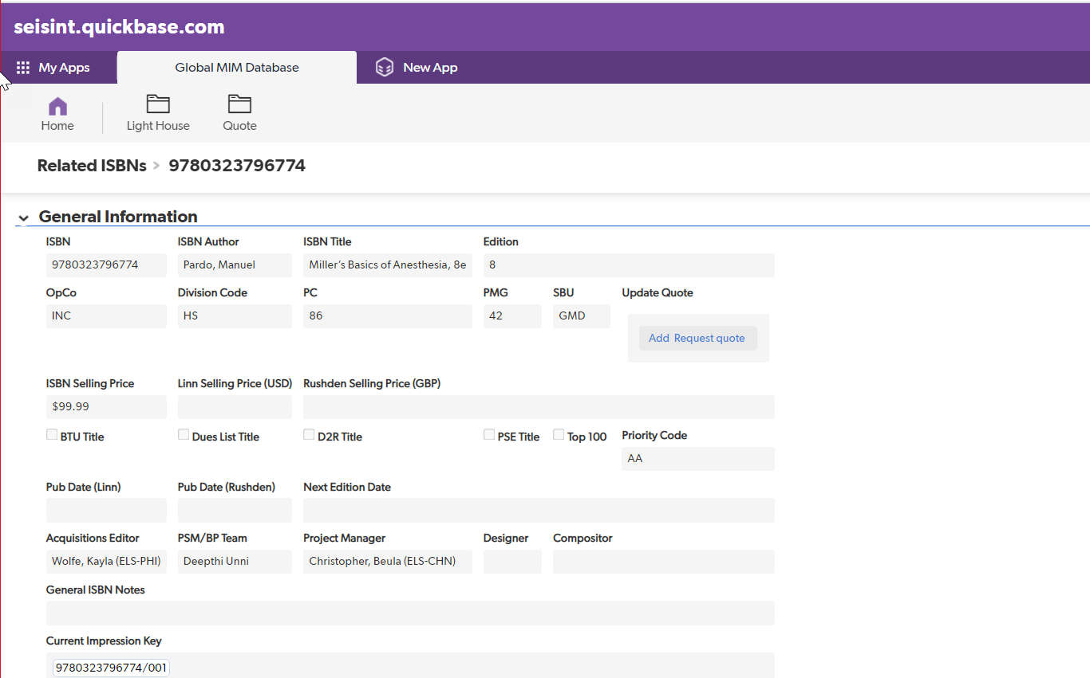

- Fill in the fields below:
  - Estimate field
    - Please fill in the print method that you will be using.
    - If there is a need for multiple estimates for the same title (example: Offset and Digital both requested), fill in the estimate for Offset quote and then click Save & Close to submit. Redo the entire process and fill in the form again for the Digital quote. This will help Elsevier choose the right estimate by comparing cost and timelines between the two quotes.

  - Print run is not an editable field, however, if you would like to offer better cost for higher print runs please mention the alternative print run pricing in the comments sections.

  - Supplier FTP date: Please calculate backwards from the pub date. This is based on the time taken for the supplier from the files received date till the books reach the warehouse.

  - Username: Pick the correct email ID. If you do not see your/your organization mail ID here. Please write to m.jeyakodi@elsevier.com

  - Currency

  - Paper cost
  - Print cost
  - Bind cost
  - Total additional cost
  - Total shipping cost (FOB/Freight)
  - Preferred transport mode
  - Unit cost- Auto calculated
  - Total cost- Auto calculated
  - Run back cost per thousand copies
  - Run forward cost per thousand copies
  - Spine width
  - Unit weight
  - Total weight of the order
  - For both Elsevier or printer supplied Stock, please list:
    - Size of the paper
    - Total weight of paper
    - Brand name, basis weight, ppi (put in notes sections)
    - Size of paper 2
    - Total weight of paper 2
    - Brand name, basis weight, ppi 2 (put in notes sections)

  - Comments: Make sure to mention any assumptions made while estimating the cost, if there was not a clear specification on the quote request. Please note the material or process used in the notes section.

  - Attachment of quotation document: Please attach the cost estimate in your organization’s format, which the Elsevier print specialist will need for archival purposes.
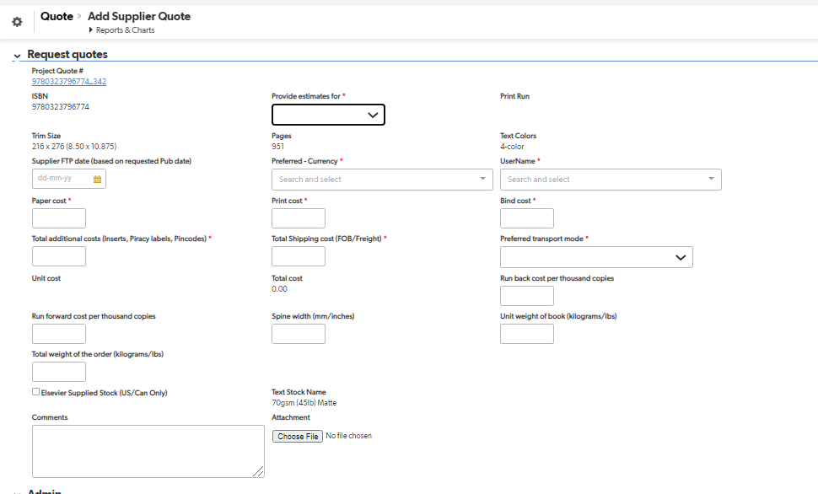

- Click Save and Close to submit the cost estimate.

