

PRINT SUPPLIER GLOBAL DISTRIBUTION

BOOK PACKING STANDARDS

Packing Standards for the US and UK
Elsevier Books and Journals

https://www.elsevier.com/legal/global-distribution-center

Contact details in the USA and the UK:
Quality Assurance Mailbox
Email: elsevierqualityassurancebooks@elsevier.com

Updated: December 2025
1. CARTON PACKAGING REQUIREMENTS 3
a) Standard Carton 3
b) Tape 3
c) Carton Quantity 3
d) Weight 4
e) Packing 4
f) Small Product 4
g) Void Fill 4
h) Pack Instructions 4
i) Sets 4
j) Reprints 5
k) Special Major Reference Works (MRW) Carton 5

2 CARTON LABEL SPECIFICATION REQUIREMENTS 6
a) Product Carton Label specs 6
b) Product Carton Label Barcode Specs 8
c) Product Carton Label placing 8
d) Multi Box Set Carton Label 9
e) Miscellaneous Carton Labels 10
3 REQUIREMENTS FOR PRODUCTS 11
a) Component / Volume Overages 11
b) Barcodes for Individual Volumes 11
c) Product Identification 11
D) HOLOGRAPHIC LABELS 11
E) Product PACKAGING 12
4. REQUIREMENTS FOR JOURNALS 12
a) Journal Carton Label Specs 12
b) Journal Packing Specs 14
c) Journal Pallet Specs 14
5 PALLET & PALLETIZING REQUIREMENTS 14
a) General Pallet Specifications 14
b) Pallet Specifications 15
c) International Pallet Regulations 16
6 Cross Dock Pallet Requirements 16
e) Palletizing Requirements 17
f) Pallet Identification Requirements/Receiving Information 18
7 VENDORS NON-CONFORMANCE 19
a) Notice to Vendors 19
b) Vendor Non-Compliance Chargeback Rates 19
c) Exemption Approval 19

9. UK booking -In Procedures…………………………………………………………………………..20

.

* PLEASE REFER TO THE US FREIGHT ROUTING GUIDE ON THIS SAME URL FOR SHIPPING INSTRUCTIONS

Failure to comply with any of the specifications and requirements outlined in this document will be subject to a chargeback for any required rework. Incurred reverse transport and redelivery costs will be the responsibility of the supplier.

CARTON PACKAGING REQUIREMENTS

Standard Carton
The standard carton to be used for all books will be a 275 lbs. (pounds per square inch) burst test, double-wall container (High Performance Liner). European equivalent: 275 Kraft outer liner, B-flute, double wall, C-flute, 275 Test inner liner, commonly referred to as 275K/BC/275T. Minimum compression requirement must be 725 lbs./sq. inch. A 48 ECT (Edge Crush Test) DOUBLE WALL carton or a 52 ECT are acceptable substitutes. However, a single wall 44 ECT is NOT acceptable.

The maximum and minimum carton specifications are as follows:

Description | Minimum | Maximum
Imperial (inches) | 10” L x 4”H x 9” W | 18” L x 10”H x 11.5” W
Metric (millimeter) | 254mmL x 101mmH x 229mmW | 457mmL x 254mmH x 292mmW

Tape
Each carton must be securely taped all round (top and bottom) with 3” / 75mm wide tape. Top / bottom glued or stapled is not acceptable. Industrial strength pressure-sensitive box sealing tape is permissible. (For example, 3M brand sealing tape). Banding is not allowed on individual cartons.

Carton Quantity
All products must be packed in uniform quantities per carton. Partial cartons (those having less than uniform quantity) should be flagged with a neon color label stating “PARTIAL QTY”. In addition, partial carton quantities must be listed as a separate line item on the Advanced Shipping Notice. Partial carton should be noted on the top of the partial pallet.

Weight
Cartons must not exceed 40lb/18kg gross weight. This is a Health and Safety requirement, and noncompliance will lead to refusal or re-box costs. The minimum carton weight is 2lb. / 0.9kg.

Packing
All products are to be packed flat/horizontally, in stacks of one, two, three, or four, etc., depending on trim size, with books facing alternate directions. DO NOT PACK ON SIDES OR BINDINGS.

Small Product
Answer keys, small manuals, etc., where practical, are to be packed in cartons with the weight between 20lb / 9kg and 40lb / 18kg. Manuals of less than 25 pages are to be divided into groups of twenty to fifty in multiples of ten and secured with bands showing the quantity enclosed.

Void Fill
All voids in cartons should be filled to protect books and preserve strength of cartons when packed on top of each other. There should be no movement in the cartons once books are packed. Required void fill should be corrugated pads (or wrap). Loose fill such as biodegradable or polystyrene chips/peanuts are unacceptable. The amount of stuffing should not be excessive; however, all void spaces MUST be filled.

Pack Instructions
All products including Sets and individual CD-ROMs, Videos, etc. must be packed in accordance with the instructions from the respective purchase order. In the event that specific instructions are not listed on the purchase order enough packing to provide security and product protection must be used.

Sets
In the event that grouping individual pieces into a set creates a different ISBN, the carton quantity should reflect that of the Set ISBN, not of the individual pieces. All multi-volume sets must have only one set per carton.

Sets must ensure that the SKU# is visible either through the shrink or a label on top of the shrink wrap.

All multi-volume sets must be shrink-wrapped and include a neon pink (or neon colored) “Do Not Separate” sticker on the front of the set.

If a set consists of multiple cartons, each carton should be labeled accordingly. (ex; 1 of 2 of 2 cartons, 2 of 2 of 2 cartons) (Vol 1-7 of 15 Volumes, Vol 8-15 of 15 Volumes) AND a separate ISBN/part number for each box should be obtained from the customer and be printed on the specific carton label (see 3C Multi Box Set Carton Label for specs)

The number of cartons per set is determined by the number and weight of volumes (see 1D Weight for restrictions)

Reprints
Please refer to the section labeled ‘Carton Quantity’ and ‘Weight’ in sections 1c and 1d. Instructions in these two sections will apply to all reprint titles.

Special Major Reference Works (MRW) Carton
The special carton to be used for all MRWs is a 300-lbs. (pounds per square inch) burst test, double-wall container. European equivalent: 300 Kraft outer liner, B-flute, double wall, C-flute, 300 Kraft inner liner, commonly referred to as 300K/BC/300K. Strength characteristics of: Edge Crush Test of 9.61 KN/M, Burst Strength of 346 lbs. psi and Box Compression Strength of 485.09 kg.

The cartons for MRWs must be manufactured to the correct dimensions, only requiring filling on top. The preferred method is to use corrugated pads which should be equally spaced at the top and bottom of the carton, with one pad also separating each volume. There should be no movement in the cartons once books are packed.

All MRW sets should be shrink-wrapped unless specified otherwise.

CARTON LABEL SPECIFICATION REQUIREMENTS

Note: Carton labels have been simplified. However, they must meet the barcode specifications detailed below.

Product Carton Label specs
The carton label contains information pertaining to the product inside the specific container, not the shipment. The product label is for single title cartons only. All cartons containing more than one product must be marked “MIXED TITLES ENCLOSED”. All fields not specified in “human readable format” must be bar-coded. A divider line is preferred between zone 1 and zone 2.
Please see the examples below.

Shipping Label Size
Zone Height – Each zone must measure 1.0″ in height ± 0.2″. However, a zone may be doubled in height to accommodate additional information. The height of the double-high zone is 2.0″ in height ± 0.4″. Please note that Zone H when present must always be 2.0″ ± 0.4″ to accommodate the SSCC-18 bar code.

Zone Width – The width of the zones is determined by the width of the label. In some cases, the label width can be divided to accommodate two zones side by side.

Label Height – The recommended minimum label height is 6.0″. The height of the label can be taller if necessary to accommodate additional information. However, the sequence of zones must be preserved and the placement guidelines described below must be observed.

Label Width – The recommended minimum label width is 4.0″. The label may be wider if necessary to accommodate additional information.

- Zone 1 – The information in Zone 1 is to include (in human readable format) the title, author, publisher and your assigned vendor code, all left justified. (If you are not aware of your assigned vendor code, please contact the business unit responsible for the placement of the purchase order) Zone 1 must also note “Printed in (country)”.
- Zone 2 – Publisher Purchase Order Number and Printing number. PPON and PRTG “x” should be left justified above the barcode. All barcodes should be Code 128 Symbology. All barcodes must be at least 0.5 inch / 1.3 cm high.
*Please note print number on carton label should match the far-left number on the print line of the copyright page.
- Zone 3 - The information in Zone 3 includes carton quantity, carton weight, and ISBN. Only the 13-digit ISBN is now required. All barcodes should be Code 128 Symbology. The ISBN bar code should be built using the MOD 10 check. All bar codes and the human readable ISBN must be at least 0.5 inch / 1.3 cm in height.

Product Carton Label sample
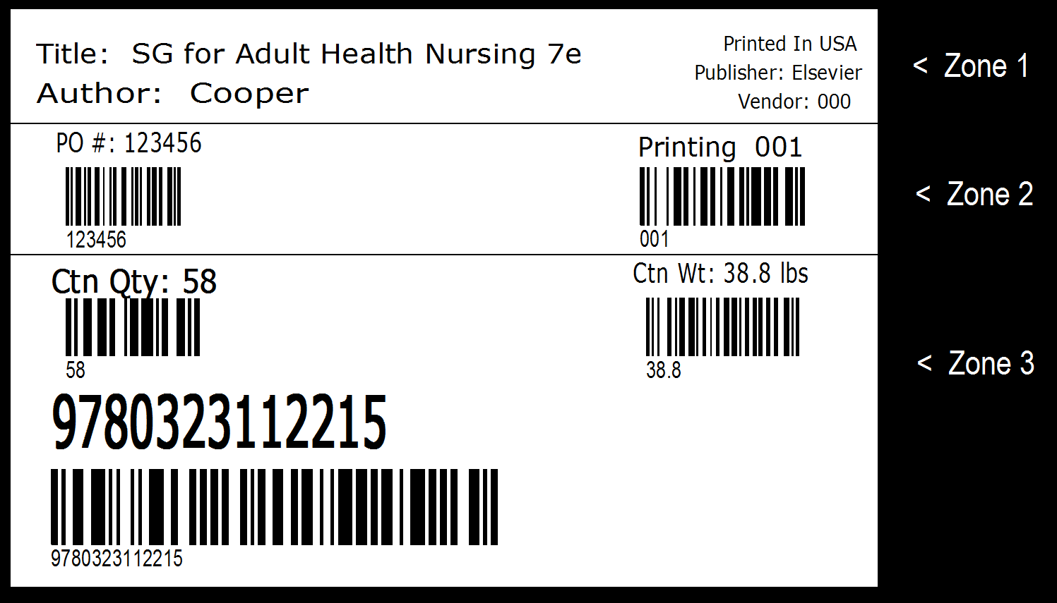

Product Carton Label Barcode Specs

Field Name | Use on Product Label
Purchase Order Number | To identify the Publisher’s purchase order
Impression number | To identify the printing number (fixed length of numbers)
Carton Quantity | To identify the total number of units/pkgs contained in the container.  *Please note that if the carton contains multiple volumes creating one set, the carton label must state “1 SET” but barcode must scan only “1” (see sample 2 below)
Carton Weight | To identify the weight of the shipping container
ISBN | UCC/EAN 128 Symbology

Do not use Application Identifiers in the barcode format. This is the number in ( ) prior to the text encoded in the barcode. Nonconformance to this will result in a chargeback for necessary rework for corrections to the carton labels.

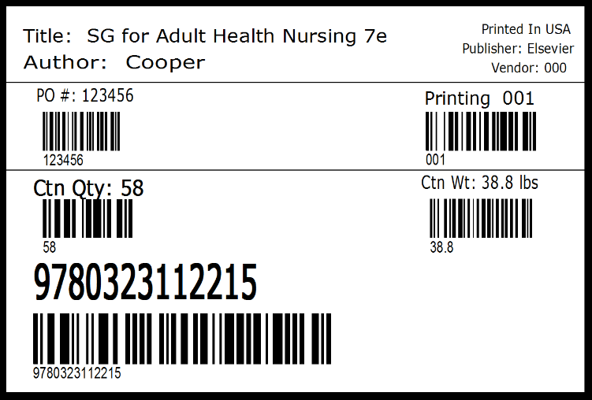

Multi-Unit Carton Label

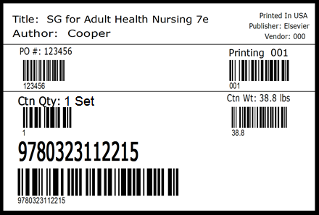 Set Carton Label

Product Carton Label placing
There must be one carton label on both the short and long side of the carton at least 2” / 50mm from the bottom and the right corner of the carton.

We understand that these instructions are very specific. However, due to automatic scanning it is necessary that these procedures be followed as detailed. The NEON PINK OR NEON COLORED Multi-Volume Set Label must be applied to a single carton flap on top of carton. DO NOT PLACE OVER THE MIDDLE OF THE CARTON.
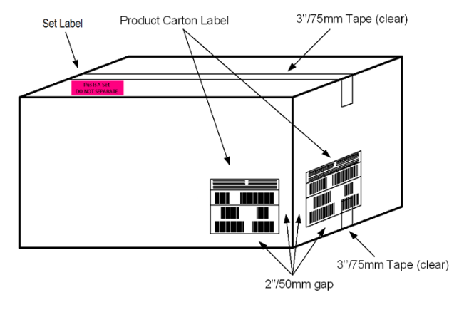

Multi Box Set Carton Label
A product set that consists of multiple cartons must have individual ISBN’s or Part Numbers displayed on the labels. For example, for three cartons you will need three individual ISBN’s or Part Numbers. The ISBN or Part Number must be displayed in Zone 3, like a regular carton label. The complete set ISBN must be listed in Zone 1 and include the text “(Consists of # cartons)”, as per the sample below:
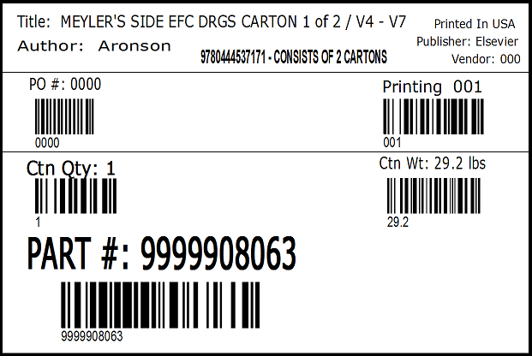

Miscellaneous Carton Labels
Multi-volume Sets: The supplier shall be responsible for printing and affixing a neon pink or neon colored label to the far left, bottom panel of the carton that reads: “This Is A Set - DO NOT SEPARATE”. The label MUST be placed on one of the carton flaps and must be 4” x 6” / 100mm x 150mm.



Partial quantity- if a box on a shipment contains less/more than the uniform carton quantity for that ISBN, a Neon label to the top panel of the carton needs to be affixed that reads” Partial QTY”

4 REQUIREMENTS FOR PRODUCTS

Component / Volume Overages
Delivery of Component/Volume overages (such as extra CD’s) to the Distribution Center must be identified by the product ISBN / part number, not the Kit / Set ISBN. (For example, the CD part number should be on the product/carton, not the ISBN of the product with the CD in it) Unless specifically instructed to do so, only 25 overages should be sent to the warehouse.
Barcodes for Individual Volumes
Multiple volume set components must have two barcodes; one (1) for the text ISBN for the individual volume, the second (2nd) should indicate the set ISBN and corresponding barcode.
Sample:
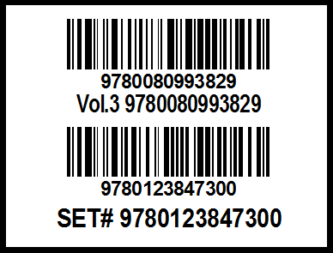

Product Identification
All products should contain the 13-digit ISBN bar code.
Sample:


- Holographic Labels
All products are required to have a holographic label applied to the product (as instructed on the PO). Placement of the label on the product must not be too close in horizontal proximity of the SKU barcode, to eliminate scanning issues. For placement examples, please refer to the Hologram Sticker Placement Guide PDF linked on the Global distribution center vendor guide web page
( https://www.elsevier.com/legal/global-distribution-center )

For procurement of holographic label stickers, please refer to the contact details below.

- UFLEX SPOC contact is Abhishek Kumar - abhishek.kumar@uflexltd.com;
- additional UFLEX contacts: ashim.sinha1@uflexltd.com; kaustav.roy@uflexltd.com

- Product Packaging
Unless sold as a set, individual units should not be shrink-wrapped or paper-wrapped together inside of cartons.

5 REQUIREMENTS FOR JOURNALS

Journal Carton Label Specs
The carton label contains information pertaining to the product inside the specific container, not the shipment. The product label is for single title cartons only and should be 4X6 in size. Specific fields that must be barcoded are listed below in zone 2. A divider line is preferred between zone 1 and zone 2. Please see the example label below.

- Zone 1 – The information in Zone 1 is to include (in human readable format) the Journal Title, Volume/Issue, Month/Year (all 3 to be left justified) and your assigned vendor code. If you are not aware of your assigned vendor code, please contact the business unit responsible for purchase order.
- Zone 2 – The following information in Zone 2 is to include both human readable format and barcodes: Carton Quantity, Carton Weight and the Product ID.
The Product ID is listed as follows:

Journal Acronym* | Volume | Separator | Issue | Product ID
6 Characters | 4 Characters | 1 Character | 4 Characters | 15 Characters Total

*If the Journal Acronym is less than 6 characters, enter spaces to populate this section. See example label below.

All should be left justified above the barcode. All barcodes must be at least 0.5 inch / 1.3 cm.
All barcodes should be Code 128 Symbology.
Also included in this zone are the Publisher and Country of Print. No barcodes are needed for these items.
Product carton label sample:

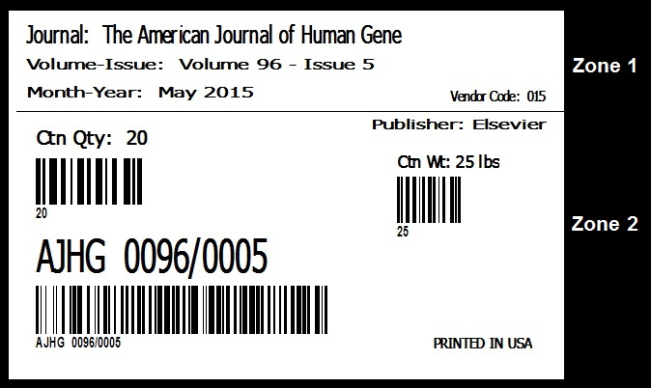

Journal Packing Specs
All packing specifications are to be followed as outlined in Section 1 of LSC Communications Global Distribution Standards.

Journal Pallet Specs
All pallet specifications are to be followed as outlined in Section 6 of LSC Communications Global Distribution Standards.

6 PALLET & PALLETIZING REQUIREMENTS

General Pallet Specifications
This standardization is intended to be for all truck load shipments. However, this may apply to suppliers who make regular LTL (less than truckload) shipments to our Distribution Center. If the required pallets are not available for LTL shipments, then any standard two-way, wood pallet may be used as long as they are acceptable quality and 40’’ x 48’’ / 1000mm x 1200mm size. Foam pallets, slip-sheet, power boxes and glide packs are not permitted.

 | Linn, USA | Hachette
Pallet Size | 40” x 48” | 1000mm x 1200mm
Maximum pallet height ++ | 54” | 1200mm
Maximum pallet weight | 2500 # | 800kg
Pallet overhang allowed | None | None
“Kits” pallet overhang | None | None
Corrugated specifications | Same as Book Specs | Same as Book Specs

(++) = Pallet Height is measured from floor to top of carton stack (includes pallet height.)

Pallet Specifications

QTY | DESCRIPTION | DIMENSIONS
 | Pallet Size: Flush, Non-Reversible, Multiple Use | 40” W x 48” L x 5”H
 | Maximum Weight Capacity | 2,500 LB. (Fully Loaded)
2 | Top Outside Boards, 9 screw nails each | ¾” x 5-3/4” x 40”
5 | Top Inside Boards evenly spaced between outside boards, 6 drive nails each | ¾” x 3-3/4” x 40”
3 | Runners (minimum specifications) | 1-3/4” x 3-3/4” x 48”
2 | Bottom outside boards: Chamfers (four points) per board. Face of board at chamfers will not exceed 1/8” and taper on 45-degree angle, 9 drive screw nails each | ¾” x 5-3/4” x 40”
2 | Bottom inside board; evenly spaced, Chamfers (four points) per board. Face of board at chamfers will not exceed 1/8” and taper on 45-degree angle, 6 drive screw nails each | ¾” x 3-3/4” x 40”

- Chamfers on outside edges of bottom deck, for ease of entry of Pallet Jack.
- Use standard screw nails throughout assembly.
- Commercial tolerances to apply to all sizes and dimensions.
- Hardwood construction. No Coniferous Wood.
- Four-way pallets will not be accepted.
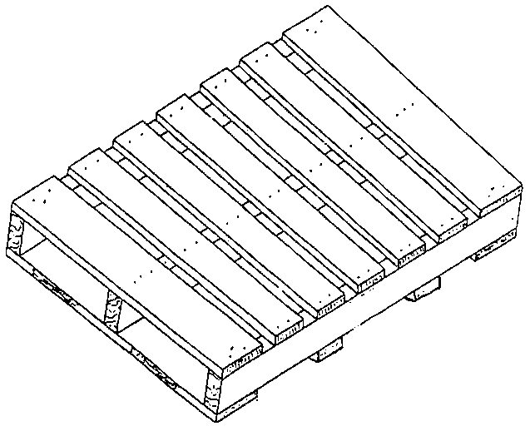

International Pallet Regulations

US Regulations
Importers and suppliers of US imports must ensure all solid Wood Packing Material (WPM) meet the ISPM 15 standard. Shipments containing noncompliant regulated WPM will not be allowed to enter the USA.
APHIS has set standards for Wood Packaging Material imported into the USA through 7 CFR 319.40 - Importation of Wood Packaging Material. This Final Rule states that all regulated wood packaging material shall be appropriately treated and marked under an official program developed and overseen by the National Plant Protection Organization (NPPO) in the country of export. Additionally, per APHIS PPQ policy, findings of insects in the families of Cerambycidae, Buprestidae, Siricidae, Cossidae, Curculionidae, Platypodidae, Sesiidae and Scolytidae represent timber pests that, when found live in otherwise properly marked WPM, signify that the WPM was not properly treated and safeguarded in accordance with 7CFR319.40-3(b)(1). Beginning July 5, 2006 ISPM 15 marked WPM containing pests in the above-mentioned families shall be immediately re-exported pursuant to 7CFR319.40-3(b)(3). The importer of record is responsible for any costs or charges associated with the re-export.
Anticipating questions and concerns from stakeholders for the phase in periods for ISPM 15 Enforcement, Customs and Border Protection (CBP) and APHIS PPQ have posted information on the respective websites. Questions concerning Port of Entry Enforcement may be referred to DHS CBP 202.354.1000 or 877.227.5511 Monday-Friday, between 8:30 and 5:00 Eastern Time.
EU Regulations
The European Union (EU) issued emergency measures affecting coniferous Solid Wood Packing Material (SWPM) exported from the United States, Canada, China and Japan, which become mandatory October 1, 2001. The purpose of these regulations is to prevent the pinewood nematode, a microscopic eelworm that kills pines, from causing the same damage in the EU that it has in the countries to which the regulations apply. “To avoid problems, use only hardwood pallets, no coniferous wood.”

Any coniferous SWPM from the United States, Canada, China and Japan, must be appropriately treated before it is allowed entry into the EU. Appropriate treatment consists of heat-treating or kiln-drying, pressure treating or fumigating with approved chemicals. Once treated, all SWPM must display a special mark which verifies proper treatment. Although no paper certification is required, it is recommended to make a notation on the commercial invoice and the bill of lading regarding the type of SWPM used, if any, and its treatment status. This should help prevent delays.

d) Cross Dock Pallet Requirements

Any Foreign Cross Dock to USA shipments must be delivered on pallets that comply with the APHIS standards for Wood Packaging Material imported into the USA and must be treated and marked according to ISPM 15.

http://www.aphis.usda.gov/import_export/plants/plant_imports/wood_packaging_materials.shtml

http://www.forestry.gov.uk/pdf/USAWPMimplementation_plan160905.pdf/$FILE/USAWPMimplementation_plan160905.pdf

Sample of an acceptable WPM / ISPM 15 mark:


e) Palletizing Requirements

All pallets must have a slip sheet between the pallet and the parcels. All parcels must be interlocked when stacked on a pallet and must not overhang the perimeter of the pallet. The resulting packs, when stacked, must be appropriately “rigid” – i.e. the parcels will not slide when the pallet is moved/handled. For any one delivery of a title, there should be a constant number of cartons per layer and a constant number of layers per pallet.

Parcels must be made secure on the pallet by overall stretch or shrink-wrap. Additional banding/strapping can be applied with top boards in such a way that strapping does not cut into the edge of the parcel potentially damaging the contents. Plastic bands are preferred over steel - steel stretches.

To cut down on carriage costs when the delivery consists of very small quantities of a number of titles, the pallets can be stacked on top of each other for transportation (piggy back). This is acceptable only if the cartons are being packed properly to avoid being crushed.

Occasionally, books will be requested to be packed loose on pallets. All books are to be stacked 36” / 92cm to 54” / 137cm high (depending on bulk) in alternating, interlocking layers, with sheets of paper between the layers, to prevent shifting. Each layer is to be packed uniformly and, if more than one pallet, all pallets should be packed identically. Any additional loose books should be secured with pallet tops or angle boards, stretch wrapped, and banded with four steel bands, two in each direction. Shipments of loose books packed on pallets are to be sent as part of the first shipment to the LSC Communications Distribution Center.

f) Pallet Identification Requirements/Receiving Information

Pallet Address Label
Each pallet should have an address label affixed stating the sender and the receiver’s address. The label should also indicate the number of pallets on the shipment and the specific pallet number (e.g. 1 of 10, 2 of 10, etc.)

Receiving hours: 7:30 a.m. – 2:00 p.m.

Linn, US address:

UPS Shipments

Elsevier Inc.

Attention: New Receiving

1801 Hwy 50 East

Linn, MO 65051

United States

ALL OTHER SHIP METHODS

Elsevier Inc.

Attention: New Receiving

1801 Hwy 50 East

Linn, MO 65051

United States

UK address:

ELSEVIER C/O HACHETTE

UK DISTRIBUTION

HELY HUTCHINSON CENTRE

MILTON ROAD

DIDCOT

OX11 7HH UNITED KINGDOM

Mixed pallet label
The general rule is one title only per pallet. However, in very small print runs this is inappropriate. In the latter case, 4 titles can be put together on a single pallet if they are kept apart clearly, and the cartons, pallet and documentation are clearly marked "MIXED PRODUCT ON THIS PALLET".
LTL shipment label

For LTL shipments - Attach pallet signs that read “DO NOT BREAKDOWN – DO NOT DOUBLE STACK.”

7 VENDORS NON-CONFORMANCE

Notice to Vendors

We reserve the right to refuse any shipment not stacked, wrapped, bound, identified, documented, or shipped in accordance with the instructions, forms and charts contained herein. In such cases, transportation charges back to the supplier and subsequent transportation charges on reshipment are to be borne by the supplier. We reserve the right to audit compliance and charge back if instructions are not followed and/or variances granted.

Vendor Non-Compliance Chargeback Rates
Vendors will be charged back for violations of the specifications contained herein.
The minimum charge will be $250 per occurrence: An occurrence is defined by each order or each individual issued PO.

- Book Error - $1.00/unit: Where Linn Distribution Center assigns personnel and/or materials to correct errors that appear on the book unit in the form of missing or incorrect ISBN, missing or incorrect barcode, missing shrink wrap, and where after investigating the root of the error, it is agreed that the error originated with the vendor.
- Book Error - $1.00/unit: Where Linn Distribution Center personnel are assigned to inspect books to determine printing or binding errors, and where after investigating the root of the error, it is agreed that the error originated with the vendor.
- Carton Error - $1.00/ per carton: Where Linn Distribution Center assigns personnel and/or materials to correct errors as they appear on an individual carton in the form of missing/incorrect carton labels, wrong size or overweight cartons, incorrect/insufficient packing materials, incorrect carton strength used, incorrect carton stacking, etc.…

*need chargeback totals confirmed

Exemption Approval

If the need to deviate from these specifications should arise, it is the responsibility of the vendor to request an exemption form. This form should be completed to document any pre-approved exemptions to the specifications outlined in this guide. Informational requests (purchase order numbers, and vendor codes) should be directed to the respective Business Unit. Exemptions concerning physical specifications (carton/pallet sizes and weights) should be directed to:
Linn US inventory Management
Mary Bushman
Email:us.inventory@elsevier.com or elsevierqualityassurancebooks@elsevier.com
Tel: +1 314-447-8129

Procedure for booking in deliveries at Hachette UK Distribution:
Delivery address:
Hachette UK Distribution
Hely Hutchinson Centre
Milton Road
Didcot OX11 7HH
Oxfordshire
United Kingdom

Booking In procedure:
Telephone bookings taken from 0700 to 1800 (UK time) Monday to Friday (excluding Bank Holidays). Telephone bookings can be made a minimum of 48 hours prior to delivery.
Phone number: 01235 759720
By Phone:
- Supplier calls Goods In.
- Goods In issues a booking reference, delivery date and time
- Goods In emails a pre-filled inbound shipment manifest* (Excel spreadsheet – see Appendix 1 for example manifest) to the supplier.
- Supplier completes the manifest with ISBN, title, quantity etc.
- Supplier returns the completed manifest to Goods In.

Alternatively booking requests can be made via email outside of these UK office hours:
Email: hukdgoodsin@hachette.co.uk
By Email:
- Supplier must register email address with goods in team to participate; this can be done by calling the goods in line.
- Supplier holds a template copy of the inbound shipment manifest* (Excel spreadsheet – See Appendix 1).
- Supplier populates the manifest with ISBN, title, quantity etc. and sends it to hukdgoodsin@hachette.co.uk
- Goods In issue a booking reference, delivery date and time and adds these to the manifest
- Goods In returns the completed manifest to the supplier as confirmation of the booking Without this reference loads will be rejected.

*Electronic transfer of inbound shipment manifest also available please contact Goods in team for more details.
In the case that you do not receive a reply, call the goods-in line which is open Monday – Friday 7.00am – 6.00pm (excluding bank holidays).
In the event that you wish to change a pre-arranged booking please use the same telephone number / email address, this is also the number for drivers to use in case of delay enroute.
  - Booking in reference and time must appear on your delivery paperwork.
  - If your driver knows in advance that they will be early or late for their slot please call the goods-in line and we will be able to advise if we can accept the delivery.
  - If the delivery vehicle arrives later than the agreed booking in slot then we will endeavour to accommodate the delivery in the next available slot. If there are no free slots remaining on that day the delivery will be refused and you will need to obtain a new booking in time.
  - Please note that the booking reference and time is for a stated number of pallets only, excess pallets could result in the whole load being refused.

Deliveries received:
Deliveries will only be accepted when an inbound shipment manifest has been supplied
From 0600 to 2200 Monday to Friday
Bookings outside of these times are strictly by arrangement.
DELIVERIES WITHOUT A VALID BOOKING IN WILL BE REFUSED. The weight of carton should not exceed 17kg.
Information the warehouse will require when making a booking
- A valid Inbound shipment manifest must be sent at least 24 hours in advance of delivery.
- Delivery paperwork must contain the following information
  - Supplier name & address
  - Carrier name and address
  - Booking in reference
  - Date of despatch
  - Total number of pallets
  - Detailed pallet manifest
- A minimum of 2 copies of paperwork will be required with each delivery.

Appendix 1:
