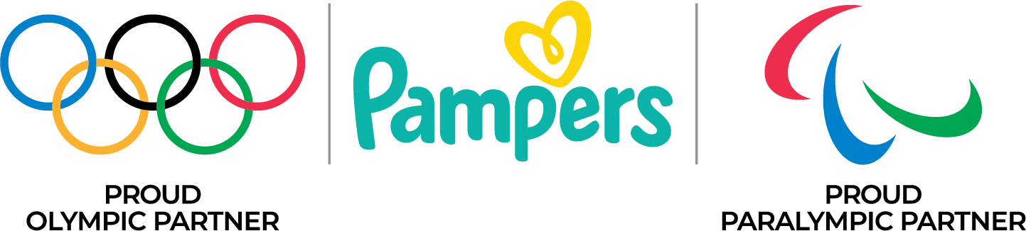

The Village Nursery with Pampers:
The first ever baby care space, featuring the comforts of home, within an Olympic (and Paralympic) Village of Paris 2024, for athletes to spend time with their babies and young children during the Olympic and Paralympic Games Paris 2024

- Pampers in partnership with the International Olympic Committee and the Paris 2024 Organizing Committee has created the Village Nursery in the heart of the Olympic (and Paralympic) Village.
- The Village Nursery with Pampers features the comforts of home and enables athlete parents and their babies and young children to enjoy precious moments together, giving them the peace of mind to perform at their best.
- Universally accessible, it includes dedicated spaces for nursing, playtime and a changing station
offering access to Pampers high-quality diapers and wipes.
- Pampers, the Official Baby Care Products of the Olympic and Paralympic Games Paris 2024.

Pampers, part of the Procter & Gamble company – a Worldwide Olympic and Paralympic Partner - is sponsoring a dedicated space, featuring the comforts of home, to enable athlete parents from around the globe to reunite with their babies and young children during the Games for bonding, nursing and playtime.

Athletes, both past and present, have been highly vocal in expressing the need for a comfortable and convenient space to spend time with their babies and young children. In previous Olympic and Paralympic Games, such a place did not exist, adding to the stress these athletes can already be feeling at such a pivotal moment in their sporting careers.​ Recognising this need, Pampers in partnership with the IOC and the Paris 2024 Organizing Committee, have created the Village Nursery right in the heart of the Olympic (and Paralympic) Village to help make this important experience a positive one for the whole family.

“After the birth of my daughter I understood how difficult it is to compete at the highest level while balancing the demands of parenthood. The Olympic Games environment comes with a lot of complexity and pressures, and one way to offer relief is make it easier on athletes to spend time with their babies and young children without leaving the Olympic (and Paralympic) Village. I'm so pleased to partner with Pampers to make the Village Nursery a reality for the next generation of athletes who are chasing their dreams while also choosing parenthood,” says Allyson Felix, 11- time Track & Field Olympic Medallist.

Dame Laura Kenny, 5-time Olympic Cycling Champion adds, “As a mum to two boys, I know all about the challenges of juggling a career and parenthood. The Village Nursery with Pampers, a first of its kind in the heart of the Athlete’s Village, is an absolute game changer for athlete parents of babies and young children at this year’s Olympic and Paralympic Games. Being able to see your children, hold them, and simply share this once in a lifetime experience, is priceless. It’s wonderful to see Pampers in partnership with the IOC and the Paris 2024 Organizing Committee, do what they do best, care for babies and those who care for them.”

Xu Xin, 2-time Olympic Table Tennis Champion comments, “As a proud father of two and a former Olympic Champion, I understand the challenges of being focused on the Games and wanting to be there for my family and share this once in a lifetime experience with them. Having the opportunity to reunite and bond with my family during this special time is fantastic. It’s great to see Pampers sponsoring this family space, making this year’s Olympic Games the most family friendly games ever.”
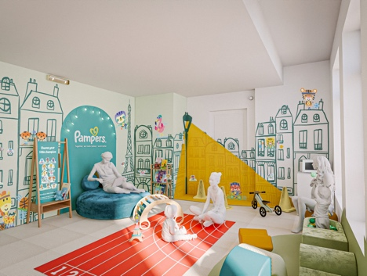
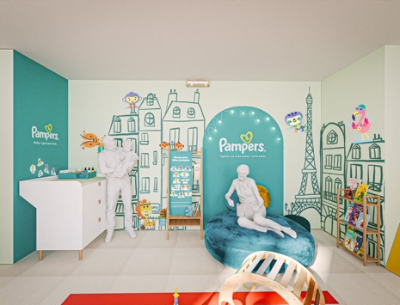
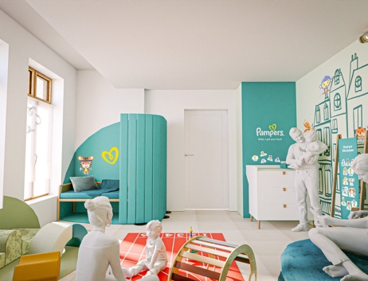

Universally accessible, the Village Nursery with Pampers will cater for all babies and young children’s needs, including dedicated spaces for nursing, a family lounge area for fun playtime, and a changing station. Parents can rely on Pampers high quality diapers, offering their highest comfort and superior leakage protection with our 360⁰ fit and Stop & Protect Pocket, as well as Pampers baby wipes formulated to clean and help protect babies’ delicate skin.

The Village Nursery with Pampers is open from 9am-9pm during the Olympic Games (July 18 – August 13) and Paralympic Games (August 21 – September). The space caters for up to two families at a time with babies and young children and both private and shared timeslots can be booked.

Ranya Shamoon, Senior Vice President Baby Care Europe, Procter and Gamble comments: “As a brand committed to supporting babies and those who care for them, it was natural for us at Pampers to step in and help champion athlete parents when they need it the most. We are delighted to partner with the IOC and the Paris 2024 Organizing Committee to create the first nursery space, with the comforts of home, in the Olympic (and Paralympic) Village. At such an important milestone, we are so proud to help empower athletes on their journey to the Olympic and Paralympic Games Paris 2024.”

Pampers, the Official Baby Care Products of the Olympic and Paralympic Games Paris 2024, is supporting all parents and their little champions, together with athlete ambassadors from USA, UK and China:

- Allyson Felix, 11- time Track & Field Olympic Medallist, USA
- Dame Laura Kenny, 5-time Olympic Cycling Champion, UK
- Xu Xin, 2-time Olympic Table Tennis Champion, China

About Pampers®
Pampers® is a part of the Procter & Gamble Company, offering a complete range of diapers, pants and baby wipes designed to provide leakage protection and comfort for every age and stage of your baby’s development. We believe in the power of working together - with parents, experts and valued partners - on our journey to care for every baby, today and tomorrow.
Visit www.pampers.com to learn more about Pampers and our diapering world.

About P&G’s Olympic & Paralympic Games Program
P&G has been a Worldwide Partner of the International Olympic Committee (IOC) since 2010. In July 2020, P&G announced the extension of its worldwide partnership with the Olympic Games through the LA2028 Games, including global rights with the International Paralympic Committee (IPC) and the Paralympic Games. Since becoming a Worldwide Partner of the Olympic Games, the Company and its brands including Always®, Tide®/Ariel®, Gillette® and Head & Shoulders® have partnered with more than 500 athletes to shine a light on their daily commitment to be the best they can be, just as P&G brands commit to delivering superior performance for people who count on us in their everyday lives.

About Procter & Gamble
P&G serves consumers around the world with one of the strongest portfolios of trusted, quality, leadership brands, including Always®, Ambi Pur®, Ariel®, Bounty®, Charlie Banana™, Charmin®, Crest®, Dawn®, Downy®, Fairy®, Febreze®, Gain®, Gillette®, Head & Shoulders®, Lenor®, Olay®, Oral-B®, Pampers®, Pantene®, SK-II®, Tide®, Vicks®, and Whisper®. The P&G community includes operations in approximately 70 countries worldwide. Please visit http://www.pg.com for the latest news and information about P&G and its brands. For other P&G news, visit us at www.pg.com/news.

