**RURAL HUMAN RIGHTS ACTIVISTS PROGRAMME**

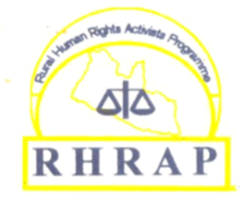

**(RHRAP) FACTSHEET**

**Broad & Gurley Streets-Raymond Building-2nd Floor-Apt. 15- Monrovia-Liberia Email:** [**info@rhrapliberia.org**](mailto:info@rhrapliberia.org) **Website:** [**www.rhrapliberia.org**](http://www.rhrapliberia.org)

**T**he Rural Human Rights Activists Programme (RHRAP) is a human rights organization that was established in December 1997 by a group of activists to educate the rural inhabitants on issues of human rights, peace, & social developments. It is a non-profit, non-governmental and non-political organization with registered number 051723279 with the Liberia’s Business Registral. RHRAP mission *is “To promote Sustainable Development Including Rule of Law, Human Rights and Democratic Principles*; and its goal is “*To Promote and Advocate for Sustainable Development at Community and National Levels*”. RHRAP belief that Every human being irrespective of color, race, sex, tribe, religion, and creed has a right to life, dignity, and freedom.

In line with its program strategy 2022-2026, RHRAP has 3 key programatic pillers which include: Human Rights, the Rule of Law & Democracy; Natural Resource Management & Climate Change and Peace building.

***Human Rights, Rule of Law & Democracy:***

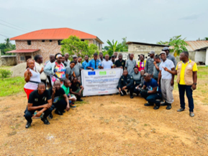RHRAP is currently engaged in Criminal Justice education and reforms at various levels to protect the rights of residents. RHRAP provides trainings for Law Enforcement Officers (Police, Correction) on human rights perspectives in policing and correction to reduce the occurances of human rights violations & abuses. Provide legal representations and vocational training for prolonged pretrial detainees to enhance their livilihoods after serving jail term. To enhance the capacity of Community, Traditional and Religious Leaders to contribute to the promotion and protection of thier fundamental human rights, to hold duty beariers accountable, RHRAP provides training on the Criminal Justice Highway starting from *arrest- detention-court-parole.* In addition, RHRAP constantly monitored prisons, police withholding cells and used findings to develop Policy Briefs that are used for its advocacy engagements on policy reforms. RHRAP also organizes county and national levels dialogue forums where issues concerning rights violations and abuses of residents are thoroughly assessed by stakeholders with recommandations to national actors for accountability. At the Gbarnga, Sanniquellie, Kakata, & Bondinway Prisons, RHRAP has provided Desk Phones for the use of inmates to communicate with the outside world including their families and lawyers. With funding from the European Union (EU) this project is being implemented in 4 counties (Bong, Margibi, Nimba and Grand Cape Mount Counties.)

***Natural Resource Management and Climate Change.***

**N**atural resource extraction by extractive companies remains a serious threat to the country’s indigenous inhabitants in mining communities. There are increased in rampant human rights violations and abuses. Environmental pollution, deforestation as a result of mining minerals, is contributing to the destruction of the indigenous forest ecosystem which are challenging factors to the survival of indigenous communities in Liberia’s extractive communities. These and many more are national and global threats to the environment. At the Kinjor Gold Mine in Grand Cape Mount County, Cyanide and other chemicals that are used in the extraction and purification of gold has led to the pollution of the indigenous peoples land and waters. With funding from the LUSH Charatible Pot, RHRAP has been working with residents to expose the dangers of these chemicals on human life which have gradually helped residents to avoid getting in contacts with these chemicals. Polluted communities have avoided farming on polluted lands, eating fish, crab, and others from their waters to safe lives whch affects their livilihoods. RHRAP and communities are working together to find alternatives to livelihoods soruces through sustained engagements with donors, and education and advocacy with extractive companies and national government to address issues afffecting these mining communities.

***Natural Resource Mining- The Impacts of Gold Mining on Communities.***

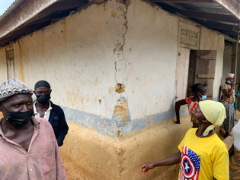Natural Resource extraction has and continue to diminish the living condition including livelihoods of mining communities in Kinjor, Grand Cape Mount County. As a result of blasting, houses including religious shelters of indigenous residents are being destroyed. Mining activities have caused dirking waters like well, streams or creeks and farmland polluted without compensation. RHRAP is working with affected community residents engaging duty bearers are various levels organizing engaging and advocacy events for redress to the plight of residents.

***RHRAP Social Justice Program***

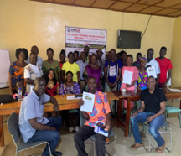Using USAID funding through Civil Society Activity CSA/DAI/USAID RHRAP worked with rural communities to empowered them in establishing a Revolving Drug Scheme called *Revolving Drug Fund (RDF)* that will provide timely, reliable, and affordable medications for high impoverished populations in Bong and Lofa Counties. For the past 6 years, health centers across the country have nearly collapsed due to the lack of essential medications, the low incentives, and salaries for health workers. Curable sicknesses are gradually killing residents that have increased maternal mortality across the country. To contribute to addressing this problem, RHRAP worked with County authorities including Health Centers, Health Care Workers, Traditional, Religious, and Community Leaders to engage in the identification and development of policy that will support the establishment and running of a Revolving Drug Fund (RDF) that will help alleviate the sufferings of community residents by providing timely, quality, and affordable medications and services to the public.

**Organizing & Empowering Communities:**

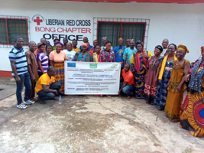Over the years, RHRAP has worked with community residents (Traditional, Community & Religious Leaders) of Gbarnga, Bong County providing them with trainings on how to promote and protect their fundamental human rights as required for by national and international laws. In 2011, RHRAP and community residents of Gbarnga worked together to establish the Citizen Action Committee (CAC) comprised of representatives from the 19 Zones of Gbarnga called Zonal Heads. The CAC also include Religious, Traditional Leaders. This group is an active Community Based Organization. Since 2011, RHRAP has continue to work with this group at various levels including the provision of trainings, advocacy engagements, amongst others.

***Working with the Prisons:***

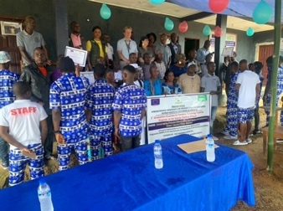RHRAP and partner are providing the following supports to the Kakata prison: Provide legal representation for prolonged pretrial detainees, provide rehabilitation and psychosocial training, provide medication, training of Correction Officers, the provision of resource (Reading Room) center for inmates, etc. RHRAP and partner also provided desk phones and support the refilling of phones (phone credit) for the use of inmates at the Sanniquellie, Gbarnga, and Bodinway Prisons. RHRAP has just extended these services to the Robertsports Central Prison, in Grand Cape Mount County. RHRAP monitored the prisons on a weekly basis and used the findings to engage in Criminal Justice policy dialogues and reforms to address issues identified from the monitoring.

|  |  |
| --- | --- |
| Rural Human Rights Activists Programme (RHRAP)  Broad and Gurley Streets-Raymond Building  2nd Floor-Apt. 15-Monrovia-Liberia  Republic of Liberia | Rural Human Rights Activists Programme (RHRAP)  Far East Community-Old UNCHR Junction  Gbarnga City, Bong County  Republic of Liberia |