**Historic** **Experimental Chrysler Jet Car Gets Feature-Length Documentary**

*Hagerty Drivers Foundation documents automotive icon with free in-depth film on the history of the Chrysler Turbine Car to complement 2022 National Historic Vehicle Register Inclusion*

**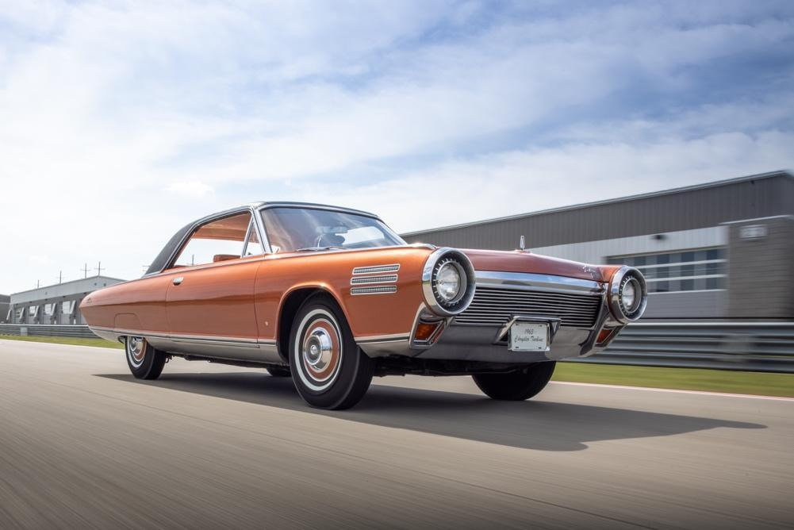**

**Traverse City, Mich., June 29, 2023** – The Hagerty Drivers Foundation, a 501 (c) (3) nonprofit organization, debuts documentary on the history of the Chrysler Turbine Car.

Link:  *[https://youtu.be/fOIrB1fwVPc](https://c212.net/c/link/?t=0&l=en&o=3908351-1&h=1546472243&u=https%3A%2F%2Fyoutu.be%2FfOIrB1fwVPc&a=https%3A%2F%2Fyoutu.be%2FfOIrB1fwVPc" \t "_blank)*

The film *The Chrysler Turbine Car: Engineering a Revolution* traces Chrysler’s groundbreaking efforts beginning in the 1950s to disrupt the automotive industry with their multimillion-dollar turbine research program. With the economy booming, the jet age at its peak, and the Jetsons representing the model TV family, Americans expected a marvelous cutting-edge future. The Chrysler Corporation was the only company with the gumption to double down and deliver the closest thing to a *REAL* jet car for the masses. Steve Lehto, turbine historian and author of *Chrysler’s Turbine Car: The Rise and Fall of Detroit’s Coolest Creation* and comedian, car collector, and Chrysler Turbine owner, Jay Leno are just two of the many people that provide insight into this fascinating endeavor. Told from the point of view of the engineers and mechanics that were responsible for the program and historians that have spent decades researching this incredible aspect of American automotive history, the film preserves the important story of Chrysler’s attempt to re-write the rules to automotive transportation.

While the program was a remarkable engineering feat, what really set Chrysler apart from its crosstown Motor City competitors is the user test program. In an unprecedented PR blitz and engineering trial, the Chrysler Corporation built 55 prototype cars in 1963 and 1964 and gave them to 203 members of the general public to gather user feedback. In the documentary, the Hagerty Drivers Foundation interviews the son of one of the chosen users who was a 16-year-old car lover when Chrysler delivered the concept car to his family’s driveway. He tells of what it was like to drive through small towns in America at a time when the mere idea of jet cars captivated the public and how that experience changed his life.

“While the Stahls Automotive Collection features many incredible examples of automotive history, our Turbine car is a standout. We are excited to present it to the public and see it inspire young people to understand the history of the automobile. This documentary uncovers and captures the heart of the people that were originally behind this car and those that continue to bolster its history all these decades later.” Terri Coppens, General Manager, Stahls Automotive Collection.

“The Chrysler Turbine represents this fascinating time in automotive history where a major manufacturer pushed the engineering limits while leveraging the power marketing to excite a car-crazed American public. We will likely never see a program like this again, but we can find inspiration in the challenges to bring a completely unorthodox technology to the mainstream. It is therefore, an important touchpoint in our nation’s history and essential to document for the National Historic Vehicle Register, ensuring the story lives on future generations,” said Casey Maxon, Senior Manager of Heritage for the Hagerty Drivers Foundation.

*The Chrysler Turbine Car: Engineering a Revolution* is being released for free on YouTube by the Hagerty Drivers Foundation to further its mission to preserve America’s automotive past for future generations. The Chrysler Turbine Car at the center of the documentary, Serial No. 9912-31, owned by the Stahls Automotive Collection in Chesterfield, MI, was added to the National Historic Vehicle Register in 2022 to further preserve this important aspect of automotive heritage.

***Additional photos of the Chrysler Turbine can be found*** [***here***](https://www.dropbox.com/scl/fo/2x4ogsfkyukib41zhmbts/h?dl=0&rlkey=57c15hjphkyd2i7ksxdw9ne0u)***.***

**About Hagerty Drivers Foundation**

The Hagerty Drivers Foundation is a 501c3 nonprofit launched in 2021 by Hagerty. With the purpose of shaping the future of car culture while celebrating our automotive past, the Hagerty Drivers Foundation provides scholarships for students in the automotive field of education, as well as students seeking formal driver education training. In addition, the Foundation continues to build a federally recognized program – the National Historic Vehicle Register – that documents and records the important history of our automotive past. For more information, please visit https://driversfoundation.org/.

**Media Contact**

Andy Heller, Hagerty  
[aheller@hagerty.com](mailto:aheller@hagerty.com)Mobile: 231-632-1583