KS5 Physics – Stress and Strain
Name: _______________________________
As you work through the video, press pause to enable you to think, and to complete this worksheet. You will need separate paper to answer the questions, in order to show your working out / give full explanations!
Questions
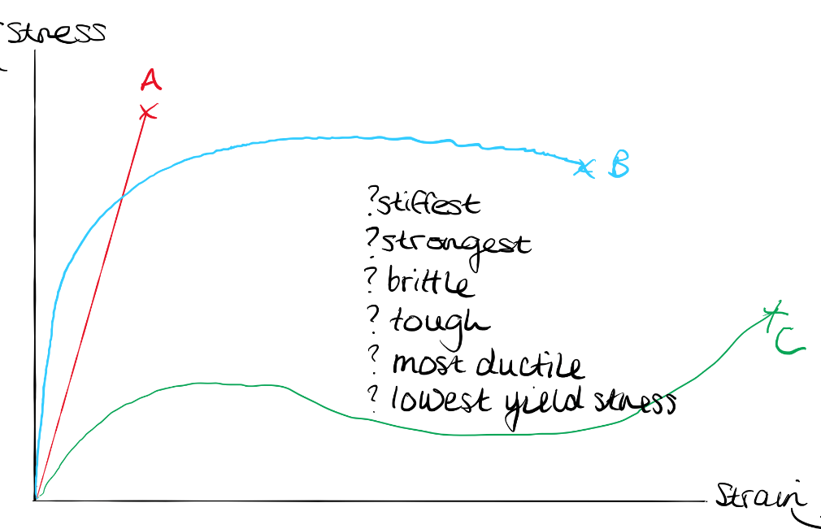

- Look at the graph above. Which line is for the material that…
  - Is the stiffest? _________
  - Is the strongest? _______
  - Is brittle? _______
  - Is tough________
  - Is the most ductile? ______
  - Has the lowest yield stress? _____

- Convert the following cross-sectional areas into m²:

  - 70mm²

  - 350 cm²

- The diameter of a rope is 1.2 cm. What stress would a load of 0.75 kN exert on the rope?

- A climbing rope has an ultimate tensile stress of 3100MPa. How thick would the rope need to be, to support a load of 15000N?

- A 50m rope will stretch about 7cm under a given load. Calculate the size of the tensile strain.

- A material is quoted has having a strain of 3%. If an unstretched length measures 5m, what would the stretched length be?

