Living Things and Their Habitats: Identify and name common plants and animals

Key Stage 1

Activity: Can you find….?
Go and spot different plants and animals outside (take a grown up!)
Remember to be careful, do not disturb or hurt living things. Put them back where you found them.
Make a detailed drawing of some of the things that you find. Look really closely. You could take photographs too.

Activity: Match the cards
Can you match the pictures to the names of these plants and animals?
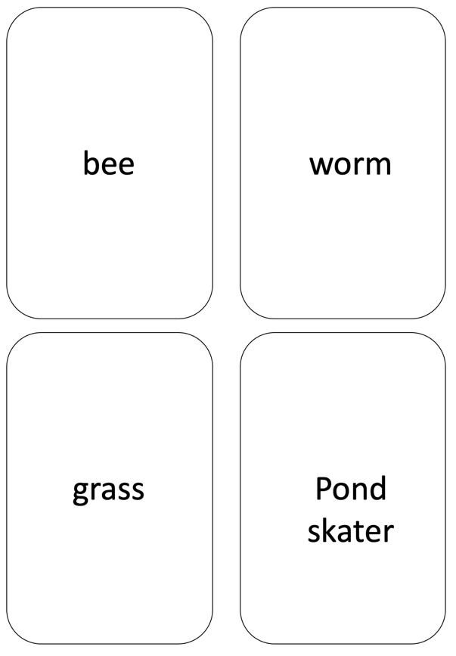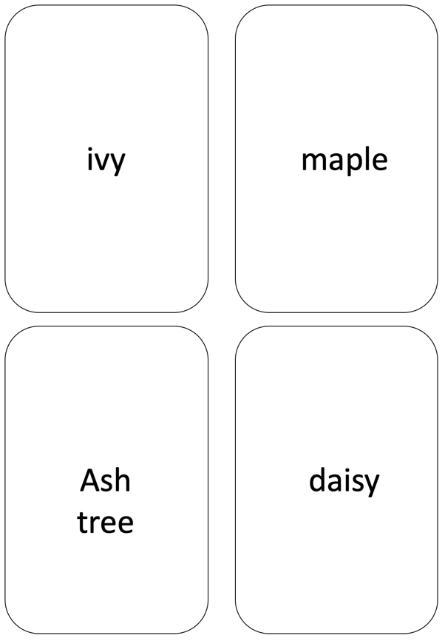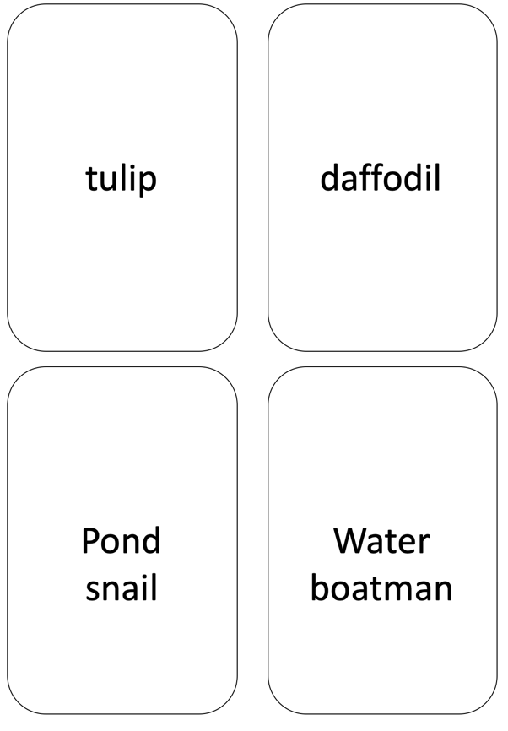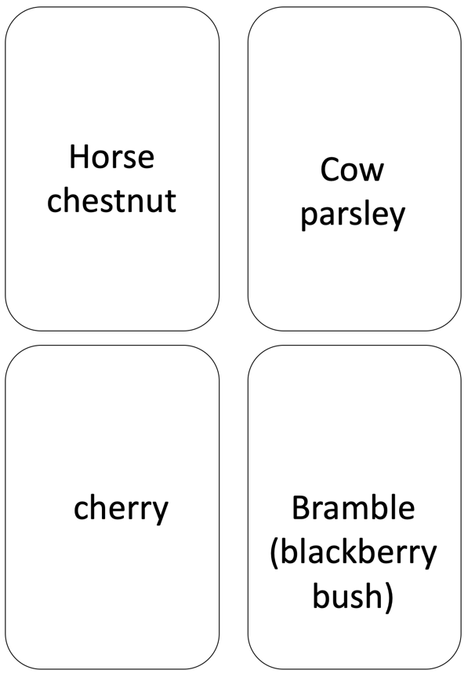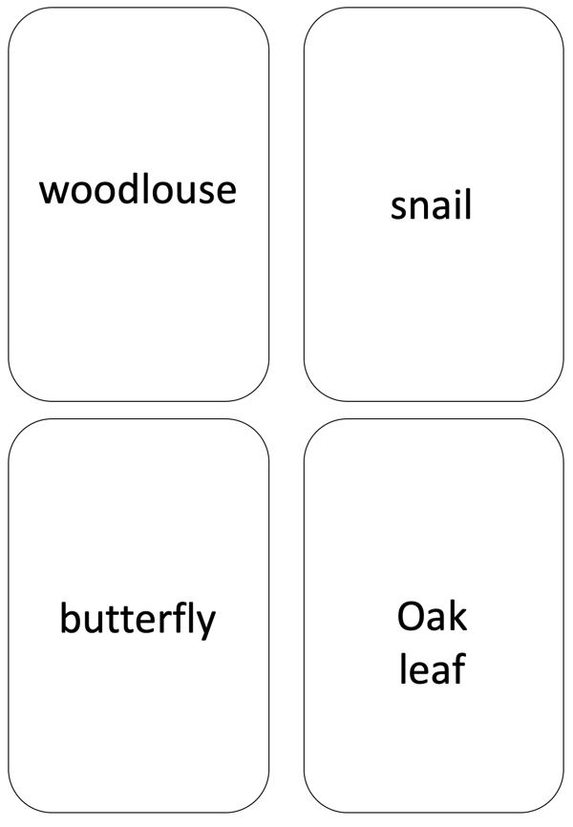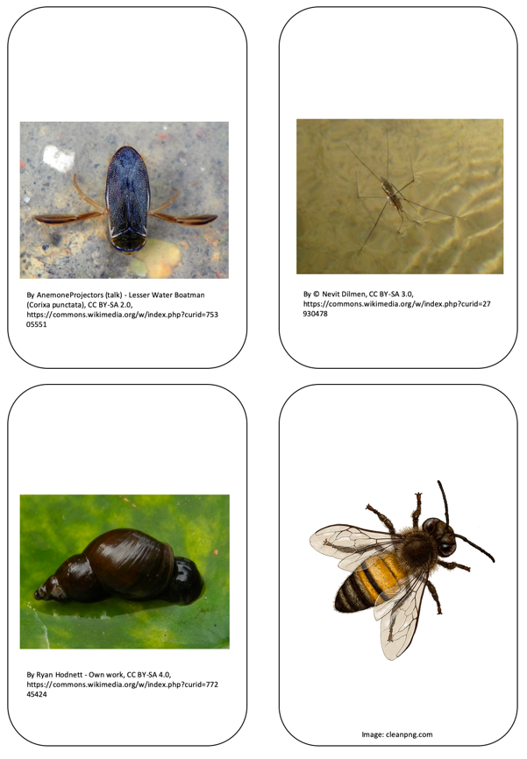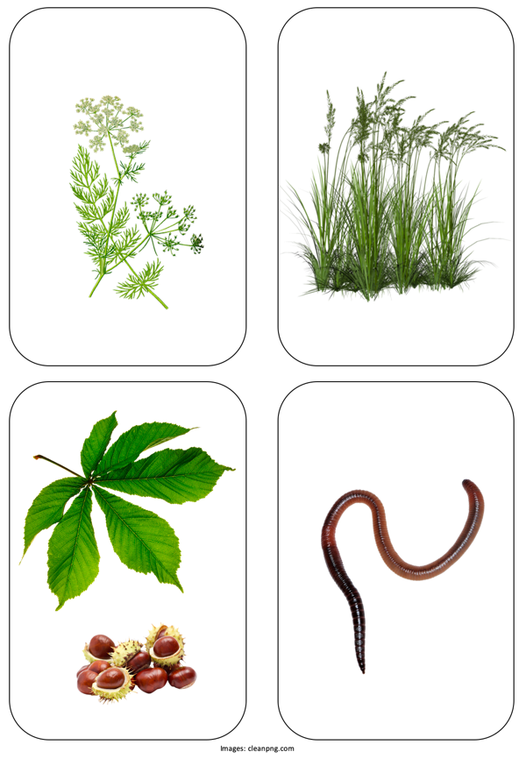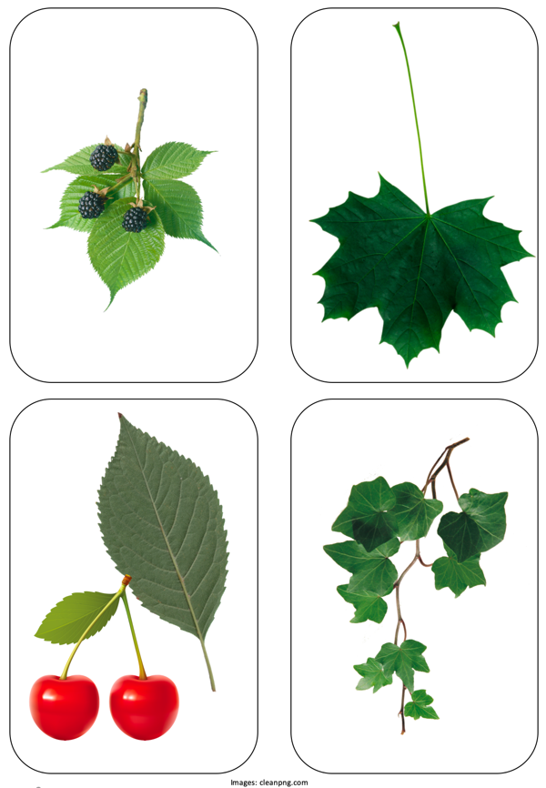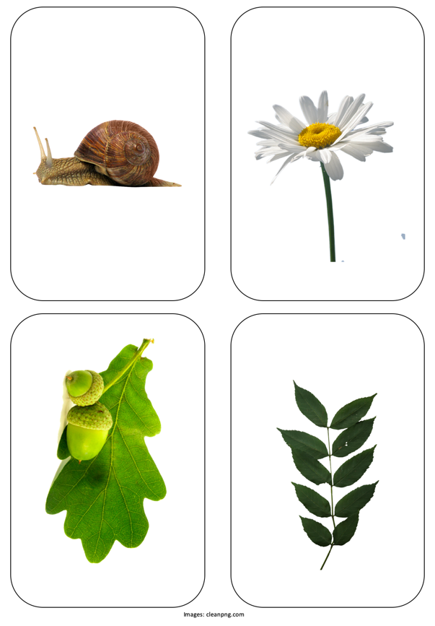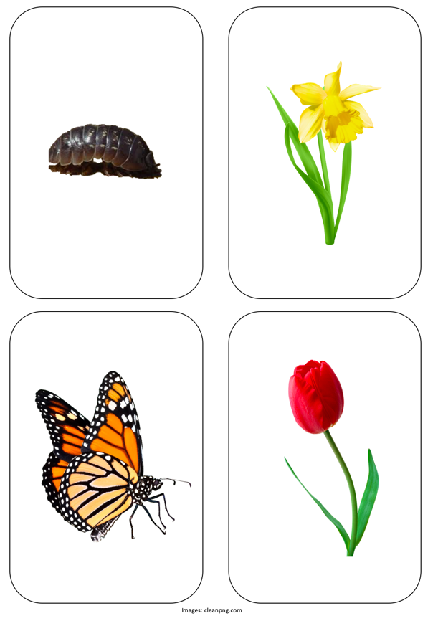

Activity: Find out more
Watch this BBC clip of woodland, pond and ditch habitats
www.bbc.co.uk/bitesize/clips/zf6mhyc
Find even more activities about living things and their habitats (suitable for home learning) at:
https://www.stem.org.uk/resources/elibrary/resource/34255/grouping-and-classification-suitable-home-teaching
https://www.stem.org.uk/resources/elibrary/resource/29002/perfectly-printable-puzzles-suitable-home-teaching

Activity: Snap Trumps ID
Play a card game:
- Print out two sets of the picture cards above (or draw your own) and play a game of card snap – calling out the name of the plant or animal each time you turn over a card. Take it in turns and call snap when the cards match!
- Create your own Trumps card game by adding some number details to the cards, for example:
  - How many of each did you find?
  - How big is the plant or animal?
  - You could just give each one a mark out of 10 for cuteness or beauty
Then you compare your scores with the other player.
- Create your own cards by drawing pictures of the plants and animals you find in your school grounds or near where you live using these blanks:


