Staying Healthy: The importance of Exercise, Nutrition and Hygiene

Activity: Nutrition

We need to eat a balanced diet of different types of food to eat and drink 6-8 glasses of water every day.
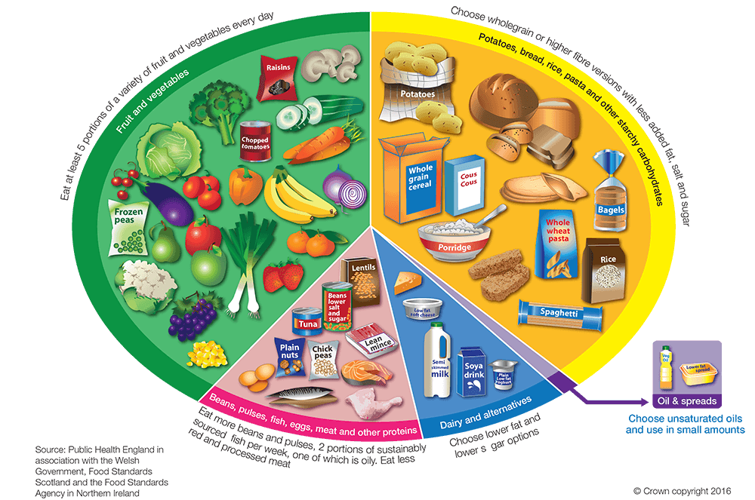

Can you find examples of food to put in each of these groups? Use the pictures on the next page or find food from the kkitchen.

Cut out these foods and arrange into groups:
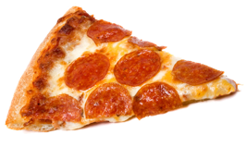
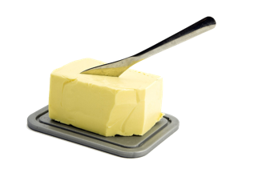
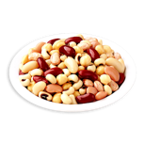
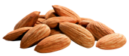
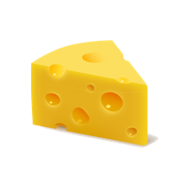
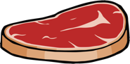

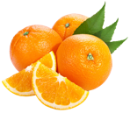
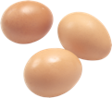


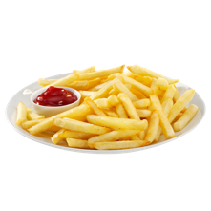

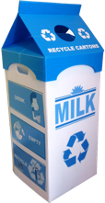
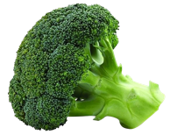
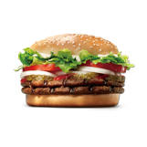

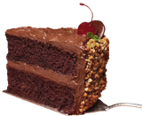
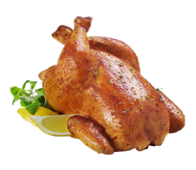
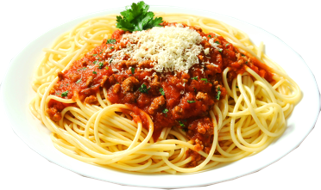
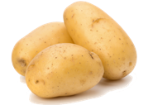
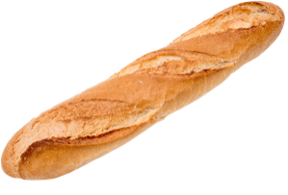

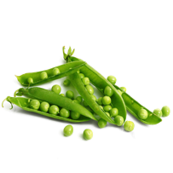
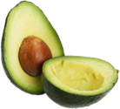

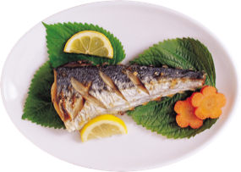
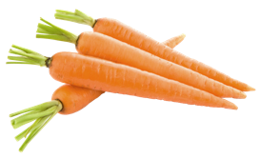
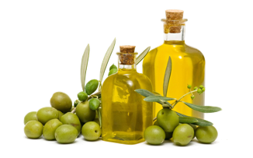

ClipArt from CleanPNG
You can also find more activities linked to nutrition at:
https://www.stem.org.uk/resources/community/resource/310469/eatwell-guide
https://www.stem.org.uk/resources/elibrary/resource/465023/street-food-superstars-english
https://www.stem.org.uk/resources/elibrary/resource/34184/snacks-snakes-and-ladders

Activity: Exercise

Can you find out the effect of exercise on your heart rate?
Measure your pulse (heart rate) by using two fingers on your wrist and counting how many beats in 60 seconds (1 minute)
- Measure your pulse before you exercise (resting)
- Jump around! Do 20 star jumps, run on the spot and so 20 bunny hops
- Measure your pulse again
- Rest for 5 minutes
- Measure your pulse again
- Record your findings in the table below
What happens to your heart rate?

 | Before (resting) | During exercise  (20 star jumps, run on the spot and 10 bunny hops) | After exercise  (rest for 5 minutes)
My heart rate (beats per minute)

You could even try making a graph of your results.
You can also find more activities - Train Like an Astronaut at: https://www.stem.org.uk/elibrary/resource/31444

Activity: Hygiene

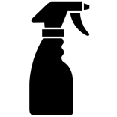
Make a sneeze gun!

You will need:
- A clean spray bottle
- Some water (optional addition of colour, but be careful where you spray it!)
- A board or large sheet of paper or wall outside

Use a spray bottle with trigger spray to be a pretend sneeze!
Watch how far the droplets travel; stand at different distances to your board/wall/paper and measure how wide they reach (you could try drawing around the area and mark the distance from the board eg 10cm, 30cm, 1m, 2m, 3m).
Remember to ‘Catch it, Bin it, Kill it’ when you cough or sneeze!
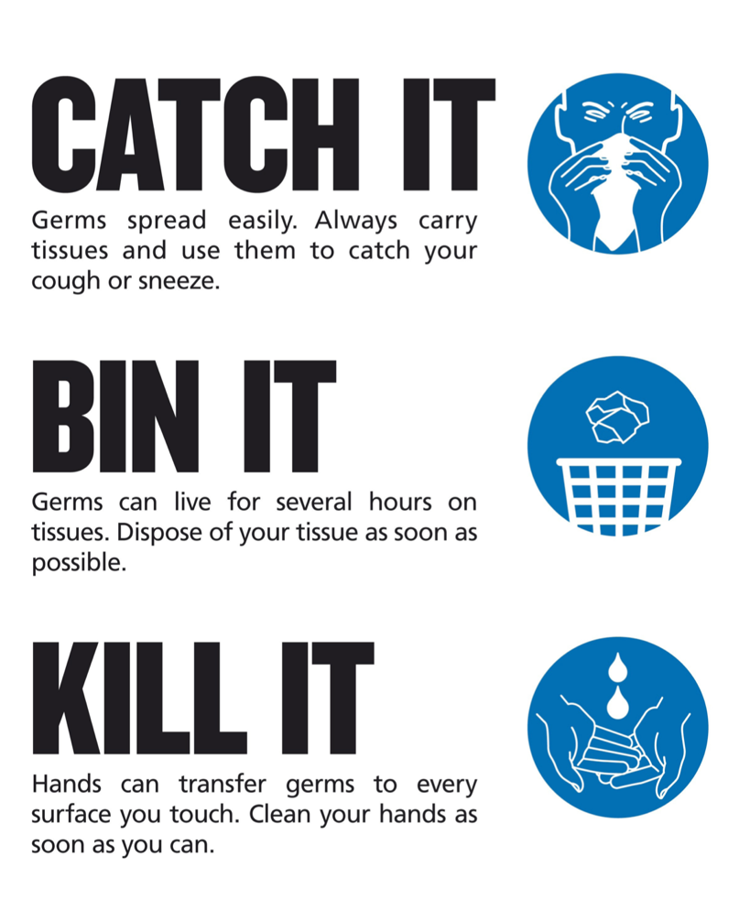
Watch this BBC short video clip on sneezing and germs at https://www.youtube.com/watch?v=BPXY8Xa8icw

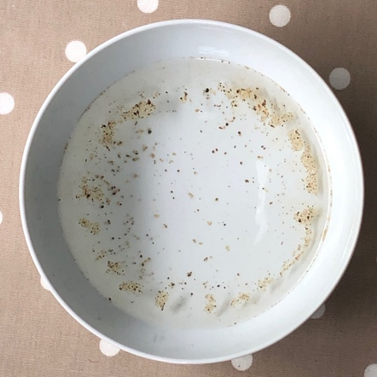
Activity: Hygiene

Scared pepper

Can you make the tiny specks of pepper ‘run away’?
You will need:
- Bowl of water
- Some ground pepper
- Some liquid soap or washing up liquid
Grind or scatter some ground pepper onto the surface of the water in the bowl.
Dip one clean finger into the water. What happens?
Now, put a small amount of liquid soap onto a clean finger and try dipping this finger into the water. What happens this time?
The pepper should ‘run away’ and all move to the edges of the bowl and start to sink.

What’s happening?
This is sometimes used to demonstrate how effective soap is at getting rid of germs when you wash your hands.
Whilst it looks good, this isn’t actually what’s happening to germs when you wash your hands.
The pepper floats on the surface of the water because of something called surface tension. The molecules of water are attracted to each other and it’s almost like they are holding hands to make a protective barrier at the surface. When you add soap to this, it disrupts (or stops) the surface tension (a bit like all the molecules have let go of each other’s hands) and this lets the pepper sink. It moves to the edges because the surface tension is first broken in the middle where you dip your soapy finger.

Activity: Hygiene

Stop the spread

Can you ‘see’ how far germs might travel? You could try doing a version of the UV pretend germ powder activity in the video with something you can see without a UV torch – perhaps use glitter glue or hand gel or paint (take care not to get paint on anything that can’t easily be cleaned!) to be pretend ‘germs’
- Put a small amount of glitter gel or paint on one hand
- Watch how far the ‘germs’ could spread by touching several objects or other people’s hands and see how far traces of the gel or paint go…
- Remember to wash everything carefully
If these were real germs you could have spread them from one person to another, or onto different surfaces like door handles, tables, chairs or water bottles!
You can stop the spread by coughing or sneezing into a tissue, blowing your nose and throwing the tissue in the bin and remember to wash your hands!
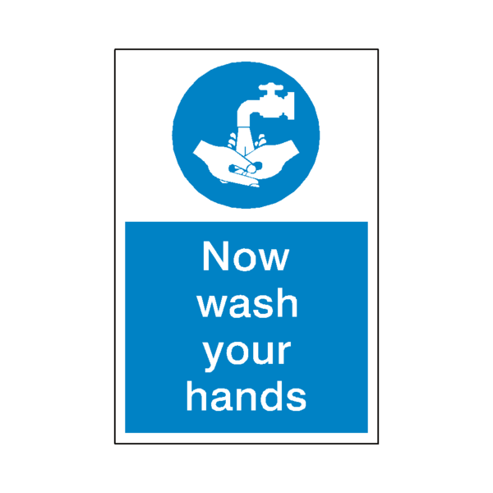

Activity: Hygiene

Show me how

Choose one of the following:
- design a poster to help people wash their hands properly?
- make up a song to sing to help remember how to wash their hands
- write a list of instructions for hand washing
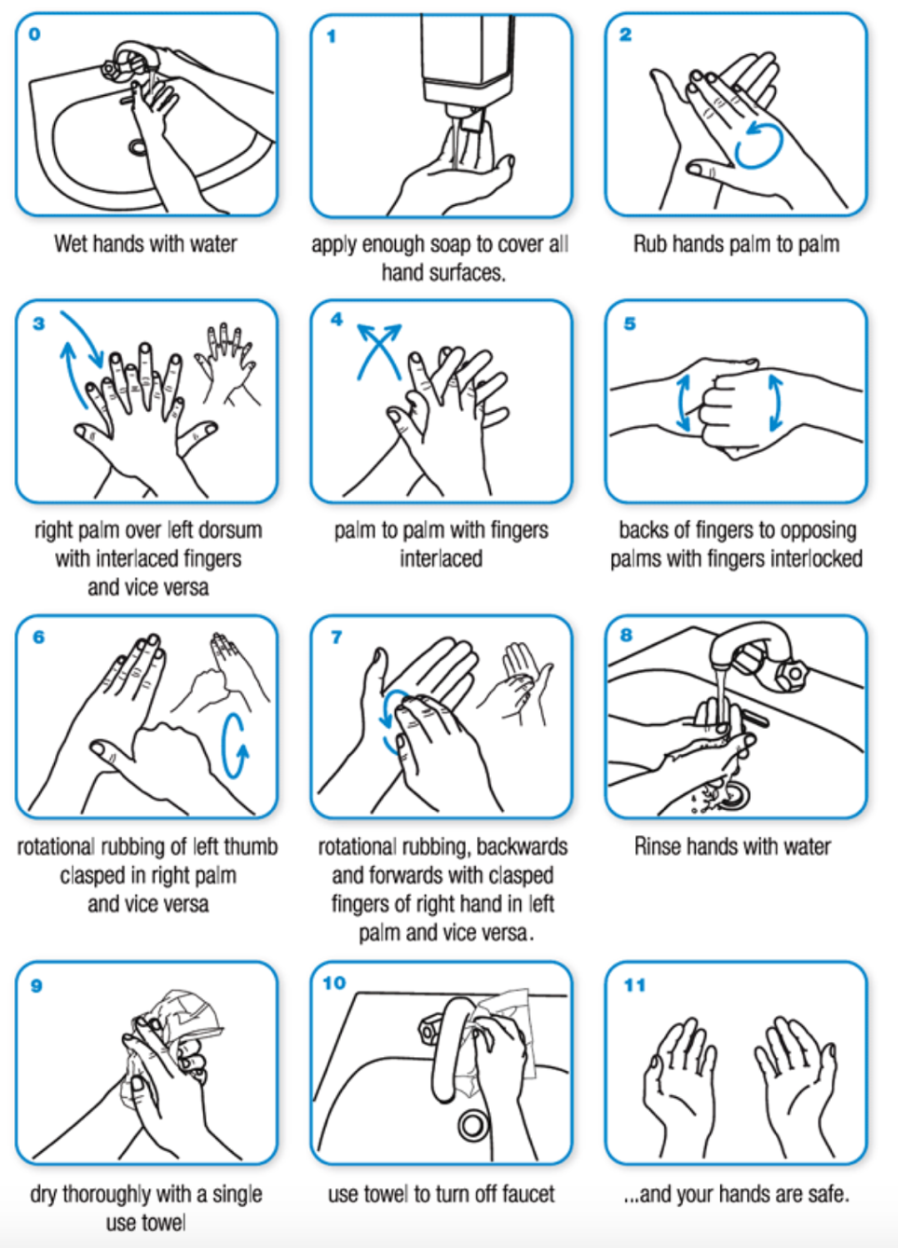
Image credit: www.who.int/gpsc/clean_hands_protection/en/

