Animals including humans

Key Stage 1:

Parts of the Human Body

Activity: Draw around your body – and label it
If you have a hard area where you can do this safely outside, why not draw around your body in chalk (or ask a grown-up helper). If not, you could stick old newspaper sheets, or blank paper, together and draw around your body. Can you label different parts?
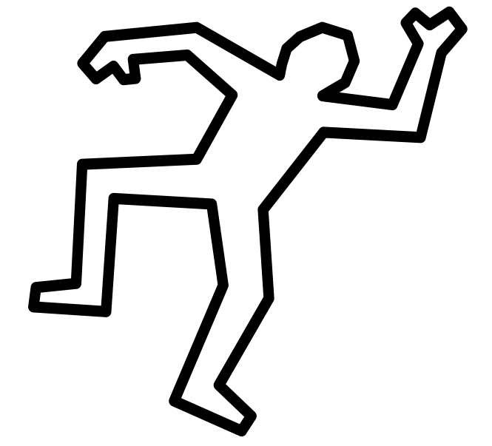image: cleanpng.com

Activity: Can you label the parts of the body?

Head | Ears | Eyes | Nose | Mouth
Neck | Elbow | Arm | Leg | Knee
Feet | Hands | Hair | Shoulders | Face
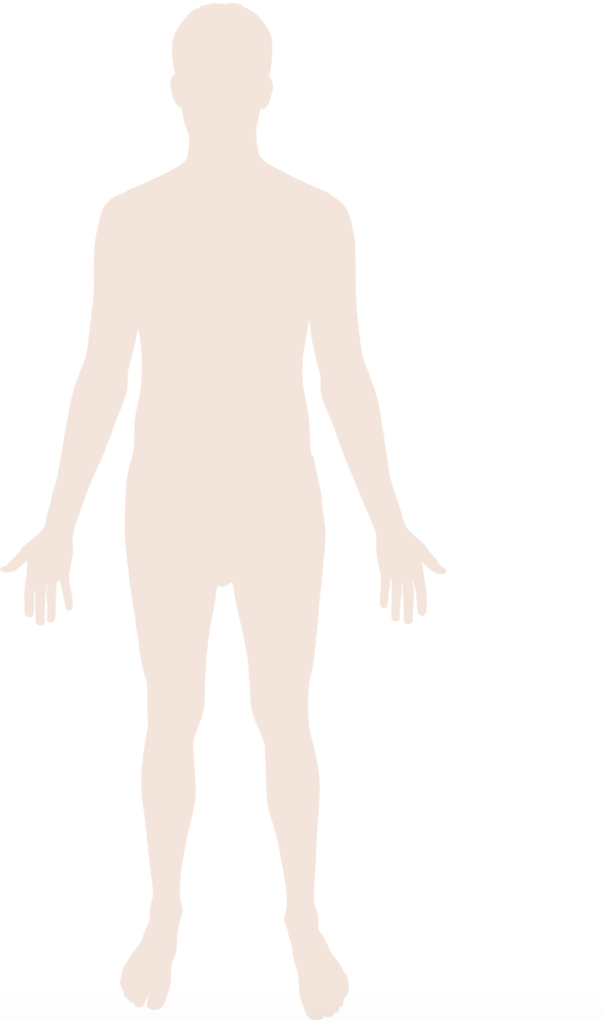

Activity: Parts of the face
Can you find and label the different parts of the face?
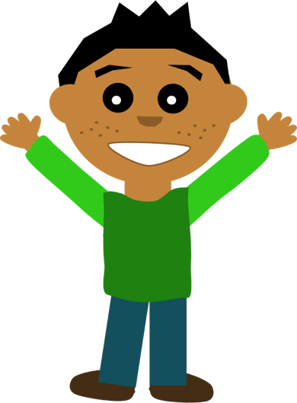Image: cleanpng.com

Eyes | Head
Ears | Face
Mouth | Nose

What senses do we use our nose, mouth, eyes and ears for?

Activity: Play ‘Simon says’
Play a game of ‘Simon says’, where one person gives instructions, such as:
- Simon says touch your nose
- Simon says bend your knees
- Simon says cross your legs
- Simon says pat your head
- Touch your ear (!)
And the other person/people do the action - but ONLY do the action IF the instruction starts with ‘Simon says’. If you touched your ear (without ‘Simon says’), you’re out. Play again.

Activity: Sing Head, Shoulders, Knees and Toes
Sing the song Head, Shoulders, Knees and Toes and do the actions:
🎵 🎶 Head, shoulders, knees and toes
🎵 🎶 Knees and toes
🎵 🎶 Head, shoulders, knees and toes
🎵 🎶 Knees and toes
🎵 🎶 And eyes and ears and mouth and nose
🎵 🎶 Head, shoulders, knees and toes
🎵 🎶 Knees and toes!
Can you make up any more lyrics with different body parts?

Activity: A little Quiz
Here’s a little quiz to check what you’ve learned about the parts of the body.
Tick the correct answers

- Which of these might you find on a face?
Eyes
Mouth
Knees
Hands
Nose

- Which of these protect our head?
Arms
Mouth
Hair
Elbow

- What do elbows do?
Help us to bend our legs
Help us to bend our arms
Help us to walk
Help us to taste

- What does the neck do?
Connect body to legs
Connect hands to arm
Connect feet to legs
Connect head to body

Activity: Find out more
Parts of the body
https://www.bbc.co.uk/bitesize/topics/z9yycdm/articles/zqhbr82#zpbdjxs

How do we change as we grow?
www.bbc.co.uk/education/clips/zt7w2hv BBC Bitesize 35 second clip on growing older
www.bbc.co.uk/education/clips/z4tmhyc BBC Bitesize Growing and changing.

