Classification and Grouping

lower Key Stage 2

Activity: Can you put these living things into different groups?
How many ways could you sort them?
For example, what they look like, where they live etc.
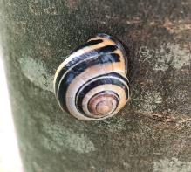
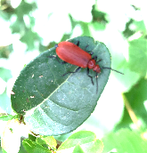
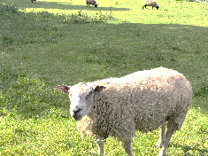
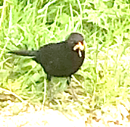
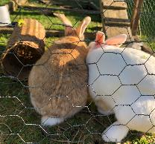
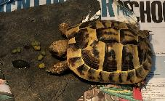
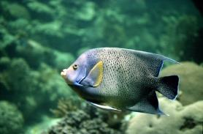
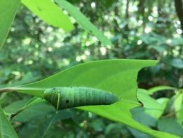
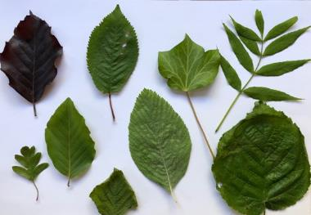
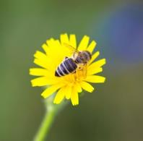
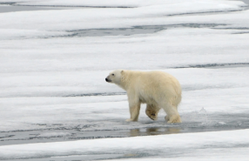
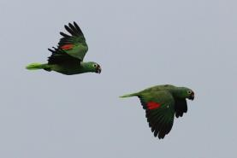
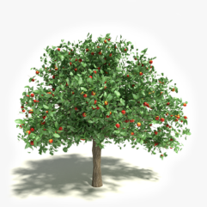
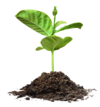
Image: www.piqsels.com
Image: Jo Montgomery
Image: www.piqsels.com
Image: www.cleanPNG.com
Image: www.cleanPNG.com
By CSIRO, CC BY 3.0, https://commons.wikimedia.org/w/index.php?curid=35475199
sharpphotography.co.uk, CC BY-SA 4.0, commons.wikimedia.org/w/index.php?curid=80879131
www.all-free-photos.com
Images: Jo Montgomery

Activity: Can you sort these animals into groups based on their observable features?
By CSIRO, CC BY 3.0, https://commons.wikimedia.org/w/index.php?curid=35475199

https://www.stem.org.uk/resources/community/resource/363665/animal-sorting-cards
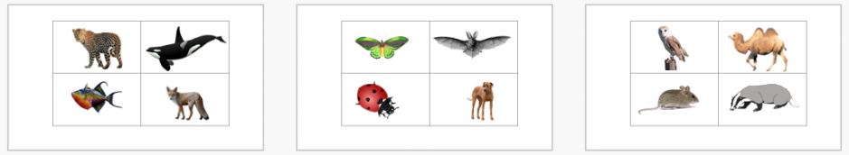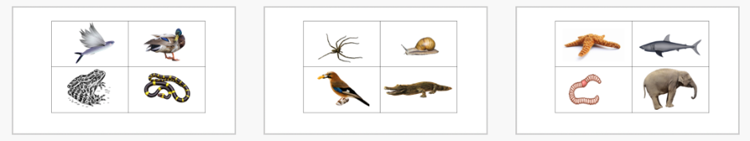

Activity: Have a look in your local are for plants or animals and create a classification key, or use one, to identify them
By CSIRO, CC BY 3.0, https://commons.wikimedia.org/w/index.php?curid=35475199

Other resources
Bird spotter sheets https://www.stem.org.uk/resources/elibrary/resource/417954/birds-spotter-sheets-suitable-home-learning
Invertebrate spotter sheet https://www.stem.org.uk/resources/elibrary/resource/417950/invertebrates-spotter-sheets-suitable-home-learning
Leaf ID from The Woodland Trust
https://www.woodlandtrust.org.uk/blog/2020/03/tree-id-kids/

Activity: Create a classification key to identify these sweets
By CSIRO, CC BY 3.0, https://commons.wikimedia.org/w/index.php?curid=35475199

For example, you could ask Yes/No questions such as:
- Is it all black?
- Is it more than one colour?
- Is it bobbly?
- Is it striped
- Does it contain liquorice?

Lay your classification key out a bit like this:
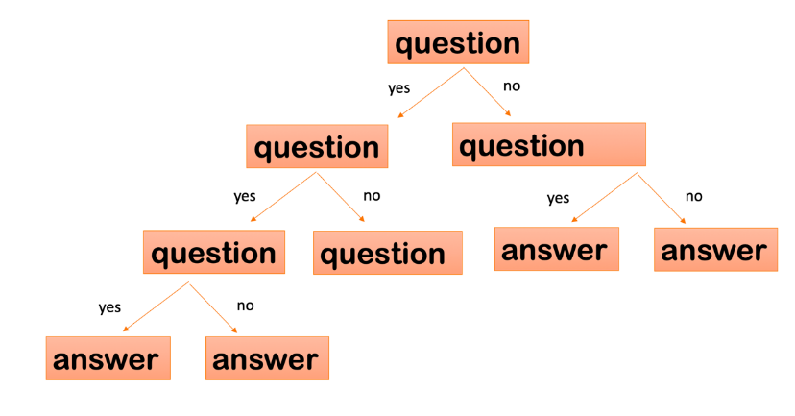

Activity: Do some secondary research to find out how environments change over time
By CSIRO, CC BY 3.0, https://commons.wikimedia.org/w/index.php?curid=35475199


Images: cleanPNG.com

Activity: Do some secondary research to find out the positive and negative impact humans can have on environments

Images: cleanPNG.com

