KS5 Standing waves
Q1)
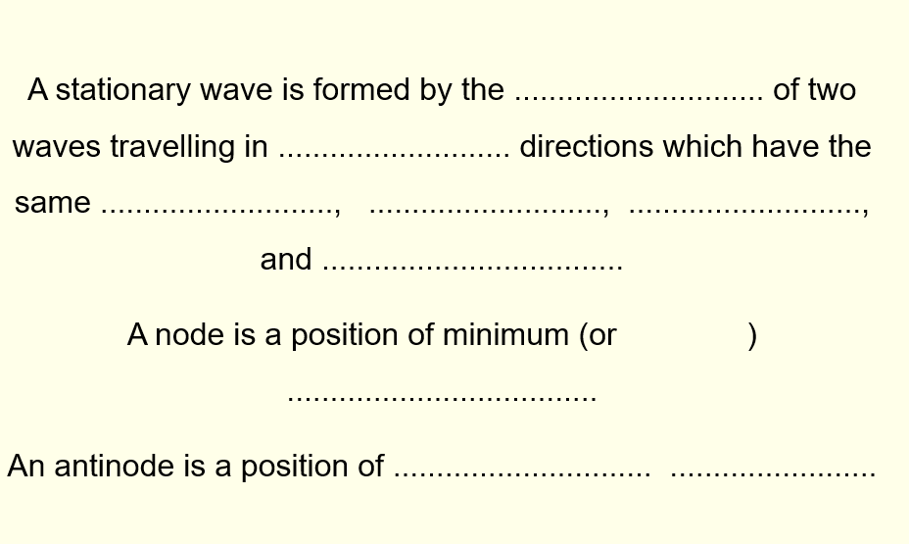
Q2)
Figure 1 is a diagram of a microwave oven.
Figure 1
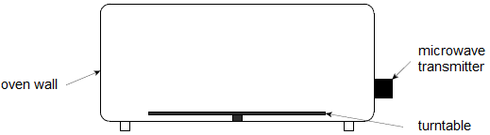
A student wants to use the stationary waves formed in the microwave oven to measure the frequency of the microwaves emitted by the transmitter.
(a) Suggest how stationary waves are formed in the microwave oven.
(2)

(b) The student removes the turntable and places a bar of chocolate on the floor of the oven. He then switches the oven on for about one minute. When the chocolate is removed the student observes that there are three small patches of melted chocolate with unmelted chocolate between them. Figure 2 is a full-sized diagram of the chocolate bar.
Figure 2

Suggest why the chocolate only melts in the positions shown.
___________________________________________________________________
___________________________________________________________________
___________________________________________________________________
___________________________________________________________________
(2)
(c) Calculate, by making suitable measurements on Figure 2, the frequency of the microwaves used by the oven.
frequency = ____________________ Hz
(5)
(d) Explain why most microwave ovens contain a rotating turntable on which the food is placed during cooking.
___________________________________________________________________
___________________________________________________________________
___________________________________________________________________
(1)
(Total 10 marks)

I hope you go and explore standing waves in physics. Acoustic levitation is a real thing. There are lots of examples in the internet. For example.
https://phys.org/news/2016-08-acoustic-levitation-large-sphere.html

