Adaptation and Evolution KS2

Activity 1 – The peppered moth story

You will need:
2 pieces of white or light paper
2 pieces of black or dark paper
Scissors

Keep one sheet each of the light and dark paper as background.
Cut 6-8 small triangles (pretend moths) from the light and dark paper.
First place lots of light triangles (moths) and a few dark moths on the light background.
Imagine you are a bird picking off the ones which are most easy to see. Mostly light moths remain. Add a few extra light moths as these are most likely to survive and reproduce, making more light peppered moths.
Add some extra light moths.
The Industrial revolution caused pollution to increase and trees to blacken.
Now try the same on the dark background (a few dark moths and lots of light moths).
Imagine you are a bird picking off the ones which are most easy to see. Now mostly dark moths remain. Add a few extra dark moths as these are most likely to survive and reproduce, making more dark peppered moths.
The air was gradually cleaned up and trees lightened again. Go back to the light background and move the moths across.
Imagine you are a bird picking off the ones which are most easy to see. Now mostly light moths remain again. Add a few extra light moths as these are most likely to survive and reproduce, making more light peppered moths.

Which peppered moths are better adapted to the current tree colour?

Activity 2 – Zwimble World Survival of an imaginary animal in an imaginary environment

Choose the features from the list on the left for your imaginary Zwinble dog in Zwimble land, draw a picture and then keep count of how many Zwimble dogs you have at the end of the activity.
(see the story on next page).

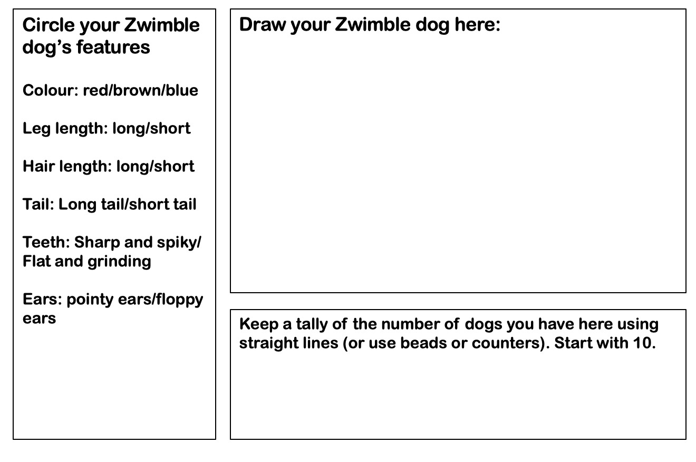
This has been adapted from a popular teaching activity.

The story of Zwimble world
Welcome to the land of Zwimble dogs.
Tall Zwimble dogs, short Zwimble dogs. Zwimble dogs with long legs and spiky teeth. Zwimble dogs with floppy ears and some with big, sharp claws. A huge variety of Zwimble dogs all living in their Zwimble dog land.
Make sure that you now have ten Zwimble dogs tallied onto your page. We are going to follow the story of your Zwimble dog.
1st generation Zwimble dogs: It’s the height of summer, the hottest summer that has ever been and temperatures soar at 38 degrees. Zwimble dogs with long hair suffer from dehydration. Short haired Zwimble dogs, however, roam around freely and don’t get too hot.
If your Zwimble dog has long hair they can’t keep cool and some die without having babies; lose 3 Zwimble dogs. If your Zwimble dog has short hair it is more likely to survive and reproduce; gain an extra 3 Zwimble dogs.
2nd generation: The offspring of your first Zwimble dogs roam the land and food is plentiful. The Zwimble dogs are happy. However, forest fires spring up, ravaging the land and consuming everything in their wake. Long legged Zwimble dogs are able to run quickly and are better able to out-run the spreading fires. Short legged Zwimble dogs, sadly, are more likely to be consumed by the flames.
Long-legged Zwimble dogs are more likely to survive and reproduce; gain 4 Zwimble dogs. Short-legged Zwimble dogs sadly lose out – lose 3 stickies.
3rd generation: The great grand-dogs of your first Zwimble dogs are now in charge. It’s springtime and blood-sucking ear mites are in breeding season. Zwimble dogs with long tails can swish away the flying monsters although having pointy ears are makes some Zwimble dogs an easy target.
If your Zwimble dog has a long tail it is more likely to reproduce than those with a short tail. Long tailed Zwimble dogs, gain 5 dogs, short tailed Zwimble dogs lose three. If your Zwimble dog has pointy ears, halve in number, if your Zwimble dog has floppy ears, add five.
4th generation: The great great grand-dogs of your first Zwimble dogs pound along. It’s been a tough year and the normal food source of the Zwimble dog (Zwimble zebra) are few and far between and Zwimble dogs have had to look for new things to eat. Luckily, Zwimble Dog Land also has a large number of Zwimble-trees which grow Zwimble nuts. Not quite as tasty as the zebra but very nutritious.
Zwimble dogs with flat grinding teeth are able to grind away at the hard shells of the Zwimble nut to get to the nutty prize. Zwimble dogs with sharp pointing teeth aren’t so lucky so many go hungry and die. If your Zwimble dogs have sharp teeth, lose 4 Zwimble dogs. If your Zwimble dogs have grinding teeth gain an extra 10.
5th generation and our story is coming to an end: Shhhhh! A new predator is on the loose and it finds Zwimble dogs very tasty. Long legs won’t help, nor will good hearing. The only thing that might save you is camouflage. Red Zwimble dogs blend in a little with the red flowers on the top of the Zwimble-trees. Brown Zwimble dogs are the masters of disguise and look just like the tree trunks of all the vegetation found in Zwimble-dog land. Blue Zwimble dogs, you stick out like a sore thumb and will make a very tasty meal. Red Zwimble dogs, gain 5, blue Zwimble dogs lose 5, brown Zwimble dogs add 10.
Now count up the number of Zwimble dog you have at the end of 5 generations.

Links for further optional activities

How to hunt banded snails
https://www.stem.org.uk/elibrary/resource/34437
The peppered moth
https://www.stem.org.uk/resources/elibrary/resource/25294/evolution-peppered-moth
Darwin’s finches
https://www.stem.org.uk/resources/elibrary/resource/35391/evolution-darwins-finches-suitable-home-learning
Wellcome Trust: The Tree of Life
https://www.stem.org.uk/elibrary/resource/30498
Video on Variation, Evolution and Inheritance
https://www.stem.org.uk/resources/elibrary/resource/34341/professor-steve-jones-variation-evolution-and-inheritance
Discussion on future human characteristics
https://www.stem.org.uk/resources/elibrary/resource/34879/evolution
Animation about evolution still happening
https://www.stem.org.uk/elibrary/resource/28506
A series of lessons on fossils and evolution https://www.stem.org.uk/resources/elibrary/resource/35345/evolution-and-inheritance-game-survival

