Animals Including Humans – camouflage
Activity 1: SPOT THE MOTH
- Choose a surface such as a wall, a tree trunk, a fence or any other vertical surface.
- Using the template below, design a moth which will be camouflaged against this surface. Use paints, crayons or felt tips to create suitable colouring and patterns OR use things in the environment to decorate it.
- Attach the completed moth to the surface.
- Stand as far away from the surface as possible, and then walk closer and closer until you spot the moth. Measure the distance to the moth when you spot it.
- Repeat with other moths.
- The moth with the shortest distance is most likely to survive, as a predator has to be really close up before it is spotted. Look carefully at the camouflage. Why was it successful and how does it compare to real moths?

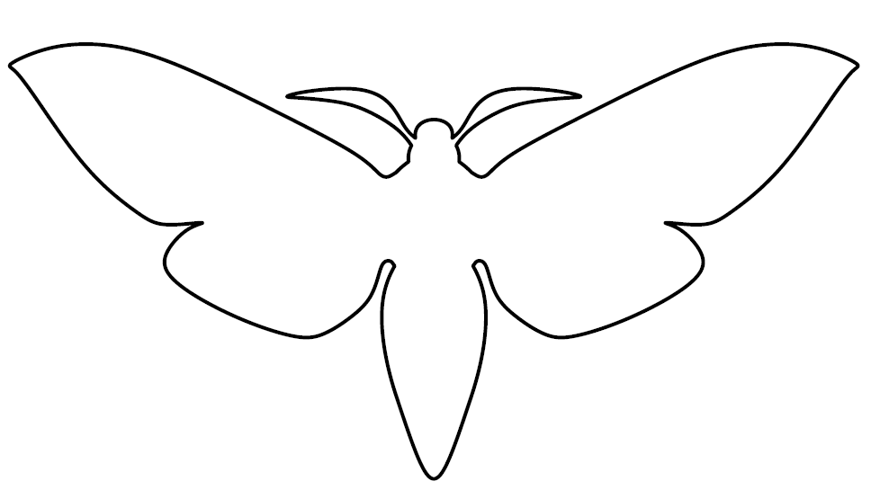
(moth-pattern, PatternUniverse.com, https://patternuniverse.com/download/moth-pattern/, Patterns may be used for personal, non-commercial purposes only. They may not be distributed or published elsewhere. You may download and print these for classes.)

Activity 2: SPAGHETTI WORMS:
Create different coloured ‘worms’ by dyeing cooked spaghetti. Put them outside where birds might find them. Which colour ‘worms’ get eaten first? Which colour worm would you prefer to be?

Links to further activities:
https://www.stem.org.uk/elibrary/resource/29024
Look for the following downloads:
- Help the animals camouflage themselves - use pictures of animals and habitats to find out who goes where, where they will feel safe and maybe have a game of hide and seek with a helper.
- Camouflage Yourself – can you dress or decorate yourself so you blend into a background at home?
- Camouflage Notebook - get outside and see how many animals you can find. Use this booklet to record your own observations of how animals camouflage themselves.

