Properties of Materials: Separation Key Stage 2

Activity: Group materials according to their properties
Remind yourself of the properties of materials by finding objects from around the house, grouping them according to whether they are solids, liquids, or gases then use these cards from The Royal Society of Chemistry to match materials to their properties:
https://edu.rsc.org/resources/materials-cards/2360.article

Activity: Soluble or insoluble?
Test a range of different materials to see if they dissolve: are they soluble (dissolve) or insoluble (do not dissolve). You could try:
- Salt
- Sugar
- Coffee
- Sand
- Soil
- Herbs and spices
Record your results in the table below.
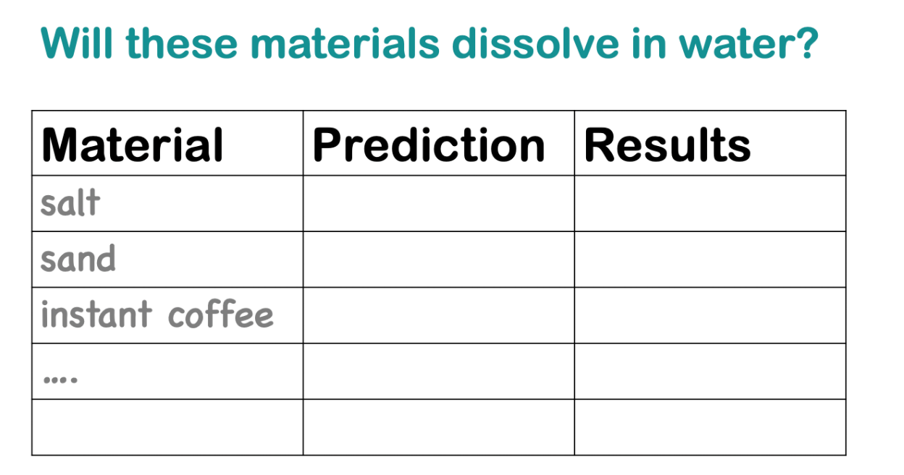
This is a comparative test. You are comparing different materials.

Activity: Dissolving - a Fair test
Carry out a fair test to investigate dissolving.
Choose one of the materials from the activity above which did dissolve in water (for example, sugar).
Now, investigate which variables could change whether the sugar dissolves or not.
Only change one variable at a time.
Variables (things) to keep the same:
- The material (eg sugar)
Variables (things) you could change (only change one in each investigation):
- The amount (volume) of water
- The temperature of the water (be careful with hot water! Get a grown up!)
- The amount of material (eg sugar)
- Number of times you stir the solution
Does the volume of water affect the rate of dissolving? Or the temperature of the water? What about the amount (quantity) of sugar? Or the number of times you stir it? Only change one thing each time you investigate. What makes the sugar dissolve the quickest?

Activity: Separating
- Make a mixture using things like water, soil, stones, leaves, paperclips, sand, salt.
- Choose some appropriate equipment to separate your mixture.
What will you do?
You could…. Sieve or filter your mixture.
Evaporate.
Use a magnet.
Equipment you might use:
- Sieve or colander
- magnet
- Cloth, fabric or cotton wool
- Coffee filter/filter paper
- Funnel
- Bottle
- Stones, beads, lentils
- Sunshine/heat (such as a radiator) to evaporate

Activity: Further investigations
Further investigations from STEM Learning
Teachers TV videos on materials and separating https://www.stem.org.uk/resources/elibrary/resource/30667/materials
activities to investigate magnetic materials https://www.stem.org.uk/resources/elibrary/resource/446800/magnetic-materials

