Biology at Home – video 4

Behaviour and adaptation task sheet

This task sheet supports the activities suggested by Alan in Biology at Home video 4. The main focus of this video is to get you looking at the adaptive features of the living things around you and also to ask questions that you can try and answer by carrying out your own experiments. Please keep a record of what you do in your journal/notebook or on your phone.

Rather than list all of the tasks given in the video a summary is provided below under two sections: adaptation and behaviour. You do not need to carry out all of the activities suggested and it may be that you have your own ideas for what you would like to do. Please let us know what you find out during the question and answer sessions.

Adaptation

In the video Alan mentions that a flea can jump as high as St Paul’s Cathedral – what should he have said so this statement would make sense?

Here is a summary of some of the questions you could answer and experiments you could carry out:
- How do the hairs on the underside of leaves help a plant to reduce water loss?
- How do insects and other animals see colour and why might their colour vision be different to ours?
- How do seaweeds ensure they get enough sunlight when under water? Why are the three types of seaweed so different (saw wrack, egg wrack and bladder wrack)?

- If you have a dog why don’t you compare her to Lilly? How might the body of your dog be different?

- Create your own adaptation Top Trump cards for your favourite animals.

- Find out about the experiments carried out by the Priest Spallanzni in the 1700’s. What did he do to prove that bats ‘see’ with their ears?

- If you get the chance to visit the beach you could investigate shell size in Limpits? Are their shells taller in sheltered or exposed places and why might that be?

- Eight years ago Alan and Ruby tried to work out how many newts there were in the pond. The caught and identified 10 and put them back. A few days later they caught 20 and found that 4 of those they could identify from before. Can you use these figures to estimate the number of newts? What math’s skills are you using to solve this problem?

Behaviour

Find some daisy flowers and watch them open during the day and close at night. The same process allows plants to bend towards the light – can you find out how this happens? What role do hormones have in this process?

In the video Alan suggests a number of experiments that you could carry out:
- Build a wormery.
- Investigate which foods invertebrates prefer.
- Find out which foods would work best in a wasp trap.
- Set up a choice chamber to find out what conditions woodlice prefer.
- Observe the behaviour of the animals in your garden just like Alan did with the bees.
- Find out if pigeons can tell the time, how intelligent snails are and if fish can learn colours.

At the end Alan thinks out loud and suggests a number of other experiments that might work. Which of these would you like to try?

Close up quiz

Can you identify what each picture is?
One of the pictures is not from a living thing – can you work out which it is?

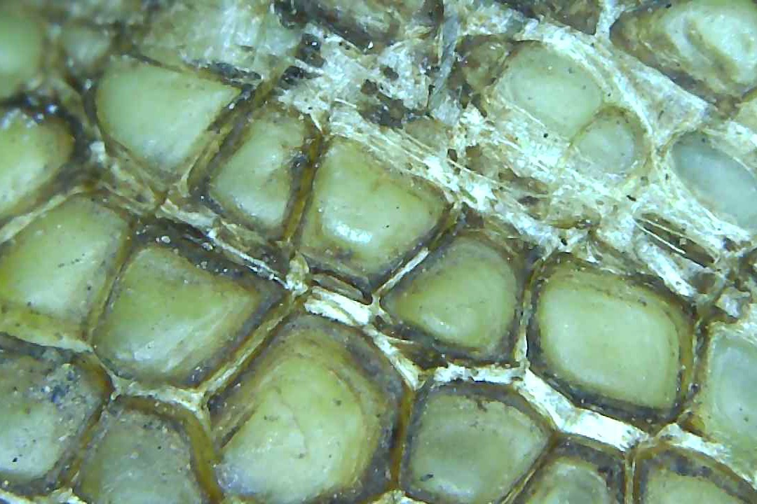 | 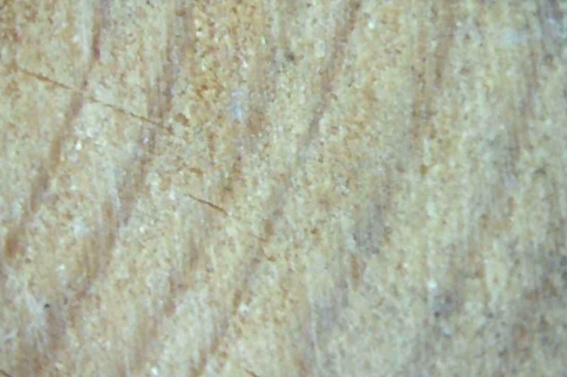 | 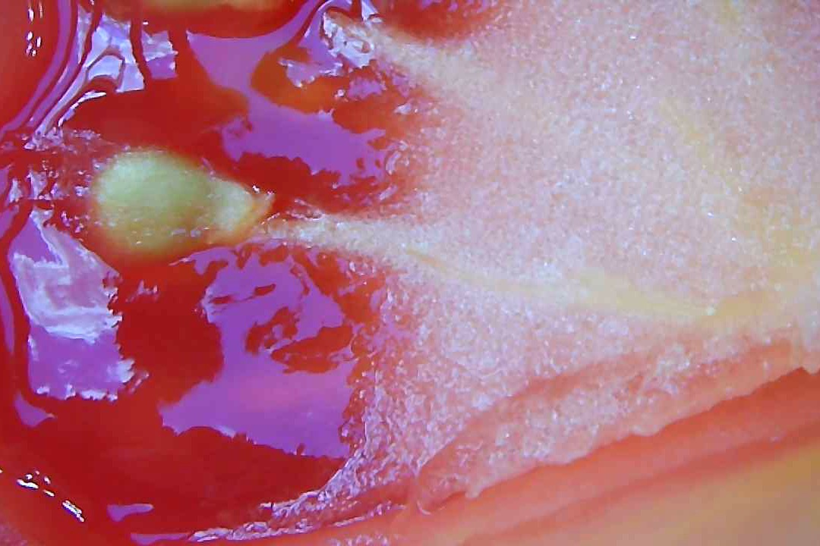
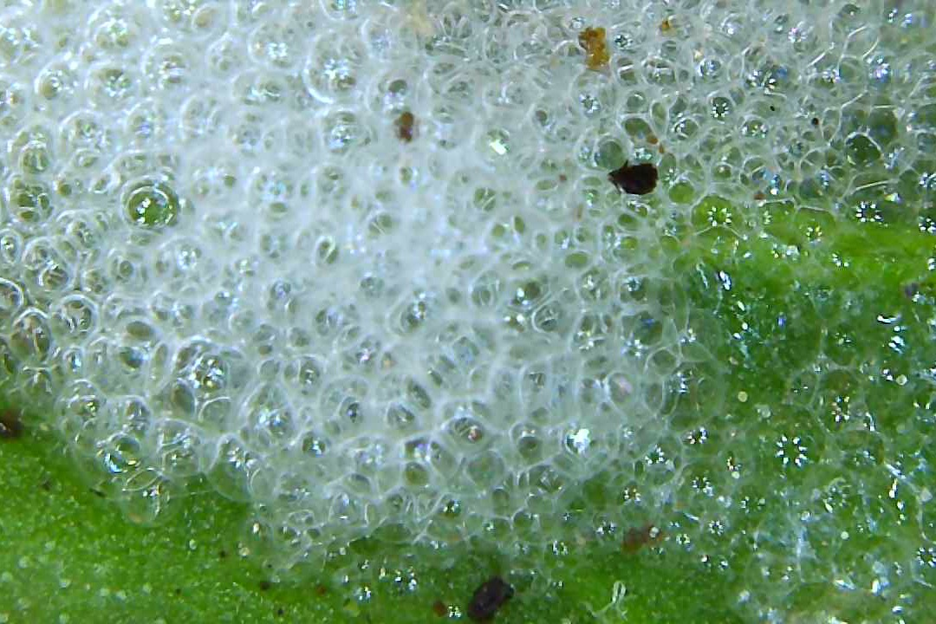 | 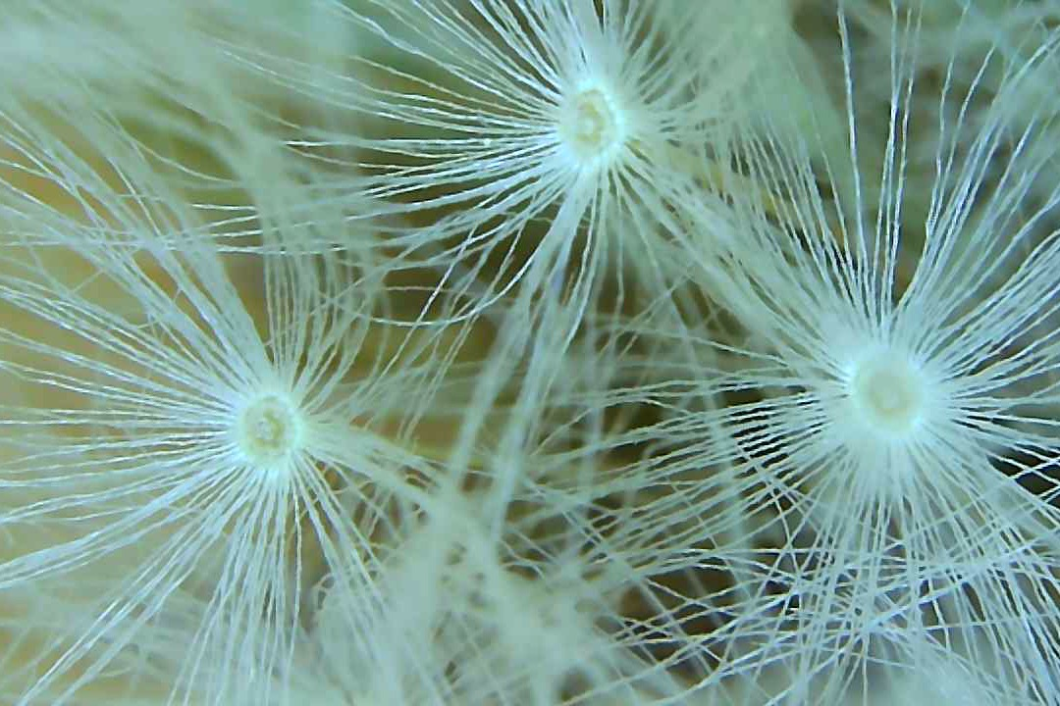 | 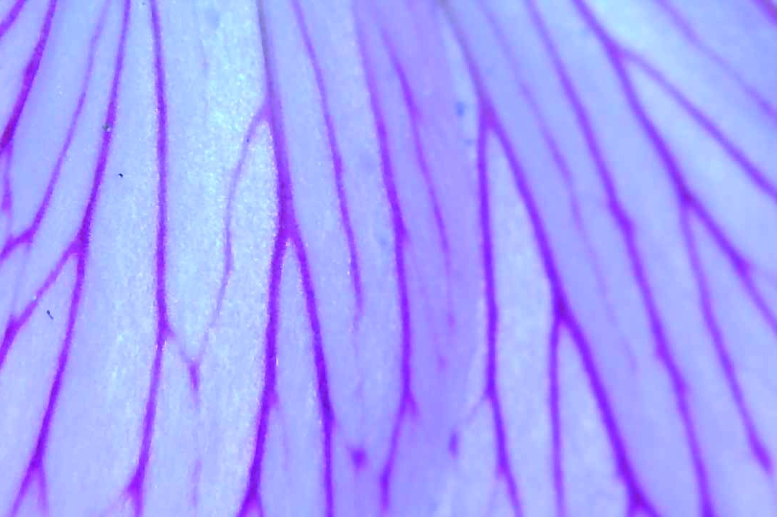
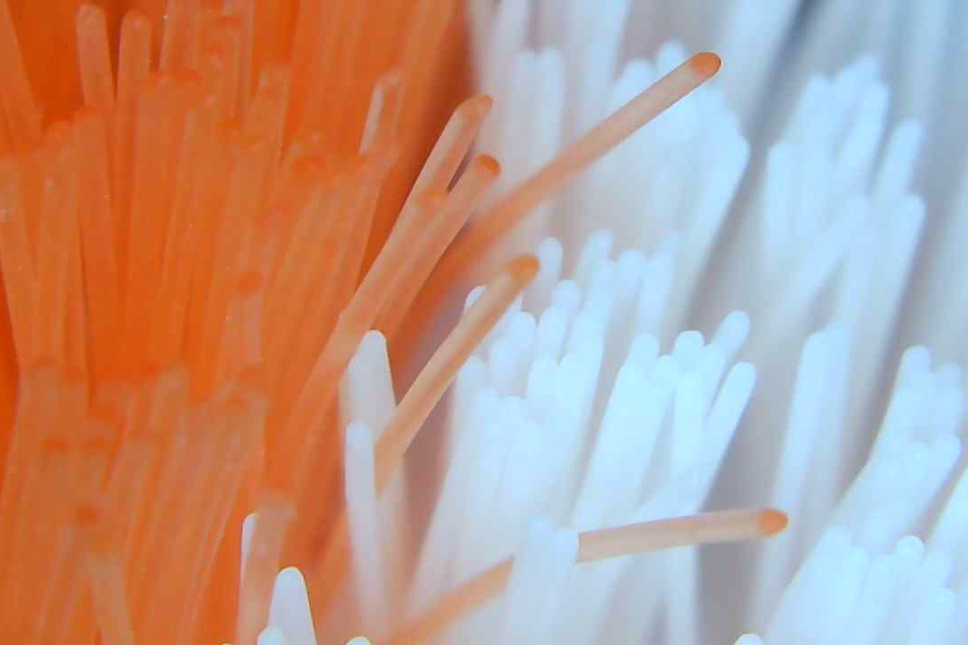 | 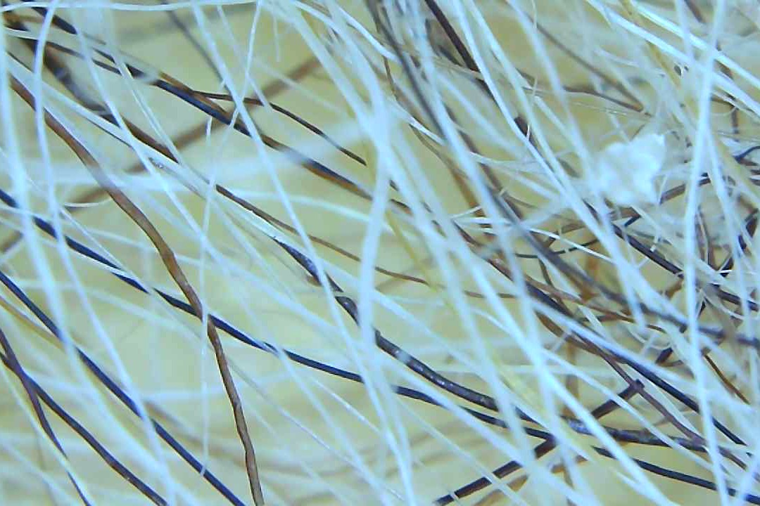 | 