Light – how do we see things?

Name: _______________________________
As you work through the video, press pause to enable you to think, join in, try some of the activities, and write the answers on this worksheet. You will then be able to take it back into school to show your teacher! To join in with some of the activities, you will need a piece of paper, a pen/pencil, sticky-tape or blu-tac, mirror, torch and an object you can’t see through!


- Watch this video https://www.bbc.co.uk/bitesize/clips/zjkc87h
then complete the table, giving examples of natural and artificial sources of light:

Natural sources of light | Artificial (man-made)

- The moon is not a source of light. Explain why we can still see it at night:

- Match the following words with the correct description. The first one has been done for you!
Nearly all light passes through these objects
Opaque
Translucent
Artificial
Transparent

No light can pass through these objects

Another word for ‘man-made’

Some light passes through – but you can’t see clearly

- Watch this video about light, reflection and shadows https://www.bbc.co.uk/bitesize/clips/zg6r82p
Write down something new you learnt from this video:

- After you have done your investigation into how to change the size of shadows, complete the following sentences:

If you move a light source closer to an object, the shadow gets ______________________
If you move a light source further away, the object’s shadow gets_____________________

- To learn more about light, visit the following websites:
https://www.stem.org.uk/resources/community/collection/12719/year-3-light
https://www.stem.org.uk/resources/community/collection/12741/year-6-light
https://www.bbc.co.uk/bitesize/topics/zbssgk7/articles/z2s4xfr

Are you ready for a Challenge?
Why not try the Challenges below – we’d love to see your attempts on Twitter – tag us @NwySlp and we will comment back!
Challenge 1 – Make a periscope!
Use these links to make your own periscope to see around corners!
https://www.cnhs.org/ourpages/auto/2018/5/9/54422247/Periscope.pdf
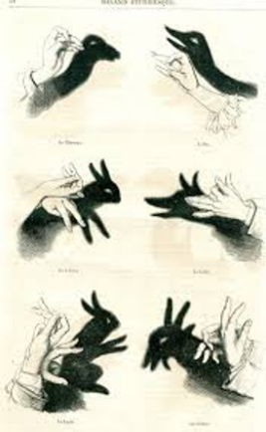
http://www.webinnate.co.uk/science/docs/periscope_pattern.pdf
Challenge 2 – Make your own string instrument
Make some shadow puppets using card, or your hands. Put on a puppet show for family and friends!
https://www.stem.org.uk/resources/elibrary/resource/35265/making-shadow-puppets
https://commons.wikimedia.org/wiki/File:Hand_Shadows_I_(7356719426).jpg

How did you get on? Upload your photo/video onto Twitter – tag us @NwySlp

