Properties of Materials: Irreversible Changes Key Stage 2

Activity: Group materials according to their properties
Remind yourself of the properties of materials by finding objects from around the house, grouping them according to whether they are solids, liquids, or gases then use these cards from The Royal Society of Chemistry to match materials to their properties:
https://edu.rsc.org/resources/materials-cards/2360.article

Activity: Chemical reactions
Can you investigate an irreversible chemical change? Mix some sodium bicarbonate (we often use it in the kitchen to help cakes or pancakes rise in cooking!) with some vinegar or lemon juice.
Use small quantities and keep away from eyes and skin. Rinse immediately with water in case of splashes and spills. Adult supervision required.
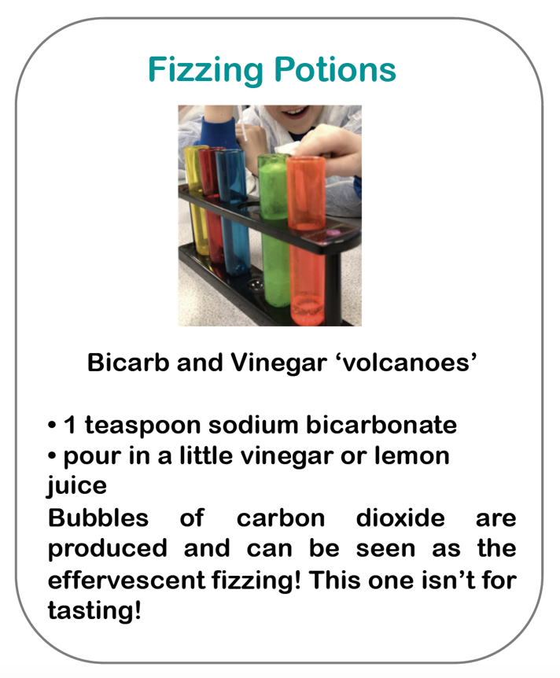
NB Do not use heat or investigate burning without close adult supervision.

Activity: Physical and chemical changes
Fill in the gaps:
Some ______________ to materials such as dissolving, mixing and
changes of states are reversible.

Some changes to materials such as burning wood, rusting and
mixing vinegar with sodium bicarbonate result in the formation of
new materials and these are not ______________________.

Reversible means it can be changed back. Irreversible means it
_____________________ be changed back.

You can separate some materials from solutions or mixtures by
evaporating, __________________ or sieving.

Some simple reversible changes include _______________________
ice to get water or ____________________ water to get steam.

An example of an irreversible reaction can be a physical change,
such as cutting a loaf of ________________, or a chemical change
such as __________________ metal or ____________________ wood.
Missing words:
burning | cannot | heating
melting | changes | reversible
filtering | rusting | bread

Activity: Secondary Research
Find out about some new materials which have been produced by chemists:
- Research Spencer Silver and sticky note glue

- Research Ruth Benerito and wrinkle free cotton



