Food Groups
Think about the different foods that you have eaten in the last few days. Sort them into the different food groups. Some foods may appear in more than one column.
Starchy Food | Fruit and Vegetables | Milk and Dairy | Fat and Sugar | Proteins

Food Label Collection Sheet

Carry out a survey of different foods or drinks. Look at the food labels and find out how much sugar there is per 100ml or 100g.
Write the results down in the table below
Name | Amount of sugar per 100ml or 100g

Plot this data as a bar graph.

Which had the most sugar?

Which had the least sugar?

Eatwell Guide
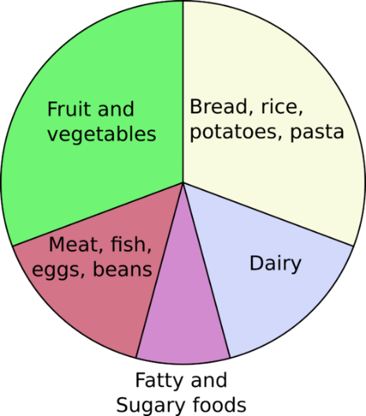

Use this guide to plan your meals.

Fruit and Vegetables
Starchy Food
Protein Foods
Milk and Dairy
Fat and Sugar

