Worksheet: States of matter (KS2)
As you work through the video, press pause to enable you to think, try some of the activities and write the answers on this worksheet. You will then be able to take it back into school to show your teacher. If you don’t have a printer, don’t worry – why not just use a piece of paper and follow the video instructions.

Section 1 – States of matter

Challenge 1: Go around your house and gather as many different materials/ objects as you can – group them together based on which of the three states of matter you think they are in. Use what we have learnt to help you and rewind the video if you need. Can you describe the properties of each of the objects?


Challenge 2: Create a flow chart that shows step by step how someone can group a material as a solid liquid or gas. Use what we have learnt to think about the questions you would use (the questions need yes or no answers)
Example flow chart:
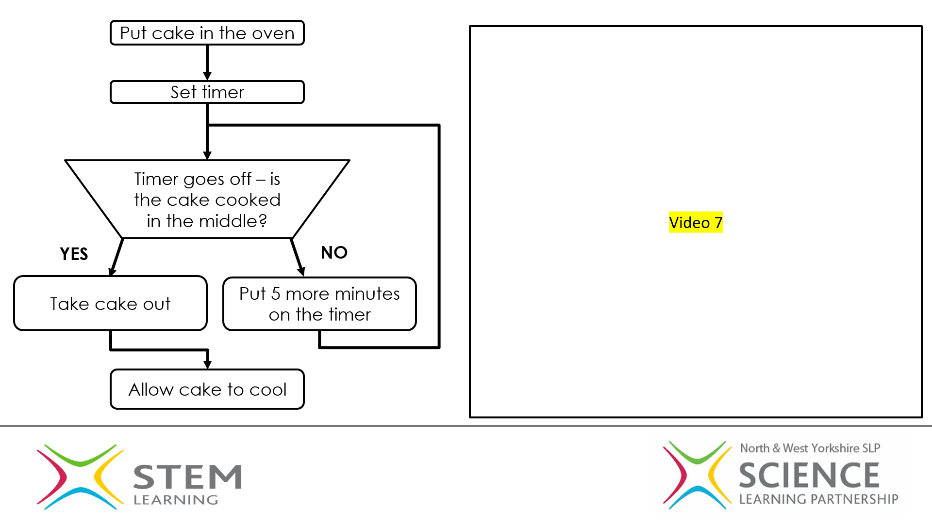


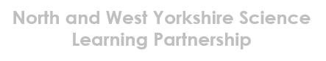
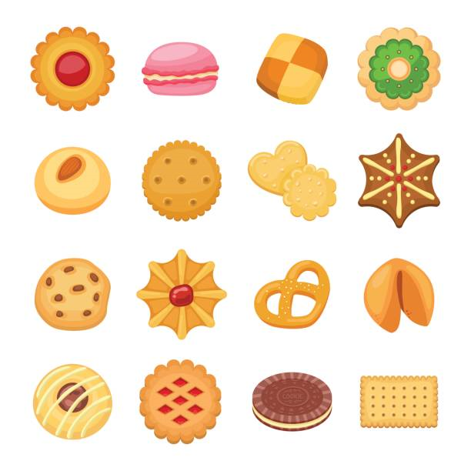
How did you get on? Upload your photo/video onto Twitter – tag us @NwySlp
Explore this topic further using the following resources:

Solid
Liquid
Gas
_________________________________________________________________________________________
_________________________________________________________________________________________
_________________________________________________________________________________________
Draw or write down the objects you have found in each box

What properties do they have?

Section 2 – Changes of state
1.Complete the changes of state diagrams by filling in the coloured boxes using the changes of state keywords from the video lesson
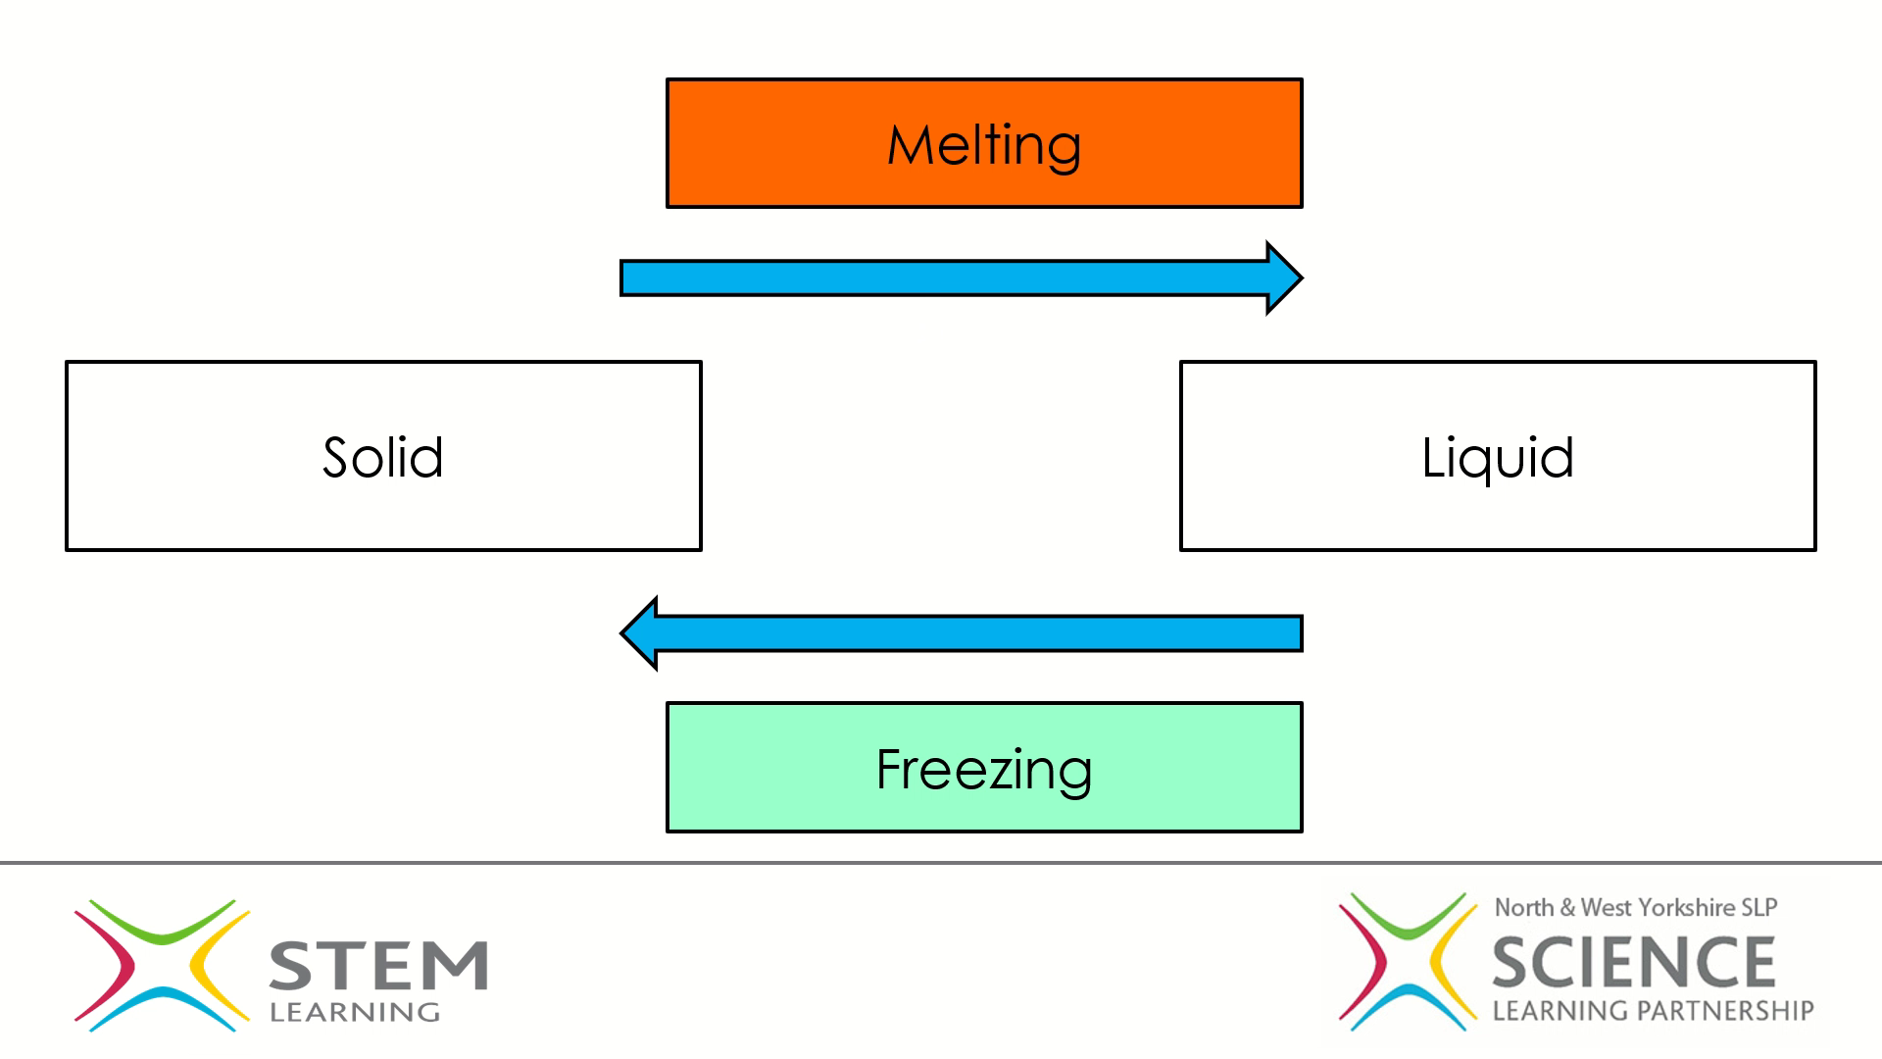
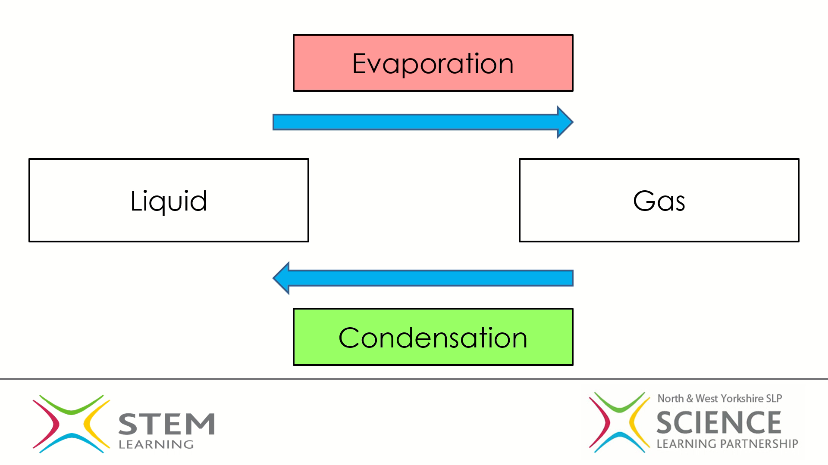

2. Describe what happened to the chocolate when you placed it onto your tongue. Can you use the key words you filled into the diagrams above?
___________________________________________________________________________________________________________________________________________________________________________________________________________________________________________________________________________________________________________________________________________________________________________________________________________________________________________________________________________________________________________________________________________________________
3. Describe what happened to the steam coming from the kettle when it hit the surface of the cold mirror. Can you use the key words you filled into the diagrams above?
___________________________________________________________________________________________________________________________________________________________________________________________________________________________________________________________________________________________________________________________________________________________________________________________________________________________________________________________________________________________________________________________________________________________

Section 3 – The water cycle
Challenge 1: Water cycle modelling
Watch the video to help you if you need
Step 1: Decorate your bag using a waterproof pen– make sure you include clouds and the sun at the top near the Ziplock, they are important. You can draw faces on your clouds if you want
Step 2: If you want you, can colour your water using food colouring, but you don’t have to, carefully pour about 1cm of water into the bag and seal it – make sure no water can escape
Step 3: Hang up the bag, pick a window that gets lots of sunshine and securely tape the bag to the window, you don’t want it to fall!
Step 4: Leave the bag a couple of hours and go back and check, what do you see? Leave it another day again what do you see?
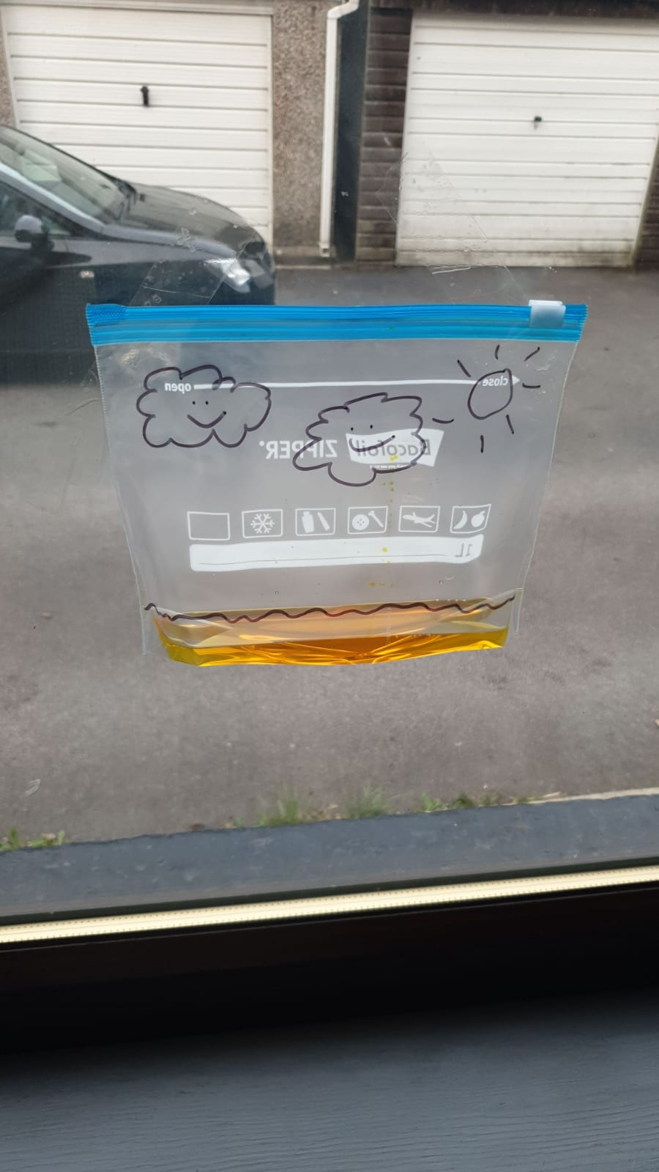
Describe what you can see happening within your Ziplock bag over a couple of days observing it
______________________________________________________________________________________________________________________________________________________________________________________________________________________________________________________________________________________________________________________________________________________________________________________________________________________________________________________________________________
What two changes of state occur in the water cycle?
__________________________________________________________________________________________________________________________________________________________
Why do these changes of state occur?
__________________________________________________________________________________________________________________________________________________________

Additional activities – please show us what you get up to at home on social media and tag us using @NwySlp

Investigating Liquids:
- Choose a variety of liquids, for example: water, golden syrup, oil, mayonnaise
- Put a drop of each at the top of a tray. Which do you think will reach the bottom first when you tip the tray? Make a prediction.
- Tip the tray – which liquid was fastest? Why was this? How does this change if you:
- Put the liquids in the fridge first
- Put the liquids outside on a warm day first

Investigating gases:
What you need: 2 balloons, 2 plastic bottles, warm water (get an adult to help you with this)
- Attach a balloon to the top of each plastic bottle, leave one plastic bottle just on the side and place the other bottle in warm water
- What happens to the balloons? Why do you think this has happened?
- Research how a hot air balloon works, and how is this similar to what you have just investigated

