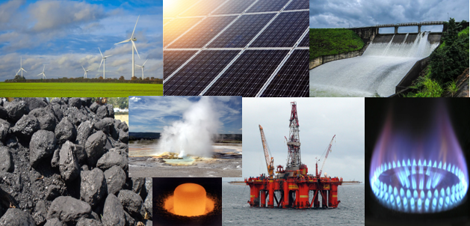
Sources of Electricity

Write all of the sources of electricity that you can identify in the box below:

Can you sort the sources of electricity into renewable and non-renewable?
Renewable sources of electricity | Non-renewable sources of electricity

Image rights
https://pixabay.com/photos/wind-turbines-norfolk-power-england-1117890/
https://www.publicdomainpictures.net/en/view-image.php?image=9099&picture=solar-panels
https://www.pxfuel.com/en/free-photo-eizqw
https://en.wikipedia.org/wiki/File:Plutonium_pellet.jpg
https://www.flickr.com/photos/oatsy40/9333525319
https://commons.wikimedia.org/wiki/File:Oil_platform_in_the_North_Sea.jpg
https://www.flickr.com/photos/amerune/14693491932
https://pixabay.com/photos/flame-gas-gas-flame-blue-hot-ring-580342/

