Activity 1 – warm up What makes a balanced healthy diet?


Activity 2 Peristalsis practical

http://science-mattersblog.blogspot.com/2011/11/body-systems-digestive-system.html

Resources
- Tights with toe cut off - oesophagus
- Smooth ball that will be tight when put into the tights - food

Instructions

- Place the ball in one end of the oesophagus

- Hold the oesophagus up (it should not move)

- Discover - What is the best way to move the ball?

- You will realise that squeezing above or below the ball is the best way to move it. That is haw peristalsis works.

Here is a video to help…

https://www.youtube.com/watch?v=7av19YhNkhE

Activity 3
Digestion practical

Here is a video of my daughter having a go at the experiment… it is a bit chaotic
https://www.youtube.com/watch?v=dTrL6Y1YLa4&t=6s

STEM has a free to access video and instruction sheet for the practical I have shown you, please follow the link.
Dazzling digestion
https://www.stem.org.uk/elibrary/resource/35396 - Digestive system experiment;

Here is another example of the practical
http://www.homeschoolroom.com/digestive-system-demonstration/

Activity 4
Label the diagram – maybe make a model of the organs

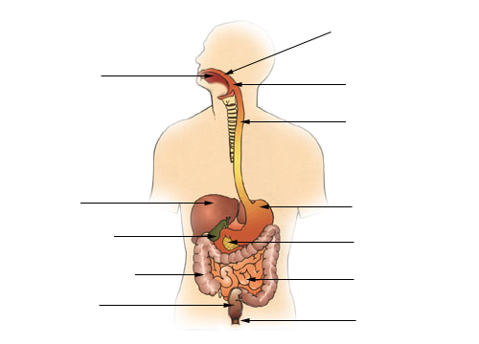

Model ideas

Here is a link to some ideas for models
https://www.google.com/search?q=model%20ideas%20for%20digestive%20system&tbm=isch&hl=en&hl=en&tbs&rlz=1C5CHFA_enGB895GB895&ved=0CAEQpwVqFwoTCND7mNiSmOkCFQAAAAAdAAAAABAC&biw=1012&bih=554

Card board
Modelling clay or play dough
Junk modelling – bottles and tubes
Labelled diagram
A t-shirt print or apron

Label it and add lots of notes
Activity 5
Retell the story of digestion

Idea 1
The story of a piece of food.

Example
Samantha the sausage enters the mouth… describe the process and what happens to her.

Idea 2
Video a news report

Idea 3
Newspaper report of the amazing journey

Idea 4
A comic

Idea 5
A series of interviews with different digestive

Activity 6 – Feces
You might like this for your bathroom wall…

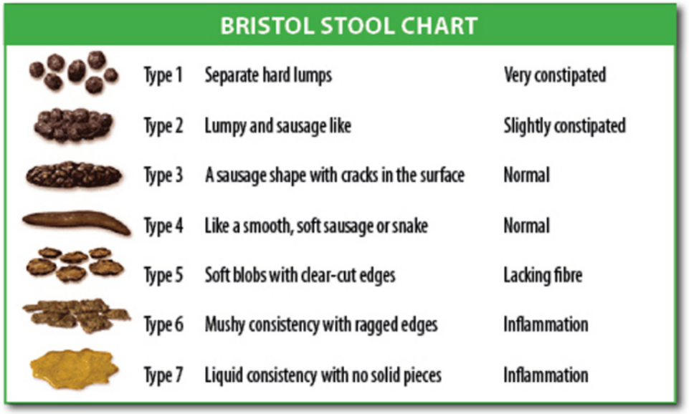

Can you make a child friendly stool chart so they know whether they are healthy?

Type 1 – rabbit pellets
Type 2 – a lumpy log
Type 3 – a think and bumpy sausage
Type 4 – smooth mushy snakes
Type 5 – mushy chicken nuggets
Type 6 – Lumpy gravy
Type 7 – Watery gravy

Activity 7 – Animal digestive systems

Carry out you own investigation into animal digestive systems.

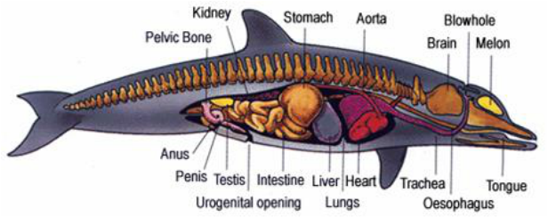
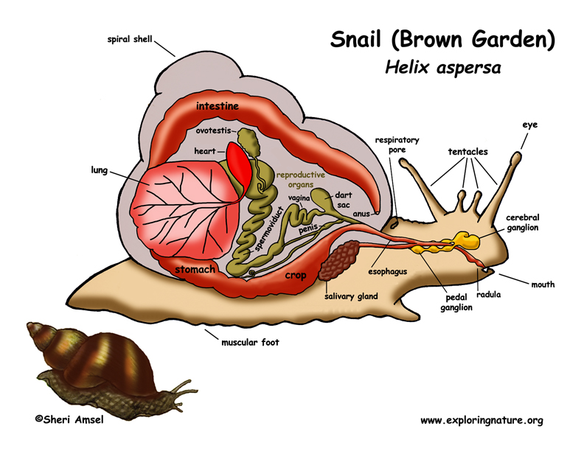
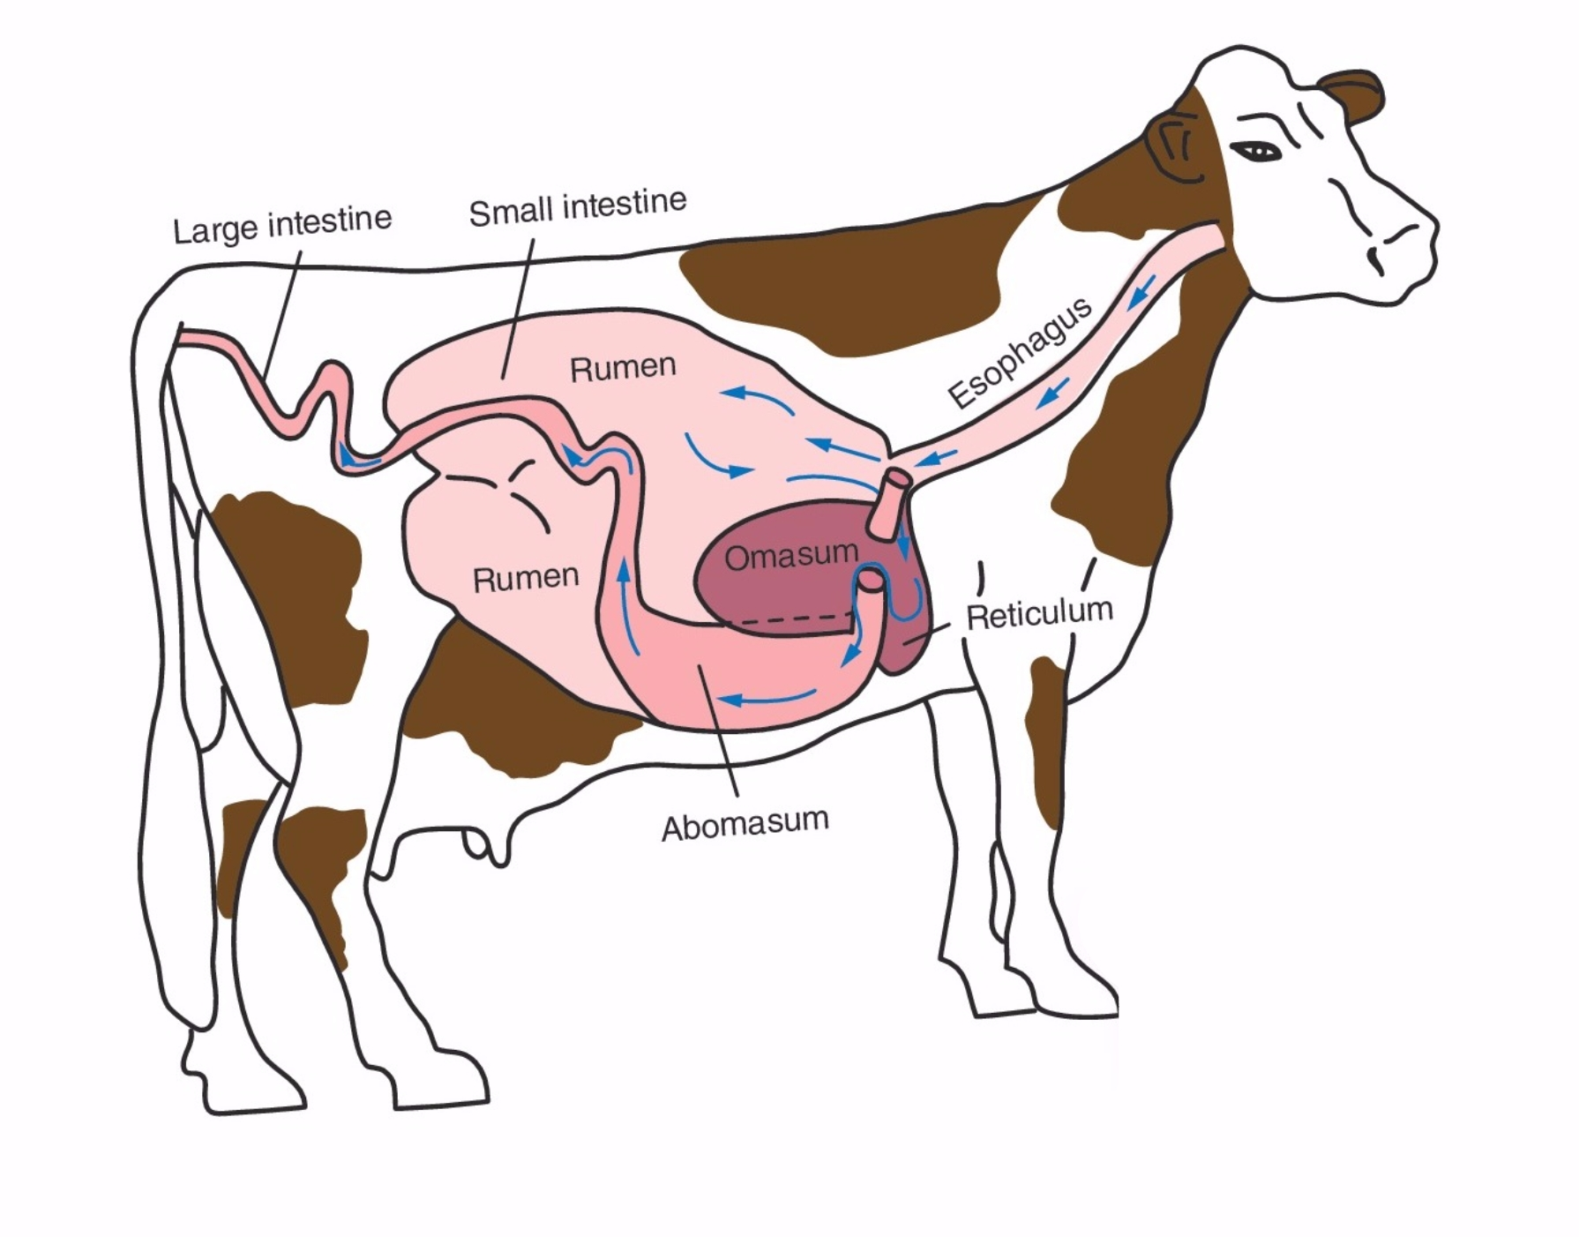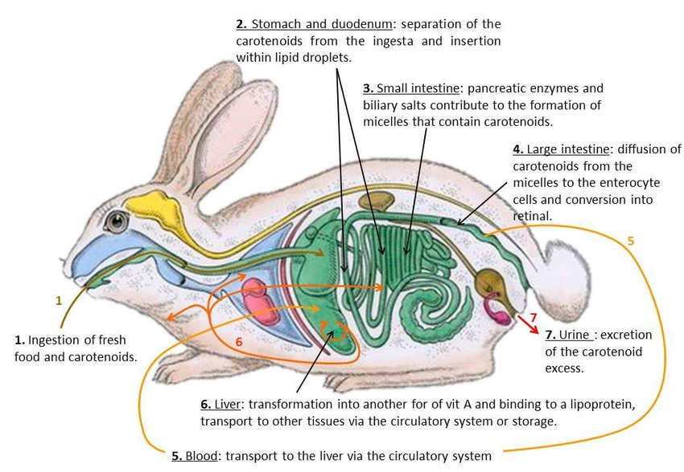

Websites and video links

Kids health
https://kidshealth.org/en/kids/dsmovie.html

DK findout
https://www.dkfindout.com/uk/human-body/digestion/

National Geographic
https://www.natgeokids.com/uk/primary-resource/digestive-system-science/

Reach out CPD – Digestion practical
https://www.reachoutcpd.com/how-parents-can-help/

BBC bitesize

