Sound – how is it made?

Name: _______________________________
As you work through the video, press pause to enable you to think, join in, try some of the activities, and write the answers on this worksheet. You will then be able to take it back into school to show your teacher!


- Why can you only hear a bee when it is flying?

______________________________________

- What does the “pitch” of a sound tell us? _________________________________________

- Try this website, and see what else you can find out about sound:

https://musiclab.chromeexperiments.com/Strings/

Please click on the parts of the string for it to make a sound

What did you find out?

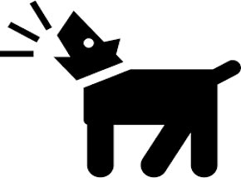

- Which has a higher pitch bark, a small dog or a large dog? ___________


- When Laura played her two recorders, which had a lower pitch note? _________________

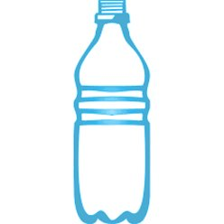


- Which of your two bottles made a lower note? __________________


- How can you make a drum make a louder noise?

- Watch the peppercorns jumping on the drum - what does a loud noise tell you about the size of the vibrations?

- The further away a sound is the __________________ it is.

- Explore sound further using these resources:
https://www.stem.org.uk/resources/elibrary/resource/468114/learning-projects-year-3-and-4
https://www.bbc.co.uk/bitesize/topics/zgffr82
https://musiclab.chromeexperiments.com/Experiments

Are you ready for a Challenge?
Why not try the Challenges below – we’d love to see your attempts on Twitter – tag us @NwySlp and we will comment back!

Challenge 1 - Make your own bottle band
Get some empty bottles, 3 or 4 will do. Blow across them like you did before.

Get a jug of water and pour some into one of the bottles until it’s about ¼ full. Blow across the top and listen to the sound that it makes now. Pour in some more water until it’s ½ full, then blow across the top of it again. How has this altered the sound?
Try this with all of your bottles then try to make some notes that you recognise to play a tune.
The harder you blow the louder the sound will be.
How did you get on? Upload your photo/video onto Twitter – tag us @NwySlp

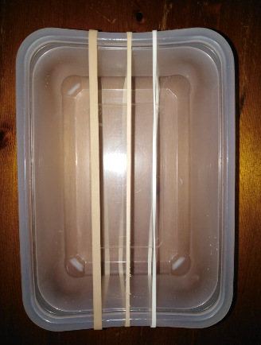
Challenge 2 – Make your own string instrument
Get some different width elastic bands and an empty plastic box or empty tissue box. Stretch the elastic bands around the box like in the picture…
Twang the elastic bands – which ones make higher pitched sounds? How can you make the sounds louder?

How did you get on? Upload your photo/video onto Twitter – tag us @NwySlp

