KS5 Physics – Young’s Modulus
Name: _______________________________
As you work through the video, press pause to enable you to think, and to complete this worksheet. You will need separate paper to answer the questions, in order to show your working out / give full explanations!
Questions

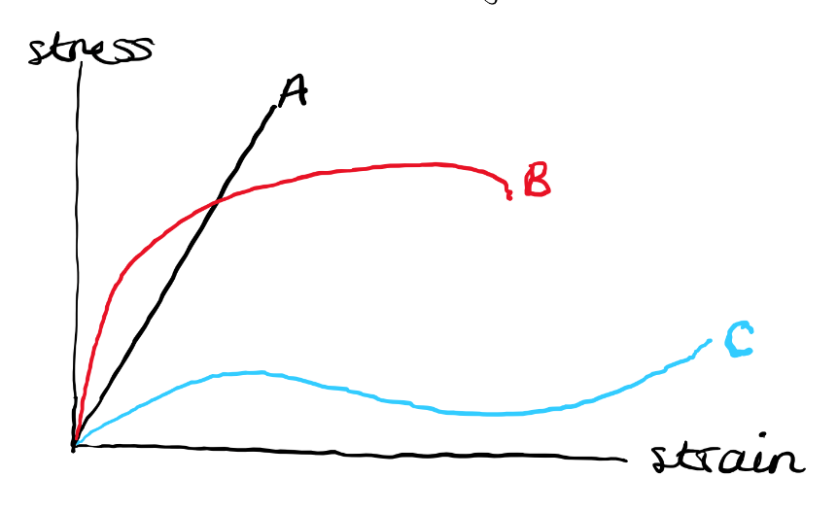

- Look at the graph above. Which line is for the material that…
  - Is the stiffest? _________
  - Is the strongest? _______
  - Most ductile? _______
  - Has the lowest yield stress?________
  - Is brittle? ______
  - Is the toughest? _____

- Sketch the stress-strain graphs for Kevlar and Spider Silk on the axes below – and write notes around the graph explaining what these tell you about the properties of these two materials.
Stress

Strain
3.
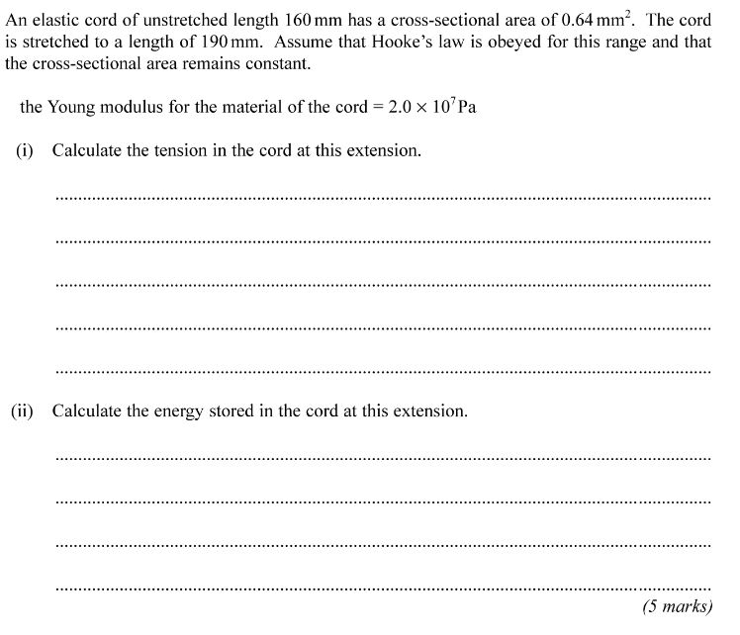
Space for Notes
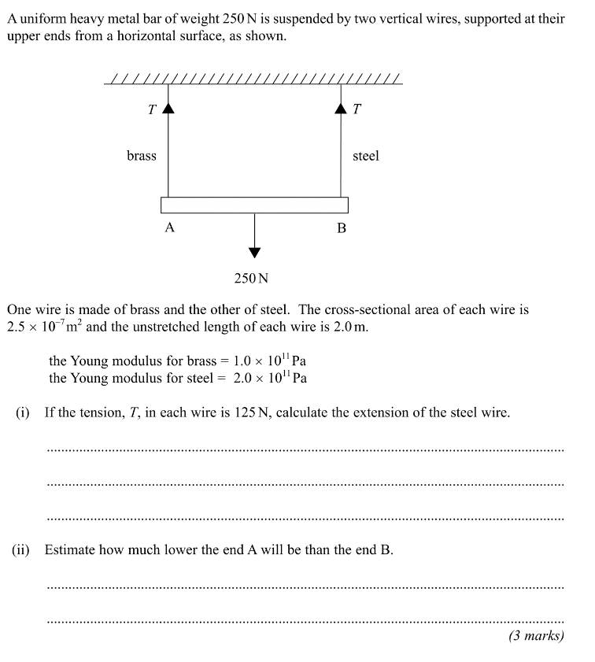
Space for Notes

More practice questions: https://www.physicsandmathstutor.com/physics-revision/
4.

